Appendix:
Table S1: Number of patients per facility
(The name of facilities has been blinded for confidentiality purpose)
Facility | No of Patients | % of total patients
1 | 2587 | 0.4
2 | 15979 | 2.8
3 | 18927 | 3.3
4 | 20833 | 3.6
5 | 24243 | 4.2
6 | 26980 | 4.7
7 | 29415 | 5.1
8 | 31424 | 5.5
9 | 33594 | 5.8
10 | 50169 | 8.7
11 | 51846 | 9.0
12 | 53978 | 9.4
13 | 54321 | 9.4
14 | 72545 | 12.6
15 | 89313 | 15.5
Total | 576154 | 100.0

Table S2: Distribution of Patient by month
Month | No of Patients | % of total patients
Jul | 42891 | 7.4
Jan | 43900 | 7.6
Feb | 44281 | 7.7
Aug | 44746 | 7.8
Jun | 45763 | 7.9
Apr | 45933 | 8.0
Mar | 48745 | 8.5
Sep | 49306 | 8.6
Dec | 50181 | 8.7
May | 51333 | 8.9
Nov | 54148 | 9.4
Oct | 54927 | 9.5
Total | 576154 | 100.0
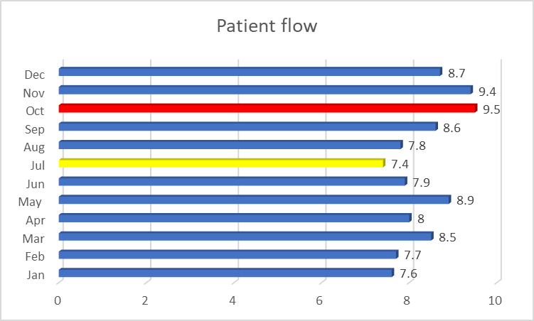
Figure S1 Percentage of footfall of patients during different months of the year

Table S3: Age distribution of patients
Age group | No of Patients | % of total patients
0 to 10 | 153804 | 26.7
11 to 20 | 73665 | 12.8
21 to 30 | 122998 | 21.3
31 to 40 | 101046 | 17.5
41 to 50 | 48571 | 8.4
51 to 60 | 31147 | 5.4
61 to 70 | 22235 | 3.9
71 to 80 | 12812 | 2.2
80+ | 7213 | 1.3
Missing | 2663 | 0.5
Total | 576154 | 100.0
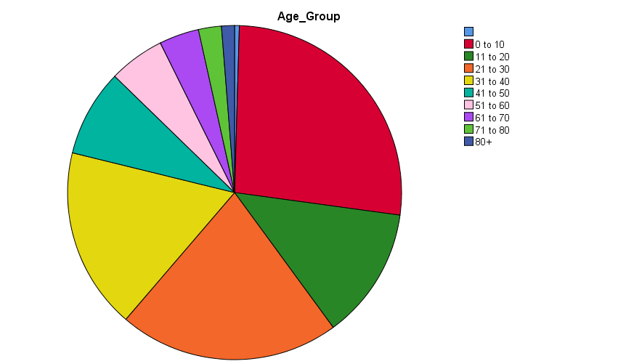
Figure S2 Age Distribution of patients presenting to ED

Table S4: Sex Distribution of patients
Sex | No of Patients | % of total patients
Female | 261500 | 45.4
Male | 314637 | 54.6
Missing | 17 | 0.0
Total | 576154 | 100
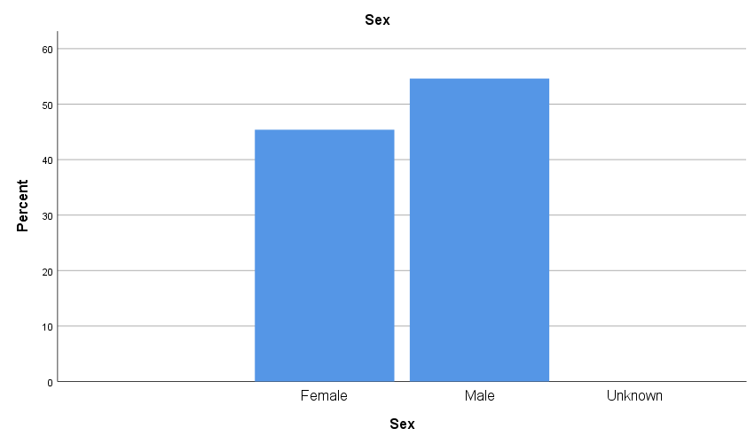
Figure S3 Gender Distribution of patients presenting to ED

Table S5: Emirati v/s Non Emirati patients
Emirati v/s Non-Emirati | No of Patients | % of total patients
Emirati | 352513 | 61.2
Non -Emirati | 223641 | 38.8
Total | 576154 | 100

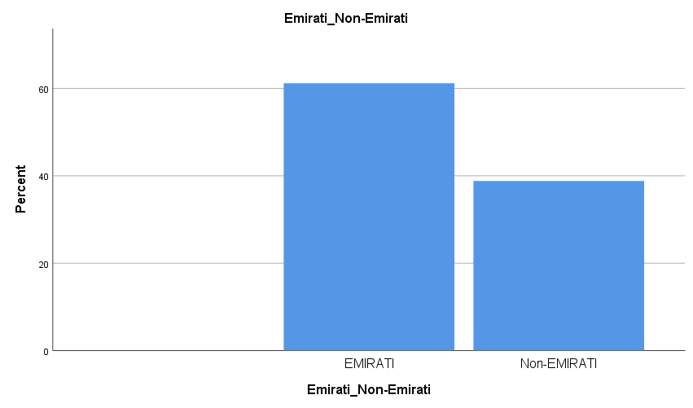
Figure S4 Nationality Distribution of patients presenting to ED

Table S6: Acuity distribution
Acuity level | Number of patients | % of total patients
1 | 1948 | 0.3
2 | 21044 | 3.7
3 | 242538 | 42.1
4 | 247365 | 42.9
5 | 52181 | 9.1
Missing | 11078 | 1.9
Total | 576154 | 100

Table S7: Median LOS as per assigned acuity
Acuity level | Median LOS (minutes)
1 | 171.00
2 | 135.00
3 | 102.00
4 | 64.00
5 | 52.00
Overall | 78.00

