Supplementary data
Figure S1. Structure of N3-Alendronate. Chemical Formula: C8H18N4O8P2; Exact Mass: 360.0600; Molecular Weight: 360.1980

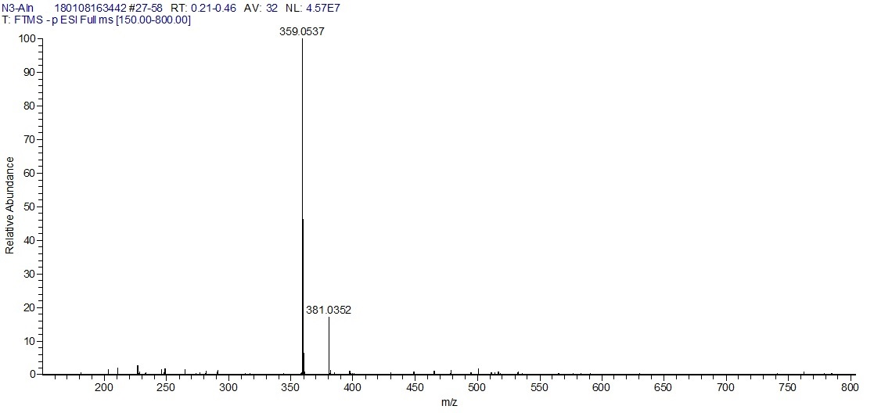
Figure S2. ESI-MS of N3-Alendronate (negative mode).Calculated: 360.06. Found: 359.05 (M-H), 381.04 (M-H+Na)

