Supplementary Data:

High resolution mass spectra:

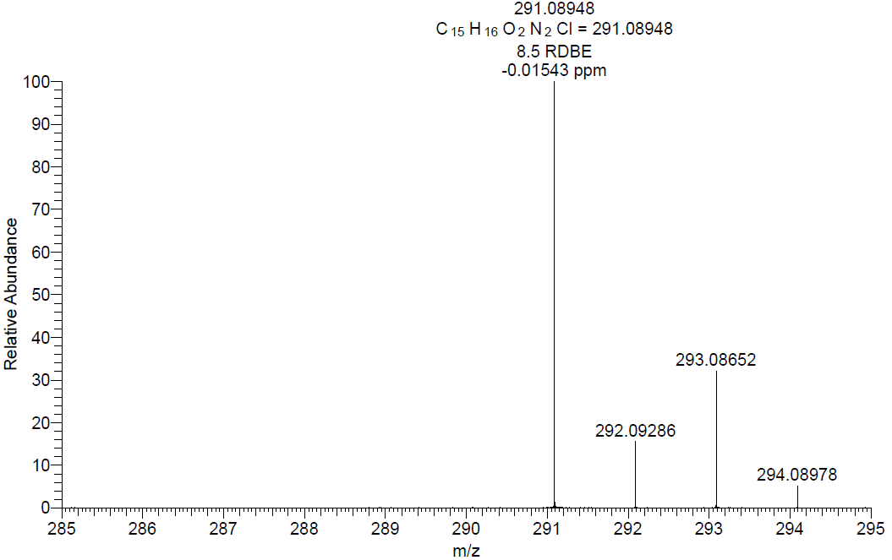

¹H NMR:

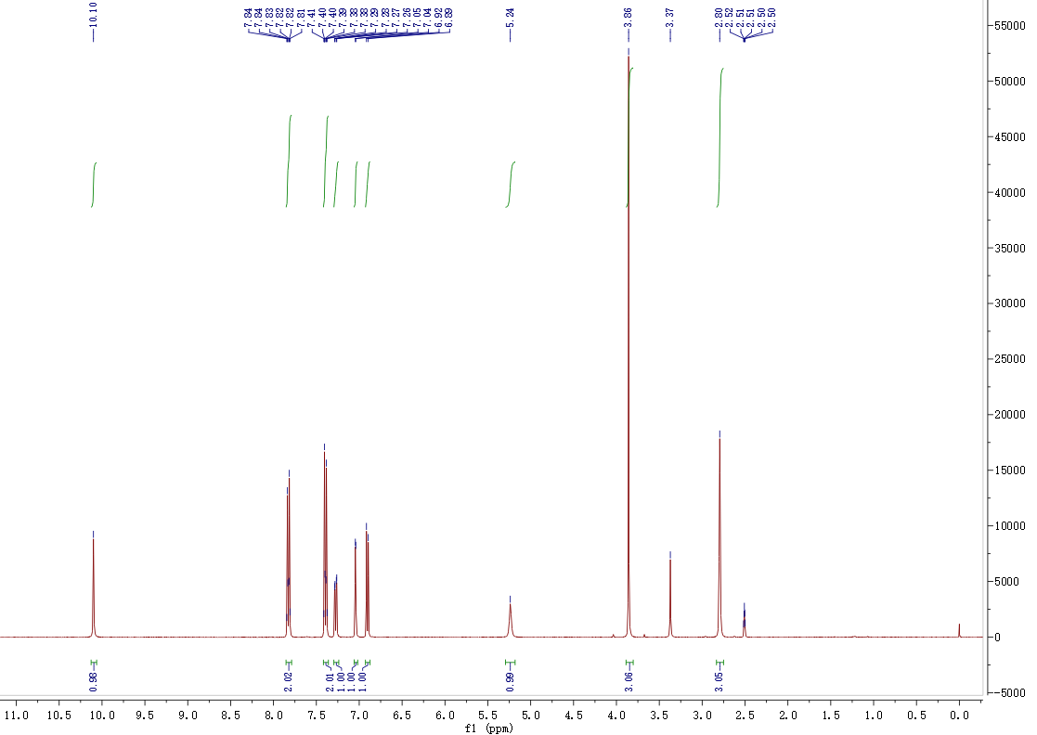

¹³C NMR:

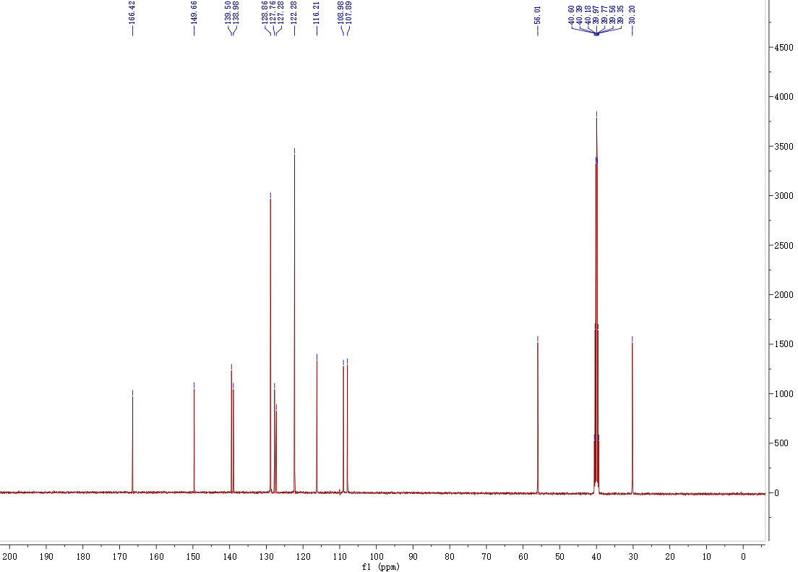

HPLC:

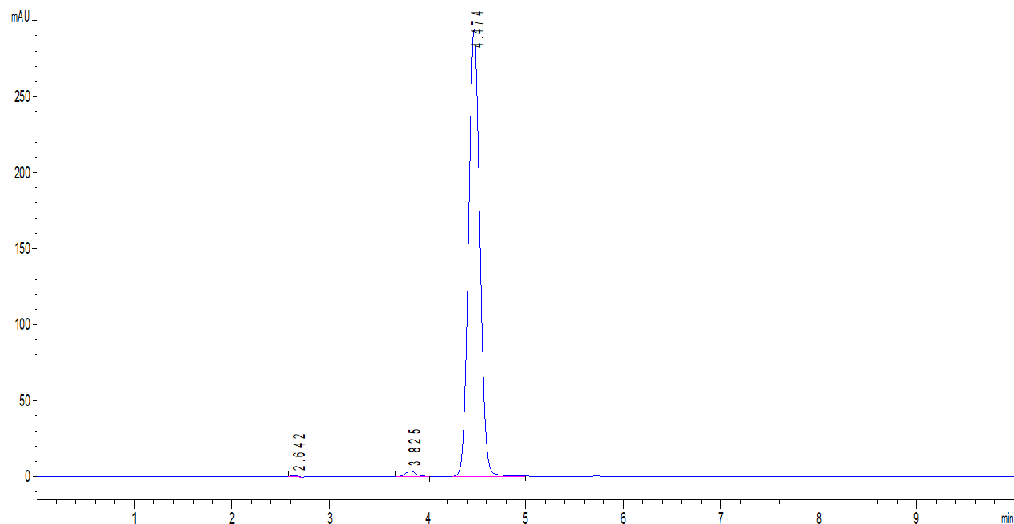

Table S1. Mean (±SD) plasma concentration of IMB-0523 in SD rats (n = 3).

Time (h) | Plasma concentration (ng/mL)
0.083 | 1088.94±359.93
0.25 | 1941.08±304.96
0.5 | 1989.39±184.03
1 | 2582.55±704.91
2 | 1984.45±871.36
3 | 1346.94±632.10
4 | 567.25±331.07
6 | 65.37±41.36
8 | 7.44±5.21
12 | ND
24 | ND
ND: Not detected.

