The search strategies and inclusion/exclusion criteria for circRNA research in the OSCC field as follows.
(1) Enter the following search terms in PubMed：
("circular rna"[Title/Abstract] OR "circRNA"[Title/Abstract]) AND (("OSCC"[Title/Abstract] OR "oral squamous cell carcinoma"[Title/Abstract]) OR "oral cancer"[Title/Abstract])
(2) Exclusion criteria:
1) Non-SCI articles: exclude 3 articles.
2) Articles with low relevance: After reading these articles carefully, we excluded 6 articles with poor correlation with OSCC or circRNA.
3) Review articles: exclude 3 articles.
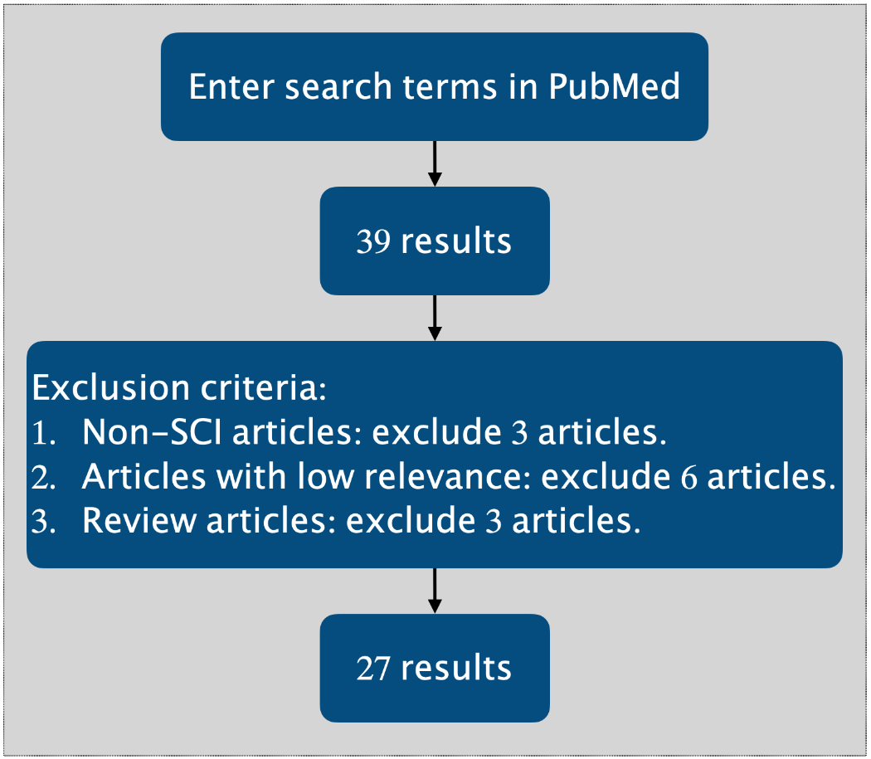
Supplementary Figure 1 Search strategy of journal identification in the present review

