Appendix S1
Rehabilitation following Arthroscopic Rotator Cuff Repair (ARCR)

Patient Education:
- The training provided in this booklet should be taken under the direction of your doctor
- Pain following surgery is a part of healing. However, if you experience extensive and prolonged pain, please consult your doctor immediately.
- Emphasize the importance of meeting staged ROM goals but not exceeding it to a large extent.
- Disclose the importance of tissue healing (The purpose of the early restriction was to promote tissue healing)
- Please note that if you are in an exceptional case after discharge, you must consult your doctor immediately.

PHASE 1
POD 1 to ~ POW 6
(POD, Postoperative Day; POW, Postoperative Week)
Interventions:
- No active range of motion (AROM) of shoulder
- No lifting of objects
- No excessive stretching or sudden movements
- No supporting of body weight by hands
- No aggressive or provocative passive range of motion (PROM) exercises

Immobilization:
Sling immobilization is typically 4-6 weeks, followed by a gradual weaning from the sling in controlled environments for an additional 2 weeks with goal of being out of the sling by POW 6-8.
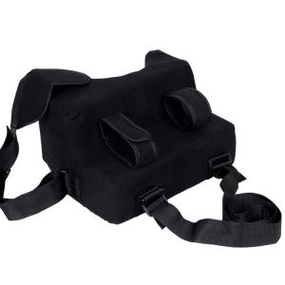
Figure 1. A typical shoulder sling recommended by ARCR surgeon. This shoulder sling consists of shoulder straps and a cushioned support that is positioned at 90º to the shoulder angle. This will give the optimal healing angle for the rotator cuff.

Training
POD 1-7
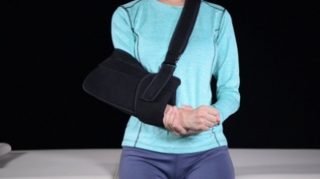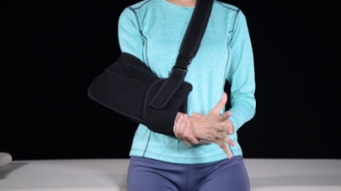
Figure 2 Figure 3
1. Finger grasp practice: Open the fingers of the affected hand, then grasp the fingers hard. (10 times/group, 10 groups/day)

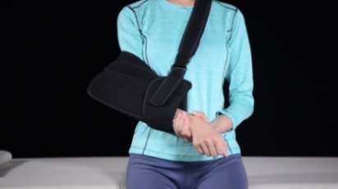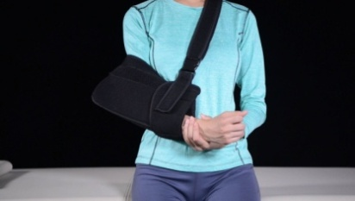
Figure 4 Figure 5
2. Wrist rotation practice: Use the good hand and hold the wrist of the affected hand. Rotate 10 times clockwise then 10 times counterclockwise. (10 times/group, 10 groups/day)

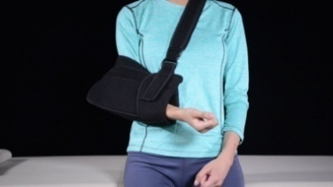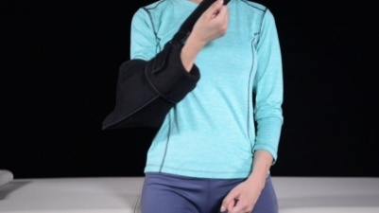
Figure 6 Figure 7
3. Elbow flexion and extension: Flex and extend the affected elbow slowly.(10 times/group, 10 groups/day)

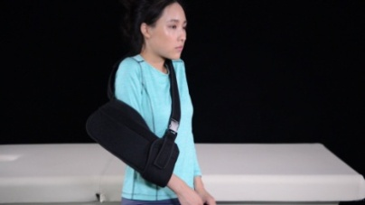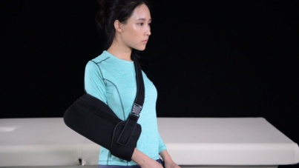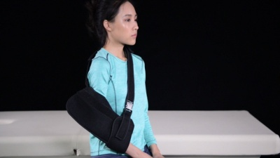
Figure 8 Figure 9 Figure 10
4. Shoulder training(shrug/extension/retraction):Slowly shrug/extend/retract/shoulder, maintain for 5 seconds. (10 times/group, 10 groups/day)

POW 1-3
• Continue the above exercises

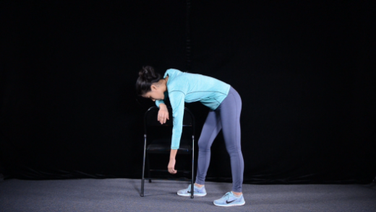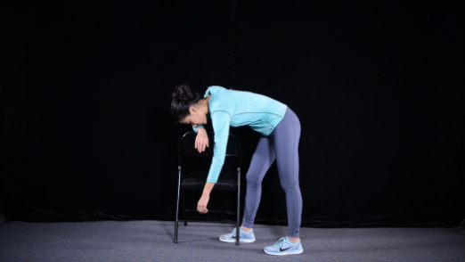
Figure 11 Figure 12
5. Pendulum exercise: Droop the affected side of the arm, relax shoulder, slowly turn the affected the arm in a clockwise direction for 10 circles, then turn in counterclockwise direction for 10 circles. (10 times/group, 3 groups/day)

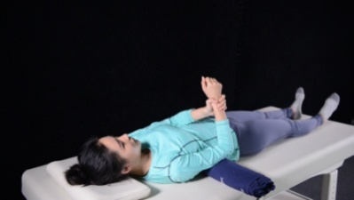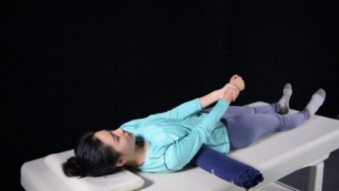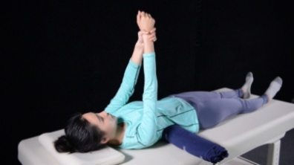
Figure 13 Figure 14 Figure 15
6. Passive activity (passive forward elevation): Lie supine, grasp the affected hand with good hand, slowly straighten the affected arm, then lift until it reaches hurting point and hold for 10 seconds. (10 times/group, 10 groups/day).

POW 3-6
• Continue the above exercises
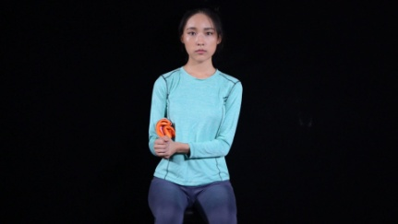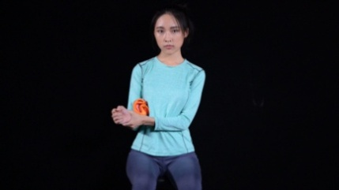
Figure 16 Figure 17
7. Passive activity (external rotation with arm by side): Put a towel between the waist and the affected arm. Grasp the affected arm with good hand, slowly extend the affected arm externally until it reaches hurting point, then hold for 10 seconds. (repeat 10 times/group, 4 to 6 groups/day)

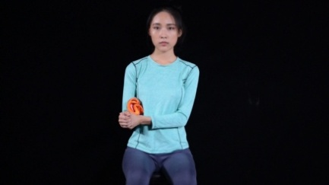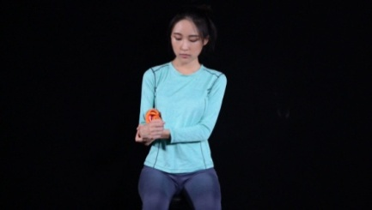
Figure 19 Figure 20
8. Passive activity (internal rotation with arm by side): Put a towel between the waist and the affected arm. Grasp the affected arm with your good arm, slowly pull it internally until it reaches hurting point, then hold for 10 seconds. (10 times/group, 4 to 6 groups/day)

Goals:
- Maintain integrity of repair
- Minimize pain and inflammation
- Achieve staged range of motion (ROM) goals

PHASE 2
POW 7 to ~ POW 12

Interventions:
- No active lifting or ADL’s that require ROM beyond staged goals
- No supporting of body weight by hands
- No excessive behind the back movements
- No sudden jerking motions
- No ROM significantly beyond staged goals

Immobilization:
Typically, gradual weaning from sling from POW 6-8. For some of the training, a short stick is required.

Training
ROM
• Continue Phase 1 exercises especially if PROM is behind staged ROM goals

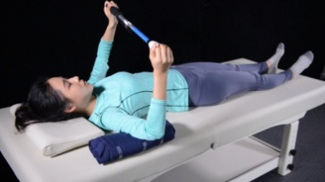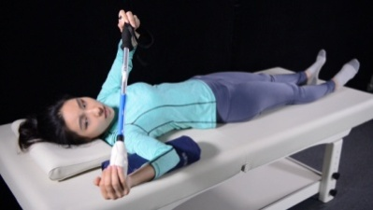
Figure 21 Figure 22
1. Passive activity (external rotation): Lie supine, hold both ends of the stick, slowly external rotates the affected arm with the stick until it hurts or limits, and hold for 10 seconds. (10 times/group, 4-6 groups/day)

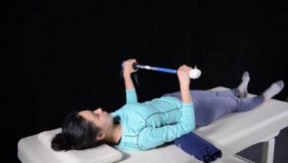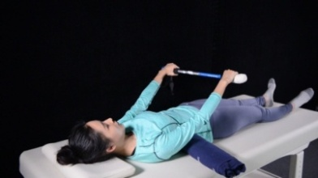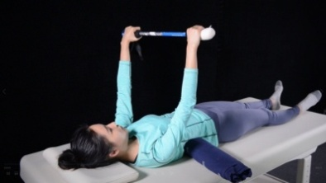
Figure 23 Figure 24 Figure 25
2. Active-assistive activity (forward elevation): Lie supine, hold both ends of the stick, slowly straighten the arms, then lift until it hurts or limits, then hold for 10 seconds. (10 times/group, 10 groups/day)

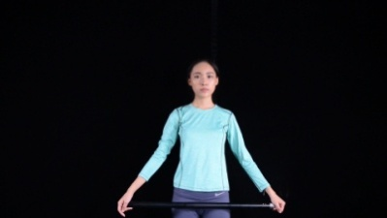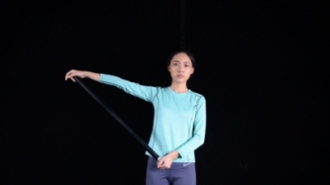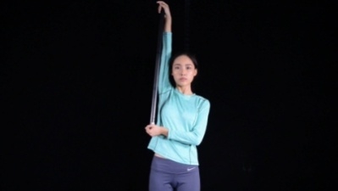
Figure 26 Figure 27 Figure 28
3. Active-assistive activity (abduction): Hold both ends of the stick, slowly abduces the arms until it hurts or limits, and hold for 10 seconds. (10 times/group, 4-6 groups/day)

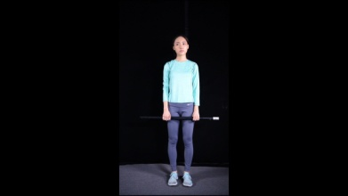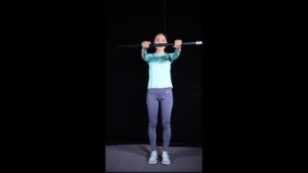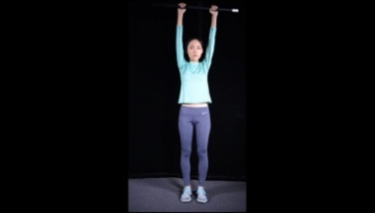
Figure 29 Figure 30 Figure 31
4. Active-assistive activity (forward elevation): Hold both ends of the stick, slowly straighten the arms, then lift until it hurts or limits, and hold for 10 seconds. (repeat 10 times/group, 10 groups/day)

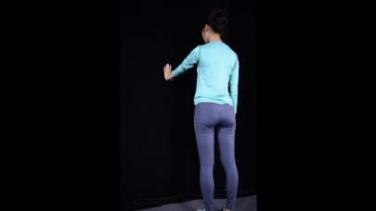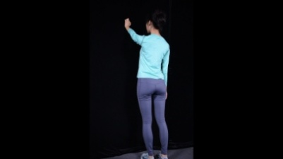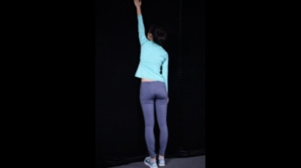
Figure 32 Figure 33 Figure 34
5. Active activity (forward wall climbing): Stand facing a wall and place your fingertips on the wall, slowly use your fingers of the affected arms to climb up until it hurts or limits, and hold for 10 seconds. (10 times/group, 10 groups/day)

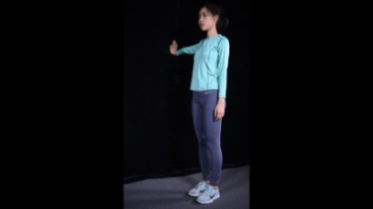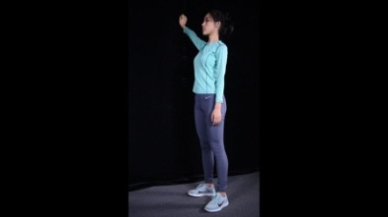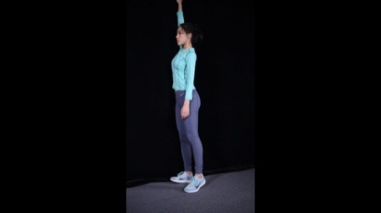
Figure 35 Figure 36 Figure 37
6. Active activity (abduction wall climbing): Stand with your affected side facing the wall and place your fingertips on the wall, slowly climb up until it hurts or limits, and hold for 10 seconds. (10 times/group, 10 groups/day)

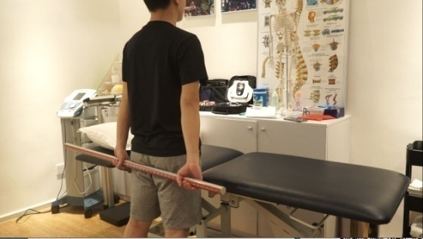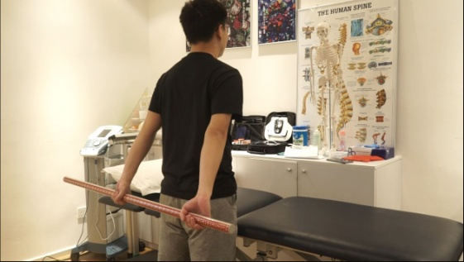
Figure 38 Figure 39
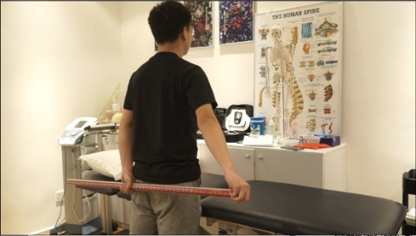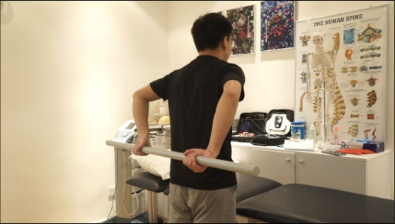
Figure 40 Figure 41
7. Back activity (extension, abduction, internal rotation): Stand and hold both ends of the gymnastics stick behind your back. Slowly extend / abduces /internal rotate until it hurts or limits, hold for 10 seconds, repeat 10 times/group, 4-6 groups/day

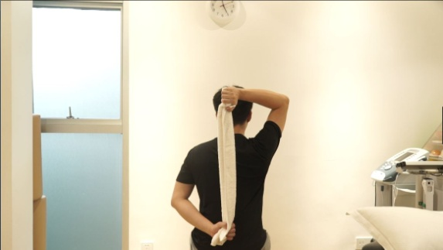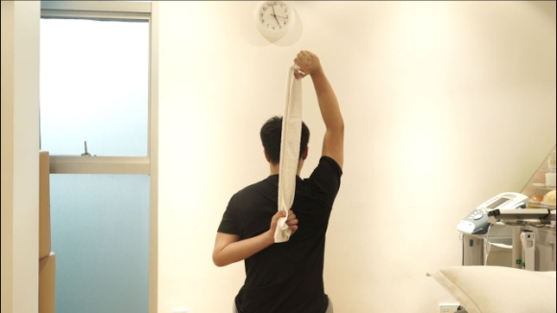
Figure 42 Figure 43
8. Back activity (internal rotation): Stand and hold both ends of the towel behind your back (the affected arm should be placed below). Slowly pull the towel until it hurts or limits, and hold for 10 seconds. (10 times/group, 4-6 groups/day)

Strength
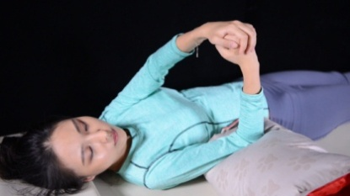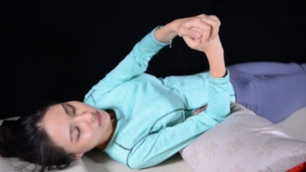
Figure 44 Figure 45
9. Isometric exercise (forward flexion): Lie supine, and place your good arm above the affected arms (left picture). Force the affected hand upwards against the good hand, but be cautious not to move the shoulder, and hold for 5 seconds. (10 times/group, 4 groups/day)

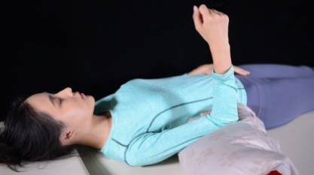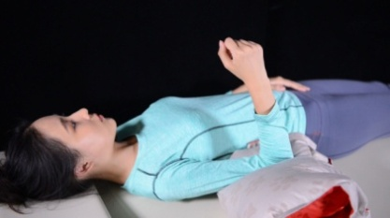
Figure 46 Figure 47
10. Isometric exercise (extension): Lie supine, the affected hand forced downward against the pillow, but be cautious not to move the shoulder, and hold for 5 seconds. (10 times/group, 4 groups/day)

Figure 48 Figure 49
11. Isometric exercise (internal rotation): The affected hand forced inwards against the good hand, but be cautious not to move the shoulder, and hold for 5 seconds. (10 times/group, 4 groups/day)

Figure 50 Figure 51
12. Isometric exercise (external rotation): The affected hand forced outwards against the good hand, but be cautious not to move the shoulder, and hold for 5 seconds. (10 times/group, 4 groups/day)

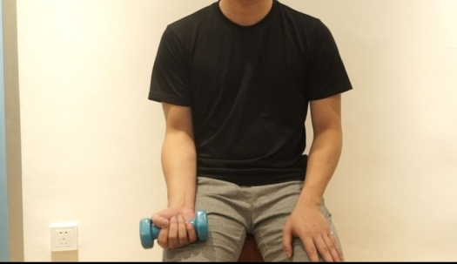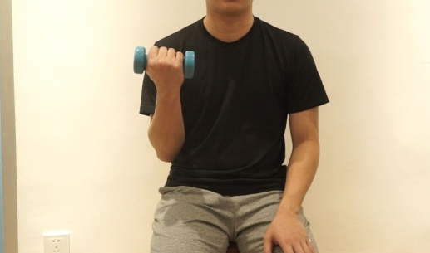
Figure 52 Figure 53
13. Resistance training (elbow flexion and extension): Elbow flex and extend with hand dumbbell slowly. (10-20 times/group, 4 groups/day) *This training needs a dumbbell, recommendation: 1 kg-2kg

Proprioceptive enhancement and stretching
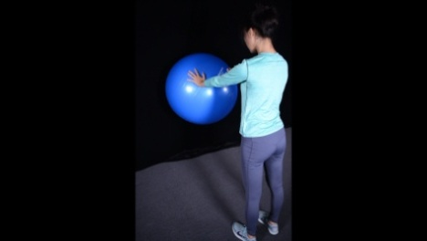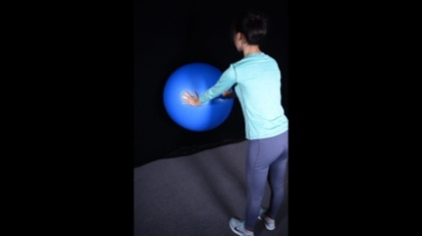
Figure 54 Figure 55
14. Ball on wall (below the shoulder): Holding the treatment ball with both hands below the shoulder, slowly rotate the treatment ball on the wall clockwise for 10 times, then counterclockwise. (10 times/group, 4 groups/day)

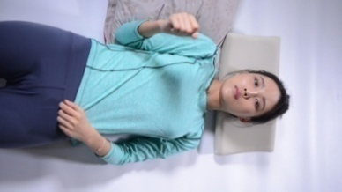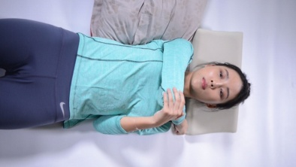
Figure 56 Figure 57
15. Stretching: Lie supine, horizontally adduct the affected shoulder, use the good hand to force against the affected elbow, slowly press down, and maintain for 10 seconds. (8-10 times/group, 2 groups/day)

Goals:
- Promote healing of soft tissue, extra care is needed to not overstress
- Achieve staged ROM goals
- Minimal pain and inflammation
- Initiate light muscle performance activities
- Perform light, non-repetitive ADL’s at chest level and below

PHASE 3
POW 12 to ~ POW 24

Interventions:
• No lifting of objects heavier than 15-20 lbs.
• No sudden lifting, jerking, or pushing activities
• No uncontrolled movements

Training
ROM
Continue stretching and passive ROM exercises as needed per patient impairments.

Strength
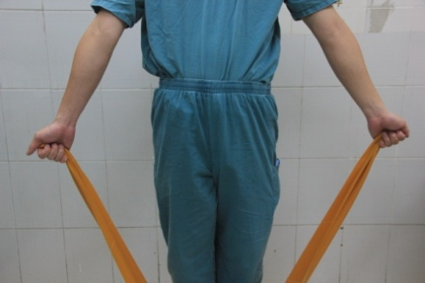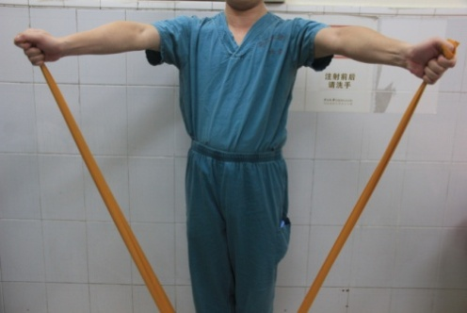
Figure 58 Figure 59
1. Resistance training (abduction): Standing with shoulder 30 °flexion, hold both ends of the TheraBand (fix the middle of the band), abduce arms as far as possible, and hold 3-5 seconds. (10 times/ group, 4 to 6 groups/day)

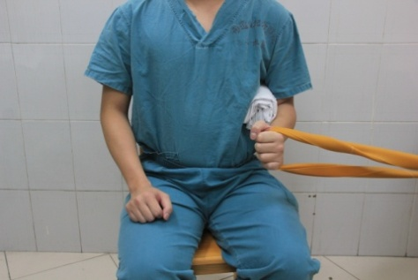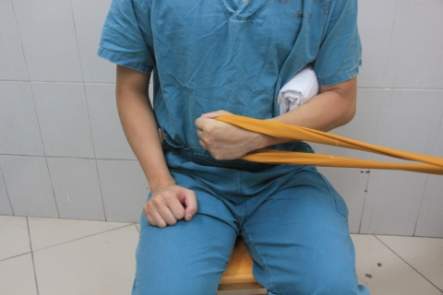
Figure 60 Figure 61
2. Resistance training (internal rotation arm by side): Fix the TheraBand on a heavy material (a table in the picture). After sitting down, use the affected hand to hold the middle of TheraBand, pull the arm inwardly as far as possible, and hold 3-5 seconds. (10 times/ group, 4-6 groups/day)

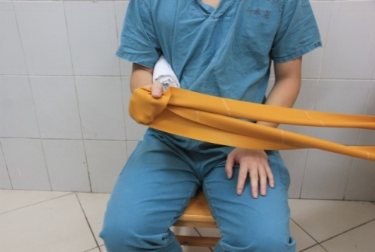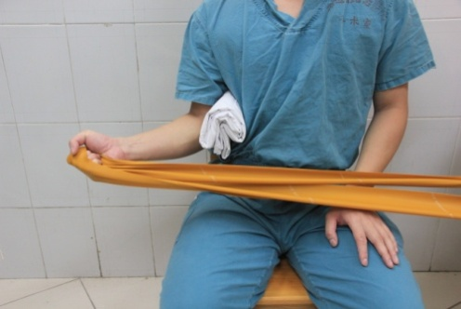
Figure 62 Figure 63
3. Resistance training (external rotation arm by side): Fix the TheraBand on a heavy material (a table in the picture). After sitting down, use the affected hand to hold the middle of TheraBand, pull the arm outwardly as far as possible, and hold 3-5 seconds. (10 times/ group, 4-6 groups/day)

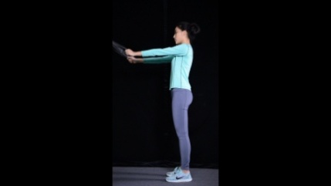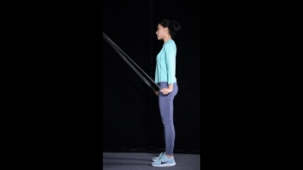
Figure 64 Figure 65
4. Resistance training (extension): Fix the TheraBand on a heavy material that is higher positioned than your arm. Hold both ends of the TheraBand and slowly extend pull both arms towards your side, and hold 3-5 seconds. (10 times/ group, 4-6 groups/day).

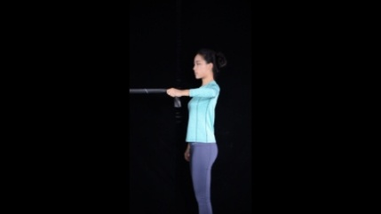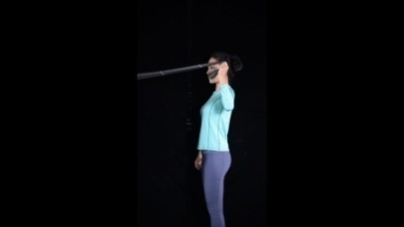
Figure 66 Figure 67
5. Resistance training (external rotation): Fix the TheraBand on a heavy material that is positioned at the same height with your shoulder. Make sure that your arm is parallel to the TheraBand (left figure). Use the affected hand to pull the TheraBand towards yourself, while ensuring the rotator cuff is being rotated; hold 3-5 seconds. (10 times/ group, 4-6 groups/day)

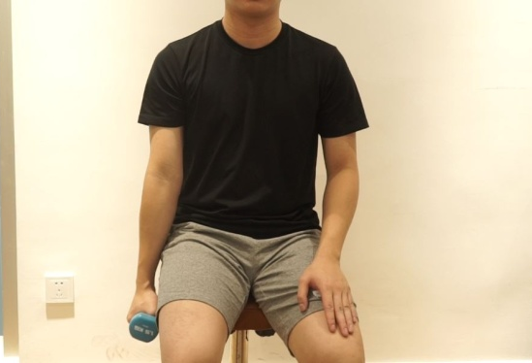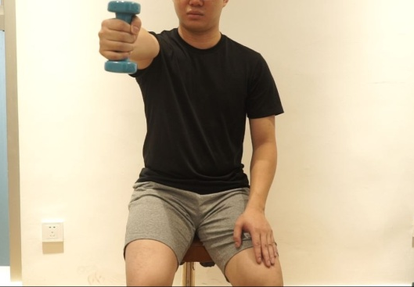
Figure 68 Figure 69
6. Resistance training (forward elevation): Forward elevate with hand dumbbell slowly (10-20 times/group, 4 groups/day). *recommended dumbbell weight = ?? kg

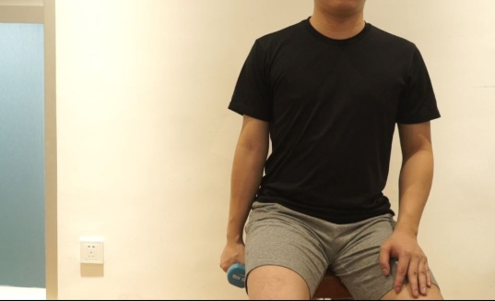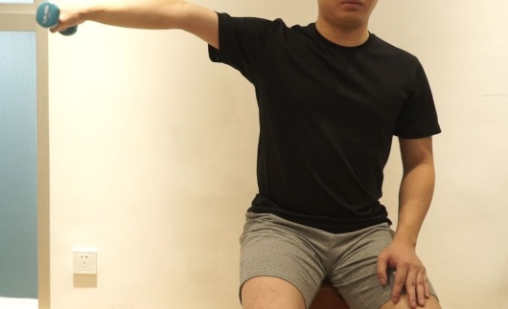
Figure 70 Figure 71
7. Resistance training (abduction): Forward elevate with hand dumbbell slowly. (10-20 times/group, 4 groups/day). *recommended dumbbell weight = ?? kg

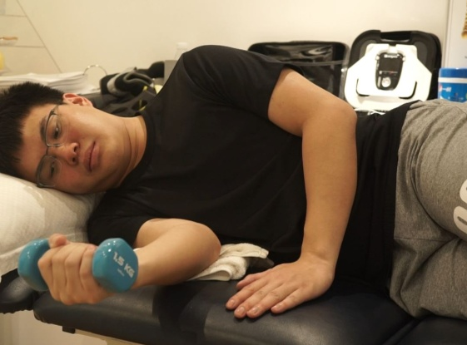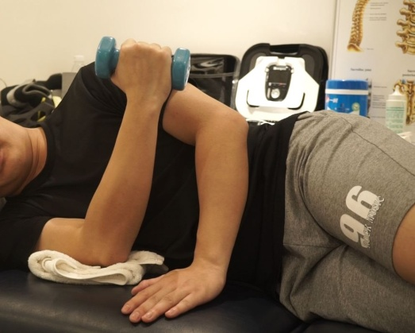
Figure 72 Figure 73
8. Resistance training (internal rotation): Internal rotation with dumbbell slowly. (10-20 times/group, 4 groups/day). **

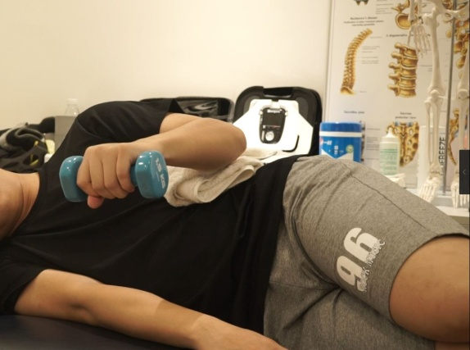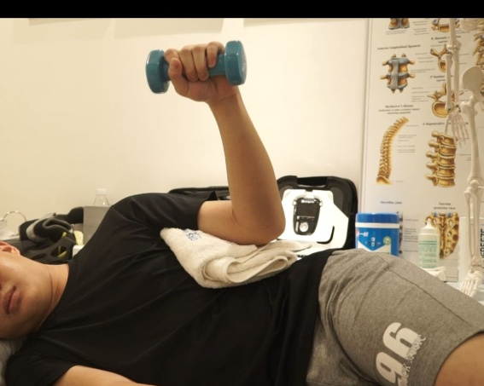
Figure 74 Figure 75
9. Resistance training (external rotation): Place a towel between your waist and affected arms. Then, rotate externally with hand dumbbell slowly (10-20 times/group, 4 groups/day). **

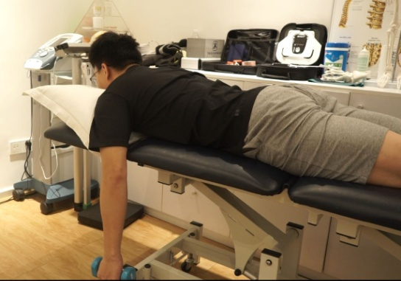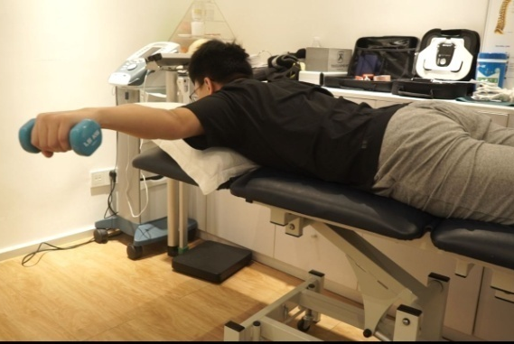
Figure 76 Figure 77
10. Resistance training (horizontal abduction): Lie Prone, horizontal abduces with hand dumbbell slowly. (10-20 times/group, 4 groups/day) **

Proprioceptive enhancement
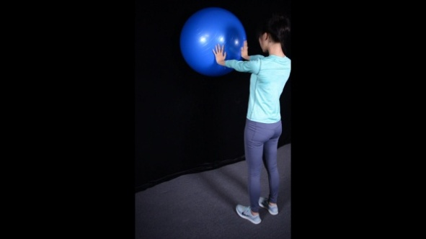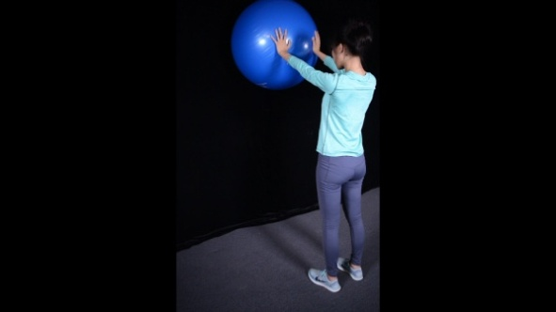
Figure 78 Figure 79
11. Ball on wall (beyond the shoulder): Holding the treatment ball with both hands beyond the shoulder, slowly rotate the treatment ball clockwise for 10 times, then counterclockwise. (10 times/group, 4 groups/day)

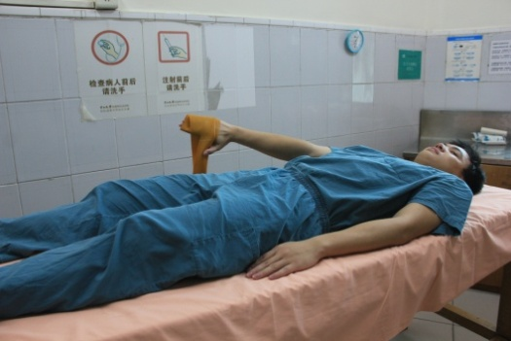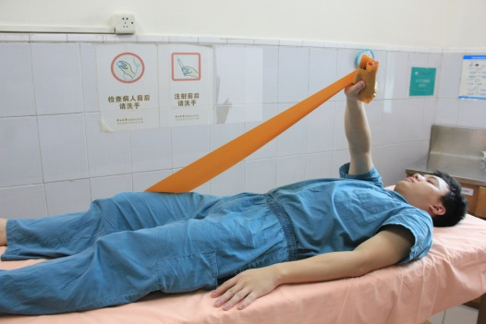
Figure 80 Figure 81
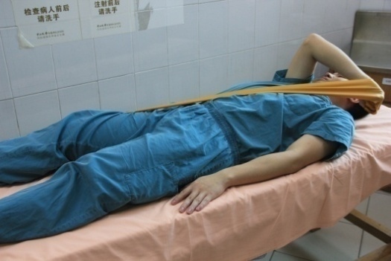
Figure 83
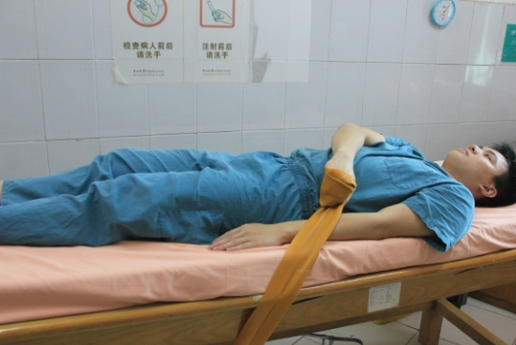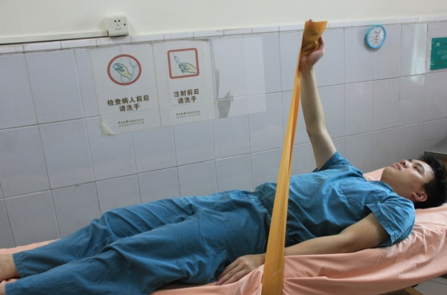
Figure 84 Figure 85
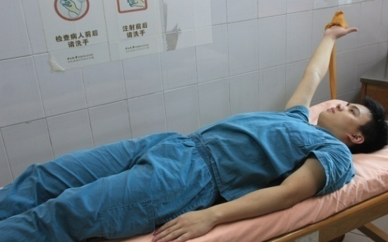
Figure 86
12. Diagonal training: Hold the end of the theraband (fix the another end), slowly flex/extend in the diagonal direction, repeat 10 times/ group, 4-6 groups/day

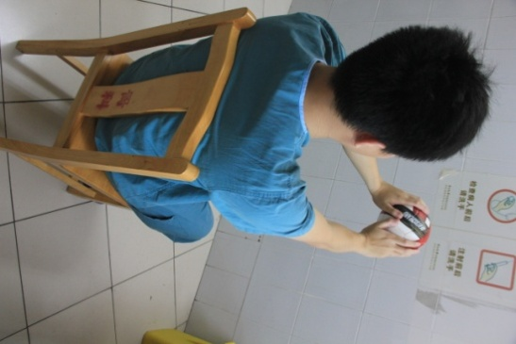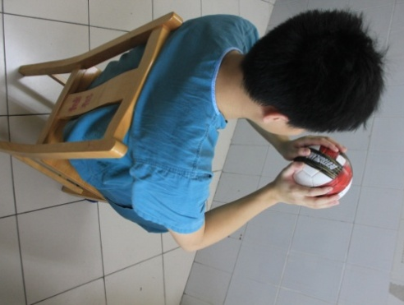
Figure 87 Figure 88
13. Catch ball: Start with soft ball, throw the ball towards the wall and catch it with both hands. Make sure both hands are on the same height as your shoulder. (20-30 times/group and 3 groups /day).

Goals:
- Pain free with basic activities of daily living and Phase 3 strengthening
- Patient work demands or goals for recreational activities requires progressive loads or positions not reached during Phase 3 exercises
- Demonstrates adequate shoulder girdle dynamic stability for progression to higher demanding work/sport specific activities.
- Surgeon approval

*All figures in Appendix 1 are original.

Appendix S2

Literature Review (Context of study)

In the development of this booklet, our goal was to cite the best available evidence, relying on randomized controlled trials when available. An electronic search of CENTRAL, MEDLINE, PubMed, PEDro and FMJS was undertaken by two researchers. We searched the following key terms: “supraspinatus” OR “infraspinatus” OR “subscapularis” OR “teres minor” OR “rotator cuff” OR “cuff muscles”, “repair” OR “surg” OR “surgery” OR “surgical treatment”, “rehabilitation” OR “rehab” OR “physical therapy” OR “physiotherapy”. Literatures that were published between September 1993 and September 2018 were included.
Database searches resulted in 471 articles. After systematic review of the abstracts, 430 articles were eliminated as they were either (i) non-related articles that did not meet the inclusion criteria or (ii) were duplicates from different databases. After reviewing the full text of the remaining 41 articles, 23 articles were eliminated (13 studies were review articles and 10 studies did not contain post-operative rehabilitation data). The remaining 18 articles were divided into two groups; the first group of articles (10) comprises randomized controlled trials, prospective therapeutic case series, therapeutic case series after RCR. The second group of articles (8) was composed of slow and accelerated rehabilitation comparing patient outcomes after RCR (Figure S1). 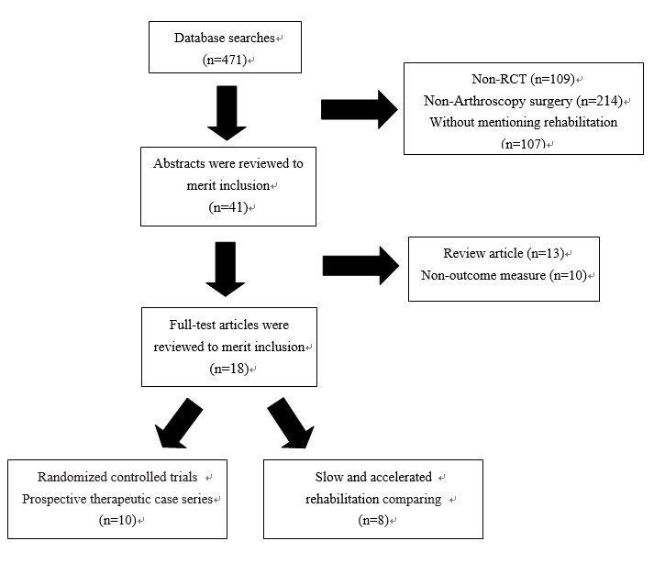
Figure S1. Detailed flowchart depicting the process of literature review.

Study selection

Inclusion criteria were defined as follows: (i) patients diagnosed with RCT; (ii) patients underwent arthroscopic RCR surgery; (iii) above 18 years old and (iv) sufficient data describing rehabilitation following arthroscopic surgery. Exclusion criteria were defined as follows: (i) retrospective studies or review papers; (ii) patients with non-RCT injury; (iii) patients who did not undergo surgery; (iv) patients undergoing open surgery; (v) patients < 18 years old; and (vi) patients lack sufficient data. One researcher applied the inclusion criteria to select potentially relevant studies using both the title and abstracts of the references retrieved by the literature search. If there was uncertainty over the inclusion of studies from the title and abstract alone, clarity was sought from the full text article and /or another researcher.

Data extraction

The articles were reviewed to evaluate for the presence or absence of therapies and recommendations for post-operative rehabilitation include goals for completion of ranges of motion, functional milestones, and exercise start times. The following broad categories were defined: immobilization, passive range of motion, active range of motion, resistance exercises and specific training (Table S1). Two researchers independently extracted the outcomes from the included studies. Disagreements in data were resolved by discussion and cross-referencing with the original study.

Table S1. Recommendation and contents of post-surgical rehabilitation compiled from various literatures.
Recommendations | Contents
Immobilization | Type of immobilization, time of immobilization
Passive ROM | Passive forward flexion (PFF), passive external rotation (PER), full passive ROM
Active ROM | Start active ROM
Strengthening | Resistance exercises
Specific Training | Proprioception, Return to sport
Abbreviation: ROM, range of motion; PFF, passive forward flexion; PER, passive external rotation

The results of the remaining 18 articles data extraction are shown in Table S2.

Table S2. Data extraction of the articles
Commencement of Postoperative Rehabilitation
 | Level of | Sample | Study | Immobilization: | Passive |  | Passive | Passive ROM | Active | Resistive
Author (Year) | Evidence | Size | Design | Time; Device | Forward  Elevation |  | External Rotation | Within Normal Limits | ROM | Exercise
Postoperative Rehabilitation
Kimberley et al. ¹ | 1 | 58 | RCT | 4 wk; | 2 wk | 2 wk |  | 12 wk | 9 wk | 12 wk
(2004) |  |  |  | Sling
Roddey et al. ² | 2 | 108 | RCT | 6 wk | 4 wk | 4 wk |  | 6 wk | 6 wk | 12 wk
(2002) |  |  |  | Sling
Kim et al. ³ | 1 | 71 | RCT | 6 wk | 2 wk | 2 wk |  | 6 wk | 6 wk | 9 wk
(2012) |  |  |  | Abduction pillow
Brady et al. ⁴ | 1 | 18 | RCT | 4 wk; | 1 wk | 1wk |  | 4wk | 4 wk | 10 wk
(2008) |  |  |  | Sling
Lastayo et al. ⁵  (1998) | 2 | 31 | PCS | 4 wk  sling | 1 wk | 4 wk |  | 8wk | 10 wk | 12 wk
Raschhofer et al. ⁶  (2017) | 1 | 29 | RCT | 6 wk  sling | 1 wk | 2 wk |  | 9 wk | 6 wk | 12 wk
Ingrid et al. ⁷ | 1 | 14 | RCT | 4 wk | 1wk | 6wk |  | 8 wk | 6 wk | 8 wk
(2009) |  |  |  | Brace
Kyoung et al. ⁸ | 1 | 100 | RCT | 4 wk | 4 wk | 4 wk |  | 10 wk | 10 wk | 11 wk
(2014) |  |  |  | Abduction pillow
Garofalo et al. ⁹ | 1 | 100 | RCT | 4 wk | 1wk | 1 wk |  | 12 wk | 12 wk | 13 wk
(2010) |  |  |  | Brace
Chou et al. ¹⁰ | 2 | 24 | RCT | 5 wk | 1 wk | 5wk |  | 8 wk | 8 wk | 12 wk
(2015) |  |  |  | Brace
Slow and Accelerated Rehabilitation
Düzgün et al. ¹¹ | 2 | 13 | RCT | 4 wk | 1 wk | 4 wk |  | 6wk | 4 wk | 6 wk
(2011) |  |  |  | Sling
 |  | 16 |  | 4 wk | 1 wk | 8 wk |  | 10 wk | 8 wk | 14 wk
 |  |  |  | Sling
Lee et al. ¹² | 2 | 30 | RCT | 6 wk | 1 wk | 1wk |  | 6 wk | 6 wk | 8 wk
(2012) |  |  |  | Abduction brace
 |  | 34 |  | 6 wk | 1 wk | 3 wk |  | 6 wk | 6 wk | 8 wk
 |  |  |  | Abduction brace
Düzgün et al. ¹³ | 2 | 19 | RCT | 2 wk | 1 wk | 1wk |  | 2wk | 3 wk | 4 wk
(2014) |  |  |  | Sling
 |  | 21 |  | 4 wk | 4 wk | 4 wk |  | 6 wk | 6 wk | 8 wk
 |  |  |  | Sling
Arndt et al. ¹⁴ | 2 | 49 | RCT | 6 wk | 1wk | 1 wk |  | 6wk | 6wk | 16 wk
(2012) |  |  |  | Sling
 |  | 43 |  | 6 wk | 6 wk | 6 wk |  | 6 wk | 6 wk | 16 wk
 |  |  |  | Sling
Kim et al. ¹⁵ | 1 | 56 | RCT | 4 wk | 1 wk | 1 wk |  | 6 wk | 6 wk | 8 wk
(2012) |  |  |  | Brace
 |  | 49 |  | 4 wk | 4 wk | 4 wk |  | 9 wk | 6 wk | 12 wk
 |  |  |  | Brace
Pieter-Jan et al. ¹⁶ |  | 79 | RCT | 4 wk | 1 wk | 1 wk |  | 5 wk | 5 wk | 8 wk
(2015) |  |  |  | Abduction brace
 |  | 51 |  | 4 wk | 5 wk | 5 wk |  | 6 wk | 5 wk | 8 wk
 |  |  |  | Abduction brace
Cuff et al. ¹⁷ | 1 | 33 | RCT | 6 wk | 1 wk | 1 wk |  | 6 wk | 6 wk | 12 wk
(2012) |  |  |  | Sling brace
 |  | 35 |  | 6 wk | 6 wk | 6 wk |  | 10 wk | 10 wk | 12 wk
 |  |  |  | Sling brace
Keener et al. ¹⁸ | 1 | 67 | RCT | 6 wk | 1 wk | 1wk |  | 6wk | 6 wk | 12 wk
(2014) |  |  |  | Sling
 |  | 62 |  | 6 wk | 6 wk | 6 wk |  | 12 wk | 12 wk | 16 wk
 |  |  |  | Sling
Abbreviation: ROM, range of motion; RCT, randomized controlled trial; PCS, prospective study; wk, week;

Quality appraisal

Two independent researchers assessed the methodological quality and risk of bias of the included studies using the standardized PEDro scale. The PEDro scale, which is a checklist composed of eleven items and each of which is scored yes or no, with one-point gain for each affirmative response, has previously been validated to assess the quality of intervention type RCTs within physiotherapy practice ¹⁹. The first question is not calculated in the total score, which is used to investigate the internal validity, therefore the maximum score is ten points. The following ranges were used to qualify the methodological quality: a score of 9 to 10 points was deemed to be an excellent-quality study; a score of 6 to 8 points a good-quality study; 4 to 5 points a fair-quality study and lower than 4 points was a poor-quality study ¹⁹.
The results of the quality appraisal assessment are shown in Table S3. Six of 18 (33%) studies were regarded as high-quality clinical trials.

Table S3. Completed PEDro quality appraisal.
 | I | II | III | IV | V | VI | VII | VIII | IX | X | XI | Total
Kimberley et al. ¹ | Yes | 1 | 0 | 1 | 0 | 0 | 1 | 1 | 1 | 1 | 1 | 7
Roddey et al. ² | Yes | 1 | 0 | 1 | 0 | 0 | 1 | 0 | 0 | 1 | 0 | 4
Kim et al. ³ | Yes | 1 | 1 | 0 | 1 | 0 | 0 | 0 | 1 | 1 | 1 | 6
Brady et al. ⁴ | No | 0 | 0 | 1 | 0 | 0 | 0 | 1 | 1 | 1 | 1 | 5
Düzgün et al. ¹¹ | Yes | 1 | 0 | 1 | 0 | 0 | 0 | 1 | 0 | 1 | 1 | 5
Lastayo et al. ⁵ | Yes | 1 | 0 | 1 | 0 | 0 | 0 | 1 | 0 | 1 | 1 | 5
Raschhofer et al. ⁶ | Yes | 1 | 1 | 1 | 1 | 0 | 0 | 1 | 0 | 1 | 1 | 7
Ingrid et al. ⁷ | Yes | 1 | 1 | 1 | 0 | 0 | 0 | 1 | 0 | 1 | 1 | 6
Kyoung et al. ⁸ | No | 1 | 1 | 1 | 0 | 0 | 1 | 1 | 1 | 1 | 1 | 8
Lee et al. ¹² | No | 1 | 1 | 1 | 0 | 0 | 0 | 0 | 0 | 1 | 1 | 5
Garofalo et al. ⁹ | Yes | 1 | 0 | 0 | 0 | 0 | 0 | 1 | 0 | 1 | 1 | 4
Chou et al. ¹⁰ | Yes | 1 | 0 | 1 | 0 | 0 | 0 | 1 | 0 | 1 | 1 | 5
Arndt et al. ¹⁴ | Yes | 1 | 0 | 1 | 0 | 0 | 0 | 1 | 0 | 1 | 1 | 5
Pieter-Jan et al. ¹⁶ | Yes | 0 | 0 | 1 | 0 | 0 | 0 | 1 | 1 | 1 | 1 | 5
Düzgün et al. ¹³ | No | 1 | 0 | 1 | 0 | 0 | 0 | 1 | 0 | 1 | 1 | 5
Kim et al. ¹⁵ | Yes | 1 | 0 | 1 | 0 | 0 | 0 | 1 | 0 | 1 | 1 | 5
Cuff et al. ¹⁷ | Yes | 1 | 1 | 0 | 0 | 0 | 1 | 0 | 0 | 1 | 0 | 4
Keener et al. ¹⁸ | Yes | 1 | 1 | 1 | 0 | 0 | 1 | 1 | 0 | 1 | 1 | 7
I, Eligibility criteria were specified; II, Subjects were randomly allocated to groups; III, Allocation was concealed; IV, Groups were similar at baseline regarding the most important prognostic indicators; V, There was blinding of all subjects; VI, There was blinding of all therapists who administered the therapy; VII, There was blinding of all assessors who measured at least one key outcome; VIII, Measures of at least one key outcome were obtained from more than 85% of the subjects initially allocated to groups; IX, All subjects for whom outcome measures were available received the treatment or control condition as allocated or, where this was not the case data for at least one key outcome was analyzed by ‘intention-to-treat’; X, The results of between-group statistical comparisons are reported for at least one key outcome; XI, The study provides both point measures and measures of variability for at least one key outcome). 1=criteria met; 0=criteria not met.

Booklet Development

The data were grouped with respect to the objectives of the study and collected in themes. The different rehabilitation protocols were described and analyzed. Building on the themes and evidence statements from the review, appropriate patient-centered messages were developed, and a booklet text was written from a patient’s point-of-view. After the development of major principles and time frames guiding rehabilitation, the recommendations were sent to two independent arthroscopic surgeons to review, provide feedback, and develop a consensus (immobilization time frames, when to initiate active ROM, time to restore normal ROM, and so on). Finally, a surgeon with extensive experience performing arthroscopic RCR reviewed the recommendation to provide a surgeon’s perspective. The final booklet represents a rehabilitation statement developed by a multidisciplinary team of rehabilitation professionals (physical therapist and arthroscopic surgeon). Therefore, this booklet provides recommendations that represent the best evidence and rationale for the key clinical decisions along the rehabilitation progression.

Data synthesis and formatting the booklet

There is strong evidence that sling immobilization is typically 4-6 weeks, followed by a gradual weaning from the sling in controlled environments for an additional 2 weeks with goal of being sling-free by POW 6-8 (Table S2). For postoperative rehabilitation, there is strong evidence that passive activity 1–6 weeks post-operatively produce faster recovery, with limited evidence for slower intervention, though there is conflicting evidence on whether that produces any long-term benefit at 1-year post-surgery. There is no clear evidence on any specific type of exercise or physiotherapy, for supervised training versus home exercises, or for multidisciplinary rehabilitation. The timing of return to sport has also generated much speculation, with Patrick et al. ²⁰ advocating sport as early as 24 weeks after operation, while others are more cautious: no clear evidence on the optimal time-point. The main aim of the present booklet was to improve understanding, reduce uncertainty and anxiety, promote positive expectations and beliefs, and build confidence during post-operative recovery. Practical advice on self-management and staged activation was also given.

References
1. Hayes K, Ginn KA, Walton JR, Szomor ZL, Murrell GAC. A randomised clinical trial evaluating the efficacy of physiotherapy after rotator cuff repair. Australian Journal of Physiotherapy. 2004;50(2):77-83.
2. Roddey TS, Olson SL, Gartsman GM, Hanten WP, Cook KF. A Randomized Controlled Trial Comparing 2 Instructional Approaches to Home Exercise Instruction Following Arthroscopic Full-Thickness Rotator Cuff Repair Surgery. Journal of Orthopaedic & Sports Physical Therapy. 2002;Volume 32 • Number 11:548-559.
3. Kim JY, Lee JS, Park CW. Extracorporeal shock wave therapy is not useful after arthroscopic rotator cuff repair. Knee Surg Sports Traumatol Arthrosc. 2012;20(12):2567-2572.
4. Brady B, Redfern J, MacDougal G, Williams J. The addition of aquatic therapy to rehabilitation following surgical rotator cuff repair: a feasibility study. Physiother Res Int. 2008;13(3):153-161.
5. LASTAYO PC, WRIGHT T, JAFFE R, HARTZEL J. Continuous Passive Motion after Repair of the Rotator Cuff. 1998.
6. Raschhofer R, Poulios N, Schimetta W, Kisling R, Mittermaier C. Early active rehabilitation after arthroscopic rotator cuff repair: a prospective randomized pilot study. Clin Rehabil. 2017;31(10):1332-1339.
7. Klintberg IH, Gunnarsson AC, Svantesson U, Styf J, Karlsson J. Early loading in physiotherapy treatment after full-thickness rotator cuff repair: a prospective randomized pilot-study with a two-year follow-up. Clin Rehabil. 2009;23(7):622-638.
8. Koh KH, Lim TK, Shon MS, Park YE, Lee SW, Yoo JC. Effect of immobilization without passive exercise after rotator cuff repair: randomized clinical trial comparing four and eight weeks of immobilization. J Bone Joint Surg Am. 2014;96(6):e44.
9. Garofalo R, Conti M, Notarnicola A, Maradei L, Giardella A, Castagna A. Effects of one-month continuous passive motion after arthroscopic rotator cuff repair: results at 1-year follow-up of a prospective randomized study. Musculoskelet Surg. 2010;94 Suppl 1:S79-83.
10. Chou CT, Hu W, Wen CS, Wang SF, Lieu FK, Teng JT. Efficacy of informed versus uninformed physiotherapy on postoperative retear rates of medium-sized and large rotator cuff tears. J Shoulder Elbow Surg. 2015;24(9):1413-1420.
11. Duzgun I, Baltaci G, Atay OA. Comparison of slow and accelerated rehabilitation protocol after arthroscopic rotator cuff repair: pain and functional activity. Acta Orthop Traumatol Turc. 2011;45(1):23-33.
12. Lee BG, Cho NS, Rhee YG. Effect of two rehabilitation protocols on range of motion and healing rates after arthroscopic rotator cuff repair: aggressive versus limited early passive exercises. Arthroscopy. 2012;28(1):34-42.
13. Duzgun I, Baltaci G, Turgut E, Atay OA. Effects of slow and accelerated rehabilitation protocols on range of motion after arthroscopic rotator cuff repair. Acta Orthop Traumatol Turc. 2014;48(6):642-648.
14. Arndt J, Clavert P, Mielcarek P, et al. Immediate passive motion versus immobilization after endoscopic supraspinatus tendon repair: a prospective randomized study. Orthop Traumatol Surg Res. 2012;98(6 Suppl):S131-138.
15. Kim YS, Chung SW, Kim JY, Ok JH, Park I, Oh JH. Is early passive motion exercise necessary after arthroscopic rotator cuff repair? Am J Sports Med. 2012;40(4):815-821.
16. Roo P-JD, Muermans S, Maroy M, Linden P, Daelen LVd. Passive mobilization after arthroscopic rotator cuff repair is not detrimental in the early postoperative period. Acta Orthop Belg. 2015;81, 485-492.
17. Cuff DJ, Pupello DR. Prospective randomized study of arthroscopic rotator cuff repair using an early versus delayed postoperative physical therapy protocol. J Shoulder Elbow Surg. 2012;21(11):1450-1455.
18. Keener JD, Galatz LM, Stobbs-Cucchi G, Patton R, Yamaguchi K. Rehabilitation following arthroscopic rotator cuff repair: a prospective randomized trial of immobilization compared with early motion. J Bone Joint Surg Am. 2014;96(1):11-19.
19. CG M, C S, RD H, AM M, M E. Reliability of the PEDro Scale for Rating Quality of Randomized Controlled Trials. Phys Ther. 2003;83(8):713–21.
20. Grueninger P, Nikolic N, Schneider J, et al. Arthroscopic Repair of Traumatic Isolated Subscapularis Tendon Lesions (Lafosse Type III or IV): A Prospective Magnetic Resonance ImagingeControlled Case Series With 1 Year of Follow-Up. Arthroscopy: The Journal of Arthroscopic and Related Surgery. 2014: pp 1-8.

Appendix S3

Questionnaire

Name:

Gender:
- Male B. Female

Age：

Years of education：

Occupation：

Helpfulness:
- Very helpful B. Generally, a little help C. Not any help

Readability
- Very easy B. Quite easy C. Just right

Content
A. Interesting B. Satisfactory C. Boring

Length
- Too long B. About right C. Too short

Easy to follow
- Yes B. No

Able to train independently
- Yes B. No

Frequency of use
- Never B. Occasionally C. Numerous times

Was everything covered?
- Yes B. No

Time to read the booklet
A. Less than 10 minutes
B. 10 to 20 minutes
C. 20 to 30 minutes
D. More than 30 minutes

Overall rating out of 10:

