Symptom improvement following treatment with the inhaled dual phosphodiesterase 3 and 4 inhibitor ensifentrine in patients with moderate to severe COPD – a detailed analysis
Henrik Watz, Kathleen Rickard, Tara Rheault, Thomas Bengtsson, Dave Singh

Supplementary results

Supplementary Figure 1. E-RS™:COPD: A) total score; B) breathlessness subscale; C) cough/sputum subscale; D) chest symptoms subscale (per protocol set).
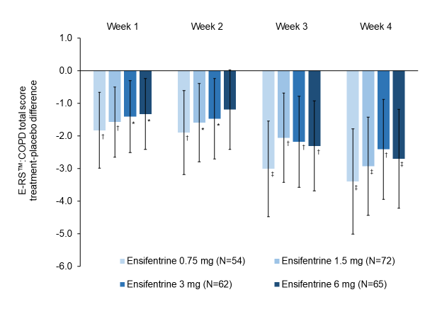
A)
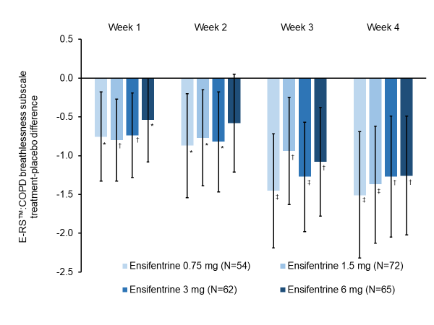
B)
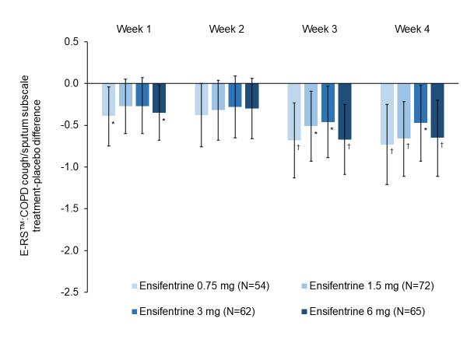
C)
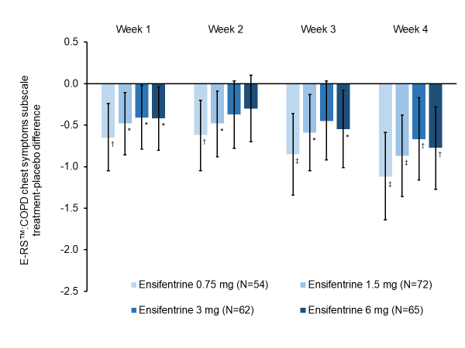
D)
Minimum clinically important differences are –2.0 for total score, –1.0 for breathlessness, and –0.7 for cough/sputum and chest symptoms. Data are least squares means treatment–placebo differences and 95% confidence intervals. *p<0.05; †p<0.01; ‡p<0.001 vs placebo. Least squares mean changes from baseline in the placebo group (N=50) were 0.73, 0.75, 1.43 and 1.78 at Weeks 1, 2, 3 and 4, respectively for the total score, 0.27, 0.31, 0.64 and 0.78 for the breathlessness subscale, 0.17, 0.16, 0.42 and 0.42 for the cough/sputum subscale, and 0.27, 0.26, 0.36 and 0.56 for the chest symptoms subscale. Data analyzed for 48, 66, 58, 61 and 47 patients in the ensifentrine 0.75, 1.5, 3 and 6 mg and placebo groups, respectively. Abbreviation: ERS:COPD™, Evaluating Respiratory Symptoms in COPD questionnaire.
Supplementary Figure 2. TDI focal score at Weeks 2 and 4 (per protocol set).
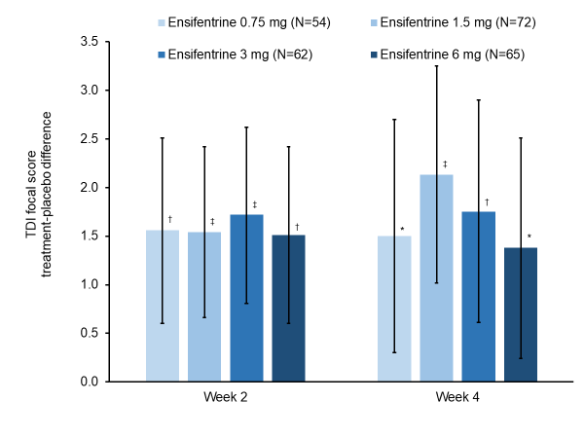
The minimum clinically important difference is 1.0. Data are least squares means treatment–placebo differences and 95% confidence intervals. *p<0.05; †p<0.01; ‡p<0.001 vs placebo. Least squares mean TDI total scores in the placebo group (N=50) were –0.11 and –0.04 at Weeks 2 and 4, respectively. Data analyzed for 51, 71, 61, 64 and 48 patients in the ensifentrine 0.75, 1.5, 3 and 6 mg and placebo groups, respectively. Abbreviation: TDI, Transition Dyspnea Index.
Supplementary Figure 3. SGRQ-C total score and domains at Week 4 (per protocol set).
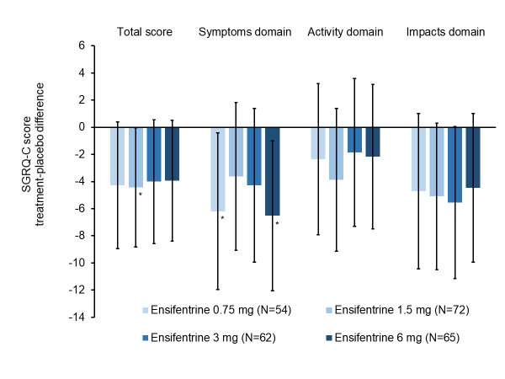
The minimum clinically important difference for SGRQ-C total score is –4; minimum values for the domains have not been determined. Data are least squares means treatment–placebo differences and 95% confidence intervals. *p<0.05 vs placebo. Least squares mean changes from baseline in the placebo group (N=50) were 0.95, 1.63, –0.97 and 2.00 for the total score and the symptoms, activity and impacts domains, respectively. Data analyzed for 51, 67, 57, 63 and 45 patients in the ensifentrine 0.75, 1.5, 3 and 6 mg and placebo groups, respectively. Abbreviation: SGRQ-C, St George’s Respiratory Questionnaire – chronic obstructive pulmonary disease specific.

Ethics committees
Romania
- Comisia Nationala de Bioetica a Medicamentului si a Dispozitivelor Medicale (National Bioethics Committee for Medicines and Medical Devices)
Czech Republic
- Etická komise, Fakultní nemocnice Královské Vinohrady, Šrobárova 1150/50, 100 34 Praha 10
- Etická komise FN u sv. Anny v Brně, FN u sv. Anny v Brně, Pekařská 53, 656 91 Brno
- Etická komise, Nemocnice Rudolfa a Stefanie Benešov, a.s., Máchova 400, 256 01 Benešov
Poland
- Komisja Bioetyczna przy Dolnośląskiej Izbie, Lekarskiej we Wrocławiu, Ul. Kazimierza Wielkiego 45, 50-077 Wrocław
Germany
- Bayerische Landesärztekammer, Ethikkommission, Mühlbaurstraße 16, 81677 München
- Ethikkommission des Fachbereichs Medizin der Ludwig-Maximilians-Universität München, Pettenkoferstraße 8a, 80336 München
- Landesamt für Gesundheit und Soziales Berlin, Geschäftsstelle der Ethik-Kommission des, Landes Berlin, Fehrbelliner Platz 1, 10707 Berlin
- Ärztekammer Hamburg, Ethikkommission, Weidestraße 112b, 22083 Hamburg
- Federführende Ethikkommission Landesärztekammer Hessen, Ethikkommission, Im Vogelsgesang 3, 60488 Frankfurt/Main
- Ärztekammer Niedersachsen, Ethikkommission, Berliner Allee 20, 30175 Hannover
- Landesärztekammer Rheinland-Pfalz, Ethikkommission, Deutschhausplatz 3, 55116 Mainz
- Sächsische Landesärztekammer, Ethikkommission, Schützenhöhe 16 – 18, 01099 Dresden
- Ärztekammer Schleswig-Holstein, Ethikkommission, Jaguarring 16, 23795 Bad Segeberg
Bulgaria
- Комисия по етика за многоцентрови изпитвания (Ethics Committee For Multicenter Trials)
United Kingdom
- North West - Liverpool Central Research Ethics Committee, 3rd Floor, Barlow House, 4 Minshull Street, Manchester, M1 3DZ

