Supplementary Table 1. Analyze the relationship between SNX family and CD8 T cells in lung adenocarcinoma (GEPIA)
Correlated Gene | Spearman's Correlation | p-Value
SNX20 | 0.62 | 4.90E-53
SNX10 | 0.47 | 2.30E-27
SNX6 | 0.2 | 1.50E-05
SNX3 | 0.19 | 1.90E-05
SNX2 | 0.17 | 1.90E-04
SNX11 | 0.16 | 2.90E-04
SNX8 | 0.13 | 5.40E-03
SNX18 | 0.12 | 0.008
SNX23 | -0.1 | 0.028
SNX22 | 0.096 | 0.035
SNX24 | 0.095 | 0.038
SNX26 | 0.083 | 0.069
SNX15 | 0.075 | 0.098
SNX25 | -0.049 | 0.28
SNX1 | -0.048 | 0.29
SNX12 | -0.041 | 0.36
SNX7 | 0.04 | 0.39
SNX19 | 0.036 | 0.43
SNX16 | 0.028 | 0.54
SNX27 | -0.028 | 0.54
SNX13 | -0.025 | 0.58
SNX5 | -0.024 | 0.6
SNX4 | 0.02 | 0.67
SNX14 | 0.013 | 0.78
SNX17 | 0.012 | 0.79
SNX21 | 0.011 | 0.81
SNX9 | 0.0095 | 0.84
GEPIA: Gene Expression Profiling Interactive Analysis; SNX: Sorting nexin.

Supplementary Figure 1. Overall survival curve comparing the high and low/median expression of SNX20 in lung squamous cell carcinoma. SNX20: Sorting nexin 20.

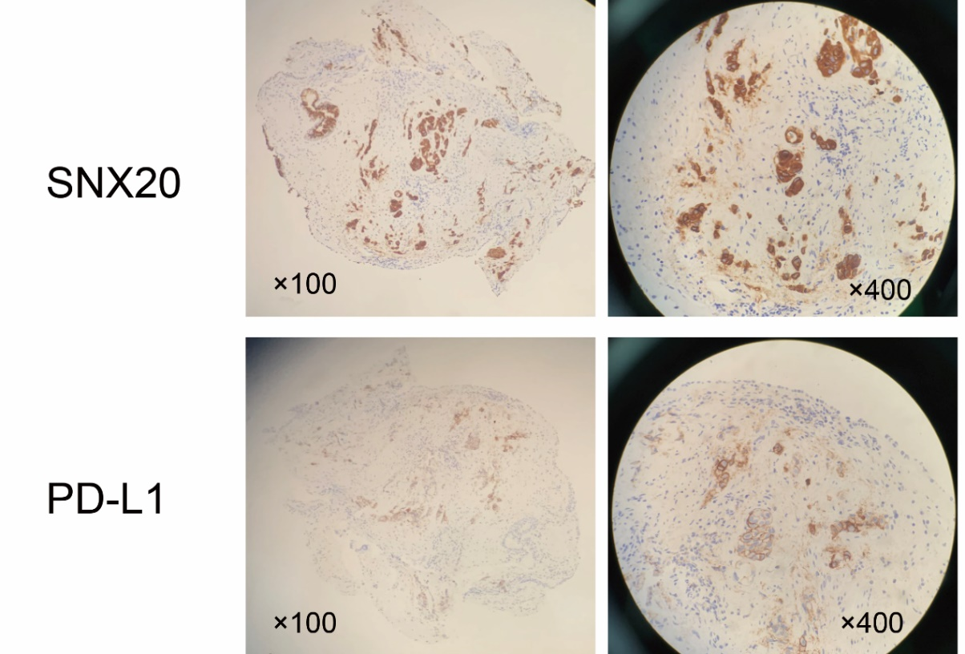
Supplementary Figure 2. The distribution of SNX20 and PD-L1 in lung adenocarcinoma tissues. PD-L1: Programmed death ligand 1; SNX20: Sorting nexin 20.

