Int. J. Nanomedicine

Supplementary Materials

Indocyanine green and curcumin co-loaded nano-fireball-like albumin nanoparticles based on near-infrared-induced hyperthermia for tumor ablation

Phuong Thi Thu Pham, Xuan Thien Le, Hanju Kim, Hwang Kyung Kim, Eun Seong Lee, Kyung Taek Oh, Han-Gon Choi, Yu Seok Youn

Figure S1. Fluorescence spectra for curcumin samples with three different concentrations showing peak emission wavelength of 520 nm.

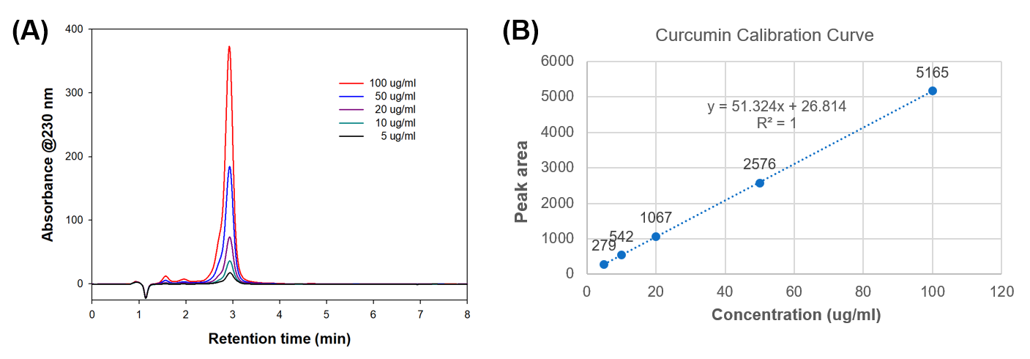

Figure S2. (A) Reversed-phase HPLC chromatogram for curcumin at the UV wavelength of 230 nm. The isocratic elution method was carried out at a flow-rate of 1.0 ml/min using solvent A (DW containing 0.1% trifluoroacetic acid) and solvent B (ACN containing 0.1% trifluoroacetic acid); that is, 0–60% B for 10 min. (B) Calibration curve of curcumin.

