Supplementary Table 1. Vital status at 10 years, sociodemographic characteristics, and TNM stage at diagnosis among colorectal cancer patients by quintiles of deprivation in Granada 2011-2013, n = 3,589 (less deprived Q1, n = 736; most deprived Q5, n = 682).

 |  |  |  | Quintiles Deprivation
Variables |  |  |  | Q1 (n = 736) |  | Q5 (n = 682)
 |  | n (%) |  | n (%) |  | n (%) |  | p-value*
Vital status at 10 years |  |  |  |  |  |  |  | 0.006
 | Alive | 2,617 (73.1) |  | 557 (75.8) |  | 471 (69.3)
 | Dead | 964 (26.9) |  | 178 (24.2) |  | 209 (30.7)
Age at diagnosis |  |  |  |  |  |  |  | <0.001
 | <50 | 265 (7.4) |  | 58 (7.9) |  | 39 (5.7)
 | 50 - 59 | 529 (14.7) |  | 142 (19.3) |  | 79 (11.6)
 | 60 - 69 | 953 (26.5) |  | 200 (27.2) |  | 170 (24.9)
 | 70 - 75 | 695 (19.4) |  | 126 (17.1) |  | 140 (20.5)
 | >75 | 1,147 (32.0) |  | 210 (28.5) | 254 (37.2)
Sex |  |  |  |  |  |  |  | 0.386
 | Male | 2,112 (58.9) |  | 416 (56.5) |  | 401 (58.8)
 | Female | 1,477 (41.1) |  | 320 (43.5) |  | 281 (41.2)
TNM stage at diagnosis |  |  |  |  |  |  |  | 0.867
 | I | 641 (18.8) |  | 133 (18.1) |  | 116 (17.0)
II |  | 1,107 (32.5) |  | 215 (29.2) |  | 203 (29.8)
 | III | 1,082 (31.8) |  | 220 (29.9) |  | 191 (28.0)
 | IV | 574 (16.9) |  | 128 (17.4) |  | 124 (18.2)
 | Missing | 185 (5.1) |  | 40 (5.4) |  | 48 (7.0)
*Differences in proportions by quintiles of the Spanish deprivation index comparing Q1 vs. Q5 (Chi-square or Fisher exact p-value)

Supplementary Table 2. Differences in the distribution of deprivation, vital status at 10 years, sociodemographic characteristics, and TNM stage at diagnosis between colorectal cancer patients who survived to 2011 from earlier cancer diagnosis (A) with those diagnosed between 2011-2013 (B) in Granada 2011-2013, n = 3,589 (A = 1,907; B = 1,682).

 |  |  | Colorectal Cancer Patients
Variables |  |  | A (n = 1,907) |  | B (n = 1,682)
 |  |  | n (%) |  | n (%)
Quintiles of deprivation
 | Q1 (less deprived) |  | 404 (21.2) |  | 332 (19.7)
 | Q2 |  | 385 (20.2) |  | 322 (19.1)
 | Q3 |  | 400 (20.9) |  | 335 (20.0)
 | Q4 |  | 386 (20.2) |  | 363 (21.6)
 | Q5 (most deprived) |  | 332 (17.4) |  | 330 (19.6)
Vital status at 10 years
 | Alive |  | 1,436 (75.3) |  | 1,181(70.6)
 | Dead |  | 471 (24.7) |  | 493 (29.4)
Age at diagnosis
 | <50 |  | 158 (8.3) |  | 107 (6.4)
 | 50 - 59 |  | 296 (15.5) |  | 233 (13.8)
 | 60 - 69 |  | 555 (29.1) |  | 398 (23.7)
 | 70 - 75 |  | 403 (21.1) |  | 292 (17.4)
 | >75 |  | 495 (25.9) | 652 (38.7)
Sex
 | Male |  | 1,098 (57.6) |  | 1,041 (60.3)
 | Female |  | 809 (42.4) |  | 668 (39.7)
TNM stage at diagnosis
 | I |  | 390 (20.5) |  | 251 (14.9)
II |  |  | 648 (33.9) |  | 459 (27.3)
 | III |  | 606 (31.8) |  | 476 (28.3)
 | IV |  | 179 (9.4) |  | 395 (23.5)
 | Missing |  | 84 (4.4) |  | 101 (6.0)

Supplementary Figure 1. Assessment of the proportionality of hazards by the quintiles of the Spanish deprivation index (2011): Test based on the scaled Schoenfeld residuals (A) and visual assessment of the proportionality assumption (B), n = 3,589.

Supplementary Figure 2. Correlation between the Spanish Deprivation Index (2011) and the average income per person by census tract in 2015 in Spain.
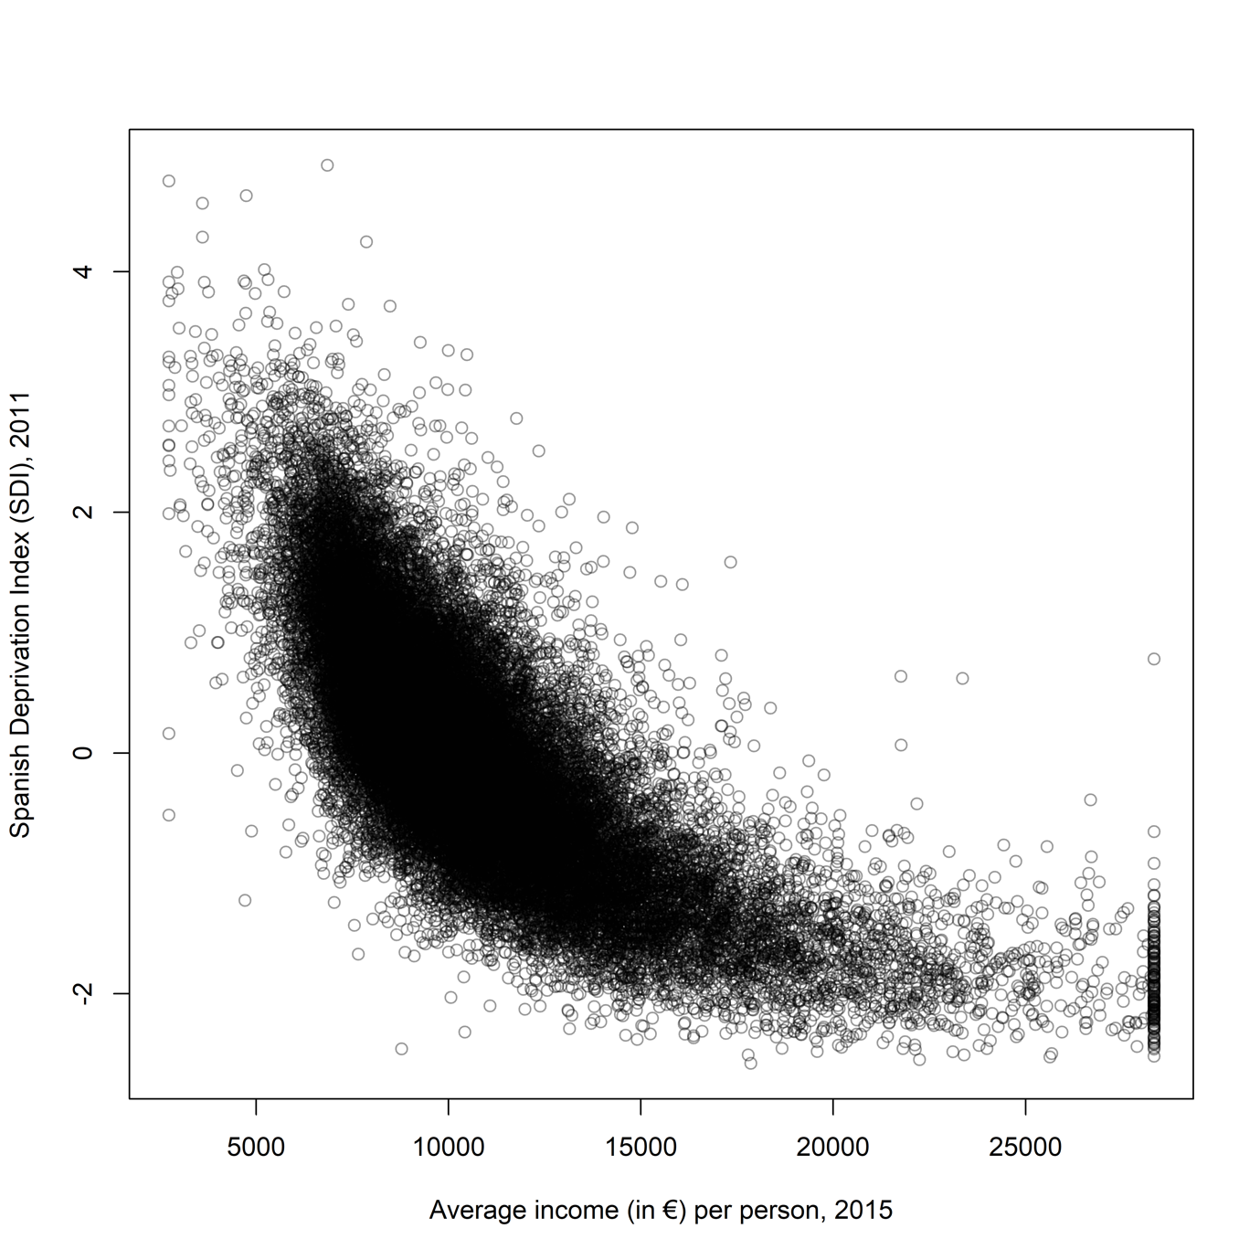

////////////////////////////////////////////////////////////////////////////////////////////////////////////////////////////////////////////////////////////////////////////////////////
// Title:
// Socioeconomic Inequalities in Colorectal Cancer Survival in Southern Spain: A multilevel Population-based Study
// Stata and R code used for statistical analysis (January 2020)
// Authors:
// Miguel Angel Luque-Fernandez [cre, aut], Daniel Redondo-Sánchez Miguel Rodríguez-Barranco, Chang-Chan Yoe Ling,
// Elena Salamanca-Fernández, Olivier Núñez, Pablo Fernandez-Navarro, Marina Pollán, María-José Sánchez
// *! Bug reports:
// *! miguel-angel.luque at lshtm.ac.uk
///////////////////////////////////////////////////////////////////////////////////////////////////////////////////////////////////////////////////////////////////////////////////////

// Variables
datediagnosis (date of diagnosis), datefollowup (date end of the follow-up),_d (death indicator), _t (follow-up time), catage (categories of age at diagnosis), agediag (age at diagnosis), sex (sex), stage (TNM cancer stage), qedi (quintiles of the Spanish deprivation index), ip2011 (Spanish index of deprivation), cusec (census tracts indicator), rate (Spanish background mortality rate), pic(indicator surviving patients diagnosed before 2011 and patients diagnosed between 2011-2013)

// Setting of time
stset datefollowup, fail(estadovital==1) origin(datediagnosis) exit(time mdy(12,31,2013)) scale(365.25) id(id)
stdescribe
stptime, per(1000)

// Table 1
tab _d
tab catage
tab sex
tab stage
tab qedi

tab _d qedi, chi col
tab sex qedi2, chi col
tab stage qedi2, miss chi col
tab catage qedi2, miss chi col

// Table 2
stdescribe
stptime, per(1000)

stptime, by(sex) per(1000)
stmh sex, c(1, 2)

stptime, by(catage) per(1000)
sts test catage, trend
stmh catage, c(2, 1)
stmh catage, c(3, 1)
stmh catage, c(4, 1)
stmh catage, c(5, 1)

stptime, by(stage) per(1000)
sts test stage, trend
stmh stage, c(2, 1)
stmh stage, c(3, 1)
stmh stage, c(4, 1)

stptime, by(qedi) per(1000)
stmh qedi, c(2, 1)
stmh qedi, c(3, 1)
stmh qedi, c(4, 1)
stmh qedi, c(5, 1)

sts graph, by(qedi)
sts test qedi, trend

// SDI proportionality of hazard assumption
stcox qedi sex edad stage
estat phtest, detail // Proporationality assumption for all covariates
estat phtest, plot(qedi) //Supplementary Figure 1A
stphplot, by(qedi) // Supplementary Figure 1B

// Background mortality data
clear
infile _year _age female male total using "MortalitySpain.txt" ///
if (_year > 1949 & _age < 100), clear
drop total
rename male rate1
rename female rate2
reshape long rate, i(_year _age)
rename _j sex
gen prob=exp(-rate)
sort _year sex _age
label data "Spanish death rates from http://www.mortality.org/"
label variable rate "Death rate (deaths/year)"
label variable prob "1-year survival probability"
label variable _year "Year of death"
label variable _age "Age"
label variable sex "Sex"
rename _age age
rename _year year
compress
keep if year>2009
save popmort_Sp_09-18, replace

// Merging with Cancer Data
clear
use grcrcJune2020.dta
stset dfu, fail(estadovital==1) origin(dod) exit(time mdy(12,31,2013)) scale(365.25) id(id)

gen age = int(min(agediag + _t,99))
gen year = int(year(dod) + _t)
merge m:1 sex year age using popmort_Sp_09-18, keepusing(rate)
save grcrcJunebh2020.dta, replace

// TABLE 3 models 1 to 5
use grcrcJunebh2020.dta
gen agediag5 = agediag/5
// Fixed effects models (flexible parametric modelling: restricted cubic splines plus tvc for stage)
stpm2 i.qedi, scale(hazard) df(3) bhazard(rate) eform
stpm2 i.qedi ib2.sex, scale(hazard) df(3) bhazard(rate) eform
stpm2 i.qedi ib2.sex i.catage, scale(hazard) df(3) bhazard(rate) eform
stpm2 i.qedi ib2.sex agediag5, scale(hazard) df(3) bhazard(rate) eform
stpm2 i.qedi ib2.sex i.catage i.stage, scale(hazard) df(3) tvc(stage) dftvc(2) bhazard(rate) eform
stpm2 i.qedi ib2.sex agediag5 i.stage, scale(hazard) df(3) tvc(stage) dftvc(2) bhazard(rate) eform
estimates store m1
// Fixed effect plus random intercept model (parametric flexible modelling: restricted cubic splines plus tvc for stage)
xi: stmixed i.qedi i.sex i.catage || cusec:, intpoints(2) distribution(rp) df(2) tvc(stage) dftvc(2) bhazard(rate)
xi: stmixed i.qedi i.sex agediag5 || cusec:, intpoints(2) distribution(rp) df(2) tvc(stage) dftvc(2) bhazard(rate)
estimates store m2
lrtest m1 m2

// FIGURE 1
clear
use grcrcJunebh2020.dta
tab catage, gen(agec)
tab stage, gen(cstage)
tab sex, gen(csex)

stpm2 qe2-qe5 agec2-agec5 csex1 cstage2-cstage4, scale(hazard) df(3) tvc(stage) dftvc(2) bhazard(rate) eform
range timevar 0 11 1000
stpm2_standsurv, atvars(surv1 surv2) at1(qe1 1) at2(qe5 1) ci timevar(timevar)
list surv1* if timevar==10, noobs
list surv2* if timevar==10, noobs

gen t_rmst10 = 10 in 1

stpm2_standsurv, at1(qe1 1) at2(qe5 1) timevar(t_rmst10) rmst ci contrast(difference) ///
atvar(rmst_h0 rmst_h1) contrastvar(rmstdiff)
list t_rmst10 rmst_h0* rmst_h1* in 1, noobs abb(12)
list t_rmst rmstdiff* in 1, noobs abb(12)

sts generate skm = s, by(qedi) // I need nonparametric net survival estimates

twoway (line surv1 timevar, sort lcolor(black) clpattern(dash)) ///
(line surv2 timevar, sort lcolor(black)) ///
//(line skm _t if qedi==1, sort lcolor(sdash)) ///
//(line skm _t if qedi==5, sort lcolor(solid)) ///
,legend(off) ///
ylabel(0(0.1)1, angle(h) format(%3.1f)) ///
ytitle("Relative Survival Probability") ///
xtitle("Time in years") ///
saving(relsurv)

range t_rmst 0 10 50
stpm2_standsurv, at1(qe1 1) at2(qe5 1) timevar(t_rmst) rmst ci contrast(difference) ///
atvar(rmst_h0b rmst_h1b) contrastvar(rmstdiffb)

twoway (line rmst_h0b rmst_h1b t_rmst) ///
, legend(off) ///
ytitle("Restricted mean survival time (years)") ///
xtitle("Time in years") ///
name(RMST,replace) ///
saving(rmst)

twoway (rarea rmstdiffb_lci rmstdiffb_uci t_rmst, color(blue%20)) ///
(line rmstdiffb t_rmst, lcolor(blue)) ///
, legend(off) ///
ylabel(, format(%3.1f)) ///
ytitle("Restricted mean survival time differences in years (Q5 vs. Q1)") ///
xtitle("Time in years") ///
name(RMSTdiff, replace) ///
saving(rmstdiff)

graph combine relsurv.gph rmst.gph rmstdiff.gph, nocopies col(3) saving(Figure1)

// Figure 2
stpm2 qe2-qe5 agec2-agec5 cstage2-cstage4 if sex==1, scale(hazard) df(3) tvc(stage) dftvc(2) bhazard(rate) eform

forvalues i = 2(1)5{
stpm2_standsurv, atvars(Q1_`i' Q5_`i') at1(qe2 1 agec`i' 1) at2(qe5 1 agec`i' 1) timevar(timevar)
tw (line Q1_`i' timevar, sort lcolor(black) clpattern(dash)) ///
(line Q5_`i' timevar, sort lcolor(black)) ///
,legend(order(0 "Q1", 1 "Q5") ring(0) cols(1) pos(1)) ///
ylabel(0(0.1)1,angle(h) format(%3.1f)) ///
ytitle("Relative Survival Probability") ///
xtitle("Time in years") ///
saving(age`i')
}
graph combine age2.gph age3.gph age4.gph age5.gph, saving(males)

stpm2 qe2-qe5 agec2-agec5 cstage2-cstage4 if sex==2, scale(hazard) df(3) tvc(stage) dftvc(2) bhazard(rate) eform

forvalues i = 2(1)5{
stpm2_standsurv, atvars(Q1f_`i' Q5f_`i') at1(qe1 1 agec`i' 1) at2(qe5 1 agec`i' 1) timevar(timevar)
tw (line Q1f_`i' timevar, sort lcolor(black) clpattern(dash)) ///
(line Q5f_`i' timevar, sort lcolor(black)) ///
,legend(order(0 "Q1", 1 "Q5") ring(0) cols(1) pos(1)) ///
ylabel(0(0.1)1,angle(h) format(%3.1f)) ///
ytitle("Relative Survival Probability") ///
xtitle("Time in years") ///
saving(agef`i')
}
graph combine agef2.gph agef3.gph agef4.gph agef5.gph, saving(females)
graph combine males.gph females.gph, saving(Figure2)

// Supplementary Tables and sensitivity analysis
// Males
preserve
keep if sex == 1
xi: stmixed i.qedi agediag stage || cusec:, intpoints(2) distribution(rp) df(2) tvc(stage) dftvc(2) bhazard(rate)
restore
// Females
preserve
keep if sex == 2
xi: stmixed i.qedi agediag stage || cusec:, intpoints(2) distribution(rp) df(2) tvc(stage) dftvc(2) bhazard(rate)
restore

stpm2 i.sex##c.ip2011 agediag stage, scale(hazard) df(3) tvc(stage) dftvc(2) bhazard(rate) eform
stpm2 i.sex agediag c.ip2011##c.stage, scale(hazard) df(3) tvc(stage) dftvc(2) bhazard(rate) eform
stpm2 i.sex i.stage c.ip2011##c.agediag, scale(hazard) df(3) tvc(stage) dftvc(2) bhazard(rate) eform
stpm2 i.qedi agediag stage sex, scale(hazard) df(3) tvc(stage) dftvc(2) bhazard(rate) eform
stpm2 i.qedi c.agediag##c.agediag i.stage sex, scale(hazard) df(3) tvc(stage) dftvc(2) bhazard(rate) eform
stpm2 i.qedi##c.agediag i.stage sex, scale(hazard) df(3) tvc(stage) dftvc(2) bhazard(rate) eform
stpm2 i.qedi##c.agediag##c.agediag i.stage sex, scale(hazard) df(3) tvc(stage) dftvc(2) bhazard(rate) eform

preserve
keep if pic == 1
stpm2 i.qedi ib2.sex i.catage i.stage, scale(hazard) df(3) tvc(stage) dftvc(2) bhazard(rate) eform
//xi: stmixed i.qedi sex age i.stage || cusec:, intpoints(2) distribution(rp) df(2) tvc(stage) dftvc(2) bhazard(rate)
restore

preserve
keep if pic == 0
stpm2 i.qedi ib2.sex i.catage i.stage, scale(hazard) df(3) tvc(stage) dftvc(2) bhazard(rate) eform
//xi: stmixed i.qedi sex age i.stage || cusec:, intpoints(2) distribution(rp) df(2) tvc(stage) dftvc(2) bhazard(rate)
restore

// Delay entry
stset dfu, fail(estadovital==1) origin(dod) entry(time mdy 01,01,2011) exit(time mdy(12,31,2013)) scale(365.25) id(id)
stpm2 i.qedi ib2.sex i.catage i.stage, scale(hazard) df(3) tvc(stage) dftvc(2) bhazard(rate) eform

