Additional files from Publication: Active Integration of Patients into Infection Control perceived by health care professionals. Results of the AHOI Pilot Study

Supplement 1:

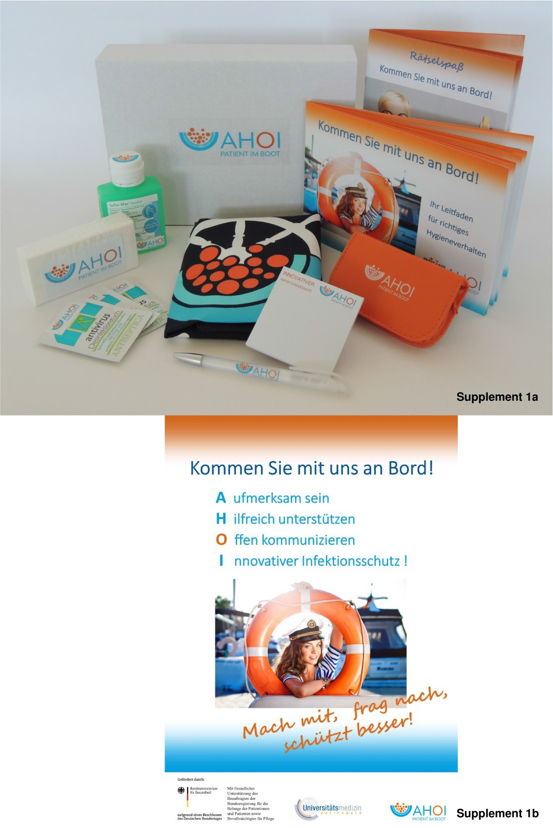
Figure 1: AHOI-welcome-box and example of visual material used. Supplement 1a: AHOI-welcome box with supportive information material, disinfection products and incentives; Supplement 1b: AHOI

supportive poster No 1 “Kommen Sie mit uns Bord - Come on board with us”, AHOI: “Aufmerksam sein - be aware, Hilfreich sein - be helpful, Offen kommunizieren – open communication, Innovativer Infektionsschutz – innovative infection prevention”; “Mach mit, frag nach, schützt besser! – Join in, ask, protects better!”.

Supplement 2:

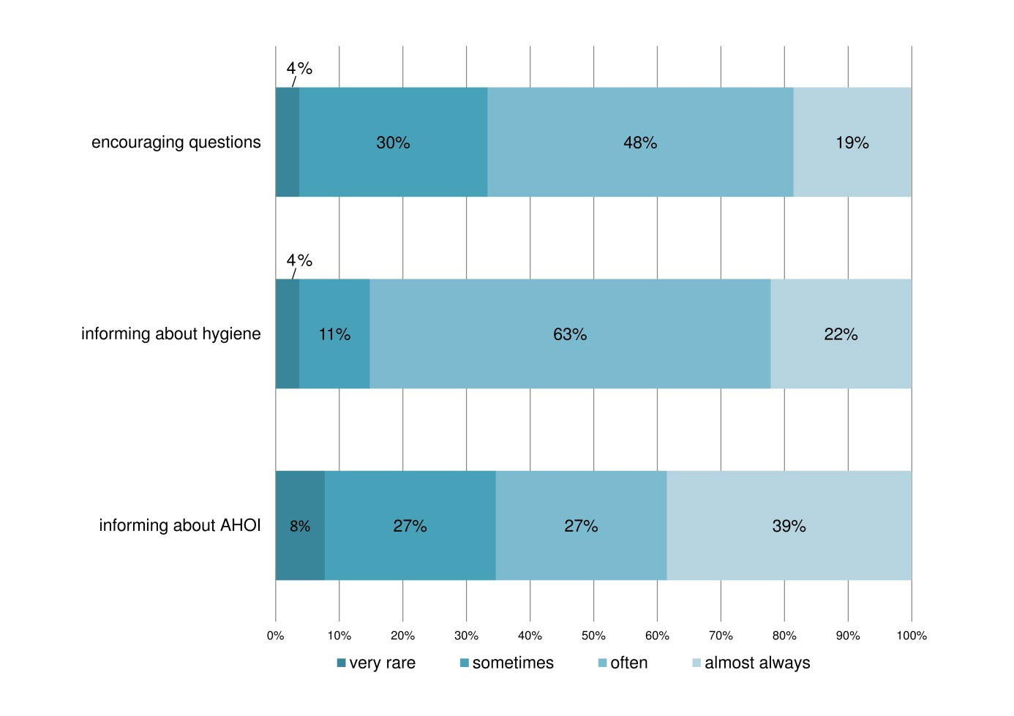
Figure 2: Health care professionals’ perception of empowering patients by encouraging questions, informing them about hygiene and AHOI. Answering of ward personnel to the questions of “How did you support patients and relatives in participating in infection protection?: "I have directly encouraged patients/ visitors to pose questions", n= 27; "I have informed patients about correct hygiene behavior", n= 27; "I informed patients about AHOI content at the beginning of their hospital stay. ", n= 26. Scale: “very rare” – “almost always”.

Supplement 3: AHOI-1 feasibility study questionnaire for ward personnel
–item overview

- Date

Personal Information

- Which professional group do you belong to?
Checkboxes: Doctor; Nursing; Medical assistant; Other (+ textbox)

- How are you currently employed? Checkboxes: Part Time; Full Time

- How long have you been employed in this hospital?
Checkboxes: <1 year; 1-5 years; 6-10 years; longer than 10 years

- How old are you?
Checkboxes: 18-25; 26-35; 36-45; 46-55; 56-65; > 65

- What gender are you? Checkboxes: Male; Female

Information on the AHOI materials

- Who conveyed the content of the AHOI project to you?
Checkboxes: I took part in the multiplier training.; I was involved by a colleague.; I was informed by an employee of the AHOI project.; none

- Which AHOI information materials did you look at? Multiple crosses are possible. Checkboxes:
Cartoons; info sheet; brochure; poster; none

- How do you rate the animated film on the subject of "hand disinfection"? Three emoticons for expressing approval or rejection in checkboxes: List of six aspects to evaluate:
Content (interesting); Drawing style (pleasant); Length; Comprehensibility; Humor (funny); Overall impression
Extra checkbox for “I can't judge because I didn't watch it.”

- How do you rate the animated film on the subject of "Speak up"?
Three emoticons for expressing approval or rejection in checkboxes:  List of six aspects to evaluate:
Content (interesting); Drawing style (pleasant); Length; Comprehensibility; Humor (funny); Overall impression
Extra checkbox for “I can't judge because I didn't watch it.”

- Which of the two films did you like better?
Three columns: Film Hand disinfection; Film Speak up; both the same
List of six aspects to evaluate:
Content; Drawing style; Length; Comprehensibility; Humor; Overall impression
Extra checkbox for “I can't judge because I didn't watch it.”

- How do you rate the brochure?
Three emoticons for expressing approval or rejection in checkboxes:  List of six aspects to evaluate:
Content; Comprehensibility; Layout; Length; Overall impression
Extra checkbox for “I can't judge because I didn't read it.”

- Can patients / relatives - in your opinion - understand the posters? Checkboxes: Yes; No

Information on the implementation of AHOI

- Did you feel well informed about the AHOI project? Checkboxes: Yes; No
Arrow departing from the “No”-checkbox to the question: “What did you miss?” Textbox

- How much can you identify with the AHOI content?
1-10-point-rating-scale with the end points “not at all” (1) and “very much” (10)

- How did you support the patients and their relatives in participating in infection control?
Please put a cross in each line. Use of a table with five columns:
Column 1: Statement; Colum 2-5 rating scales with labels: almost always, often, sometimes, very rare

Six statements:
I informed patients about AHOI content at the beginning of their hospital stay.; I have informed patients about proper hygiene behavior.;
I have directly encouraged patients / visitors to ask questions.;
I specifically reminded patients / visitors during their stay in the clinic (e.g. HD after the toilet, before eating).;
I have gladly answered questions from patients / visitors about hygiene behavior.
Extra checkbox: There were no questions asked.; I thank you for advice on my hygiene behavior.
Extra checkbox: There was no evidence.

- How helpful was the AHOI employee training for you - in retrospect?
1-10-point-rating-scale with the end points “not helpful” (1) and “very helpful” (10) Extra checkbox: I wasn't in training.

- How helpful did you find the pocket card for informing patients about AHOI?
1-10-point-rating-scale with the end points “not helpful” (1) and “very helpful” (10)

- How useful did you find the AHOI stamp as a reminder for patient education?
1-10-point-rating-scale with the end points “not helpful” (1) and “very helpful” (10)

- Please estimate how many of your doctoral colleagues educate patients about hygienically correct behavior?
0-100-percent-rating-scale with the end points “none” (0%) and “all” (100%)

- Please estimate how many of your non-doctoral colleagues inform patients about hygienically correct behavior and ask for compliance?
0-100-percent-rating-scale with the end points “none” (0%) and “all” (100%)

- To what extent are patients and their relatives / visitors currently involved in infection control in your facility?
1-10-point-rating-scale with the end points: “not at all” (1) and “very much” (10)

Information on the effects of AHOI

- Do you have the impression that the patients and relatives since the introduction of AHOI show better hygiene behavior?

Checkboxes: yes, for the most part; yes, some; yes, but only a few; no

- Please estimate how most patients now react when employees point out insufficient hygiene?
1-10-point-rating-scale with the end points: “negative” (1) and “positive” (10)

- What reactions would you most likely expect in the event of your own hygienically incorrect behavior?
Please only put one cross. Checkboxes:
None, because no one notices it.; None, as defects are not evaluated.; Complaints from patients or relatives;
A note from my hygiene specialist or doctor or nurse responsible for hygiene; A note from my direct manager

- What changes have you noticed in patients and relatives in the past few weeks? Use of a table with five columns:
Column 1: Statement; Colum 2-5 rating scales with labels: totally agree, rather agree, rather disagree, disagree
Nine statements:
Patients and visitors disinfect their hands more according to the 5 moments.; Patients are increasingly advising their visitors about hygienically correct behavior.; Patients are increasingly advising their fellow patients about hygienically correct behavior.;
Patients and visitors pay more attention to the hygienic behavior of the staff.; Patients and visitors increasingly raise concerns and problems with staff.; Patients pay more attention to the hygienically correct behavior in the bathroom.;
Patients pay more attention to the hygienically correct behavior at the washbasin / in the shower.;
Visitors increasingly refrain from bringing perishable food.;
Patients are increasingly asking about the rules for taking antibiotics.
- In the past few weeks, have you pointed out to a patient or visitor a lack of hygienic behavior?
Checkboxes: Yes; No; I have not observed any unsanitary behavior.
Arrows lead from all three checkboxes to other further questions.

Arrow for checkbox 1 leads to additional question: “If yes, how did the patient / family member / visitor react to your advice?”
1-10-point-rating-scale with the end points: “negative” (1) and “positive” (10)
Arrow for checkbox 2 leads to additional question: “If no, why didn't you do it?” Max. 3 crosses are possible!
Checkboxes:
I think he / she couldn't have got it right.; He / she would likely be rude.;
I was uncomfortable because I didn't know how to say it.; It would have taken too long.;
After all, it doesn't change anything because the patients are not interested.; I didn't think of that in the situation.
Arrow for checkbox 3 leads to informing text: “Please continue with question 28.”

- When you review the event from question 27, did you subsequently get annoyed about your reaction because you might have preferred to react differently? Checkboxes: Yes; No

- What influence did the AHOI project have on you over the past few weeks?
Use of a table with five columns: Column 1: Statement; Colum 2-5 rating scales with labels: totally agree, rather agree, rather disagree, disagree
Eight statements:
I pay more attention to patients’ and visitors’ compliance with hygienic rules. I pay more attention to my own compliance with hygienic rules.
I pay more attention to my colleagues’ compliance with hygienic rules. I feel relieved when patients and visitors behave hygienically correct.
I feel supported when patients and visitors pay attention to my hygienic behavior. I can deal better with advice on my hygiene behavior.
It makes me happier in my work situation when patients and visitors also take responsibility for infection control.
I think that the long-term use of AHOI will improve the stress situation with regard to hygiene activities on my ward.

- Have you been directly informed about hygiene deficiencies by a patient / relative / visitor in the last few weeks?
Checkboxes: Yes; No
Two arrows lead from the “Yes”-checkbox.

First arrow leads to question: “If yes, how did you most likely feel about it? Please only put one cross!”
Checkboxes:
I was pleased that he / she paid attention.;
I was annoyed because I find it outrageous.;
I was annoyed because I hadn't thought of it myself.; I was uncomfortable because he / she was right.;
I was happy because my mind was elsewhere.; I didn't care because I had other problems.
Second arrow leads to question: “If yes, how did you react to the patient / family member / visitor?”
1-10-point-rating-scale with the end points: “negative” (1) and “positive” (10)

- What influence did the AHOI project have on your colleagues in the past few weeks? Use of a table with five columns:
Column 1: Statement; Colum 2-5 rating scales with labels: totally agree, rather agree, rather disagree, disagree
Six statements:
Most colleagues pay more attention to patients’ and visitors’ compliance with hygienic rules.
Most colleagues pay more attention to colleagues’ compliance with hygienic rules. Most colleagues feel relieved when patients and visitors behave hygienically correct. Most colleagues find it helpful when patients and visitors pay attention to the colleagues’ hygiene behavior.
Most colleagues are better able to deal with advice on their hygiene behavior.
Most colleagues are more satisfied in their work situation if patients and visitors also take responsibility for infection control.

- Have you pointed out to colleagues about hygiene deficiencies in the last few weeks (without the patient / relatives being present)?
Checkboxes: Yes; No; I have not observed any unhygienic behavior.
Two arrows lead to further questions.
First arrows lead from the “Yes”-checkbox to the question “If yes, how did the doctoral colleague react to your advice?”
1-10-point-rating-scale with the end points: “negative” (1) and “positive” (10)
Second arrow leads from the “No”-checkbox to the question “If no, Why did you most likely not do this?? Please only put one cross!”

Checkboxes:
I didn't care because it didn't affect me.;
I was afraid that he / she would feel attacked and that our relationship would be strained.;
I was uncomfortable because I didn't know how to say it.;
I didn't dare because I didn't want any trouble with my manager.; It doesn't change anything.

- How much do you perceive the use of the AHOI materials as an additional workload? 1-10-point-rating-scale with the end points: “not at all” (1) and “very much” (10)

- How much do you feel supported by the AHOI materials in educating patients about important hygiene measures?
1-10-point-rating-scale with the end points: “not at all” (1) and “very much” (10)

- Do you feel that the expenditure of time spent on hygiene-related activities has increased since the introduction of AHOI?
1-10-point-rating-scale with the end points: “not at all” (1) and “very much” (10)

- Do your colleagues support the AHOI content (e.g. conversations with patients, reminders)?
Checkboxes: Yes; No

- Do you receive feedback from your colleagues about your commitment to AHOI? Checkboxes: “positive feedback”, “negative feedback”, “no feedback”

- Is your direct manager committed to the AHOI content? Checkboxes: Yes; No
One arrow leads from the “Yes”-checkbox to the question “How does your direct manager support the AHOI content? Multiple crosses are possible.” Checkboxes:
I have already seen her/him talking to patients / visitors about hygiene behavior.; The topic is brought up again and again in employee meetings so that it does not get forgotten.;
Positive examples are praised.;
If I have any questions, I will be given advice.

- Do you receive feedback from your direct manager on your commitment to AHOI? Checkboxes: “positive feedback”, “negative feedback”, “no feedback”

- How often do you get feedback from patients that hygiene management is good on this ward?
1-6-point-rating-scale with the end points: “not at all” (1) and “very often” (10)

- Annotations: Textbox

