Zhou JY et al Supplementary Materials

Supplementary Figure 1

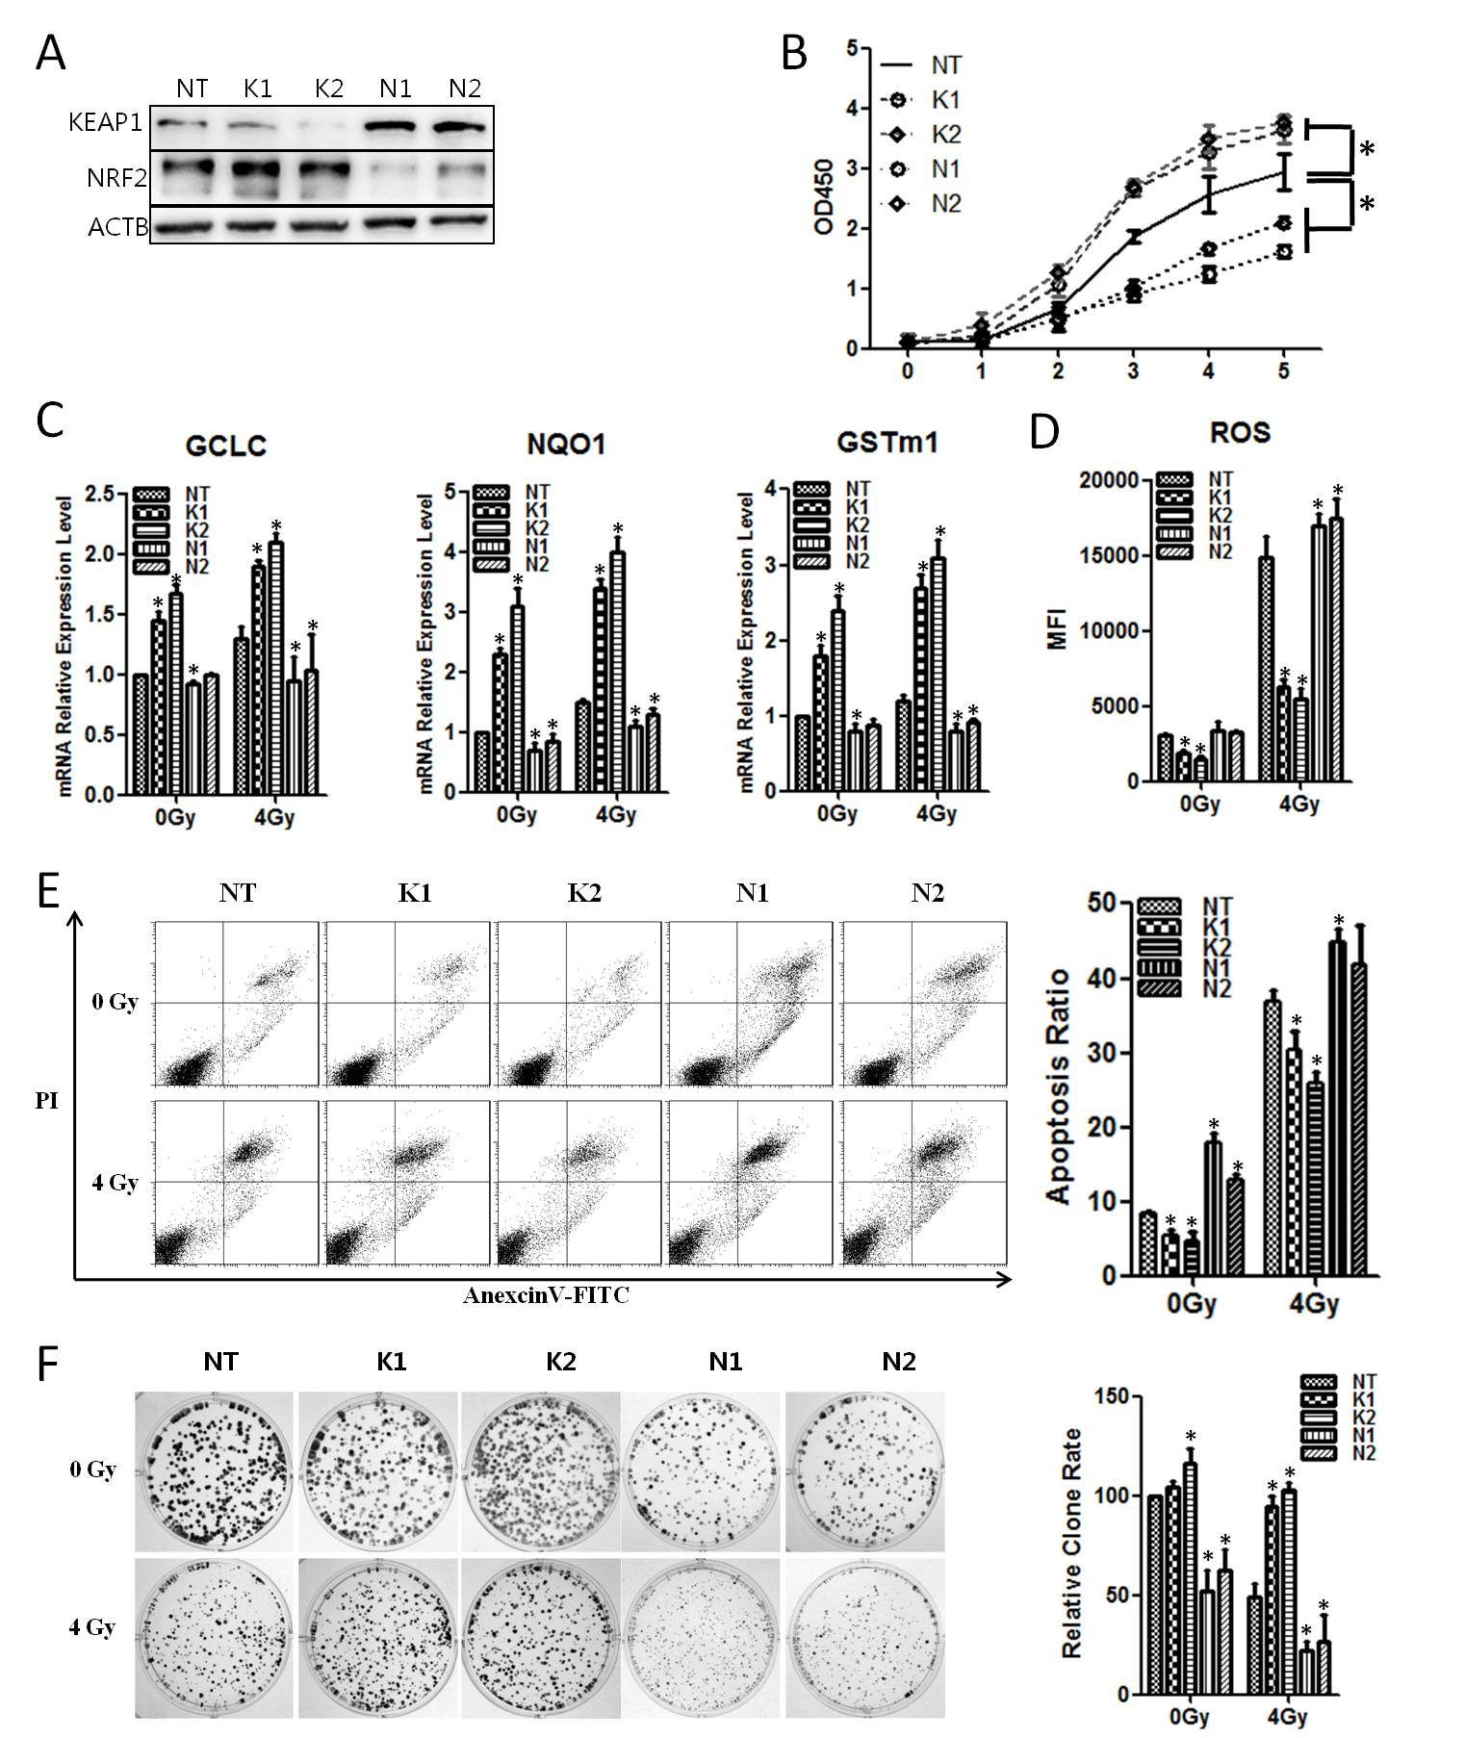

Supplementary Figure 1. when KEAP1 was knocked down, the radiosensitivity of the CNE1 cells was reduced; when NRF2 was knocked down, the radiosensitivity of the CNE1 cells was enhanced. A, The CNE1 cells were infected with retroviruses containing KEAP1 or NRF2 shRNA. The RNAi efficiency was examined with Western blot. B, The cell proliferation of KEAP1 or NRF2 RNAi CNE1 cells was measured by CCK-8 assay. C, The KEAP1 or NRF2 RNAi CNE1 cells were exposed to 4Gy rays. 24 hours later, total RNA was extracted, and the mRNA levels of anti-ROS genes were detected with qPCR. D, The KEAP1 or NRF2 RNAi CNE1 cells were exposed to 4Gy rays. 24 hours later the ROS level was detected. E, The KEAP1 or NRF2 RNAi CNE1 cells were exposed to 4Gy rays. 48 hours later the cell apoptosis rate was detected with flow cytometry. F, The KEAP1 or NRF2 RNAi CNE1 cells were plated on six-well plates at the density of 600 cells per well. After 24 hours of culture, the cells received 4Gy radiation. After to the replacement with fresh medium, the cultivation continued for 14 days, and the cells were subjected to crystal violet staining and image collection. All experiments were repeated three times and produced similar results. The data are the mean ± SD of values from three experiments. *P< .05.

