Supplementary Materials
A pH-Responsive System Based on Fluorescence Enhanced Gold Nanoparticle for Renal Targeting Drug Delivery and Fibrosis Therapy
Xuandi Lai¹
Xinran Geng²
Lishan Tan¹
Jianqiang Hu²
Shubin Wang¹

¹Department of Oncology, Shenzhen Key Laboratory of Gastrointestinal Cancer Translational Research, Peking University Shenzhen Hospital, Shenzhen Peking University-The Hong Kong University of Science and Technology Medical Center, Shenzhen 518036. People’s Republic of China; ²Department of Chemistry, School of Chemistry and Chemical Engineering, South China University of Technology, Guangzhou 510640. People’s Republic of China

Table S1 Primers used for quantitative Real-time PCR
Name | Forward | Reverse
GAPDH | GGTGAAGGTCGGTGTGAACG | CTCGCTCCTGGAAGATGGTG
Collagen-I | ATCTCCTGGTGCTGATGGAC | ACCTTGTTTGCCAGGTTCAC
Fibronectin | CGAGGTGACAGAGACCACAA | CTGGAGTCAAGCCAGACACA
TNF-α | ATGAGCACAGAAAGCATGATC | TACAGGCTTGTCACTCGAATT
MCP-1 | GCATCCACGTGTTGGCTCA | CTCCAGCCTACTCATTGGGATCA
ICAM-1 | TGCGTTTTGGAGCTAGCGGACCA | CGAGGACCATACAGCACGTGCAG
IL-6 | CATTGGGAAATTGGGGTAGGAAG | CATTGGGAAATTGGGGTAGGAAG

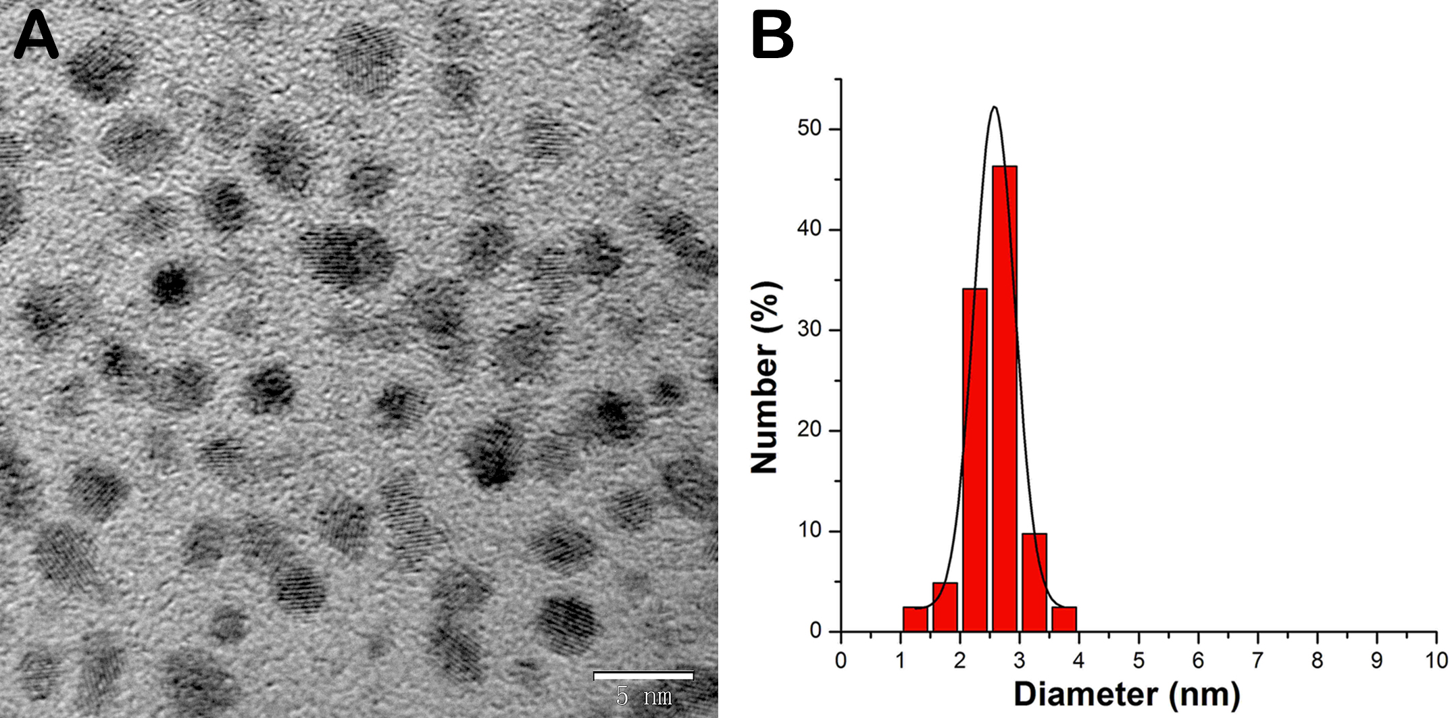
Figure S1 (A) TEM image and (B) hydrodynamic size distribution of AuLA.

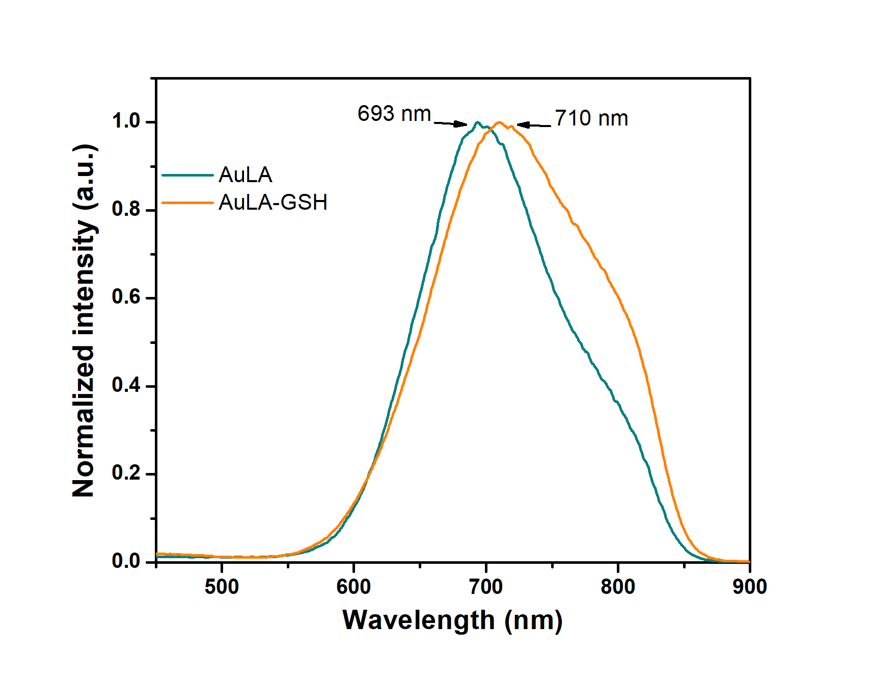
Figure S2 Fluorescence emission spectra of AuLA and AuLA-GSH.

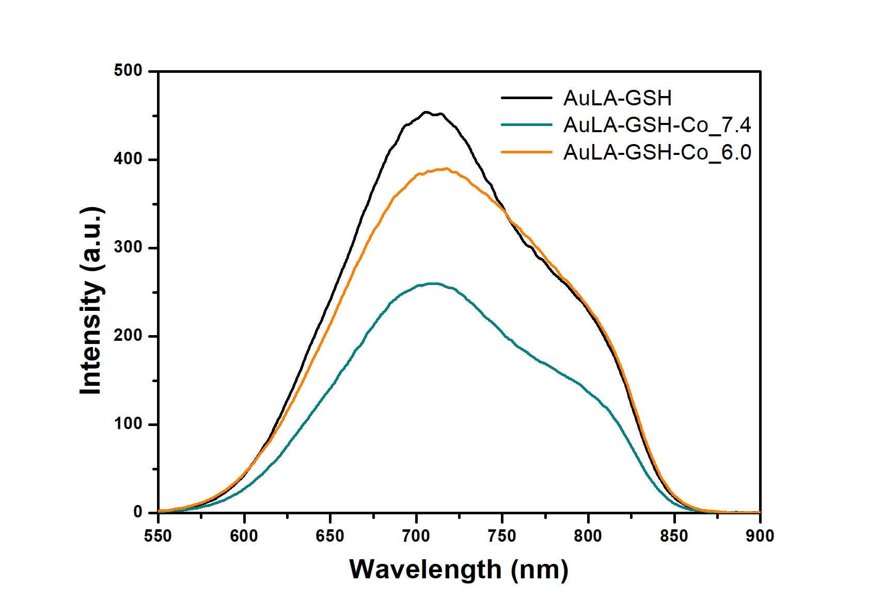
Figure S3 Fluorescence emission spectra of AuLA-GSH and AuLA-GSH-Co in pH7.4 (AuLA-GSH-Co_7.4) or in pH6.0 (AuLA-GSH-Co_6.0) condition.

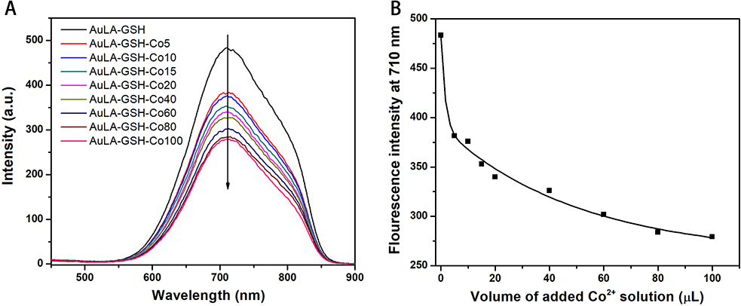
Figure S4 (A) Fluorescence emission spectra of AuLA-GSH-Cox, x represents the adding volume (µL) of 10 mM CoCl₂ and (B) corresponding fluorescence emission intensity at 700 nm.

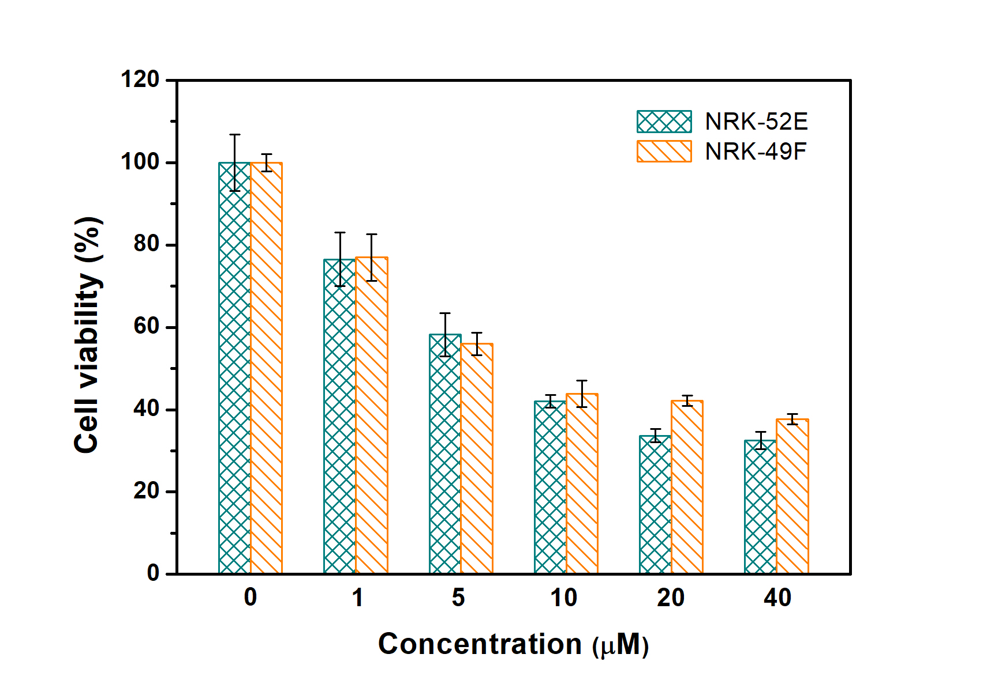
Figure S5 Cell viability of NRK-52E and NRK-49F incubated with CoCl₂ in different concentration for 24 h. 1: Image of a whole cell; 2: enlarge vision of image 1; 3: enlarge vision of image 2.

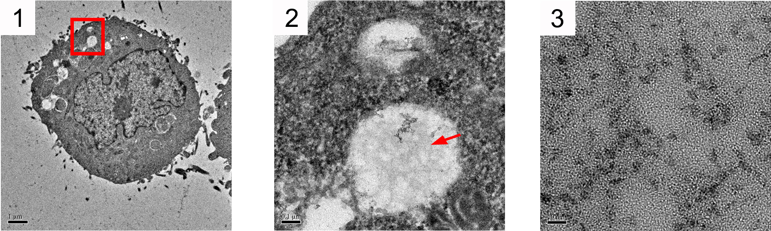
Figure S6 Cell slice TEM images of NRK-52E incubated with AuLA-GSH for 1 h. 1: Image of a whole cell; 2: enlarge vision of image 1; 3: enlarge vision of image 2.

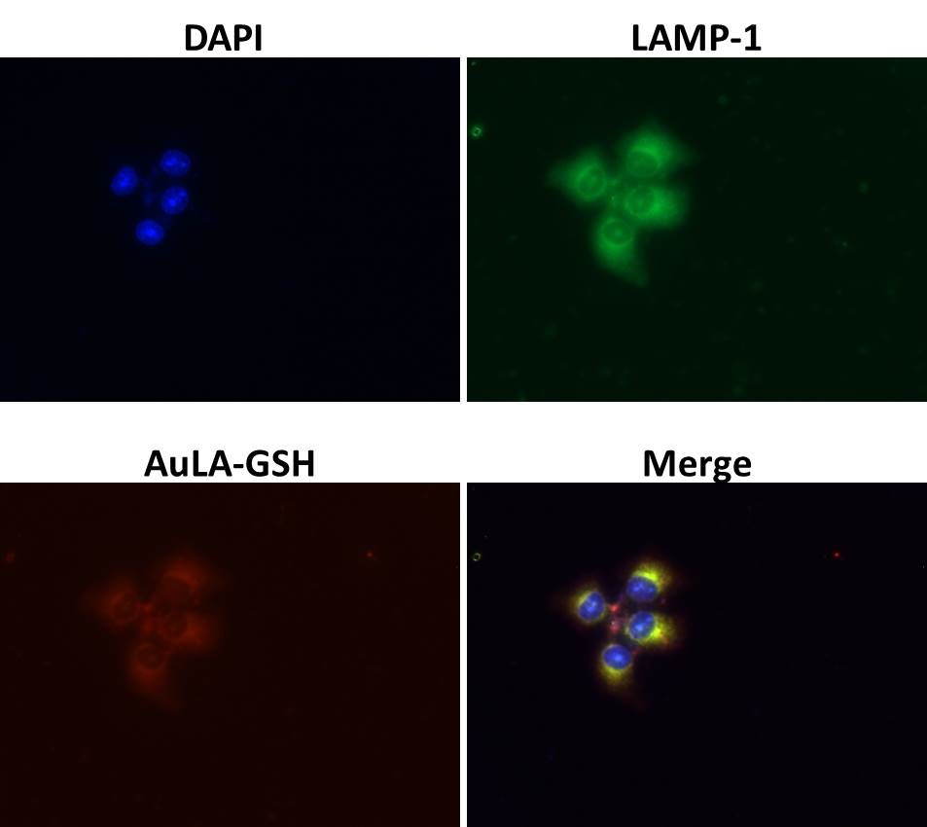
Figure S7 Three-color colocalization images of NRK-52E cells incubated with AuLA-GSH for 1 h.

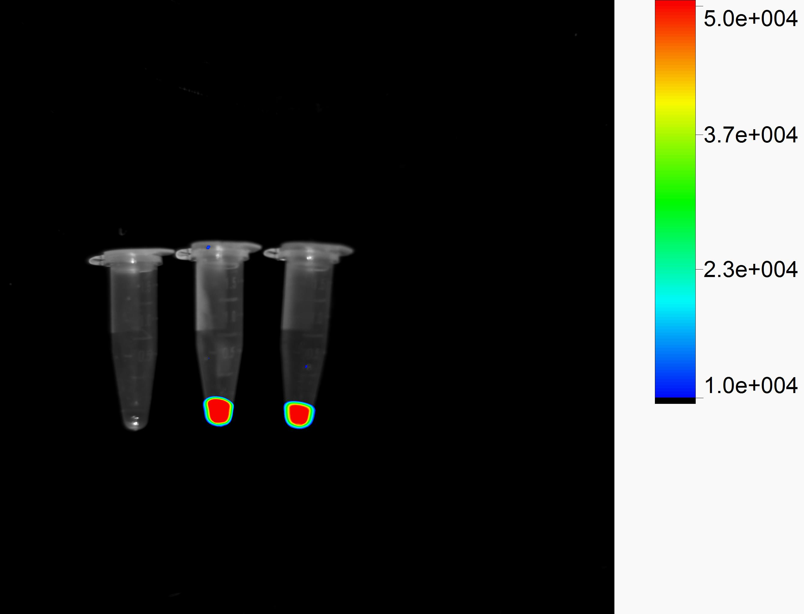
Figure S8 Fluorescence images of PBS (left) and AuLA (middle) and AuLA-GSH (right).

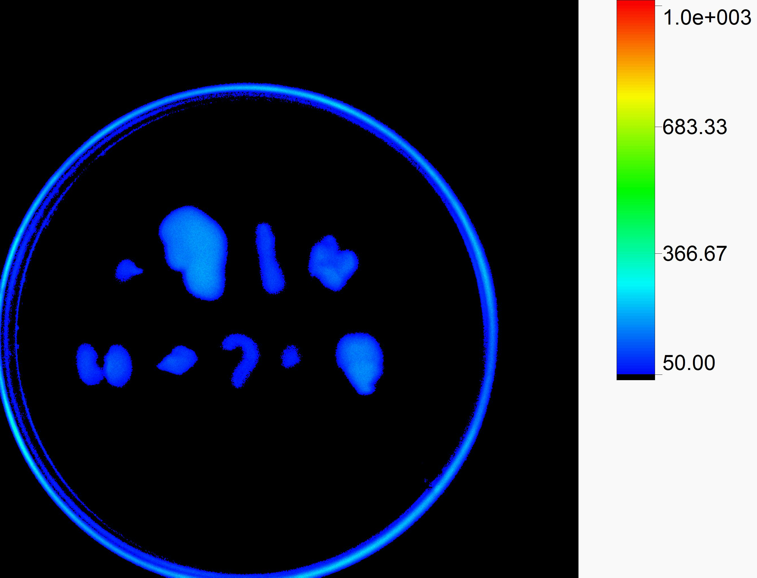
Figure S9 Ex vivo fluorescence imaging of major organs (heart, liver, spleen, lung, kidneys, thymus, small intestine, muscle, brain) collected from mice injected with saline.

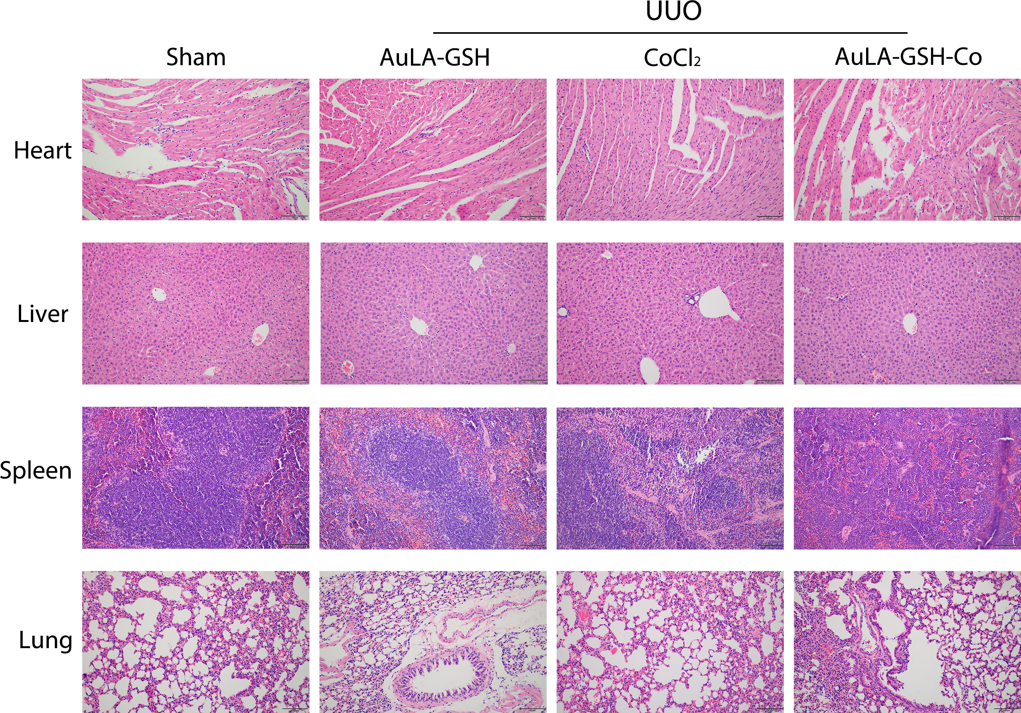
Figure S10 Histological section images of major organs (heart, liver, spleen and lung) collected from mice receiving different treatments with H&E staining (200×).

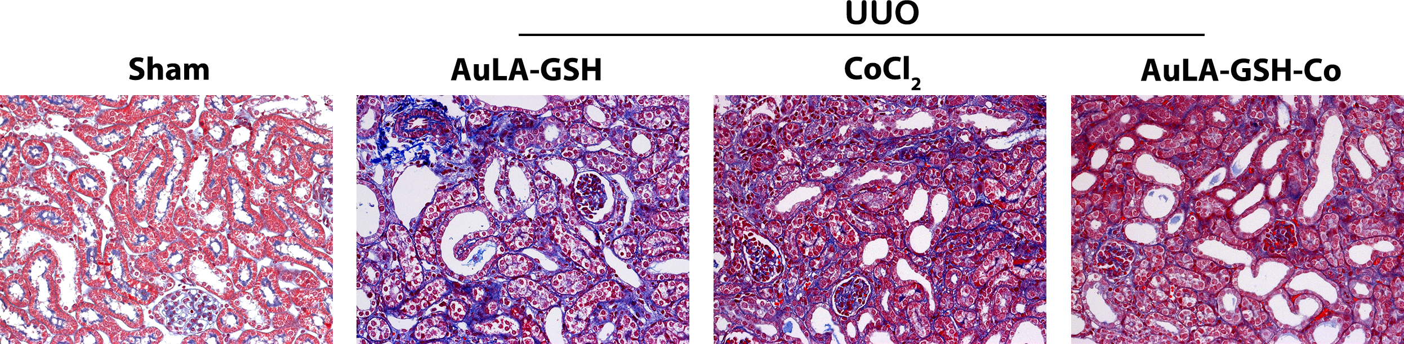
Figure S11 Histological section images of kidneys collected from mice receiving different treatments with Masson staining (200×).

