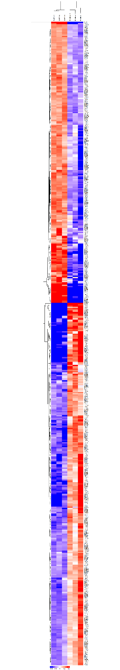
Supplementary Figure1 Full-size DEPs cluster analysis image
Each row represents one protein, and each column represents one sample. Red represent significantly upregulated proteins, blue represent significantly downregulated proteins, and white represent no significantly proteins.

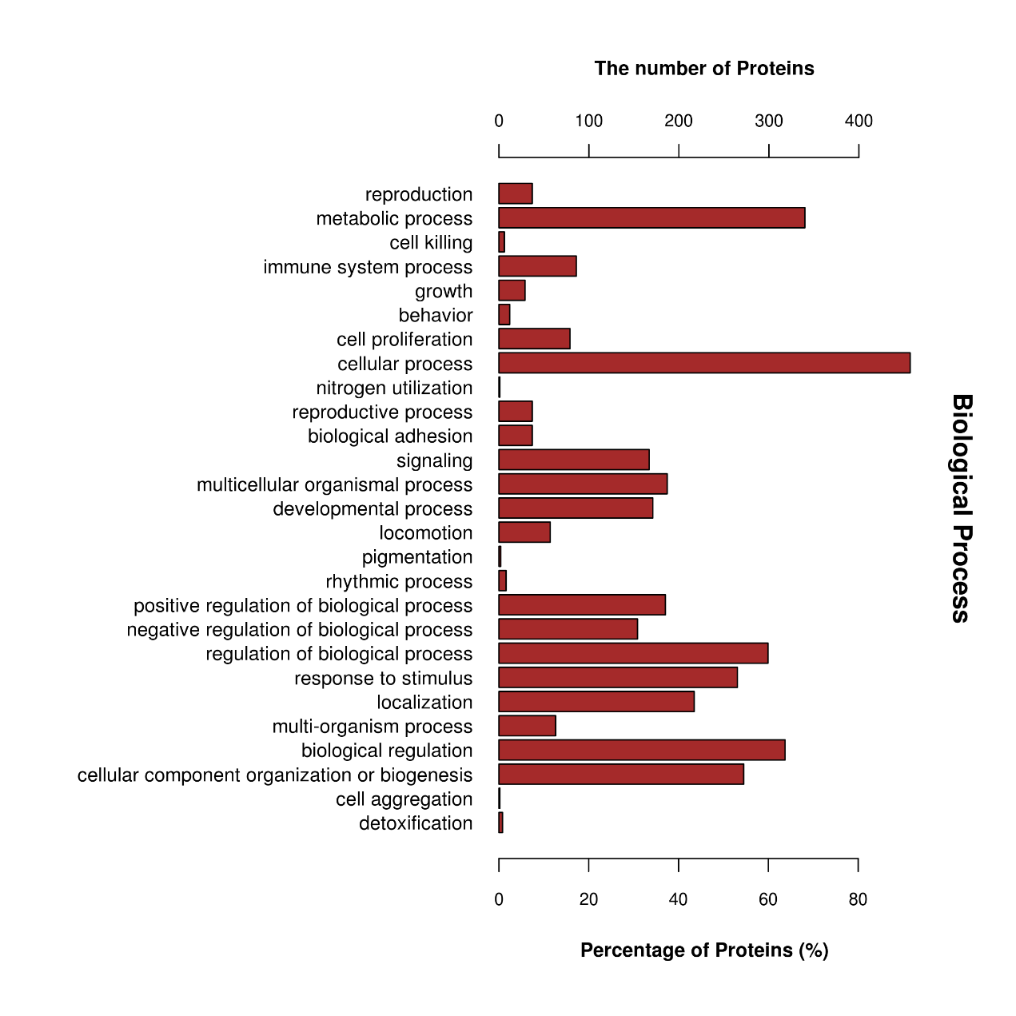
Supplementary Figure 2 GO level 2 Biological Process (BP)
X Axis: KEGG pathway name; Left Y Axis: The number of Proteins; Right Y Axis: Percentage of Proteins

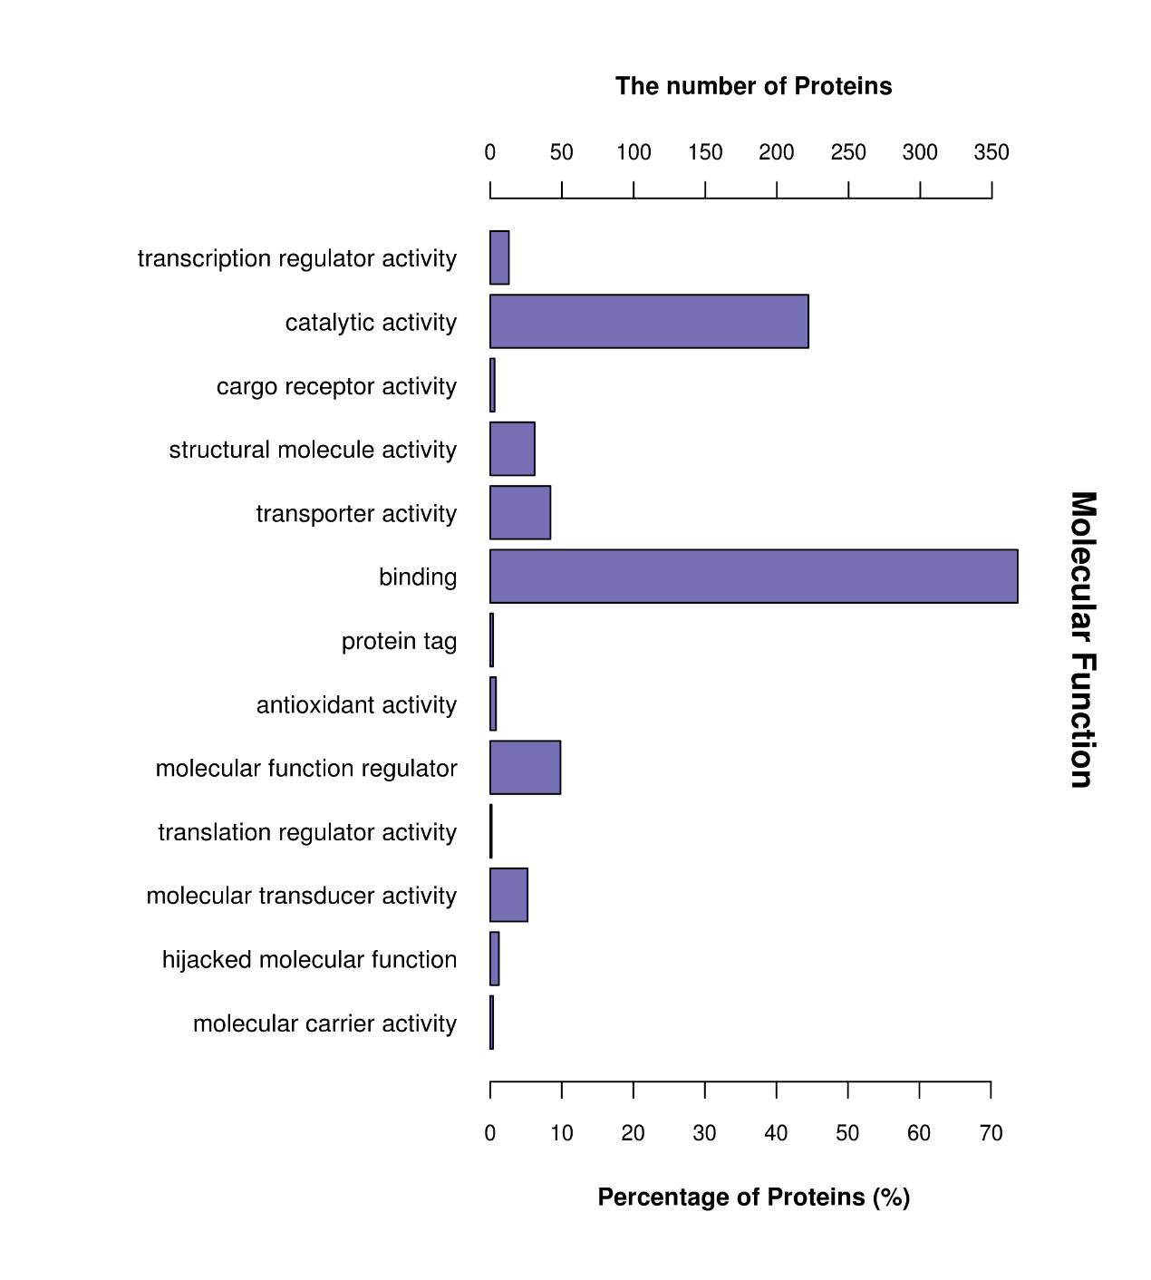
Supplementary Figure 3 GO level 2 Molecular Function (MF)
X Axis: KEGG pathway name; Left Y Axis: The number of Proteins; Right Y Axis: Percentage of Proteins

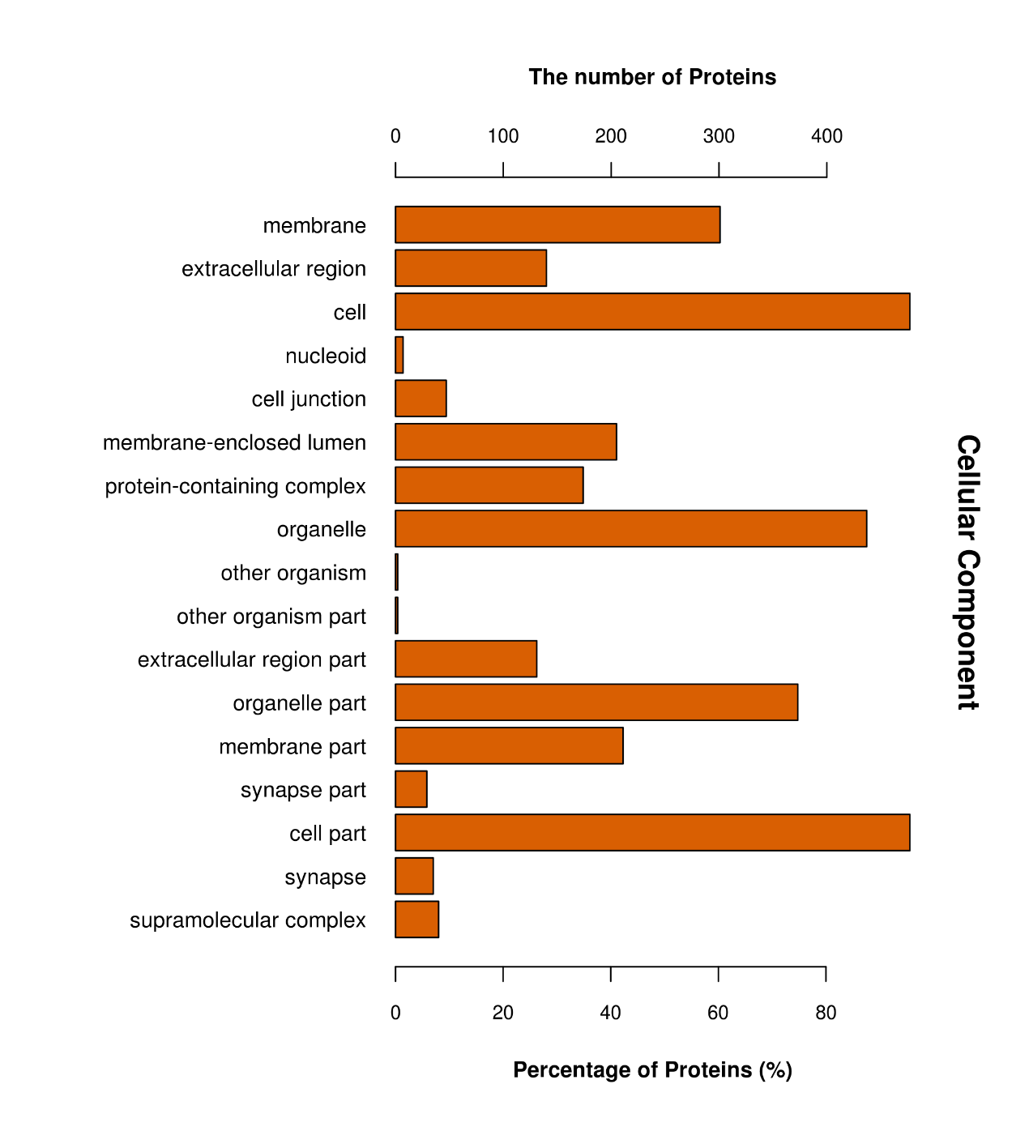
Supplementary Figure 4 GO level 2 Cellular Component (CC)
X Axis: KEGG pathway name; Left Y Axis: The number of Proteins; Right Y Axis: Percentage of Proteins

