Supplemental Figure 1: Participant flowchart
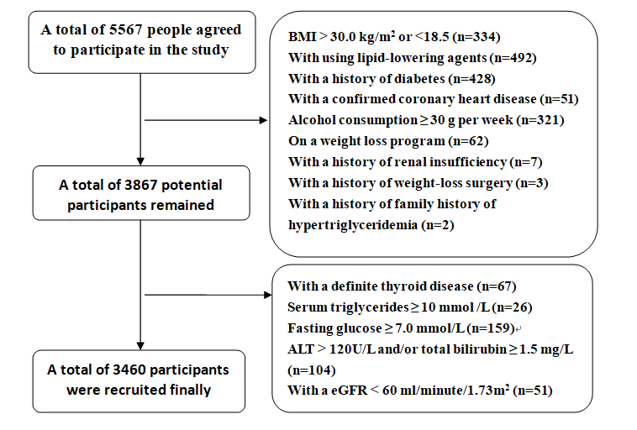

Supplementary table Spearman correlation between WTI and other anthropometric indices
Indices | Women (n=1465) |  |  |  |  |  | Men (n=1995)
Indices | Coefficient |  | P value |  |  |  | Coefficient |  | P value
TyG |  | 0.984 |  | < 0.001 |  |  |  | 0.979 | < 0.001
BMI (kg/m²) |  | 0.485 |  | < 0.001 |  |  |  | 0.371 | < 0.001
WC (cm) |  | 0.497 |  | < 0.001 |  |  |  | 0.363 | < 0.001
WHR |  | 0.499 |  | < 0.001 |  |  |  | 0.367 | < 0.001
WHtR |  | 0.456 |  | < 0.001 |  |  |  | 0.334 | < 0.001
BMI, body mass index; WC, waist circumference; WHR, waist-to-hip ratio; WHtR, waist-to-height ratio; TyG, triglyceride glucose index; WTI, waist-triglyceride index; HW, hypertriglyceridemic waist

Supplementary Figure 2 Receiver operating characteristic curves of waist-triglyceride index and other indicators used to predict the presence of metabolic syndrome in women

Supplementary Figure 3 Receiver operating characteristic curves of waist-triglyceride index and other indicators used to predict the presence of metabolic syndrome in men

