Supplementary materials

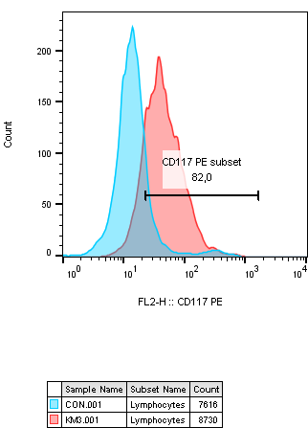
Figure S1. The expression of CD117 in KM3 lines is about 82%.

Figure S2. The cell sorting purity is 90.76%.

Figure S3. The expression of circ_0069767 in CR/VGPR/PR/PD patients were detected after bortezomib-based treatment. The expression of circ_0069767 in PD patients was the lowest. *p<0.05, **p<0.01.

