Supplementary Table-1 The association between the various variables including hematologic indices with the presence of baseline distant metastases in patients with pancreatic cancer

 | Baseline distant metastases |  | p- value | OR | 95% CI
 | Present | Absent | p- value | OR | 95% CI
Baseline  ANC≥5500  Baseline ANC<5500 | 113 (64%)  92 (52%) | 63 (36%)  85 (48%) | 0.024 | 1.65 | (1.0-2.5)
Baseline ALC≥1680  Baseline  ALC<1680 | 99 (57%)  106 (59%) | 75 (43%)  73 (41%) | 0.65 | 0.9 | (0.6-1.4)
Baseline AMC≥ 600  Baseline AMC<  600 | 117 (66%)  88 (50%) | 59 (34%)  89 (50%) | 0.001 | 2.0 | (1.3-3.0)
Baseline AEC≥ 143  Baseline AEC<  143 | 83 (62%)  76(57%) | 51 (38%)  58 (43%) | 0.38 | 1.2 | (0.7-2.0)
Baseline | 126 (69%) | 56 (31%) | <.0001 | 2.6 | (1.7-4.0)

NLR≥3.3  Baseline NLR<3.3 | 79 (46%) | 92 (54%)
Baseline MLR≥0.3  Baseline  MLR<0.3 | 130 (68%)  75 (46%) | 62 (32%)  86 (54%) | <.0001 | 2.4 | (1.5-3.7)
Baseline PLR≥0.15  Baseline  PLR<0.15 | 108 (61%)  97 (55%) | 68 (39%)  80 (45%) | 0.2 | 1.3 | (0.85-2.0)

Supplementary Table-2 The association between the various variables including hematologic indices with the presence of baseline distant metastases in patients with gastric cancer

 |  |  | Mets
name | value | Total | Yes | No | P-value
Age (grp) | Age > 57 | 210 | 55(26.2%) | 155(73.8%) | 0.005
 | Age<=57 | 291 | 111(38.1%) | 180(61.9%)
gender | FEMALE | 221 | 75(33.9%) | 146(66.1%) | 0.734
 | MALE | 280 | 91(32.5%) | 189(67.5%)
ANC median | ANC<=5730 | 236 | 65(27.5%) | 171(72.5%) | 0.012
 | ANC>5730 | 265 | 101(38.1%) | 164(61.9%)
ANC mean | ANC<=9214.38 | 348 | 103(29.6%) | 245(70.4%) | 0.011
 | ANC>9214.38 | 153 | 63(41.2%) | 90(58.8%)
AMC median | AMC<=634.4 | 232 | 73(31.5%) | 159(68.5%) | 0.461
 | AMC>634.4 | 269 | 93(34.6%) | 176(65.4%)
AMC mean | AMC<=876.59 | 335 | 110(32.8%) | 225(67.2%) | 0.841
 | AMC>876.59 | 166 | 56(33.7%) | 110(66.3%)
ALC median | ALC<=1892 | 229 | 78(34.1%) | 151(65.9%) | 0.686
 | ALC>1892 | 272 | 88(32.4%) | 184(67.6%)
ALC mean | ALC<=2383.54 | 309 | 104(33.7%) | 205(66.3%) | 0.752
 | ALC>2383.54 | 192 | 62(32.3%) | 130(67.7%)
AEC median |  | 63 | 23( . %) | 40( . %) | 0.271
 | AEC<=171.8 | 191 | 57(29.8%) | 134(70.2%)
 | AEC>171.8 | 247 | 86(34.8%) | 161(65.2%)
AEC mean |  | 63 | 23( . %) | 40( . %) | 0.101
 | AEC<=282.85 | 272 | 81(29.8%) | 191(70.2%)
 | AEC>282.85 | 166 | 62(37.3%) | 104(62.7%)
NLR median | NLR<=3.29 | 249 | 67(26.9%) | 182(73.1%) | 0.003
 | NLR>3.29 | 252 | 99(39.3%) | 153(60.7%)
NLR mean | NLR<=4.37 | 333 | 93(27.9%) | 240(72.1%) | 0.000
 | NLR>4.37 | 168 | 73(43.5%) | 95(56.5%)
NLR cutoff | NLR<=3.2 | 240 | 62(25.8%) | 178(74.2%) | 0.001
 | NLR>3.2 | 261 | 104(39.8%) | 157(60.2%)
MLR median | MLR<=0.33 | 255 | 81(31.8%) | 174(68.2%) | 0.507
 | MLR>0.33 | 246 | 85(34.6%) | 161(65.4%)
MLR mean | MLR<=0.411 | 333 | 106(31.8%) | 227(68.2%) | 0.383
 | MLR>0.411 | 168 | 60(35.7%) | 108(64.3%)
PLR median |  | 26 | 15 | 11 | 0.022
 | PLR<=0.154 | 238 | 64(26.9%) | 174(73.1%)
 | PLR>0.154 | 237 | 87(36.7%) | 150(63.3%)
PLR mean |  | 26 | 15 | 11 | 0.106
 | PLR<=0.181 | 274 | 79(28.8%) | 195(71.2%)
 | PLR>0.181 | 201 | 72(35.8%) | 129(64.2%)
WBC median | WBC<=8.1 | 283 | 77(27.2%) | 206(72.8%) | 0.001
 | WBC>8.1 | 218 | 89(40.8%) | 129(59.2%)
WBC mean | WBC<=9.17 | 343 | 102(29.7%) | 241(70.3%) | 0.017
 | WBC>9.17 | 158 | 64(40.5%) | 94(59.5%)

Supplementary Table-3 The association between the various variables including hematologic indices with the presence of baseline distant metastases in patients with biliary tract cancer

name | value | Total | Yes | No | CHI Sq. P-value
Age (grp) | Age > 57 | 43 | 23(53.5%) | 20(46.5%) | 0.901
 | Age<=57 | 46 | 24(52.2%) | 22(47.8%)
gender | FEMALE | 40 | 18(45.0%) | 22(55.0%) | 0.182
 | MALE | 49 | 29(59.2%) | 20(40.8%)
ANC median |  | 1 | 1( . %) |  | 0.370
 | ANC<=5730 | 48 | 23(47.9%) | 25(52.1%)
 | ANC>5730 | 40 | 23(57.5%) | 17(42.5%)
ANC mean |  | 1 | 1( . %) |  | 0.431
 | ANC<=9214.38 | 68 | 34(50.0%) | 34(50.0%)
 | ANC>9214.38 | 20 | 12(60.0%) | 8(40.0%)
AMC median |  | 2 | 1( . %) | 1( . %) | 0.733
 | AMC<=634.4 | 42 | 23(54.8%) | 19(45.2%)
 | AMC>634.4 | 45 | 23(51.1%) | 22(48.9%)
AMC mean |  | 2 | 1( . %) | 1( . %) | 0.620
 | AMC<=876.59 | 68 | 35(51.5%) | 33(48.5%)
 | AMC>876.59 | 19 | 11(57.9%) | 8(42.1%)
ALC median |  | 1 | 1( . %) |  | 0.776
 | ALC<=1892 | 37 | 20(54.1%) | 17(45.9%)
 | ALC>1892 | 51 | 26(51.0%) | 25(49.0%)
ALC mean |  | 1 | 1( . %) |  | 0.460
 | ALC<=2383.54 | 66 | 36(54.5%) | 30(45.5%)
 | ALC>2383.54 | 22 | 10(45.5%) | 12(54.5%)
AEC median |  | 13 | 7( . %) | 6( . %) | 0.921
 | AEC<=171.8 | 46 | 24(52.2%) | 22(47.8%) | .
 | AEC>171.8 | 30 | 16(53.3%) | 14(46.7%) | .
AEC mean |  | 13 | 7( . %) | 6( . %) | 0.923
 | AEC<=282.85 | 63 | 33(52.4%) | 30(47.6%)
 | AEC>282.85 | 13 | 7(53.8%) | 6(46.2%)
NLR median |  | 1 | 1( . %) |  | 0.357
 | NLR<=3.29 | 50 | 24(48.0%) | 26(52.0%)
 | NLR>3.29 | 38 | 22(57.9%) | 16(42.1%)
NLR mean |  | 1 | 1( . %) |  | 0.081
 | NLR<=4.37 | 59 | 27(45.8%) | 32(54.2%)
 | NLR>4.37 | 29 | 19(65.5%) | 10(34.5%)
NLR cutoff |  | 1 | 1( . %) |  | 0.185
 | NLR<=3.2 | 48 | 22(45.8%) | 26(54.2%)
 | NLR>3.2 | 40 | 24(60.0%) | 16(40.0%)
MLR median |  | 2 | 1 | 1 | 0.770
 | MLR<=0.33 | 46 | 25(54.3%) | 21(45.7%)
 | MLR>0.33 | 41 | 21(51.2%) | 20(48.8%)
MLR mean |  | 2 | 1 | 1 | 0.950
 | MLR<=0.411 | 57 | 30(52.6%) | 27(47.4%)
 | MLR>0.411 | 30 | 16(53.3%) | 14(46.7%)
PLR median |  | 1 | 1 |  | 0.868
 | PLR<=0.154 | 49 | 26(53.1%) | 23(46.9%)
 | PLR>0.154 | 39 | 20(51.3%) | 19(48.7%)
PLR mean |  | 1 | 1 |  | 0.958
 | PLR<=0.181 | 61 | 32(52.5%) | 29(47.5%)
 | PLR>0.181 | 27 | 14(51.9%) | 13(48.1%)
WBC median | WBC<=8.1 | 36 | 17(47.2%) | 19(52.8%) | 0.384
 | WBC>8.1 | 53 | 30(56.6%) | 23(43.4%)
WBC mean | WBC<=9.17 | 47 | 24(51.1%) | 23(48.9%) | 0.727
 | WBC>9.17 | 42 | 23(54.8%) | 19(45.2%)

Supplementary Figure 1A AUC for the training group
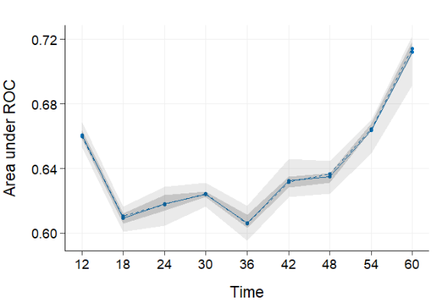

Supplementary Figure 1B AUC for the validation group
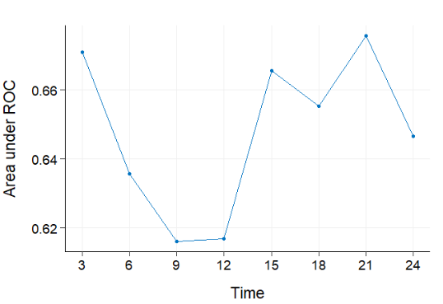

Supplementary Figure 2 Receiver-Operating-Characteristic (ROC) and area under the curve (AUC) for NLR
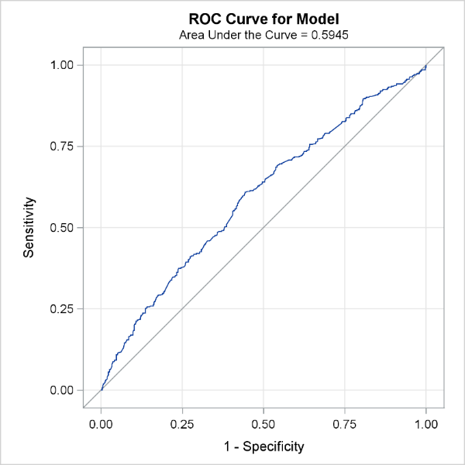

Supplementary Figure 3A Kaplan Meier curve of OS for patients with ANC>5730

Supplementary Figure 3B Kaplan Meier curve of OS for patients with ALC> 1892

Supplementary Figure 3C Kaplan Meier curve of OS for patients with NLR> 3.29

Supplementary Figure 3D Kaplan Meier curve of OS for patients with MLR> 0.33

Supplementary Figure 3E Kaplan Meier curve of OS for patients with PLR> 0.154

Supplementary Figure 4A: median OS for the training group
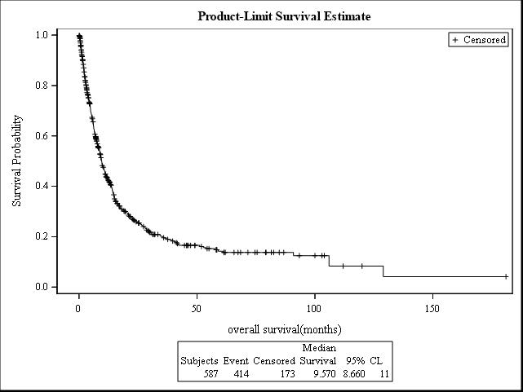

Supplementary Figure 4B: median OS for the validation group
