Electronic Supplementary Material (ESI)
Multifunctional Quaternary Phosphorus/Bromoargentate Hybrids: the Achievement of Greenish Blue Luminescence, Repeatable Photocurrent Responses and Durable Antibacterial Activities with Enhanced Water Stability

Jing-Bo Liu,ª Qiao-Jun Zhang, ^{b} Jian-Zhi Liu,*ª Wen-Ting Zhang,^{c} Yi Li,^{c} Hao-Hong Li,^{c} Wei Lin, ^{c} Zhi-Rong Chen^{c} and Da-Li Zheng*^{b}

ª Department of Otorhinolaryngology, Fujian Medical University Union Hospital, Fuzhou, Fujian, 350001, China.
^{b} Fujian Key Laboratory of Oral Diseases, Fujian Biological Materials Engineering and Technology Center of Stomatology, School and Hospital of Stomatology, Fujian Medical University, Fuzhou, Fujian, 350004, China.
^{c} College of chemistry, Fuzhou University, Fuzhou, Fujian, 350116, China.

Synthesis of quaternary phosphorus salts
Three alkyl-bis-(triphenyl)phosphonium bromides (1,2-DBTPP)Br₂, (1,3-DBTPP)Br₂ and (1,4-DBTPP)Br₂) were synthesized according to the same synthetic procedure, using triphenylphosphonium and 1,2-dibromoethane, 1,3-dibromopropane, 1,4-dibromobutane as starting materials (Scheme S1). Haloalkanes (10 mmol) and Ph₃P (30 mmol) were dissolved in 10 mL DMF, which were reacted at 130 °C for 4h. Afterwards the mixtures were cooled to room temperature, and then the solvent was removed by rotation volatilization to give raw products, which were washed with n-hexane and dried in the oven. White powders can be obtained with yield of higher than 90%. Their ¹H NMR and ³¹P NMR spectra can be seen in Fig. S1.
(1,2-DBTPP)Br₂: ¹H NMR (400 MHz, Chloroform-d) δ: 7.86-7.75 (m, 18H), 7.71 (d, J =7.1 Hz,12H), 3.74 (dq, J =13.9, 7.2 Hz,4H). ³¹P NMR (202 MHz, CDCl₃): 26.43 (s).
(1,3-DBTPP)Br₂: ¹H NMR (400 MHz, Chloroform-d) δ: 7.86 (dd, J = 11.8, 8.0 Hz, 12H), 7.67 (t, J = 7.4 Hz, 6H), 7.57 (t, J = 6.7 Hz, 12H), 4.58 (t, J = 13.8 Hz, 4H), 2.07 (s, 2H). ³¹P NMR (202 MHz, CDCl₃): 24.33 (s).
(1,4-DBTPP)Br₂: ¹H NMR (400 MHz, Chloroform-d) δ: 7.86 (dd, J = 12.6, 7.6 Hz, 12H), 7.66 (dd, J =14.5, 7.1 Hz, 18H), 4.00 (s, 4H), 2.19 (s, 4H). ³¹P NMR (202 MHz, CDCl₃): 24.55 (s).

Table S1 Summary of the crystal data and structure determination for 1-3
Compound | 1 | 2 | 3
Empirical formula | C₃₈H₃₄Ag₂Br₄P₂ | C₈₀H₇₃Ag₇Br₁₁NOP₄ | C₄₄H₄₆Ag₅Br₇N₂OP₂
Formula mass | 1087.93 | 2824.26 | 1779.48
Crystal system | Monoclinic | Monoclinic | Monoclinic
Space group | C2/c | P2₁/m | Pnma
a[Å] | 22.912(4) | 13.743(4) | 13.323(2)
b[Å] | 9.8676(12) | 23.465(6) | 28.623(5)
c [Å] | 19.266(4) | 14.193(4) | 15.867(3)
β[º] | 122.39(3) | 104.516(5) | 90.00
V[Å] | 3678.2(10) | 4431(2) | 6050.8(18)
Z | 4 | 2 | 4
D_{c}[g/cm³] | 1.965 | 2.115 | 1.951
μ[mm^{－1}] | 5.524 | 6.589 | 6.295
F(000) | 2014 | 2684 | 3360
Reflections, total | 7897 | 11934 | 19863
Reflections, unique | 3091(R_{int}=0.0606) | 7202(R_{int}=0.0822) | 5381 (R_{int}=0.0391)
Reflections, observed | 2444 | 3283 | 3756
Goodness-of-fit on F² | 0.960 | 1.007 | 1.052
No. of parameters refined | 149 | 487 | 284
R₁[I>2σ(I)] | 0.0610 | 0.0811 | 0.0558
wR₂ [I>2σ(I)] | 0.1577 | 0.1922 | 0.1472
Residual extremes(e/Å³) | 1.365, -2.33 | 2.966, -2.328 | 1.750,-1.685
Table S2 Selected bond distances (in Å) and angles (in °) for 1-3
Compound 1
Ag(1)-Br(1) | 2.6632(11) | Ag(1)-Br(2) | 2.5356(11) | Ag(1)-Br(1)#1 | 2.6961(14)
Ag(1)-Ag(1)#1 | 3.0253(14)
Br(2)-Ag(1)-Br(1) | 126.38(4) | Br(2)-Ag(1)-Br(1)#1 | 121.23(4) | Br(1)-Ag(1)-Br(1)#1 | 111.27(3)
Compound 2
Ag(1)-Br(1) | 2.863(4) | Ag(1)-Br(2) | 2.753(3) | Ag(1)-Br(2)#2 | 2.753(3)
Ag(1)-Br(6)#1 | 2.592(5) | Ag(2)-Br(1) | 2.731(3) | Ag(2)-Br(2) | 2.687(3)
Ag(2)-Br(3) | 2.632(3) | Ag(2)-Br(7) | 2.877(3) | Ag(3)-Br(3) | 2.617(3)
Ag(3)-Br(4) | 2.653(3) | Ag(3)-Br(5) | 2.671(3) | Ag(3)-Br(7) | 2.905(3)
Ag(4)-Br(5) | 2.507(2) | Ag(4)-Br(5)#2 | 2.507(2) | Ag(4)-Br(6) | 2.782(5)
Ag(5)-Br(2) | 2.832(3) | Ag(5)-Br(2)#2 | 2.832(3) | Ag(5)-Br(7) | 2.789(4)
Ag(5)-Br(8) | 2.535(6) | Ag(1)-Ag(2) | 3.139(3) | Ag(1)-Ag(5) | 3.287(5)
Ag(2)-Ag(3) | 3.026(3) | Ag(2)-Ag(2)#2 | 3.323(4)
Br(6)#1-Ag(1)-Br(2) | 109.23(10) | Br(6)#1-Ag(1)-Br(2)#2 | 109.23(10) | Br(2)-Ag(1)-Br(2)#2 | 108.91(15)
Br(6)#1-Ag(1)-Br(1) | 118.42(18) | Br(2)-Ag(1)-Br(1) | 105.34(9) | Br(2)#2-Ag(1)-Br(1) | 105.34(9)
Br(3)-Ag(2)-Br(1) | 114.40(10) | Br(2)-Ag(2)-Br(1) | 111.02(10) | Br(3)-Ag(2)-Br(7) | 110.41(9)
Br(2)-Ag(2)-Br(7) | 100.58(9) | Br(1)-Ag(2)-Br(7) | 104.61(9) | Br(3)-Ag(3)-Br(4) | 122.20(11)
Br(3)-Ag(3)-Br(5) | 122.25(10) | Br(4)-Ag(3)-Br(5) | 101.82(10) | Br(3)-Ag(3)-Br(7) | 110.00(9)
Br(4)-Ag(3)-Br(7) | 93.72(8) | Br(5)-Ag(3)-Br(7) | 101.55(9) | Br(5)-Ag(4)-Br(5)#2 | 151.28(18)
Br(5)-Ag(4)-Br(6) | 103.00(9) | Br(5)#2-Ag(4)-Br(6) | 103.00(9) | Br(8)-Ag(5)-Br(7) | 103.41(18)
Br(8)-Ag(5)-Br(2) | 122.46(9) | Br(7)-Ag(5)-Br(2) | 99.27(10) | Br(8)-Ag(5)-Br(2)#2 | 122.46(9)
Br(7)-Ag(5)-Br(2)#2 | 99.27(10) | Br(2)-Ag(5)-Br(2)#2 | 104.58(16)
Symmetry code: #1 x-1,y,z; #2 x,-y+3/2,z
Compound 3
Ag(1)-Br(2)#1 | 2.6473(11) | Ag(1)-Br(2)#2 | 2.6473(11) | Ag(1)-Br(3) | 2.7746(18)
Ag(1)-Br(4)#2 | 3.057(2) | Ag(2)-Br(1)#3 | 2.6302(13) | Ag(2)-Br(2)#1 | 2.7604(13)
Ag(2)-Br(3) | 3.0770(15) | Ag(2)-Br(5) | 2.6075(15) | Ag(3)-Br(1) | 2.6083(12)
Ag(3)-Br(2) | 2.7319(13) | Ag(3)-Br(3) | 2.8393(13) | Ag(3)-Br(4) | 2.6910(13)
Ag(1)-Ag(2) | 3.1918(14) | Ag(1)-Ag(3)#1 | 3.0289(13) | Ag(2)-Ag(3)#3 | 3.1914(13)
Br(2)#1-Ag(1)-Br(2)#2 | 135.70(8) | Br(2)#1-Ag(1)-Br(3) | 105.41(4) | Br(2)#2-Ag(1)-Br(3) | 105.41(4)
Br(2)#1-Ag(1)-Br(4)#2 | 103.99(4) | Br(2)#2-Ag(1)-Br(4)#2 | 103.99(4) | Br(3)-Ag(1)-Br(4)#2 | 95.31(6)
Br(1)#3-Ag(2)-Br(3) | 101.91(4) | Br(5)-Ag(2)-Br(1)#3 | 127.98(5) | Br(5)-Ag(2)-Br(2)#1 | 110.37(6)
Br(1)#3-Ag(2)-Br(2)#1 | 112.39(4) | Br(5)-Ag(2)-Br(3) | 102.34(4) | Br(2)#1-Ag(2)-Br(3) | 95.14(4)
Br(2)-Ag(3)-Br(3) | 99.08(4) | Br(1)-Ag(3)-Br(4) | 118.80(5) | Br(1)-Ag(3)-Br(2) | 114.21(4)
Br(4)-Ag(3)-Br(2) | 112.24(5) | Br(1)-Ag(3)-Br(3) | 109.16(4) | Br(4)-Ag(3)-Br(3) | 100.32(4)
Symmetry code: #1 x-1/2,-y+1/2,-z+3/2; #2 x-1/2,y,-z+3/2; #3 x,-y+1/2,z
Table S3 Hydrogen bridging details of 1-3
D–H···A | D–H/Å | H···A/Å | D···A/Å | ∠(D–H···A)/º | Symmetry codes
Compound 1
C(5)-H(5)···Br(2) | 0.93 | 2.90 | 3.802(8) | 163
C(6)-H(6)···Br(1) | 0.93 | 2.90 | 3.821(9) | 169
C(18)-H(18)···Br(2) | 0.93 | 2.79 | 3.603(9) | 147 | x,1+y,z
C(19)-H(19A)···Br(2) | 0.97 | 2.84 | 3.799(8) | 171 | x,1+y,z
C(19)-H(19B) ···Br(1) | 0.97 | 2.90 | 3.828(8) | 160
Compound 2
C(15)-H(15)···Br(2) | 0.93 | 2.91 | 3.74(2) | 149 | 1-x,1-y,-z
C(19)-H(19B)···Br(4) | 0.97 | 2.92 | 3.64(2) | 132 | 2-x,-1/2+y,1-z
C(20)-H(20A)···O(1) | 0.97 | 2.50 | 3.30(5) | 141
C(37)-H(37)···Br(5) | 0.93 | 2.78 | 3.53(2) | 138 | 2-x,1-y,-z
Compound 3
C(17)-H(17)···Br(4) | 0.93 | 2.92 | 3.831(9) | 166 | -1/2+x,1/2-y,3/2-z
C(19)-H(19A)···N(1) | 0.97 | 2.54 | 3.488(13) | 167 | -1/2+x,y,1/2-z
C(19)-H(19B)···Br(1) | 0.97 | 2.74 | 3.596(6) | 147 | 1/2-x,-y,-1/2+z
Scheme S1 Synthesis process of three alkyl-bis-(triphenyl)phosphonium bromides
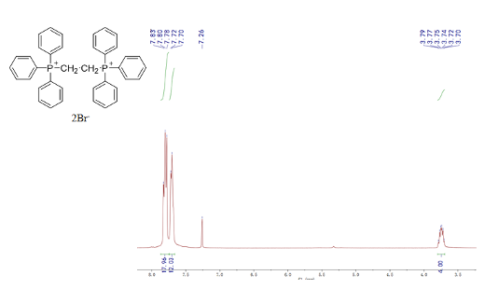
(a)
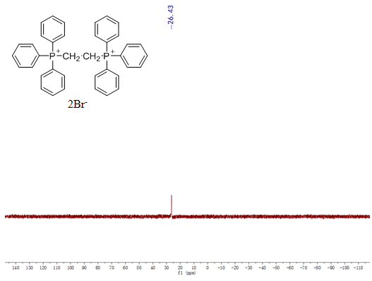
(b)
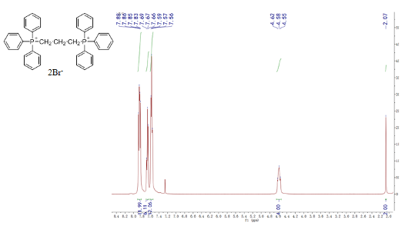
(c)
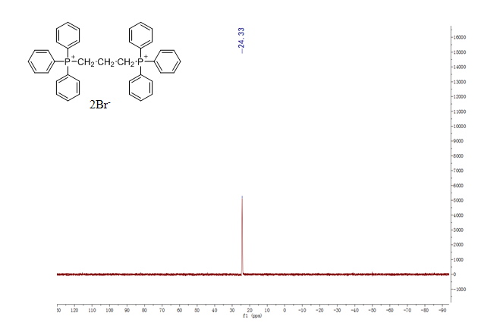
(d)
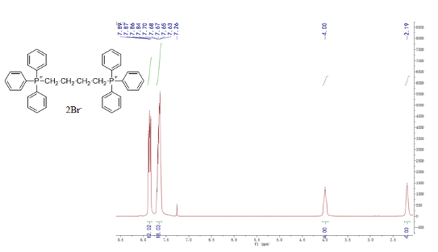
(e)
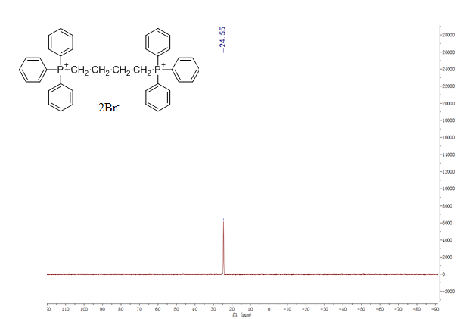
(f)
Fig. S1 ¹H NMR and ¹P NMR spectra of (1,2-DBTPP)Br₂ (a, b), (1,3-DBTPP)Br₂ (c, d), (1,4-DBTPP)Br₂ (e, f)
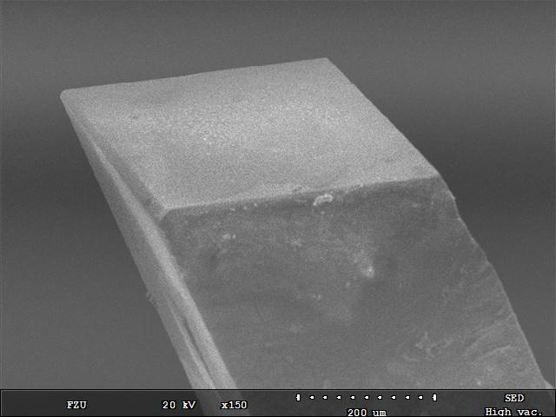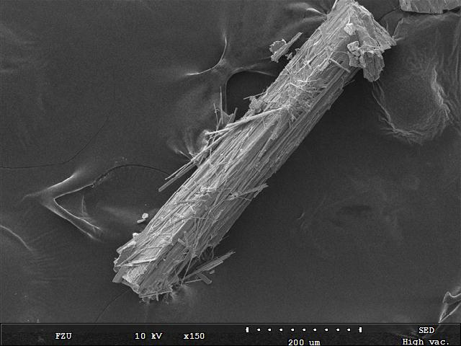

(a) (b)
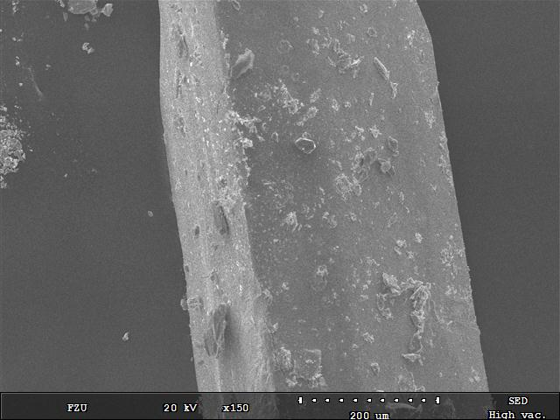
(c)

Fig. S2 SEM diagrams of 1 (a), 2 (b) and 3 (c)

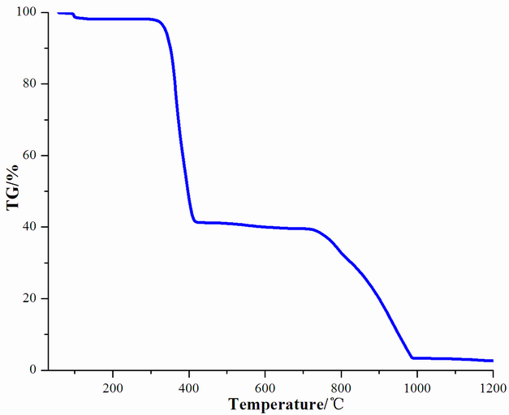
Fig. S3 TG curve of 3
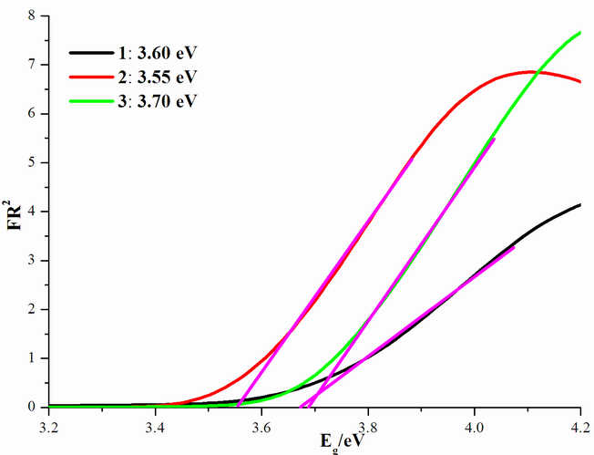
Fig. S4 Optical gaps for 1-3 calculated from the Kubelka–Munk function

