Supplementary Table-S1 APIM Analysis for all sleep parameters
 |  | Actor effect |  |  |  | Partner effect |  |  |  | Covariance
 |  | Mother | Father | overall | Difference | Father →Mother | Mother  →Father | overall | Difference | prepartum | postpartum
PSQI | estimate | 0.331 | 0.745 | 0.538 | -0.144 | 0.282 | 0.128 | 0.205 | 0.154 | 0.403 | 1.081
PSQI | std. Error | 0.099 | 0.138 | 0.084 | 0.171 | 0.139 | 0.098 | 0.084 | 0.171 | 0.748 | 0.686
PSQI | p-Value | < 0.001 | < 0.001 | < 0.001 | 0.016 | 0.042 | 0.192 | 0.015 | 0.369 | 0.590 | 0.115
SOL | estimate | 0.132 | 0.091 | 0.111 | 0.042 | 0.080 | 0.101 | 0.090 | -0-020 | -11.628 | 13.139
SOL | std. Error | 0.092 | 0.109 | 0.072 | 0.142 | 0.132 | 0.075 | 0.077 | 0.151 | 13.616 | 9.071
SOL | p-Value | 0.150 | 0.408 | 0.122 | 0.769 | 0.543 | 0.182 | 0.239 | 0.894 | 0.393 | 0.147
TST | estimate | 0.591 | 1.057 | 0.824 | -0.466 | 0.166 | 0.113 | 0.140 | 0.053 | 681.526 | 519.580
TST | std. Error | 0.115 | 0.131 | 0.083 | 0.182 | 0.149 | 0.101 | 0.086 | 0.189 | 276.852 | 243.002
TST | p-Value | < 0.001 | < 0.001 | < 0.001 | 0.010 | 0.267 | 0.263 | 0.104 | 0.781 | 0.014 | 0.033
WASO | estimate | 0.166 | 0.264 | 0.215 | -0.098 | -0.132 | -0.006 | -0.069 | -0.126 | -8.262 | 105.901
WASO | std. Error | 0.135 | 0.106 | 0.087 | 0.171 | 0.222 | 0.065 | 0.116 | 0.230 | 35.818 | 24.388
WASO | p-Value | 0.220 | 0.013 | 0.013 | 0.566 | 0.553 | 0.932 | 0.554 | 0.584 | 0.818 | 0.003
FNW | estimate | 0.410 | 0.470 | 0.440 | -0.060 | 0.234 | 0.038 | 0.136 | 0.196 | 0.146 | 0.228
FNW | std. Error | 0.128 | 0.128 | 0.085 | 0.191 | 0.172 | 0.095 | 0.093 | 0.207 | 0.069 | 0.071
FNW | p-Value | < 0.001 | < 0.001 | < 0.001 | 0.754 | 0.175 | 0.687 | 0.144 | 0.344 | 0.034 | 0.001
Sleep efficiency | estimate | 0.460 | 0.904 | 0.682 | -0.44 | 0.127 | 0.068 | 0.098 | 0.060 | -2.192 | 5.880
Sleep efficiency | std. Error | 0.107 | 0.103 | 0.075 | 0.148 | 0.147 | 0.076 | 0.083 | 0.165 | 3.900 | 2.937
Sleep efficiency | p-Value | < 0.001 | < 0.001 | < 0.001 | 0.003 | 0.386 | 0.371 | 0.240 | 0.718 | 0.574 | 0.045
Abbreviation:
PSQI, Pittsburgh Sleep Quality Index; SOL, sleep onset latency; TST, total sleep time; WASO, wake after sleep onset; FNW, frequency of night waking.
Note: Bold values denote statistical significance at the p<0.05 level.

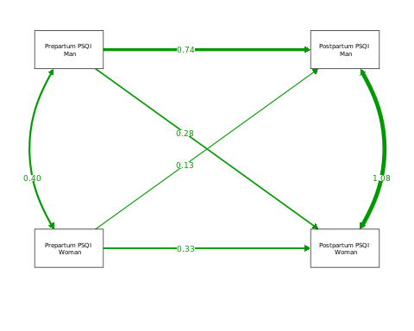
Supplementary Figure-S1. Results from APIM Analyses for PSQI

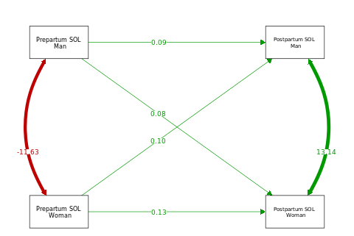
Supplementary Figure-S2. Results from APIM Analyses for SOL

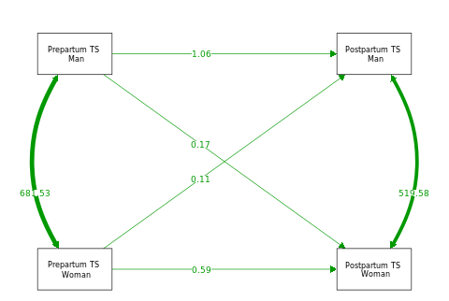
Supplementary Figure-S3. Results from APIM Analyses for TST

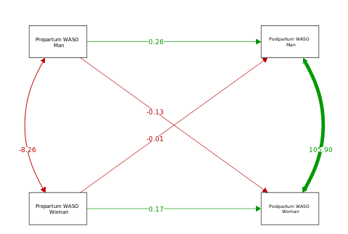
Supplementary Figure-S4. Results from APIM Analyses for WASO

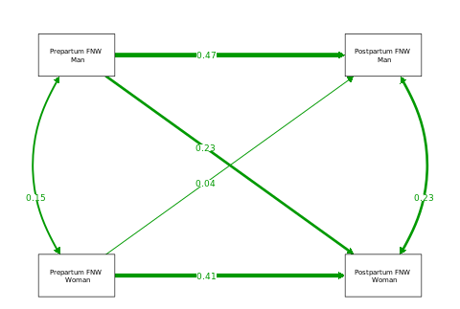
Supplementary Figure-S5. Results from APIM Analyses for FNW

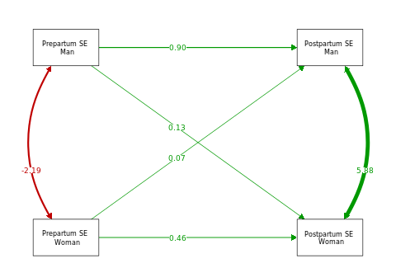
Supplementary Figure-S6. Results from APIM Analyses for SE

