Supplement
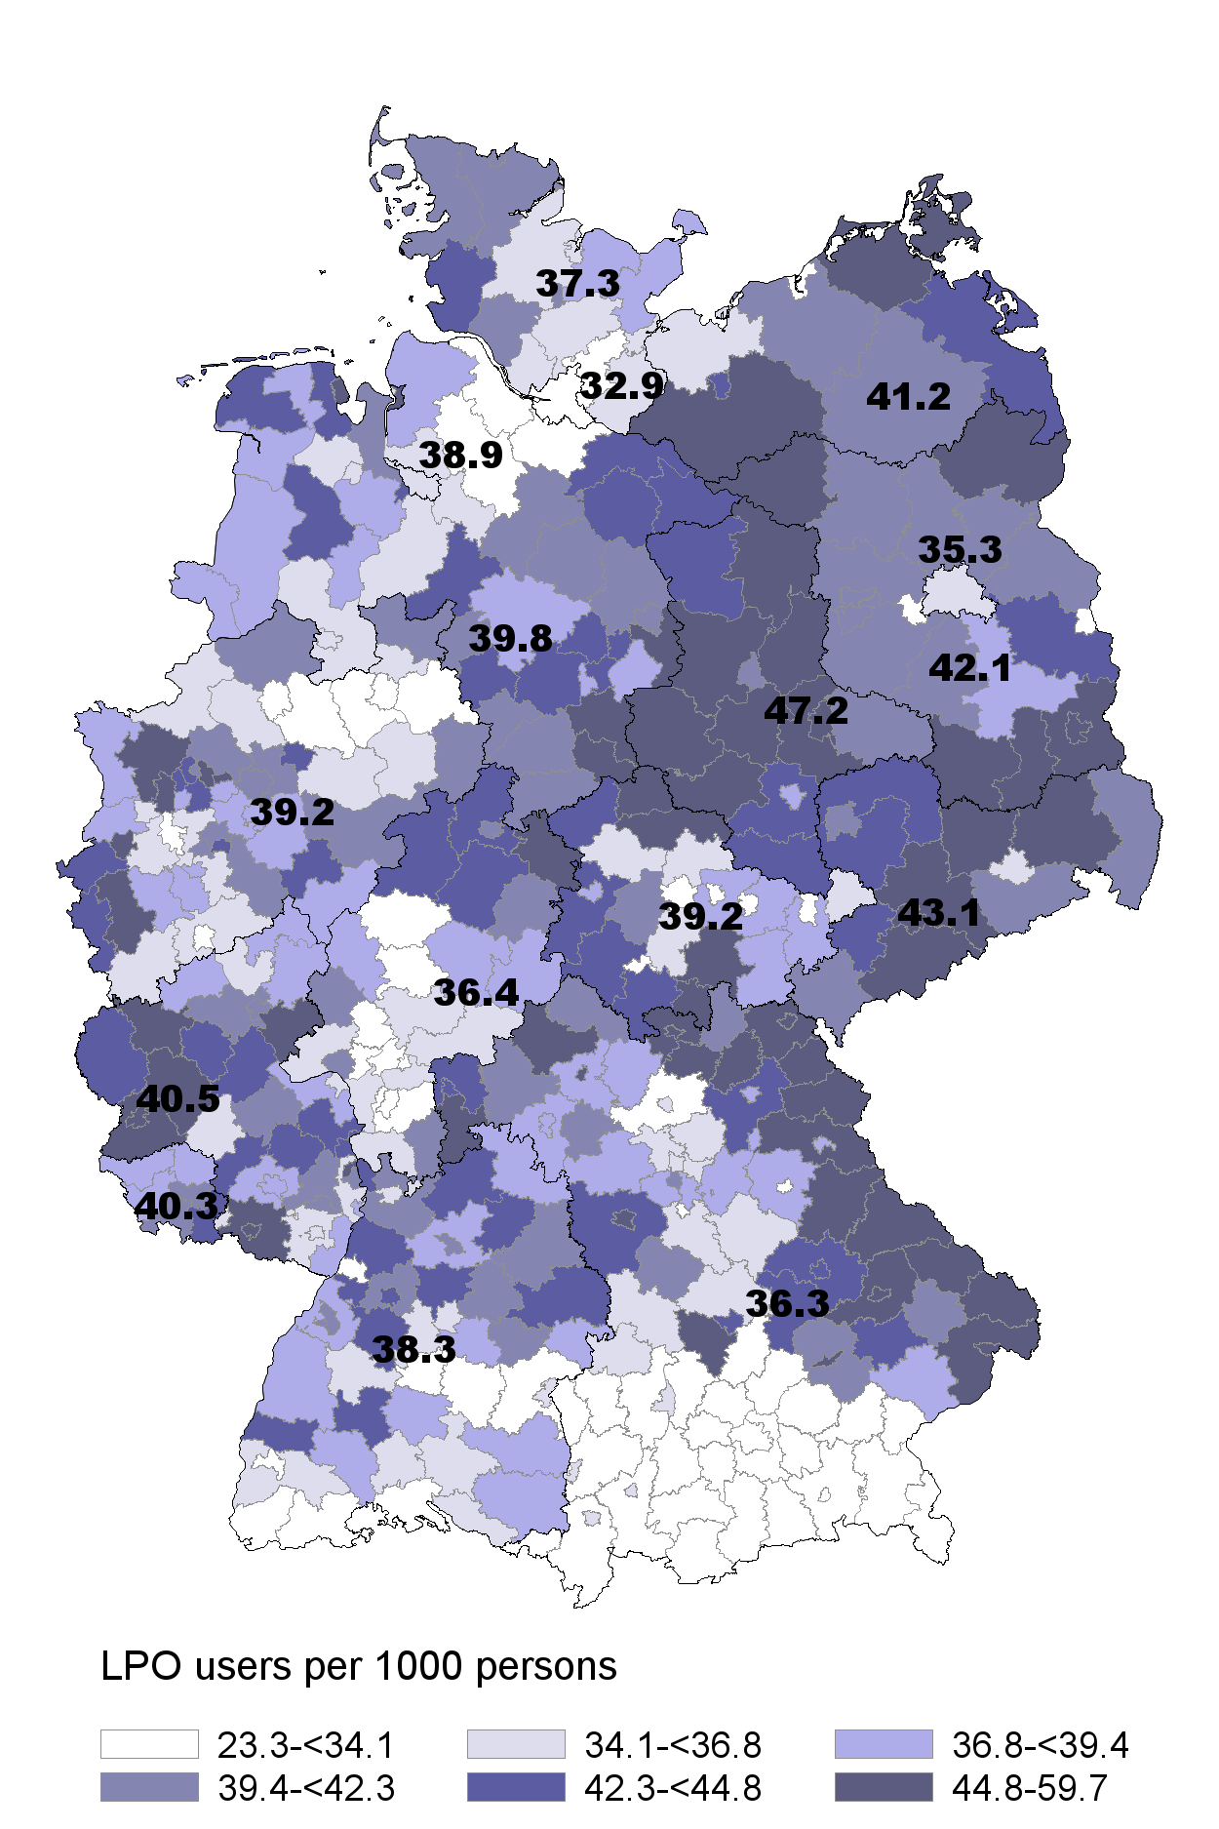 | 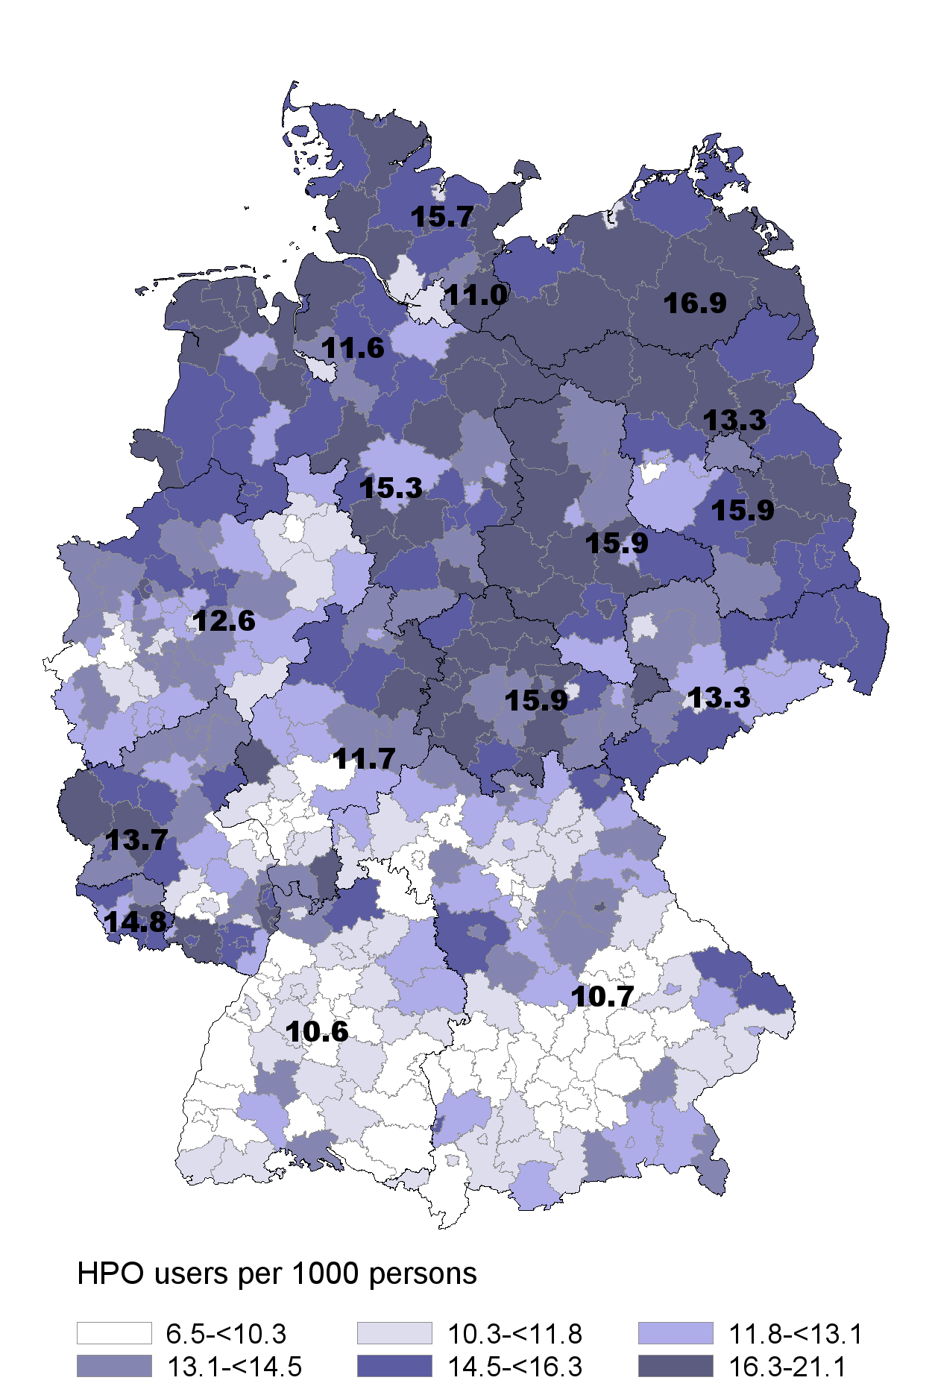
Supplemental Figure 1: LPO and HPO users per 1000 persons
HPO: high-potency opioid, LPO: low-potency opioid
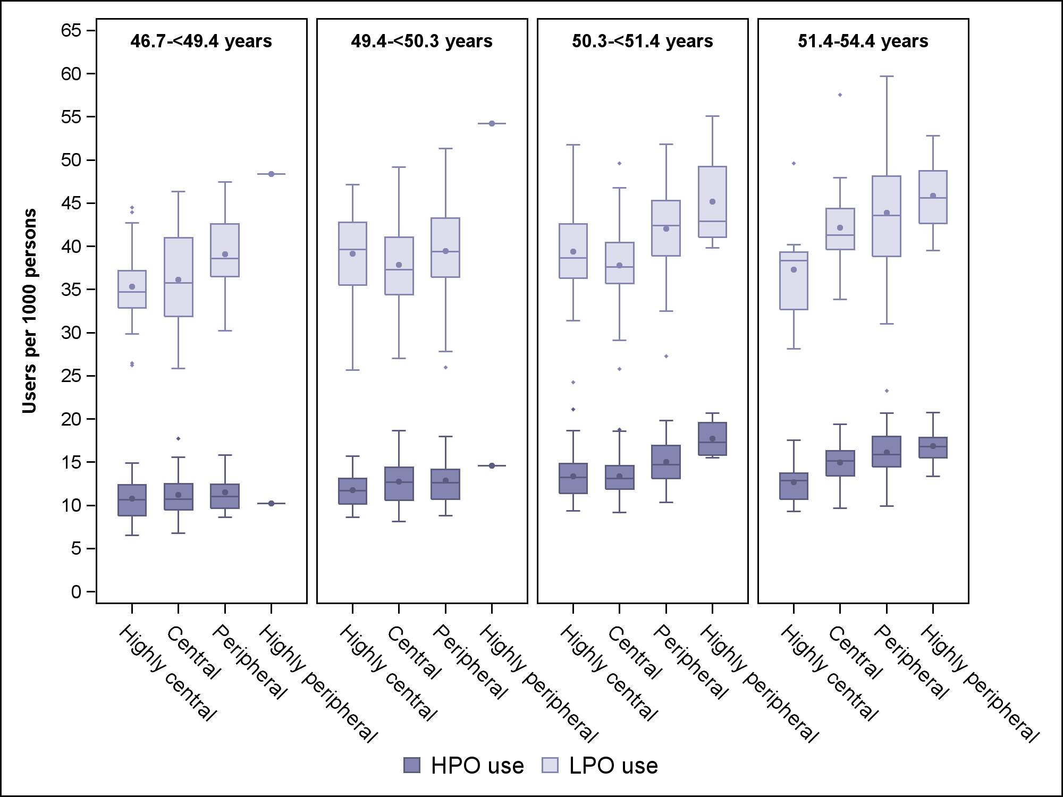
Supplemental Figure 2: LPO and HPO users per 1000 persons by districts’ mean age (categorized in quartiles) and region
HPO: high-potency opioid, LPO: low-potency opioid

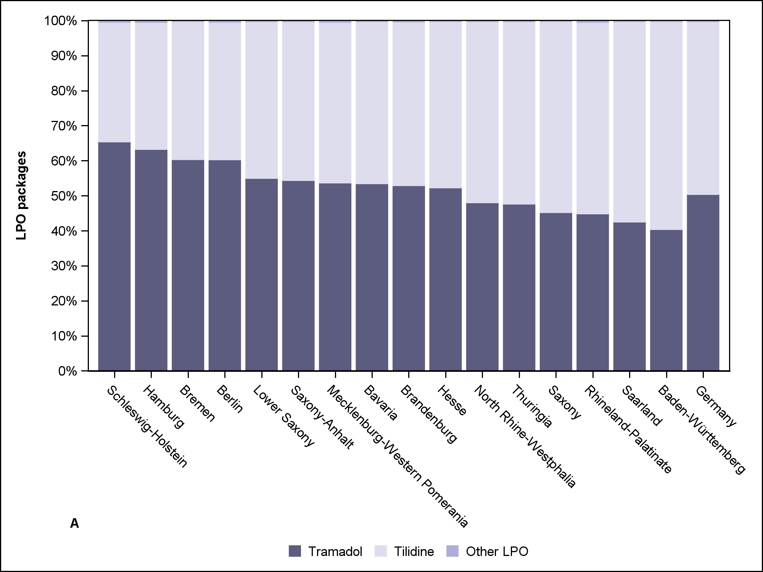
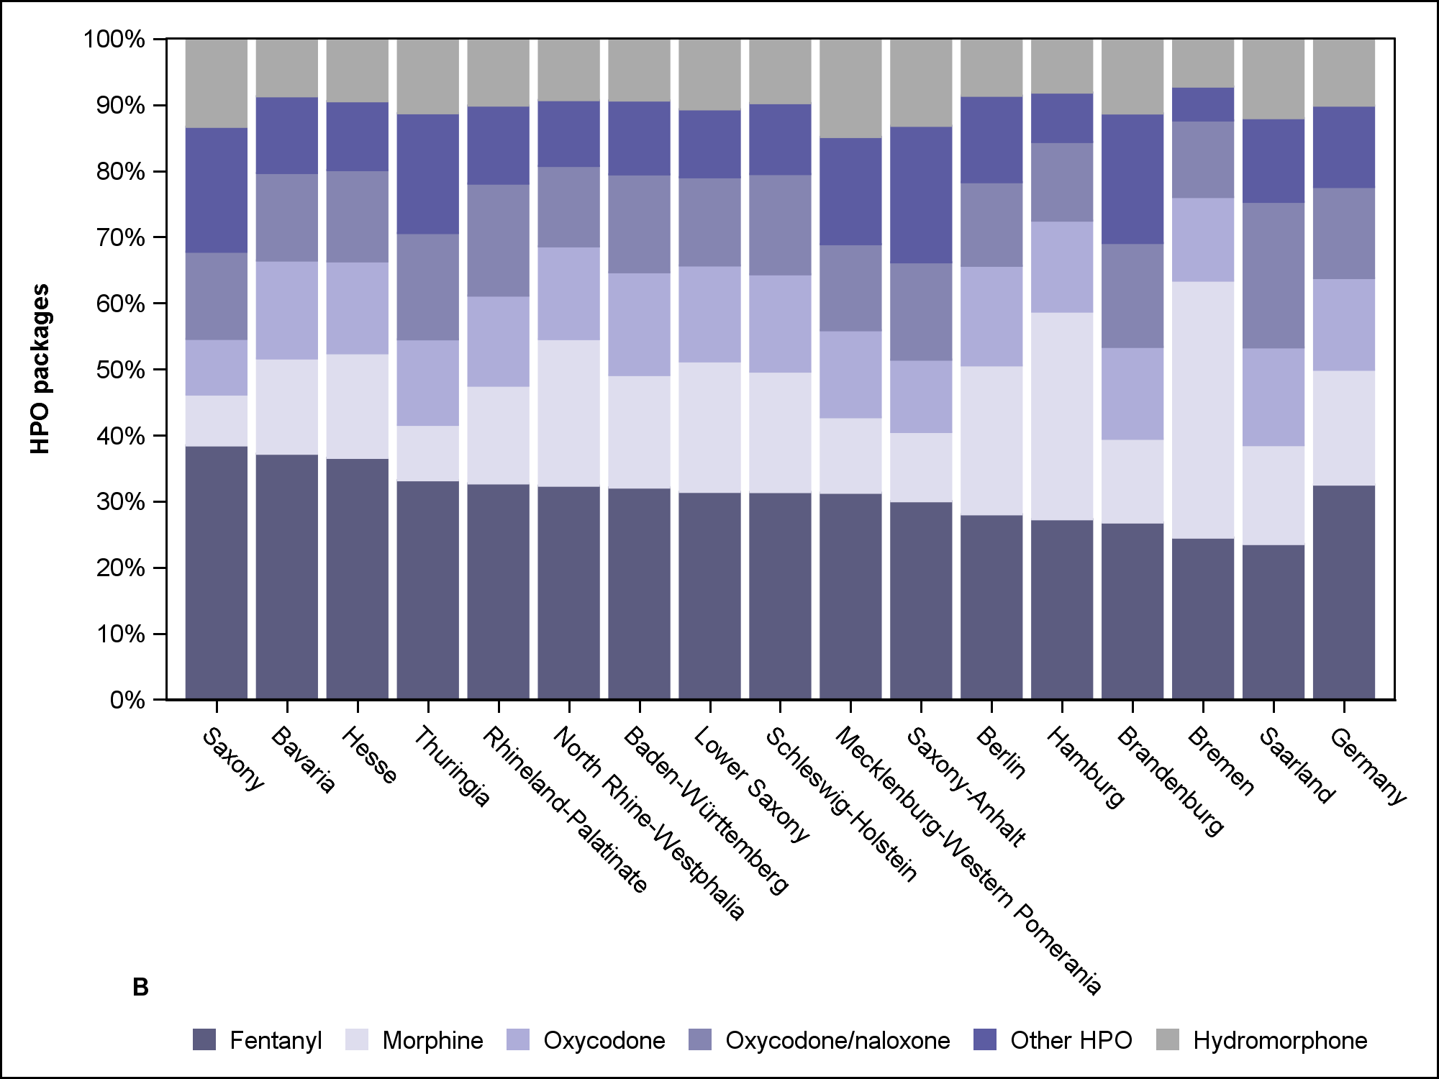
Supplemental Figure 3: LPO (A) and HPO (B) packages by federal state
HPO: high-potency opioid, LPO: low-potency opioid

