Supplementary Figure S1
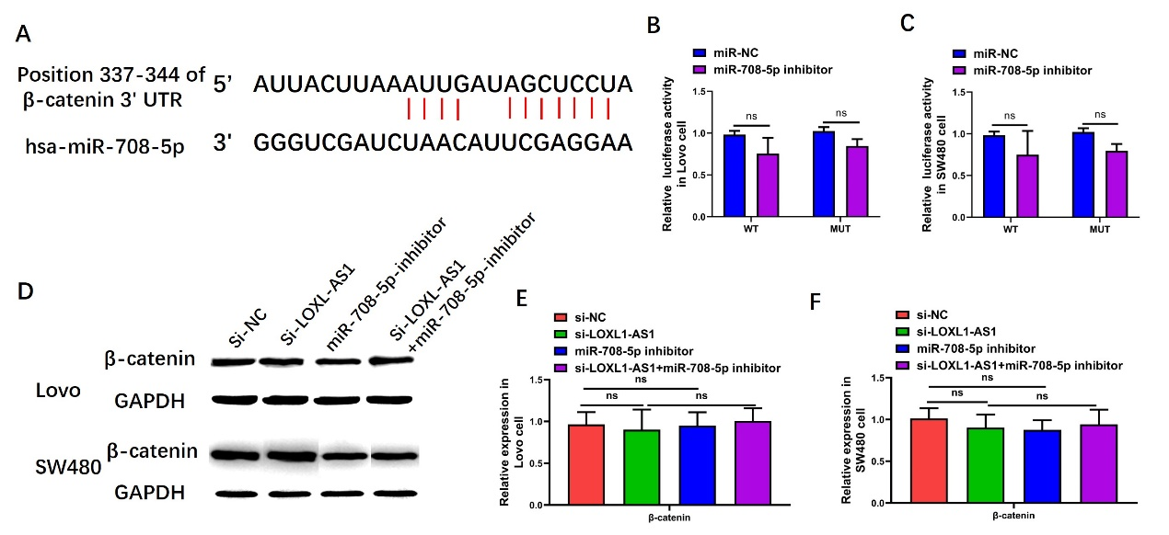
Supplementary Figure S1. β-catenin signaling was not the target pathway of miR‐708‐5p. (A) The binding site of miR‐708‐5p in the 3’UTR of β-catenin signaling was predicated by TargetScan. (B and C) Luciferase activity of the CD44 were detected by dual-luciferase reporter assay. (D, E and F) Expression of β-catenin signaling in Lovo and SW480 cells were examined by Western blot assays. Data are presented as mean ± SD of 3 independent experiments. ns, p > 0.05 versus the si-NC group. ns, p > 0.05 versus the si-LOXL1-AS1 group.

Supplementary Figure S2
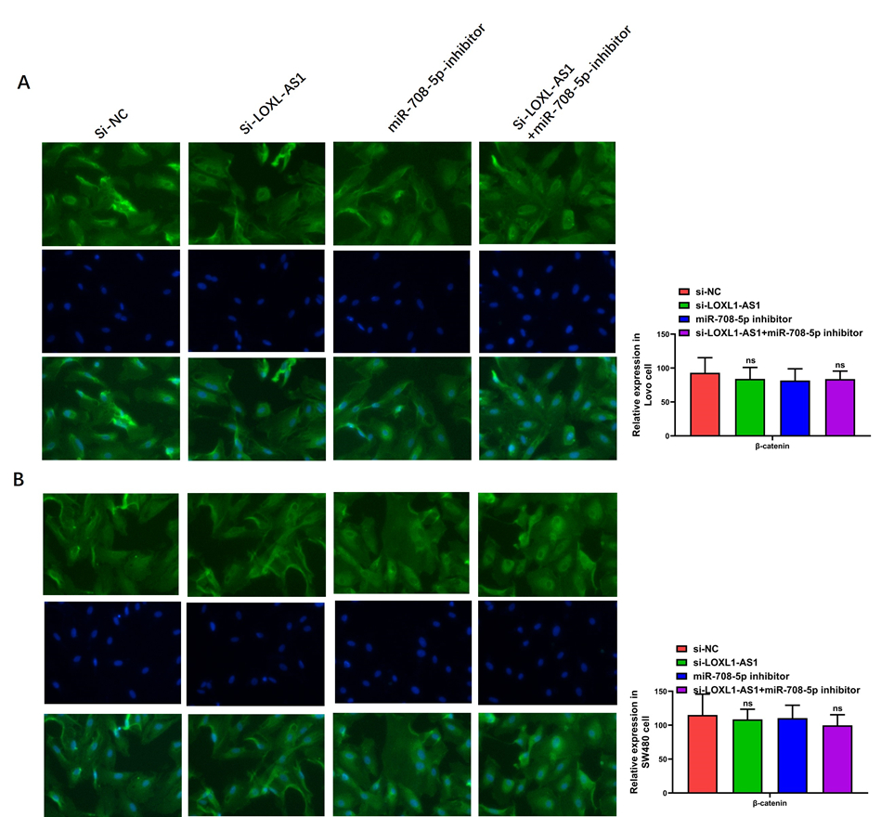
Supplementary Figure S2. β-catenin signaling was not the target pathway of miR‐708‐5p. (A and B) Luciferase activity of CD44 and EGFR in Lovo and SW480 cells were examined by immunofluorescence Assay. Representative images of the Lovo and SW480 cells by photomicrographs (400×). Data are presented as mean ± SD of 3 independent experiments. ns, p > 0.05 versus the si-NC group. ns, p > 0.05 versus the si-LOXL1-AS1 group.

