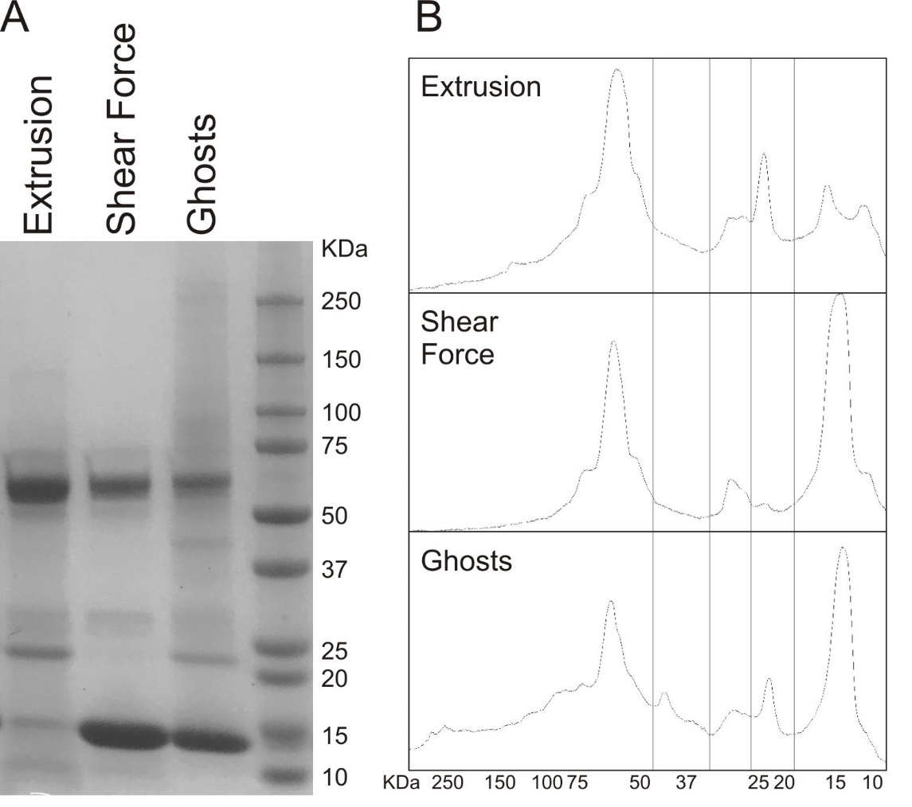
Supplementary Figure 1 Protein content. Total proteins extracted from ghosts and NEs produced by extrusion and shear force analyzed by SDS-PAGE (A). Total proteins, extracted with CelLytic M (Sigma-Aldrich Chemie GmbH) lysis buffer, were loaded on a polyacrylamide gel with 10-250 kDa protein standard (Bio-Rad Laboratories AG). The gel was stained with Comassie blue (Axon Lab AG, Baden-Dättwil, Switzerland) over night and relative semi-quantitative analysis (B) was performed by Image J version 1.46r for Windows (ImageJ Inc.).

