Supplementary figures legends
Supplementary figure S1
TN disturbed the apoptotic and anti-apoptotic protein in osteosarcoma cells. Cells were treated with various concentration of TN 10, 25, 50 and 100 nM alone or co-treated with NAC for 48h. The relative protein expression of Bax, p-cleaved-caspase, Bcl-xl and Bcl-2 were normalized by control group in MG63 (A-D) and U-2OS (E-H). The statistical difference *P＜0.05 compared with inter cells without NAC co-incubation.
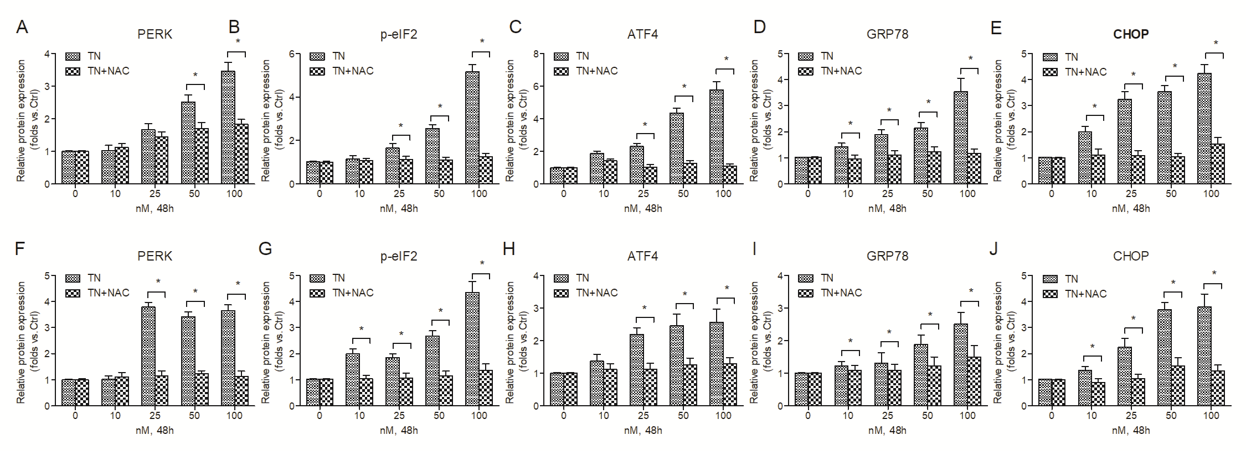
Supplementary figure S2
TN induced ROS-dependent ER-stress in osteosarcoma cells.
Cells were treated with various concentration of TN 10, 25, 50 and 100 nM alone or co-treated with NAC for 48h. The relative protein expression of ER-stress related proteins PERK, p-eIF2, GRP78, ATF4 and CHOP in both MG63 and U-2OS were normalized by control group in MG63 (A-E) and U-2OS (F-J). The statistical difference *P＜0.05 compared with inter cells without NAC co-incubation.
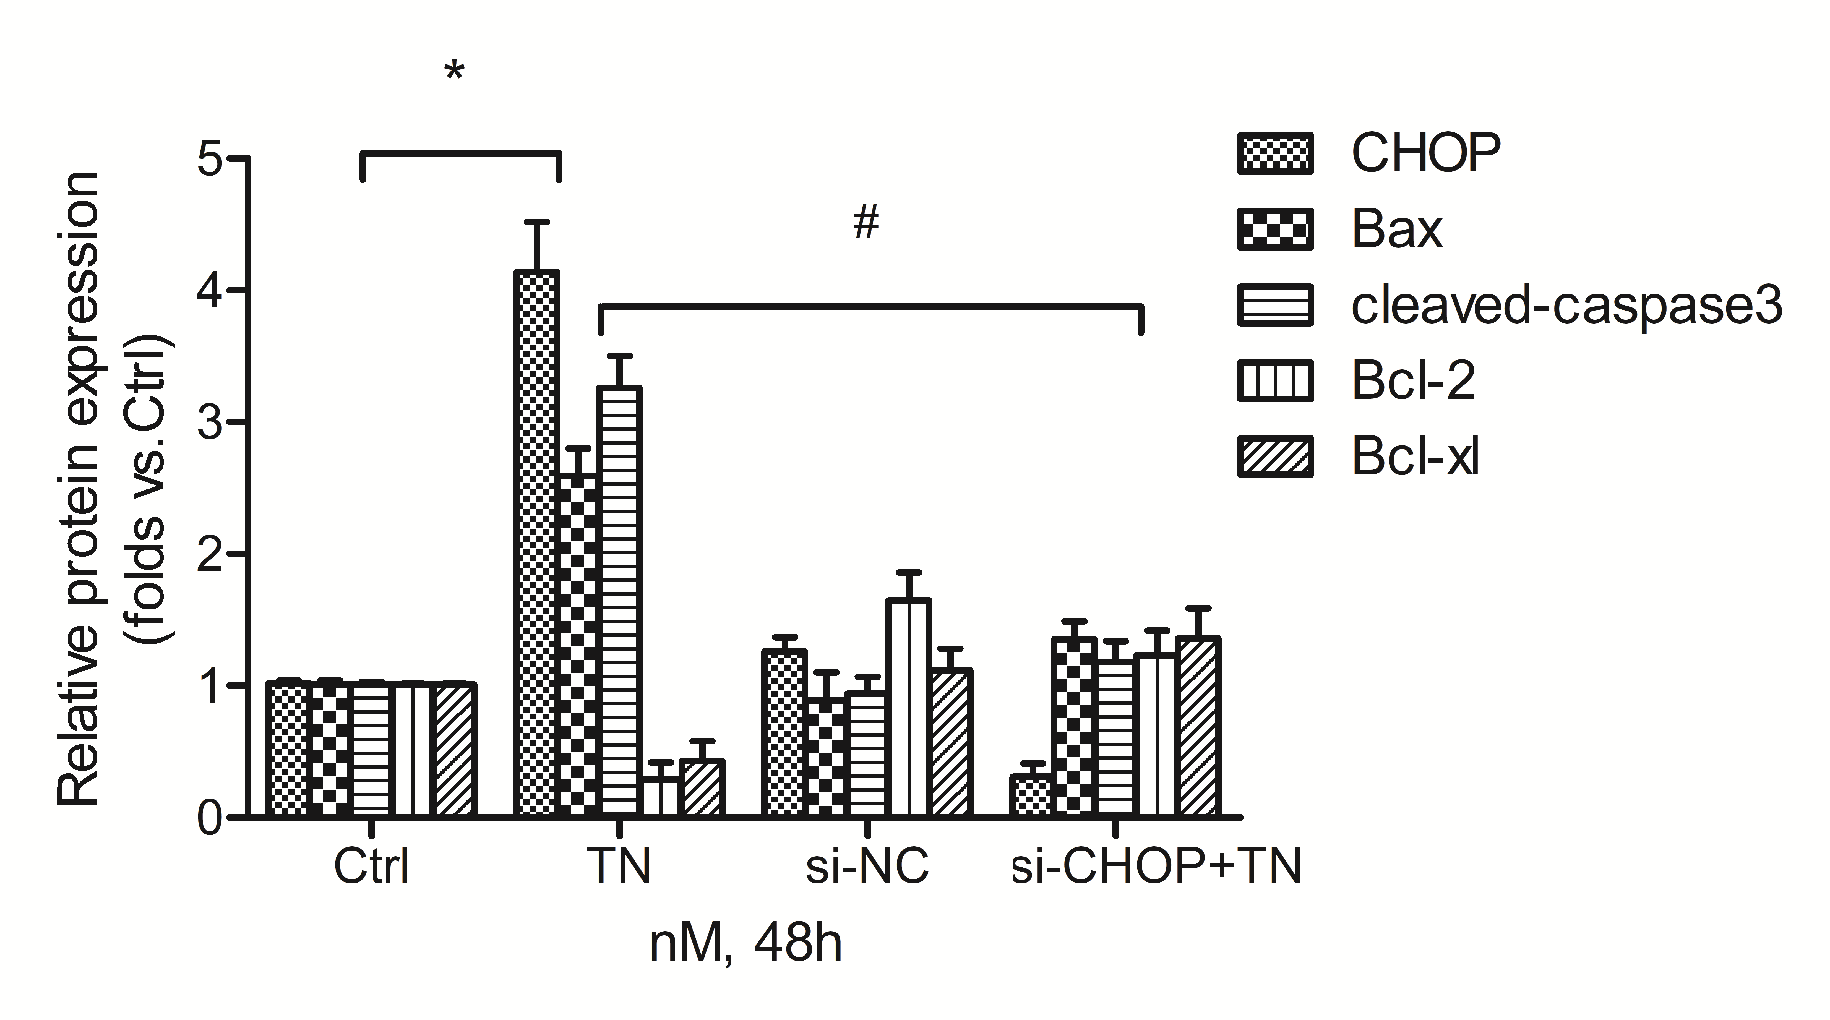
Supplementary figure S3
CHOP mediated apoptosis of MG63 cells induced by TN
MG63 cells transfected with CHOP si-RNA and then were exposed to TN for 48 h. The relative protein expression of CHOP, Bax, p-cleaved-caspase, Bcl-xl and Bcl-2 were normalized by control group in MG63 cells. The statistical difference *P＜0.05 compared with control group; The statistical difference #P＜0.05 compared with TN group.
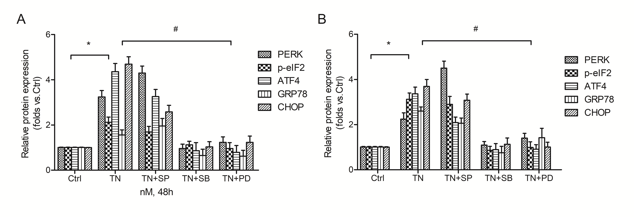
Supplementary figure S4
p38 and ERK inhibitors reversed ER stress of MG63 and U-2OS cells induced by TN
MG63 and U-2OS cells were treated with TN alone or co-treated with PD98059, SB203580 and SP600125 for 48h. (A and B) The relative protein expression of ER-stress related proteins PERK, p-eIF2, GRP78, ATF4 and CHOP in both MG63 and U-2OS were normalized by control group. The statistical difference *P＜0.05 compared with control group; The statistical difference #P＜0.05 compared with TN group.

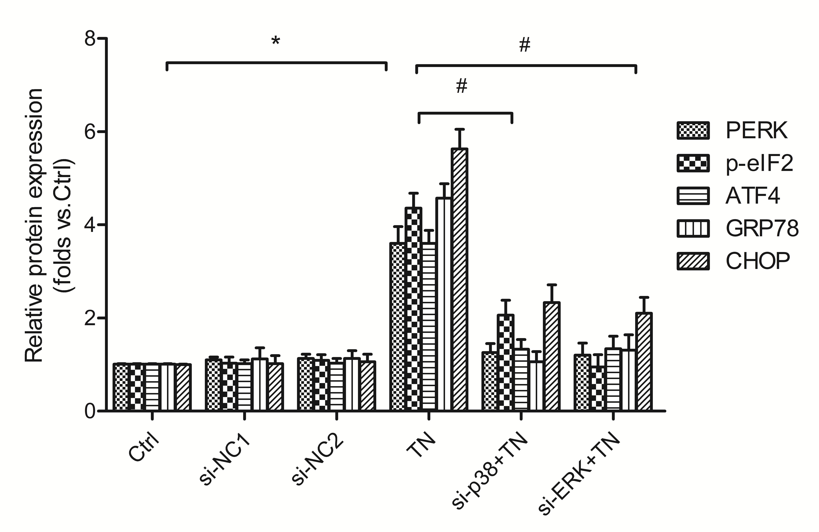Supplementary figure S5
p38 and ERK mediated ER stress of MG63 cells induced by TN
MG63 cells transfected with p38 or ERK si-RNA and then were exposed to TN for 48 h. The relative protein expression of PERK, p-eIF2, GRP78, ATF4 and CHOP were normalized by control group in MG63 cells. The statistical difference *P＜0.05 compared with control group; The statistical difference #P＜0.05 compared with TN group.

