Supplementary Materials

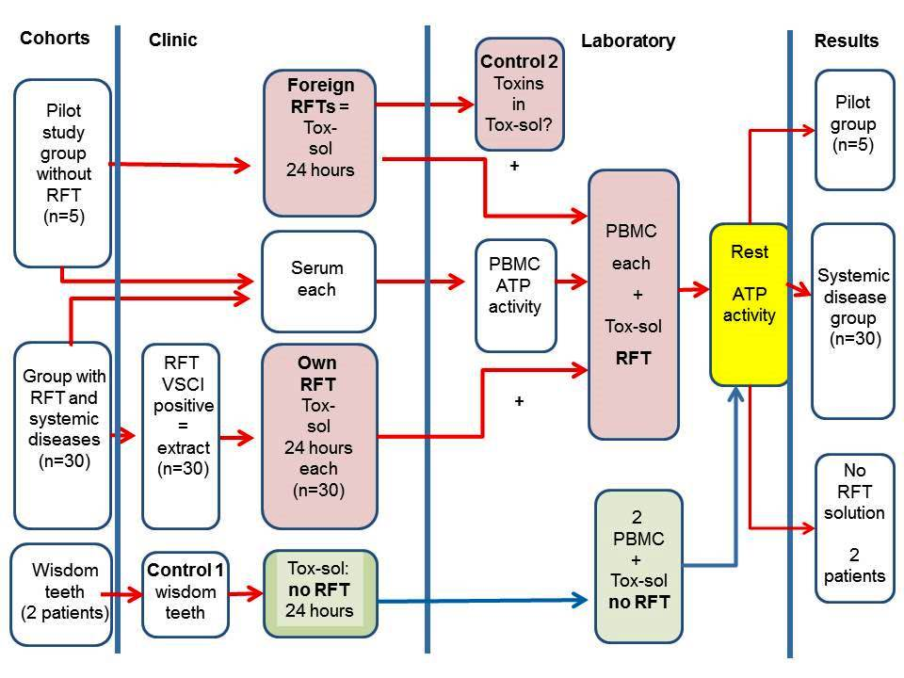
Figure S1. Overview of the study design.
Abbreviations: RFT, root-filled teeth; n, number; Tox-sol, toxin solution made by extracted RFT placed in an Aqua-Bidest solution at room temperature for 24 hours; VSCI, volatile sulfur compound indicator; PBMC, peripheral blood mononuclear cell; ATP activity, unrestricted mitochondrial membrane potential by Tox-sol.

