Table1 Antibiotic resistance information
Strain number | Levofloxacin | Imipenem | Tobramycin | Cefazolin | Cefoxitin | Ceftazidime | Cefotaxime | Cefoperazone Sulbactam | Cefepime | Tigecycline | Gentamicin | Piperacillin  tazobactam | Piperacillin | Meropenem | Ciprofloxacin | Sulfamethoxazole | Polymyxin | Aztreonam | Amikacin | Ceftazidime avibatan
A18 | R | R | R | R | R | R | R | R | R | R | R | R | R | R | R | R | R | R | R | R
15 | R | R | R | R | R | R | R | R | R | R | R | R | R | R | R | R | S | R | R | R
XY5 | R | R | R | R | R | R | R | R | R | R | R | R | R | R | R | R | R | R | R | R
FZ1 | R | R | R | R | R | R | R | R | R | R | R | R | R | R | R | R | S | R | R | R
21 | R | R | R | R | R | R | R | R | R | R | R | R | R | R | R | R | R | R | R | R
GZ20 | R | R | R | R | R | R | R | R | R | S | R | R | R | R | R | R | S | R | R | R
356 | R | R | R | R | R | R | R | R | R | R | R | R | R | R | R | R | S | R | S | R
A22 | R | R | R | R | R | R | R | R | R | R | R | R | R | R | R | R | R | R | R | R
GZ19 | R | R | R | R | R | R | R | R | R | S | R | R | R | R | R | R | S | R | R | R
JDZ25 | R | R | R | R | R | R | R | R | R | R | R | R | R | R | R | R | R | R | R | R
29 | R | R | R | R | R | R | R | S | R | S | R | R | R | R | R | R | S | R | R | R
31 | R | S | R | R | R | R | R | R | R | S | R | R | R | S | R | R | S | R | S | R
FZ2 | R | R | R | R | R | R | R | R | R | S | R | R | R | R | R | R | S | R | S | R
30 | R | R | R | R | R | R | R | R | R | S | R | R | R | S | R | R | S | R | R | R
16 | R | R | R | R | R | R | R | S | R | S | R | R | R | R | R | R | S | R | S | R
JJ10 | S | R | R | R | R | R | R | S | R | S | R | R | R | S | R | R | S | R | S | R
a | R | R | R | R | R | R | R | R | R | S | R | R | R | R | R | R | S | R | S | R
39 | R | R | R | R | R | R | R | R | R | R | R | R | R | R | R | R | S | R | S | R
1 | R | R | R | R | R | R | R | R | R | R | R | R | R | R | R | R | S | R | S | R
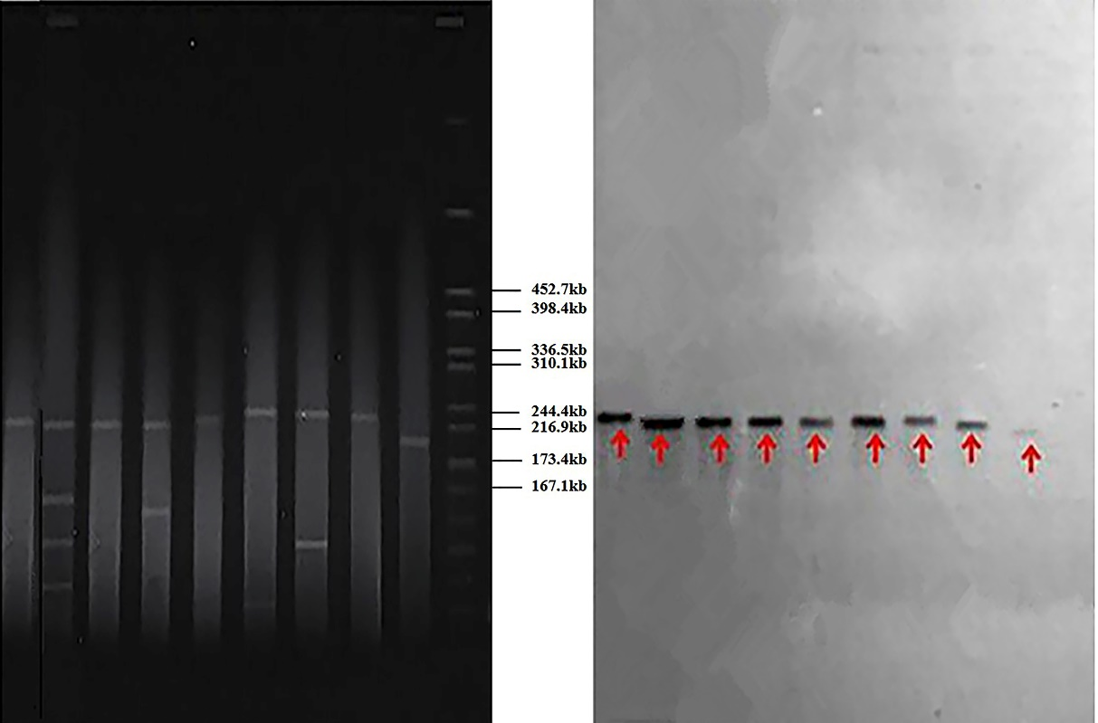

Supplementary figure 1. S1-PFGE and Southern hybridization of nine ceftazidime/avibactam-resistant hvKP strains in this study

