Supporting Information

Green One-step Synthesis of Medical Nanoagents for Advanced Radiation Therapy

Daniela Salado-Leza, Erika Porcel, Xiaomin Yang, Lenka Štefančíková, Marta Bolsa-Ferruz, Farah Savina, Diana Dragoe, Jean-Luc Guerquin-Kern, Ting-di Wu, Ryoichi Hirayama, Hynd Remita and Sandrine Lacombe*

The UV-Vis absorption spectra of precursors and mixed solutions, before and after irradiation, are shown in Figure S1. The NPs major and minor axis size distribution, and roundness analysis are presented in Figure S2. The survey XPS spectrum of the as-synthesized PtPEG NPs is displayed in Figure S3. Figure S4 is a schematic representation of the Pt^{II}-PEG conjugation shell formed prior to irradiation. An XPS data summary, listing the atomic core level, binding energy, peaks assignment and FWHM of precursors, controls and PtPEG NPs, is shown in Table S1.
Figure S1. (a) UV-vis absorption spectra of control solutions containing Pt(NH₃)₄Cl₂ (____) and PEG-OH (---) and samples consisting on diluted platinum containing solutions (10⁻³ mol.L⁻¹) before (____) and after (____) irradiation (optical path= 2 mm). Inserted pictures correspond to an aqueous solution containing Pt(NH₃)₄Cl₂ and PEG-OH before and after irradiation (10⁻² mol.L⁻¹, D= 100 kGy). (b) Absorption spectra of samples shown in (a) but in a wavelength range from 200 to 400 nm.
Figure S2. TEM micrographs analysis: size distribution of PtPEG NPs in terms of their (A) major_axis and (B) minor_axis. (C) Roundness parameter distribution.
Figure S3. Survey XPS spectrum of PtPEG NPs synthesized with a total gamma dose of 100 kGy.

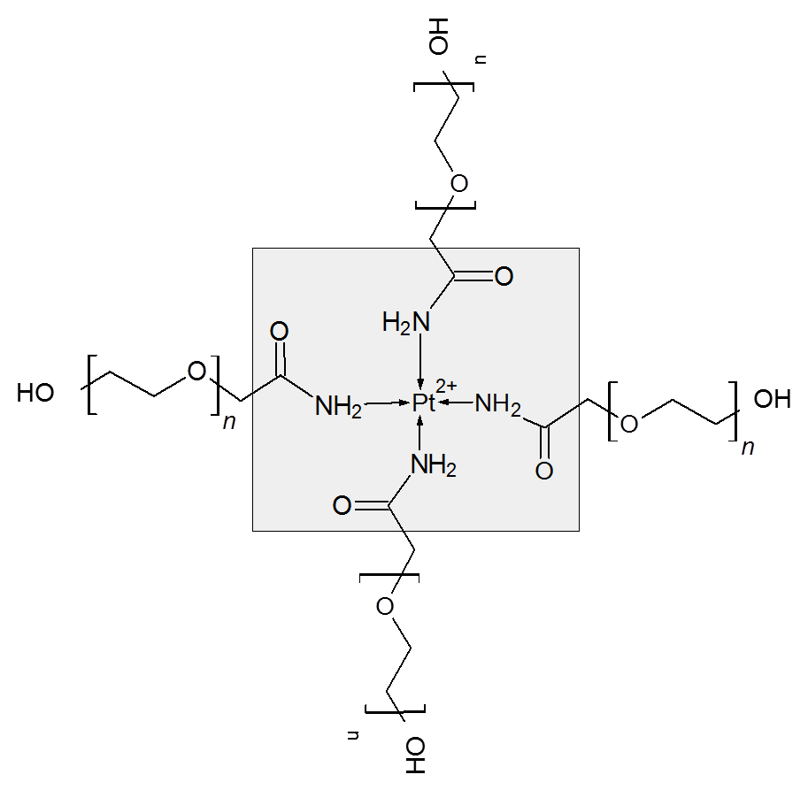
Figure S4. Pt^{II}-PEG conjugation shell before irradiation.

Table S1. XPS data summary: BE and FWHM of platinum, carbon, oxygen and nitrogen in different environments (Pt(NH₃)₄Cl₂, Pt⁰ solid, PEG-OH, and PtPEG NPs).

Compound | Atomic core level | BE (eV) | Assignment | FWHM (eV)
Pt (NH₃)₄ Cl₂ | Pt-4f_{7/2} | 73.0 | Pt^{II} | 1.7
Pt (NH₃)₄ Cl₂ | Pt-4f_{5/2} | 76.3 | Pt^{II} | 1.7
Pt (NH₃)₄ Cl₂ | N-1s | 400.2 | Pt-NH₃⁺ | 1.6
Pt⁰ solid | Pt-4f_{7/2} | 71.1 | Pt⁰ | 1.2
Pt⁰ solid | Pt-4f_{5/2} | 74.5 | Pt⁰ | 1.2
PEG-OH | C1s | 286.0 | C-O | 1.2
PEG-OH | C1s | 284.4 | C-C | 0.8
PEG-OH | O1s | 532.3 | C-O-H  C-O-C | 1.3
PtPEG NPs | Pt-4f_{7/2} surf. | 70.4 | Pt⁰ | 1.3
PtPEG NPs | Pt-4f_{5/2} surf. | 73.7 | Pt⁰ | 1.3
PtPEG NPs | Pt-4f_{7/2} core | 71.2 | Pt⁰ | 1.6
PtPEG NPs | Pt-4f_{5/2} core | 74.4 | Pt⁰ | 1.6
PtPEG NPs | C-1s | 286.0 | C-O  C-N  C=O | 1.3
PtPEG NPs | C-1s | 284.3 | C-C | 1.0
PtPEG NPs | O-1s | 532.3 | C-O-H  C-O-C  C=O | 1.3
PtPEG NPs | N-1s | 398.2 | Pt --- NH₂- | 3.9

