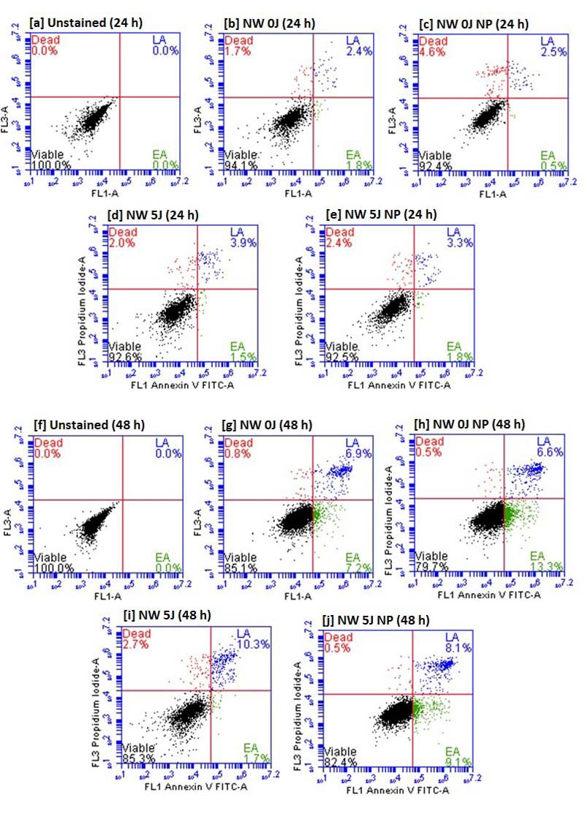
Figure S1 FITC Annexin V/PI apoptosis assay by flow cytometry. Non-irradiated normal wounded (NW 0J); non-irradiated, G-AgNP treated normal wounded (NW 0J NP); irradiated normal wounded (NW 5J); and irradiated, G-AgNP treated normal wounded (NW 5J NP) WS1 cells were analysed at 24 h (hours) [a, b, c, d and e] and 48 h [f, g, h, i, and j]. PI = Propidium iodide; G-AgNP = Green-synthesized silver nanoparticle.
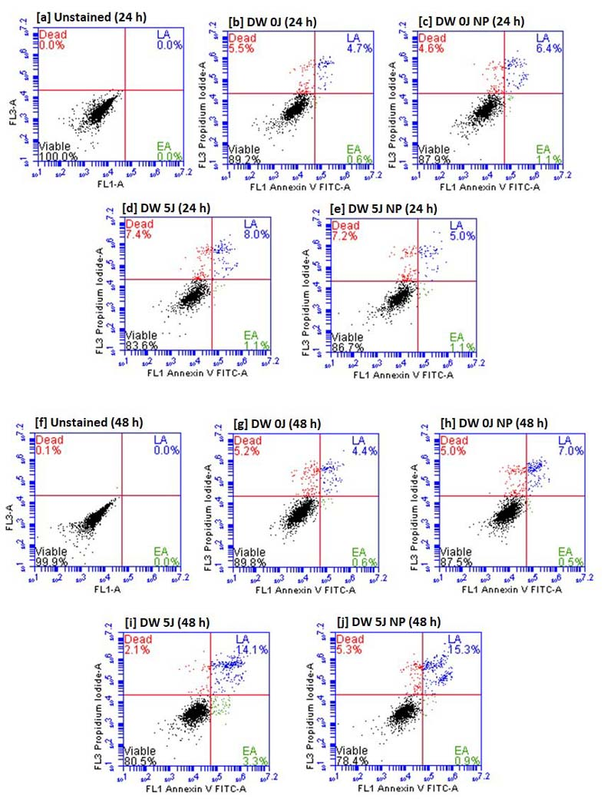
Figure S2 FITC Annexin V/PI apoptosis assay by flow cytometry. Non-irradiated diabetic wounded (DW 0J); non-irradiated G-AgNP treated diabetic wounded (DW 0J NP); irradiated diabetic wounded (DW 5J); and irradiated G-AgNP treated diabetic wounded (DW 5J NP) WS1 cells were analysed at 24 h (hours) [a, b, c, d and e] and 48 h [f, g, h, i, and j]. PI = Propidium iodide; G-AgNP = Green-synthesized silver nanoparticle.

