Title: Development and validation of a prognostic nomogram to predict the long-time prognosis in Non-B, Non-C Hepatocellular Carcinoma
Authors: Kongying Lin^{1*}, Qizhen Huang^{2*}, Yuting Huo^{3*}, Jianxing Zeng¹, Zongren Ding¹, Zhenwei Chen⁴, Pengfei Guo⁴, Yongyi Zeng¹†, Jingfeng Liu^{1,4}†

Figure S1: The flowchart for patient collection.
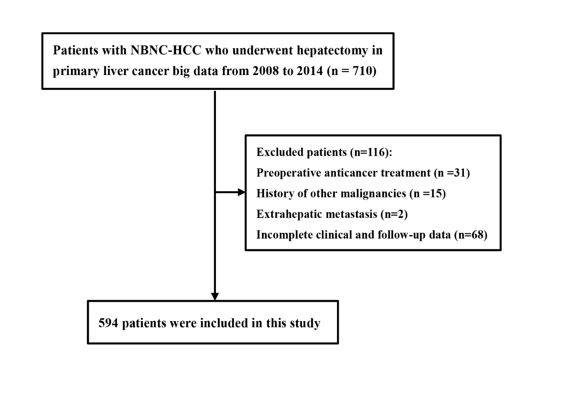
Table S1：tdAUC and 95%CI in the different prognostic models for OS.
Current model | Year rate | Training cohort (n=396) | Validation cohort (n=198)
 | 1-year | 0.775(0.702-0.847) | 0.789(0.710-0.868)
 | 2-year | 0.743(0.684-0.802) | 0.793(0.718-0.868)
Nomogram | 3-year | 0.736(0.681-0.791) | 0.751(0.670-0.832)
 | 4-year | 0.749(0.696-0.802) | 0.720(0.637-0.803)
 | 5-year | 0.743(0.683-0.803) | 0.686(0.594-0.779)
 | 1-year | 0.699(0.624-0.774) | 0.702(0.607-0.798)
 | 2-year | 0.670(0.611-0.729) | 0.692(0.610-0.773)
BCLC staging system | 3-year | 0.655(0.604-0.706) | 0.650(0.576-0.723)
 | 4-year | 0.680(0.634-0.726) | 0.643(0.575-0.710)
 | 5-year | 0.649(0.599-0.699) | 0.604(0.532-0.676)
 | 1-year | 0.722(0.649-0.795) | 0.723(0.637-0.809)
 | 2-year | 0.683(0.621-0.745) | 0.715(0.633-0.796)
AJCC staging system | 3-year | 0.690(0.635-0.744) | 0.672(0.593-0.752)
 | 4-year | 0.710(0.660-0.761) | 0.667(0.590-0.743)
 | 5-year | 0.675(0.617-0.733) | 0.626(0.539-0.713)
 | 1-year | 0.734(0.666-0.802) | 0.742(0.642-0.842)
 | 2-year | 0.688(0.626-0.750) | 0.728(0.639-0.818)
model of Zhang | 3-year | 0.693(0.636-0.750) | 0.673(0.580-0.765)
 | 4-year | 0.696(0.639-0.753) | 0.674(0.588-0.760)
 | 5-year | 0.690(0.624-0.755) | 0.638(0.542-0.734)
Abbreviations: BCLC, Barcelona Clinic Liver Cancer staging system; AJCC, American Joint Committee on Cancer.

