Supplementary material
Appendix 1. Description of registries with references
Appendix 2: Flowchart of the study cohorts
Appendix 3. Diagnostic codes
Appendix 4. Supplementary figures

Appendix 1
Data were extracted from the following registries:

The Danish Civil Registration System, established in 1967, was used to identify the members of the comparison cohorts¹ We also used this registry to extract data on sex, date of birth, immigration/emigration, loss to follow-up and death of all study participants.

The Danish National Patient Registry, established in 1977, records data on all patients discharged from non-psychiatric hospitals. Since 1994 it has also included data on all visits to outpatient departments and emergency clinics in Denmark.^{2,3} Diagnoses are coded by the attending physician according to the International Classification of Diseases, Eighth Revision [ICD-8] until 31 December 1993 and thereafter by the Tenth Revision [ICD-10].² From this registry we extracted clinical diagnoses of dementia, epilepsy, and diagnoses used to calculate Charlson Comorbidity Index scores.⁴

The Danish Cancer Registry was established in 1943. Since March 1987, reporting of data on all malignant diseases has been mandatory. Approximately 90% of cases in the registry are verified by histological examination. An extensive data validation program ensures the quality and completeness of registry data.⁵ From this registry, we extracted data on cancer diagnoses.

Statistics Denmark provided access to the following registries: (I) The Danish Educational Attainment Registry, from which we extracted data on educational achievement of members of the study cohorts.⁶ (II) The Employment Classification Module provided data on the employment status of study participants in each calendar year of the study period. It also provided data on receipt of disability pensions.⁷ (III) The housing module provided data on residency in a nursing home in each calendar year of the study period.⁸

Supplementary references
1. Schmidt M, Pedersen L, Sorensen HT. The Danish Civil Registration System as a tool in
epidemiology. Eur J Epidemiol 2014;29(8):541-9.
2. Lynge E, Sandegaard JL, Rebolj M. The Danish National Patient Register. Scand J Public Health
2011;39(7 Suppl):30-3.
3. Schmidt M, Schmidt SA, Sandegaard JL, Ehrenstein V, Pedersen L, Sorensen HT. The Danish
National Patient Registry: a review of content, data quality, and research potential. Clin Epidemiol
2015;7:449-90.
4. Charlson ME, Pompei P, Ales KL, MacKenzie CR. A new method of classifying prognostic
comorbidity in longitudinal studies: development and validation. J Chronic Dis 1987;40(5):373-83.
5. Storm HH, Michelsen EV, Clemmensen IH, Pihl J. The Danish Cancer Registry--history, content,
quality and use. Dan Med Bull 1997;44(5):535-9.
6. Jensen VM, Rasmussen AW. Danish Education Registers. Scand J Public Health 2011 ;39(7
Suppl):91-4.
7. Statistics Denmark. Employment Available from: URL:
https://www.dst.dk/en/Statistik/dokumentation/documentationofstatistics/income-statistics.
Accessed Marts 18 2019
8. Statistics Denmark. Census of Housing Available from: URL:
https://www.dst.dk/en/Statistik/dokumentation/documentationofstatistics/census-of-housing
Accessed Marts 18 2019

Appendix 2
Flow charts of study cohorts of patients with a history of herpes simplex type 1 or herpes simplex type 2 central nervous system infection (HSV-1 patients and HSV-2 patients) and their respective comparison cohorts

Appendix 3
Diagnostic codes used in the study

Cancers were coded according ICD-9/ICD-10 during the complete study period. Non-melanoma skin cancers were excluded:
Cancer excluding non-melanoma skin cancer: C00.0 to C43.9 and C45.0 to C99.9

Dementia: F0.0 to F03.0

Epilepsy: G40 to G41.9

Supplementary Figure 1. Cumulative incidence of dementia in patients with herpes simplex type 1 (HSV-1) central nervous system infection (full line) and in the comparison cohort (broken line)*.
*No HSV-2 patients were diagnosed with dementia after the date of study inclusion

Supplementary Figure 2. Proportion (%) with a hospital contact with a diagnosis of epilepsy in patients with Herpes simplex virus type 1 (HSV-1) and Herpes simplex virus type 2 (HSV-2) central nervous system infection (black) and in the comparison cohorts (white).
a) HSV-1 patients and comparison cohort members | b) HSV-2 patients and comparison cohort members
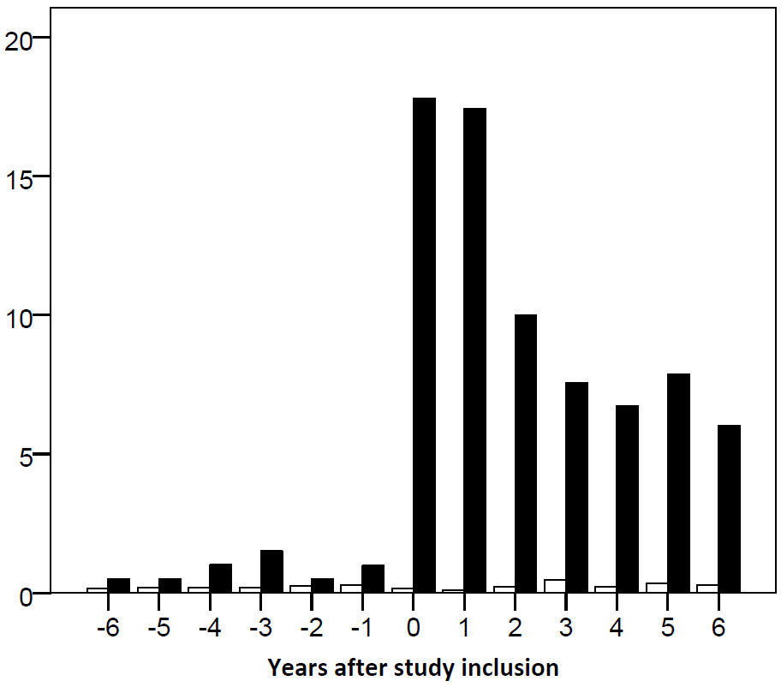 | 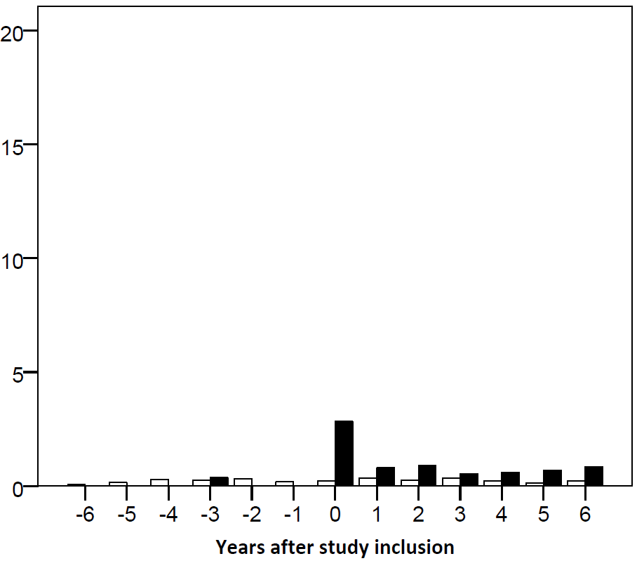

Supplementary Figure 3. Mean number of inpatient days/year and mean number of outpatient hospital visits/year in patients with Herpes simplex virus type 1 (HSV-1) and Herpes simplex virus type 2 (HSV-2) central nervous system infection (black) and in the comparison cohorts (white).
a) Mean number of inpatient days/year in HSV-1 patients and comparison cohort members | b) Mean number of inpatient days/year in HSV-2 patients and comparison cohort members
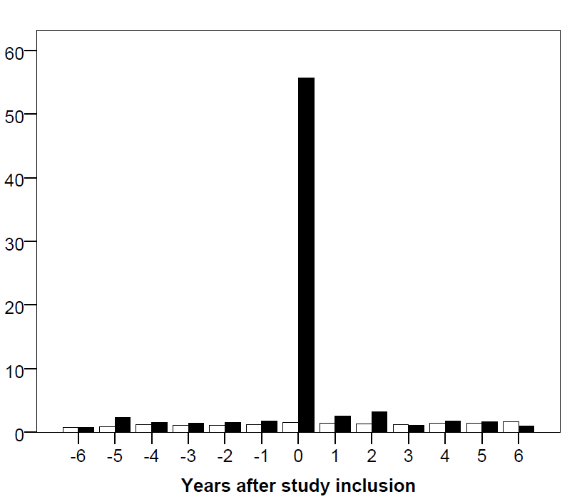
c) Mean number of outpatient visits/year in HSV-1 patients and comparison cohort members | d) Mean number of outpatient visits/year in HSV-2 patients and comparison cohort members
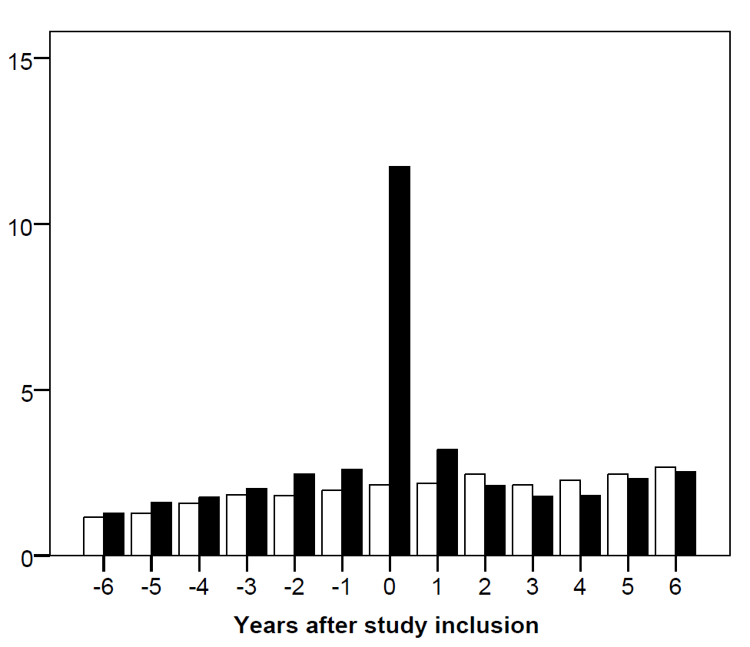

Supplementary Figure 4. Proportion (%) visiting a department of neurology in patients with Herpes simplex virus type 1 (HSV-1) and Herpes simplex virus type 2 (HSV-2) central nervous system infection (black) and in the comparison cohorts (white).
a) HSV-1 patients and comparison cohort members | b) HSV-2 patients and comparison cohort members
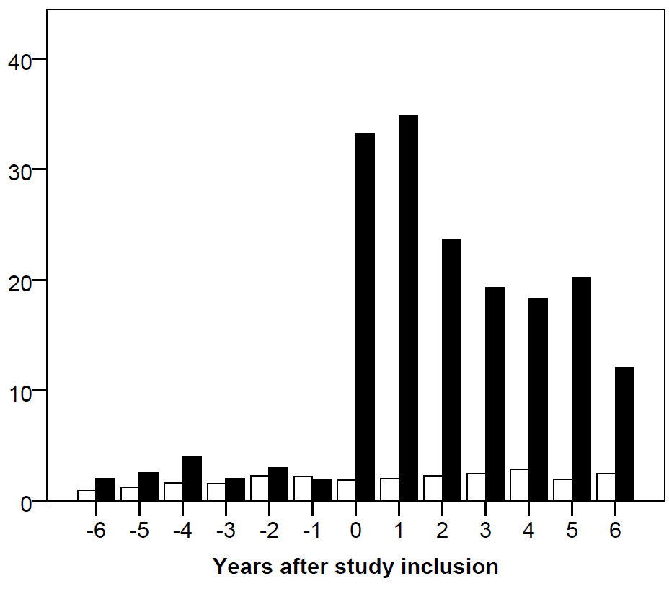 | 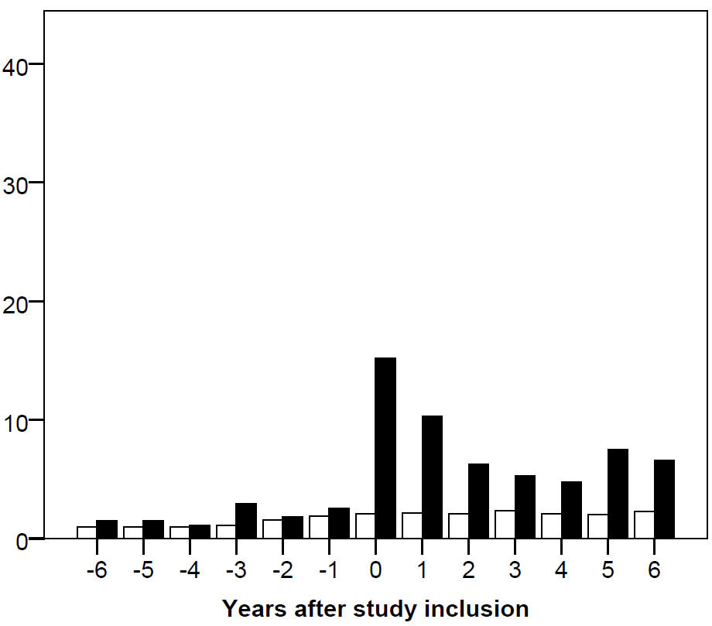

Supplementary Figure 5. Proportion employed and number of sick leave days in patients with Herpes simplex virus type 1 (HSV-1) and Herpes simplex virus type 2 (HSV-2) central nervous system infection (black) and members of the population comparison cohorts (white).
a) Proportion employed (%) in HSV-1 patients and comparison cohort members | b) Proportion employed (%) in HSV-2 patients and comparison cohort members
c) Mean number of sick leave days/year in HSV-1 patients and comparison cohort members | d) Mean number of sick leave days/year in HSV-2 patients and comparison cohort members

Supplementary Figure 6. Proportion married and proportion divorced in patients with Herpes simplex virus type 1 (HSV-1) and Herpes simplex virus type 2 (HSV-2) central nervous system infection (black) and members of the population comparison cohorts (white).
a) Proportion married (%) in HSV-1 patients and comparison cohort members | b) Proportion married (%) in HSV-2 patients and comparison cohort members
c) Proportion divorced (%) in HSV-1 patients and comparison cohort members | d) Proportion divorced (%) in HSV-2 patients and comparison cohort members

