Supplementary data
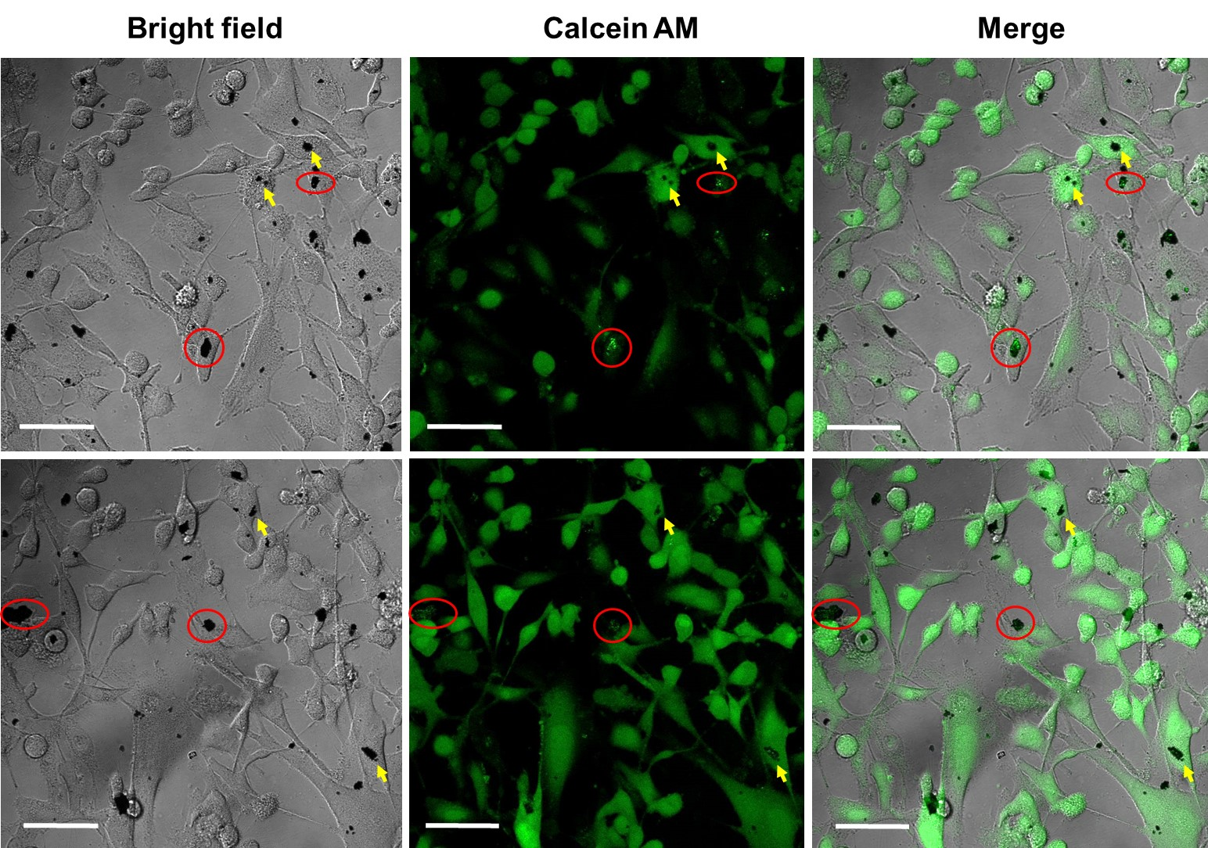Figure S1. Cells-nanocomposite interaction. Fluorescent confocal micrographs of HeLa cells with the nanocomposite pointed with yellow arrows for dark aggregates and rounded in red for intense fluorescent deposits. Scale bar is 5 µm.
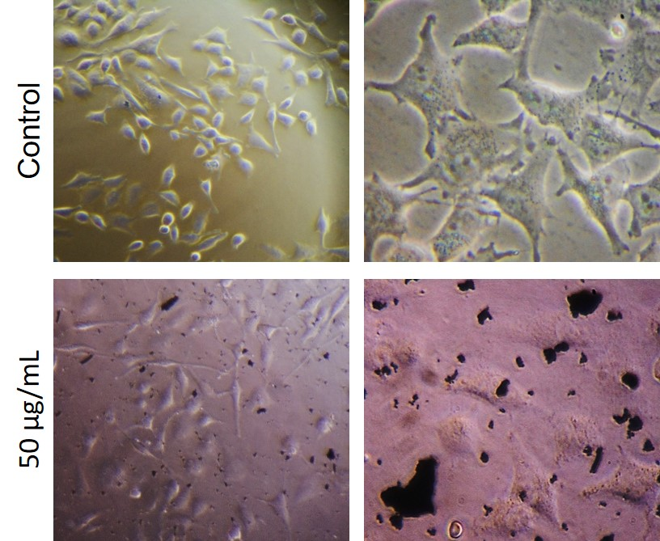
Figure S2. Cell morphology under graphene treatment. Morphology of HeLa cells observed by optical microscope under rGO-Fe₃O₄ treatment. Left image was observed at 10x and right image at 40x.

