Supplementary Table 1 Histology and staging of the malignant nodules.

Variables | All 1813 lung cancers |  | Sampled 1008 lung cancers
Variables | N | Percentage | N | Percentage
Histology
Adenocarcinoma | 1685 | 92.9 | 954 | 94.6
Squamous carcinoma | 105 | 5.8 | 44 | 4.4
Small-cell lung cancer | 9 | 0.5 | 2 | 0.2
Others | 14 | 0.8 | 8 | 0.8
Staging*
ⅠA | 1332 | 73.5 | 758 | 75.2
ⅠB | 373 | 20.6 | 186 | 18.5
ⅡA | 40 | 2.2 | 20 | 2.0
ⅡB | 14 | 0.8 | 8 | 0.8
ⅢA | 31 | 1.7 | 24 | 2.4
ⅢB | 6 | 0.3 | 3 | 0.3
ⅣA | 9 | 0.5 | 4 | 0.4
ⅣB | 8 | 0.4 | 5 | 0.5
* IASLC (International Association for the Study of Lung Cancer) 8th edition lung cancer staging system

Supplementary Table 2 Evaluating the predictive performance of four models by resampling.

Group | Model developing (N=1008) * |  | dataset 1 (N=1000) |  | dataset 2 (N=800) |  | dataset 3 (N=600)
Group | Number B/M | AUC | Number B/M | AUC | Number B/M | AUC | Number B/M | AUC
Subsolid nodule≤15mm | 93/174 | 0.83 (0.78-0.88) | 126/242 | 0.72 (0.66-0.79) | 108/192 | 0.71 (0.65-0.77) | 80/155 | 0.73 (0.66-0.80)
Subsolid nodule between 15~30mm | 21/157 | 0.84 (0.74-0.93) | 31/198 | 0.71 (0.62-0.81) | 25/168 | 0.70 (0.58-0.77) | 16/136 | 0.72 (0.59-0.85)
Solid nodule≤15mm | 246/100 | 0.82 (0.77-0.87) | 356/128 | 0.79 (0.75-0.84) | 286/111 | 0.77 (0.72-0.82) | 202/77 | 0.75 (0.70-0.82)
Solid nodule between 15~30mm | 346/275 | 0.82 (0.79-0.85) | 487/432 | 0.80 (0.77-0.83) | 381/329 | 0.80 (0.77-0.84) | 302/232 | 0.79 (0.76-0.83)
* The performance of four models in training group
Note：In order, 1000, 800, and 600 cases were randomly selected from 1008 benign and 1813 malignant nodules (sampling with replacement) to form dataset 1, dataset 2 and dataset 3, respectively.

Risk calculation of four models: probability = e^{x} / (1 + e^{x} )

For subsolid nodules ≤15 mm (outcome: benign)
X= 14.586 - 0.033*age + 1.190*female - 0.280*diameter - 0.988*upper lobe - 0.209*spiculation - 0.026*RV/TLC - 0.614*PT - 0.194*CYFRA21-1 - 0.157*NSE

For subsolid nodule between 15~30mm (outcome: benign)
X= 2.137 - 0.083*age + 1.143*female + 0.608*smoking - 0.030*RV/TLC + 0.077*APTT - 0.096*NSE

For solid nodules ≤15 mm (outcome: malignant)
X= -10.168 + 0.033*age + 0.047*diameter + 0.917*irregularity + 1.108*spiculation - 0.134*lobulation - 0.001*FEV1% + 0.020*FEV1/FVC + 0.057*MMEF% - 0.038*V50% - 0.044*V25% + 0.029*RV/TLC + 0.591*lymphocyte + 0.274*PT + 0.298*CEA

For solid nodule between 15~30mm (outcome: malignant)
X= -4.278 - 0.761*female + 0.042* age + 1.006*history of malignancy + 1.054*irregularity + 0.730*spiculation + 0.166*lobulation - 0.002*FEV1/FVC - 0.019*MMEF% + 0.016* V50% - 0.002*V25% + 0.054*RV/TLC + 0.0002*DLCO% - 0.295*RCC - 0.046*APTT + 0.132* CEA + 0.274* CYFRA21-1 + 0.046* NSE

Abbreviations: PT, prothrombin time; APTT, activated partial thromboplastin time; CEA, carcinoembryonic antigen; CYFRA21-1, cytokeratin 19 fragment; NSE, neuron specific enolase; RCC, red cell count; FEV1, forced expiratory volume in 1 second; FEV1/FVC; the ratio of FEV1 to forced vital capacity (FVC); MMEF, maximal mid-expiratory flow; V50, the 50% of FVC; V25, the 25% of FVC; RV/TLC, the ratio of residual volume to total lung capacity; DLCO, diffusing capacity for carbon monoxide.

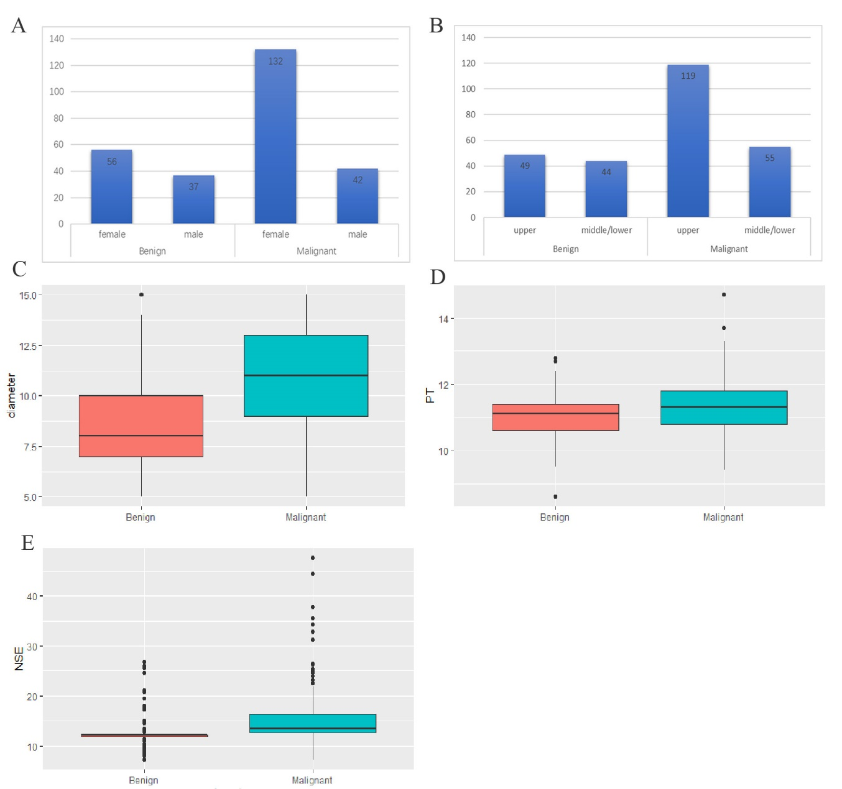

Supplementary Figure 1 Independent predictors for subsolid nodule≤15 mm

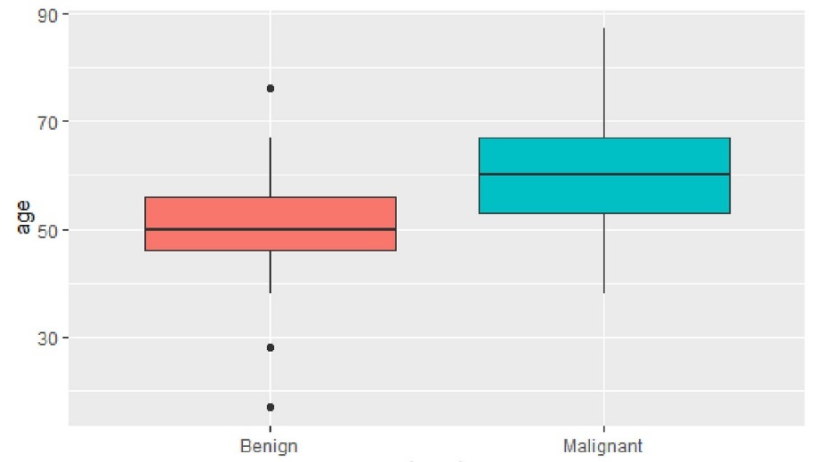

Supplementary Figure 2 Independent predictors for subsolid nodules between 15~30 mm

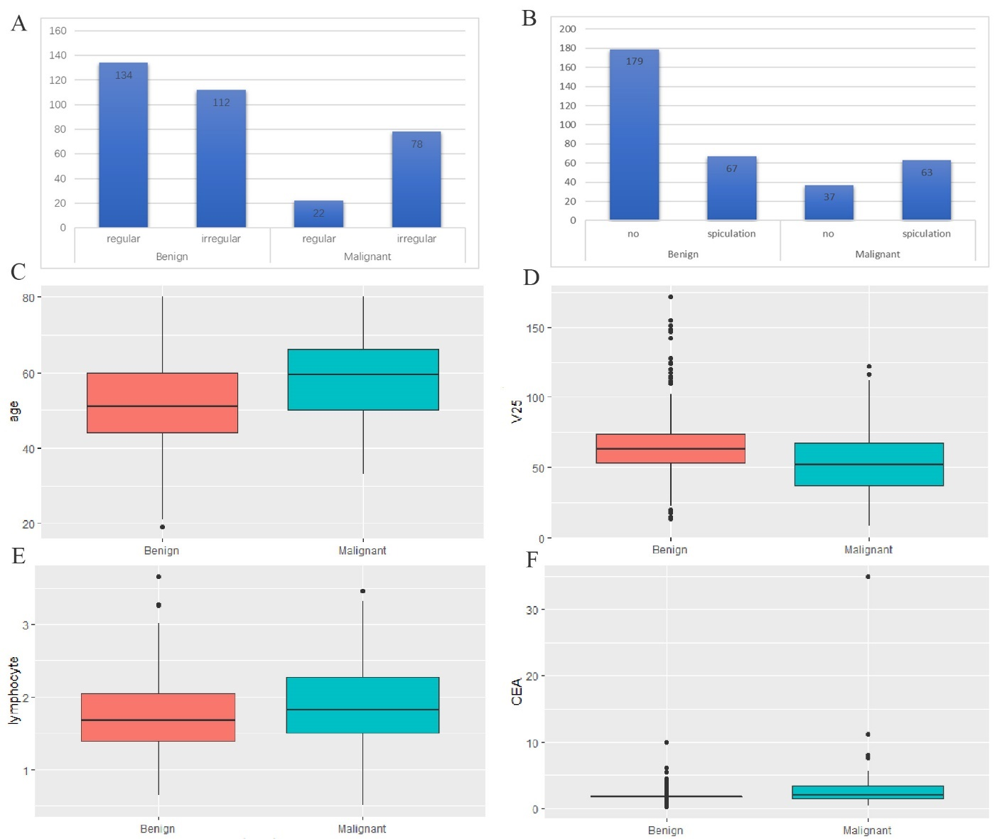

Supplementary Figure 3 Independent predictors for solid nodules≤15 mm

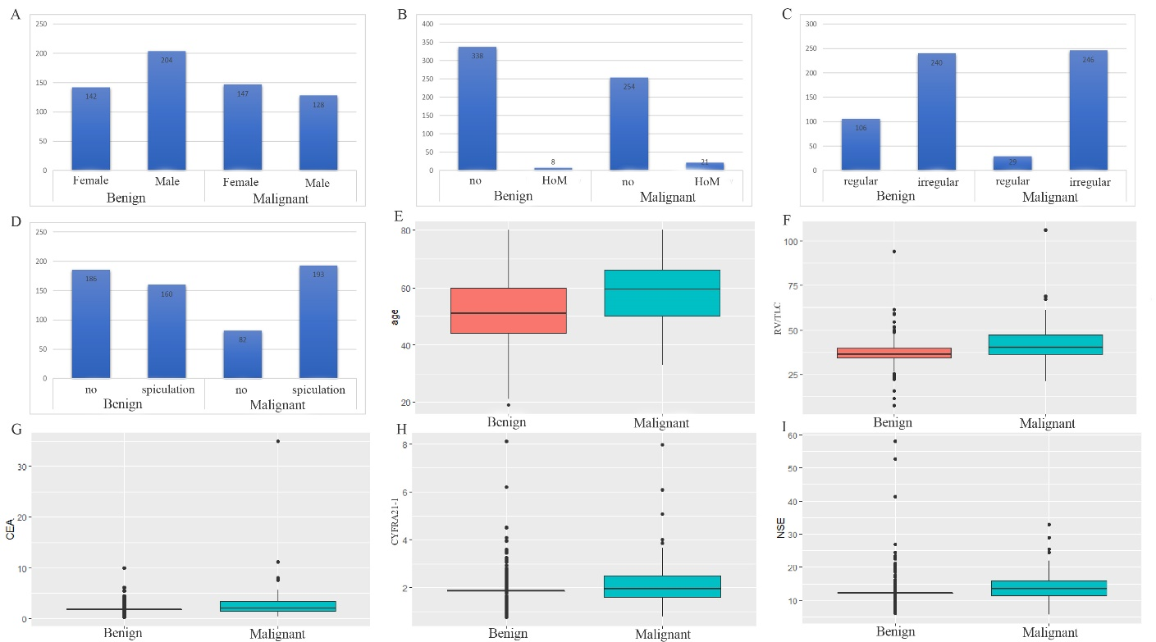

Supplementary Figure 4 Independent predictors for solid nodules between 15~30 mm. HoM, history of malignancy

