Supplemental files
Guiding appropriate timing of laser irradiation by polymeric micelles for maximizing chemo-photodynamic therapy

Figure S1. ¹H NMR spectrum of Ce6, DTPA, chitosan and Ce6-CSPD.

Figure S2. FT-IR images of Ce6, DOX and Ce6-CSPD/DOX.

Figure S3. UV−vis spectrum of Ce6 and Ce6-CSPD.

Figure S4. SEM images of Ce6-CSPD and Ce6-CSPD/DOX. Bar is 100nm.

Figure S5. UV spectrum of DOX.

Figure S6. Fluorescence intensity of DOX after incubating Ce6-CSPD/DOX in pH 7.4 PBS (3% FBS) a) without GSH and b) with 10mM GSH. c) Semi-quantitative analysis of fluorescence intensity changes by imageJ software.

Figure S7. Fluorescence images of Ce6-CSPD/DOX incubated with different medium for different time. The images were observed via Maestro in Vivo Imaging System (CRI Inc., Woburn, MA) and semi-quantitative analyzed by imageJ software.

Figure S8. Accumulated DOX releasing profile of Ce6-CSPD/DOX and DOX at various GSH.

Figure S9. Fluorescence intensity of internalized micelles and the recovered Ce6 on 4T1 cells.

Figure S10. Fluorescence intensity of internalized micelles and the recovered Ce6 on MCF-7 cells.

Figure S11. Cytotoxicity evaluation of Ce6-CSPD against 4T1 cells without/with 660nm laser irradiation in vitro.

Figure 12. Semi-quantitative analysis of fluorescence intensity of DOX in Ce6-CSPD/DOX for different time in major organs.

Figure S13. The fluorescence of DOX from Ce6-CSPD/DOX ex vivo at a) 2h and b) 12h post-injection.

Figure S14. Weight of tumor masses after different drugs treatment.

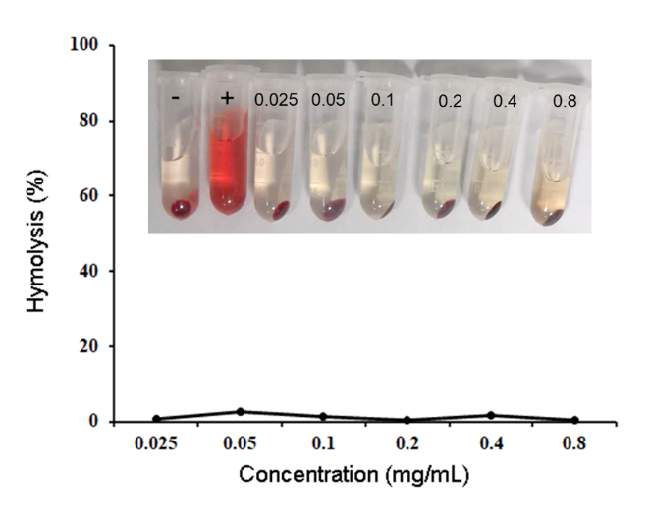
Figure S15. Hemolysis of Ce6-CSPD nano-agent after incubation with red blood cells at various concentration for 2h, using saline solution as a negative and deionized water as a positive control, respectively.

