Neuropsychiatrists’ understanding of conversion disorder survey
- How old are you?

  - <30
  - 31-40
  - 41-50
  - 51-60
  - >61

- What is your gender?

  - Male
  - Female

- What specialty are you employed in?

  - Liaison psychiatry
  - Neuropsychiatry
  - Other psychiatry
  - Neurology
  - Other physician
  - I am not a medical doctor

- How many years have you spent working in psychiatry?
- How many months have you spend working in neurology?
- Have you had any psychodynamic training, beyond the minimum college requirement (i.e. one ‘long case’)?

  - Yes
  - No

- Approximately how many new patients with conversion disorder do you see in a year?
- Briefly describe a memorable case, if you have time.
- In which country did you principally train?
- Do you think there are important differences in the clinical presentation of conversion disorder in different cultures?

  - Yes
  - No

- Do you think there are substantial differences in how frequently conversion disorder presents in different cultures?

  - Yes
  - No

- Do you think you have a sufficient model for conversion disorder in general?

  - Yes
  - No

- Do you think with enough time and a compliant patient, a psychosocial explanation could be found for a case of conversion disorder?

  - Never
  - Rarely
  - Often
  - Usually
  - Always

- How often can you find a psychosocial explanation for a patient’s symptoms in practice?

  - Never
  - Rarely
  - Often
  - Usually
  - Always

- Do you see the aetiology of conversion disorder as involving (pick one):

  - Disordered functioning of the nervous system
  - Psychogenesis
  - Disordered functioning of the nervous system plus psychogenesis
  - Feigning
  - Unknown or other

- If a referring neurologist is sure that a patient has conversion disorder but you cannot explain their symptoms, would you make the diagnosis?

  - Yes
  - Depends on the neurologist
  - No

- If a referring neurologist is not sure of the diagnosis, but you can find and explanation, would you make the diagnosis?

  - Yes
  - Depends on the neurologist
  - No

- How often do you send conversion disorder referrals back to neurologists because you do not think the patient has a psychiatric disorder?

  - Never
  - Rarely
  - Often
  - Very often

- How often do you diagnose a conversion disorder referral with a different psychiatric disorder instead?

  - Never
  - Rarely
  - Often
  - Very often

- What role do psychiatrists have in the diagnosis of conversion disorder?

  - Not helpful
  - Helpful, but not essential
  - Essential

- Would you be confident in diagnosing a case of conversion disorder without assessment by a neurologist?

  - Never
  - Rarely
  - Often
  - Usually
  - Always

- Please choose the models you employ in understanding conversion disorder yourself (choose only those that you employ, ranked in terms of importance with 1 = most important).

  - Abnormal illness behaviour
  - Brain dysfunction
  - Conversion
  - Deception
  - Dissociation
  - Psychogenesis
  - Self-deception
  - Symptom amplification
  - Symptom misinterpretation
  - Anxiety or panic
  - Reaction to stress
  - Disturbed attention
  - Other

    - If you chose the “other” option in the previous question, please specify what model you employ.
- Please choose the models you employ in explaining conversion disorder to patients (choose only those that you employ, ranked in terms of importance with 1 = most important).

  - Abnormal illness behaviour
  - Brain dysfunction
  - Conversion
  - Deception
  - Dissociation
  - Psychogenesis
  - Self-deception
  - Symptom amplification
  - Symptom misinterpretation
  - Anxiety or panic
  - Reaction to stress
  - Disturbed attention
  - Other

    - If you chose the “other” option in the previous question, please specify what model you employ.
- Do you copy letters about your conversion patients to them?

  - Never
  - Rarely
  - Often
  - Usually
  - Always

- What proportion of your patients referred with unexplained neurological symptoms do you think are feigning?

  - None
  - A few
  - Many
  - Most or all of them

- Which of the following best depicts the relationship between conversion and feigning in your opinion (1-4 from left to right)?
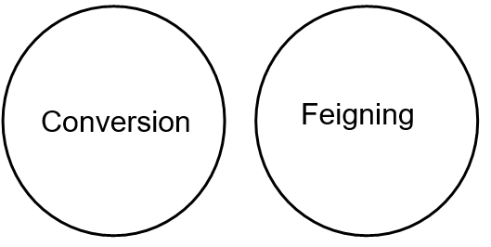
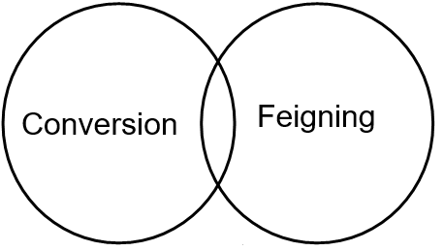
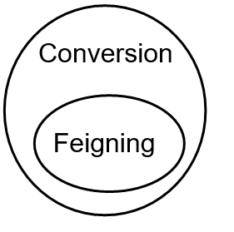
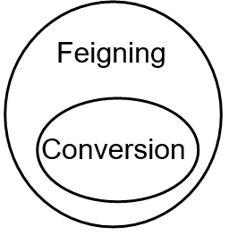

  - Option 1
  - Option 2
  - Option 3
  - Option 4

- Is it important to distinguish feigning from conversion disorder?

  - Yes
  - No

- Do you talk about feigning with patients with unexplained neurology if you suspect it?

  - Never
  - Rarely
  - Usually
  - Always

- Do you talk about feigning with patients with unexplained neurology if you are sure of it?

  - Never
  - Rarely
  - Usually
  - Always

- Do you talk about feigning with patients with unexplained neurology when you do not suspect it?

  - Never
  - Rarely
  - Usually
  - Always

- Who should address feigning in your patient? (choose all that apply)

  - Me
  - General practitioner
  - Neurologist
  - Police or some other agency
  - No-one

- Did you have exposure to conversion disorder, or a condition which you consider similar, prior to studying medicine?

  - In myself
  - A friend
  - A family member
  - No

    - If you chose the ‘family member’ option in the previous question, please specify the relative.
- What is your preferred term for use with colleagues? (choose only those that you use, ranked in terms of importance with 1 = most important)

  - Conversion disorder
  - Dissociative disorder
  - Functional neurological disorder
  - Medically unexplained
  - Psychogenic disorder
  - Other

    - If you chose the “other” option in the previous question, please specify what term you use.
- What is your preferred term for use with patients? (choose only those that you use, ranked in terms of importance with 1 = most important)

  - Conversion disorder
  - Dissociative disorder
  - Functional neurological disorder
  - Medically unexplained
  - Psychogenic disorder
  - Other

    - If you chose the “other” option in the previous question, please specify what term you use.
- What role do psychiatrists have in the management of conversion disorder?

  - Not helpful
  - Helpful, but not essential
  - Essential

- Have you ever treated anyone for conversion disorder who was:

  - A Paralympian
  - An aspiring Paralympian
  - No

- Do you understand conversion disorder to be neurological, in the same way that multiple sclerosis is neurological?

  - Yes
  - Not now, but I expect to one day
  - No, and I expect I never will

