Supporting Information

Tailoring nanoparticle-biofilm interactions to increase efficacy of antimicrobial agents against Staphylococcus aureus

Stephanie Fulaz1‡, Henry Devlin1‡, Stefania Vitale1, Laura Quinn1, James P. O’Gara2 and Eoin Casey1*

¹ UCD School of Chemical and Bioprocess Engineering, University College Dublin, Belfield, Dublin 4, Dublin, Ireland; ² Department of Microbiology, School of Natural Sciences, National University of Ireland, Galway, Ireland

‡ These authors contributed equally to this work
* Correspondence: Eoin Casey
Professor & Head of School, UCD School of Chemical and Bioprocess Engineering
University College Dublin, Belfield, Dublin 4, Dublin, Ireland
Email eoin.casey@ucd.ie

Materials and methods

1.1 EPS extraction and characterization
To ensure sufficient biomass formation to carry out an EPS extraction, biofilms were cultured in 24 well plates for 48 h at 37 ºC. MRSA biofilm formation was carried out in TSB supplemented with 2 % glucose while MSSA biofilms were cultured in TSB supplemented with 4 % NaCl. Following growth, planktonic cells were removed, and the weight of the biofilm formed was recorded. the biofilms were then removed by scraping and resuspended in NaCl (0.9%). EPS extraction was carried out using a 1% cation exchange resin (Dowex). The samples were incubated with the resin in the dark at 4°C for 2 h with shaking at 300 rpm. The sample was then centrifuged at 4°C for 30 minutes at 20,000 x g to separate the EPS components from the cellular debris. Finally, the supernatant was filtered using a filter membrane (0.2 µm). The EPS extract was stored at -80°C until component quantification was carried out. A standard Lowry method was used to quantify proteins while a phenol-sulfuric acid method was used to quantify carbohydrate concentration. To assess the natural charge of the biofilm, samples were recovered as described above and the charge was measured using a Zetasizer Nano-ZS apparatus (Malvern Instruments).
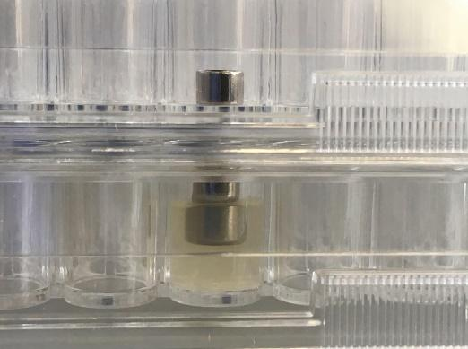
Figure S1. Culture conditions for S. aureus biofilm formation on metallic pegs.
- Results

Figure S2. FT-IR spectra of functionalized MSNs (bare (MSN-B)- black, amine (MSN-D)-red, carboxyl (MSN-C)-blue and aromatic (MSN-A)-green).

Table S1. EPS main components quantification for MRSA and MSSA (relative to total biomass) and charge measurement data of the biofilms (solution of bacterial cells and EPS).
Strain | [Protein]ª / μg mg⁻¹ | [Polysaccharide]^{b} / μg mg⁻¹ | Zeta Potential^{c} / mV
BHICC (MRSA) | 36.2 | 1.4 | -46 ± 6
8325-4 (MSSA) | 3.1 | 42.3 | -49 ± 8

ªDetermined using Lowry method
^{b}Determined with Phenol-sulfuric acid method
^{c}Measured by Zetasizer Nano-ZS

Table S2. Antimicrobial effects of free vancomycin and vancomycin loaded MSNs against MRSA and MSSA planktonic bacteria determined by minimum inhibitory concentration (MIC) and minimum biofilm inhibitory concentration (MBIC)
 | Vancomycin (µg mL⁻¹) |  | Van@MSN-B  (µg mL⁻¹) |  | Van@MSN-D  (µg mL⁻¹) |  | Van@MSN-C  (µg mL⁻¹) |  | Van@MSN-A  (µg mL⁻¹)
Strain | MIC | MBIC | MIC | MBIC | MIC | MBIC | MIC | MBIC | MIC | MBIC
MRSA | <4 | <8 | 4 | >7 | <4 | >4 | 3 | >3 | <4 | >4
MSSA | 2 | <4 | 2 | <7 | 2 | 4 | <3 | >3 | 2 | 4

