Online supplementary figure 1 Methodology to analyze recommendations and finalize themes in NCD management.
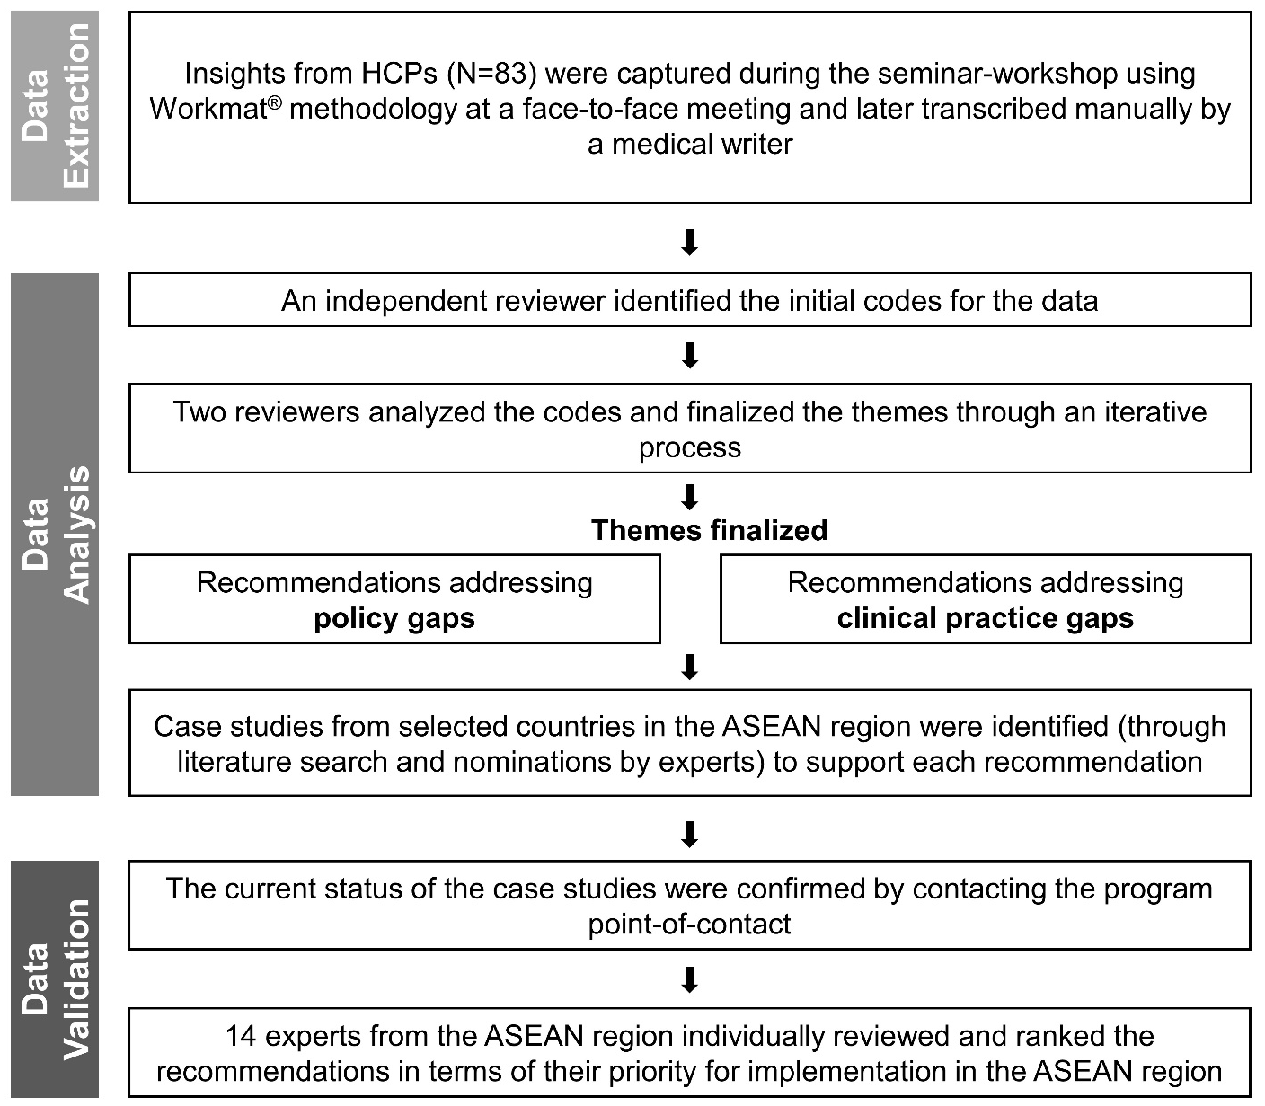

Abbreviations: ASEAN, Association of Southeast Asian Nations, HCPs, Healthcare professionals; NCD, non-communicable diseases

