[[Supplementary Tables & Figures]]
Supplementary Table 1. Input data for each analgesic and placebo for each of the 17 criteria included in the model
Criterion | Scale Type | Acetaminophen | Parecoxib | Metamizole | Nefopam | Ketorolac | Tramadol | Morphine | Diclofenac | Placebo
Efficacy
Pain relief | Preference | 35 | 100 | 80 | 35 | 90 | 20 | 90 | 90 | 0
Duration of action | Data* | 3.00 | 6.25 | 3.00 | 3.00 | 6.10 | 6.09 | 4.22 | 6.78 | 0.92
Opioid sparing | Data† | 10.5 | 13.5 | 7.7 | 10.4 | 12.9 | 7.4 | 0 | 12.9 | 0
Safety
AEs
Itchiness | Preference | 100 | 100 | 70 | 70 | 100 | 70 | 0 | 100 | 100
Nausea/vomiting | Preference | 100 | 100 | 100 | 100 | 100 | 0 | 30 | 100 | 100
Increased creatinine | Preference | 100 | 90 | 100 | 100 | 0 | 100 | 100 | 10 | 100
Hepatic effects | Preference | 0 | 100 | 100 | 100 | 70 | 100 | 100 | 50 | 100
Hypotension | Preference | 80 | 90 | 0 | 80 | 90 | 80 | 70 | 90 | 100
Psychomimetic effects | Preference | 100 | 100 | 100 | 90 | 100 | 0 | 50 | 100 | 100
SAEs
Cardiac effects | Preference | 100 | 50 | 100 | 100 | 50 | 100 | 100 | 0 | 100
Respiratory depression | Preference | 100 | 100 | 100 | 100 | 100 | 70 | 0 | 100 | 100
Renal impairment | Preference | 100 | 90 | 100 | 100 | 0 | 100 | 100 | 70 | 100
GI effects | Preference | 90 | 80 | 90 | 100 | 0 | 100 | 100 | 25 | 100
Agranulocytosis | Preference | 95 | 100 | 0 | 100 | 100 | 100 | 100 | 90 | 100
Liver dysfunction | Preference | 0 | 100 | 100 | 100 | 100 | 100 | 100 | 80 | 100
Anaphylaxis | Preference | 90 | 0 | 50 | 90 | 0 | 90 | 90 | 0 | 100
Overdose toxicity | Preference | 50 | 90 | 100 | 80 | 70 | 50 | 0 | 70 | 100

*Based on median time to rescue medication.
†Based on median reduction of morphine consumption (in mg) over 24 hours.
For the criteria Duration of Action and Opioid Sparing, values are based on empirical measures from available clinical data. For the remaining criteria, each was scored from 0 to 100, with 100 awarded to the drug that scored best and 0 to the drug that scored worst. The remaining drugs were then scored from 0 to 100 according to their standing with each other.
Abbreviations: AEs, adverse events; GI, gastrointestinal; SAEs, serious adverse events.

Supplementary Figure 1 Relative weighting of the data
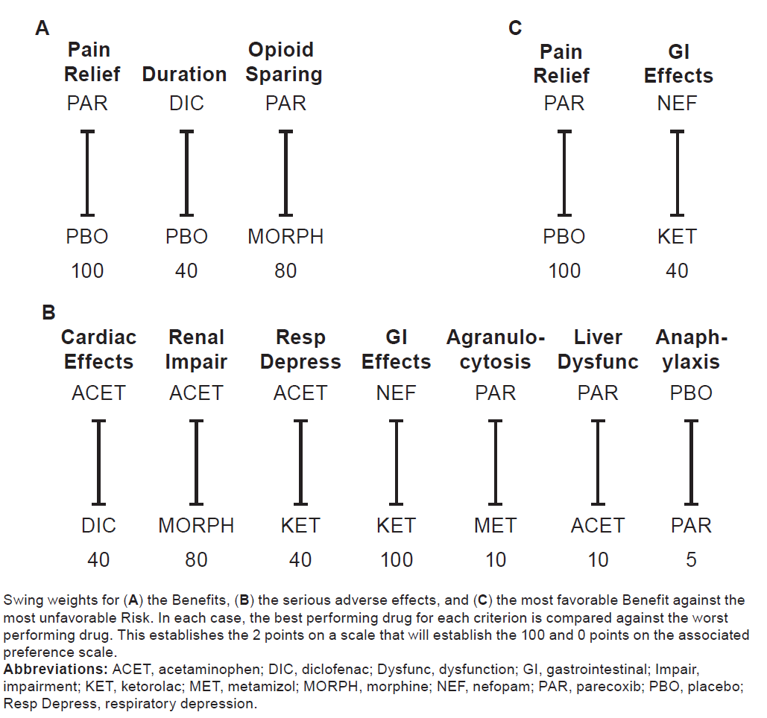

Supplementary Figure 2 Impact of changes in the weight of total safety on overall efficacy-safety profiles

Supplementary Figure 3 Impact of changes in the cumulative weight of pain relief on overall efficacy-safety profiles

