Supplementary Information

Tryptophol Coating Reduces Catheter-Related Cerebral and Pulmonary Infections by Scedosporium apiospermum

Thitinan Kitisin¹, Watcharamat Muangkaew¹, Sumate Ampawong², Passanesh Sukphopetch¹

¹Department of Microbiology and Immunology, Faculty of Tropical Medicine, Mahidol University, Bangkok, Thailand
²Department of Tropical Pathology, Faculty of Tropical Medicine, Mahidol University, Bangkok, Thailand

Correspondence: Passanesh Sukphopetch
Department of Microbiology and Immunology, Faculty of Tropical Medicine, Mahidol University, 420/6 Rajavithi Road, Ratchathewi, Bangkok 10400, Thailand
Tel +66 2 354 9100
Fax +66 2 643 5583
Email natthanej.lup@mahidol.ac.th

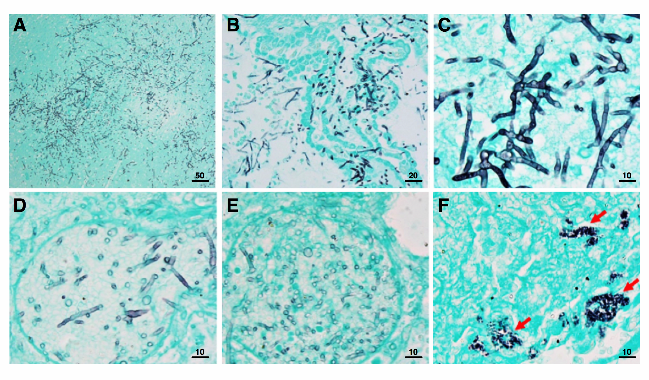
Supplementary Figure 1 The presence of S. apiospermum hyphae in brains and lungs from uncoated catheter groups were determined using gomori methenamine silver (GMS) staining. S. apiospermum hyphae were shown in black as positive silver stain in (A, C) brain tissues, perivascular area of (B) brain and (D-E) lung, and (F) lung tissue. Scale bar = 50, 20, and 10 μm.

