Clinical impact and healthcare resource utilization associated with early versus late COPD diagnosis in patients from UK CPRD database

Konstantinos Kostikas, MD, PhD¹, David Price, MD², Florian S. Gutzwiller, MD³, Bethan Jones, BSc⁴ Emil Loefroth, MSc³, Andreas Clemens, MD^{3,5}, Robert Fogel, MD⁶, Rupert Jones, MD⁷, Hui Cao, PhD⁶

¹Respiratory Medicine Department, University of Ioannina Medical School, Ioannina, Greece; ²Centre of Academic Primary Care, University of Aberdeen, Aberdeen, United Kingdom; ³Novartis Pharma AG, Basel, Switzerland; ⁴Pharmatelligence, Cardiff, United Kingdom; ⁵Department of Cardiology and Angiology I, Heart Center Freiburg University, Faculty of Medicine, University of Freiburg, Freiburg, Germany; ⁶Novartis Pharmaceuticals Corporation, East Hanover, NJ, United States; ⁷Plymouth University Peninsula School of Medicine and Dentistry, Plymouth, United Kingdom

Corresponding author
Dr. Konstantinos Kostikas, MD, PhD, FCCP
Associate Professor in Respiratory Medicine and Head Respiratory Medicine Department
University of Ioannina School of Medicine, Ioannina, Greece
Email: ktkostikas@gmail.com

Table S1. Assessment of COPD severity using the GOLD criteria (GOLD 2015)

GOLD category | Typical airflow limitation | Exacerbations history | Dyspnea
A - Low Risk, Less Symptoms | Mild or Moderate and | 0-1 exacerbation and no hospitalization for exacerbation and | mMRC grade 0-1
B – Low Risk, More Symptoms | Mild or Moderate and | 0-1 exacerbation and no hospitalization for exacerbation and | mMRC grade ≥ 2
C – High Risk, Less Symptoms | Severe or Very Severe and/or | ≥ 2 exacerbations or ≥ 1 with hospitalization for exacerbation and | mMRC grade 0-1
D – High Risk, More Symptoms | Severe or Very Severe and/or | ≥ 2 exacerbations or ≥ 1 with hospitalization for exacerbation and | mMRC grade ≥ 2
COPD, chronic obstructive pulmonary disease; GOLD, Global Initiative for Chronic Obstructive Lung Disease; mMRC, modified medical research council.

Adapted from Global Initiative for Chronic Obstructive Lung Disease (GOLD) strategy document published in 2015. © 2020, Global Initiative for Chronic Obstructive Lung Disease, available from www.goldcopd.org, published in Fontana, WI, USA

Section S1. Definition of exacerbations
Episodes of chronic obstructive pulmonary disease (COPD) exacerbation were defined according to a validated algorithm that takes into account drug codes and diagnosis codes in the Clinical Practice Research Datalink (CPRD) database. As the algorithm considered only COPD exacerbations treated in primary care (using data from the CPRD database), we integrated these data with data on exacerbation episodes treated in-hospital from the Hospital Episode Statistics (HES) database.
Episodes of severe exacerbation were defined as:
An occurrence of COPD-related hospital admission as recorded in the HES Admitted Patient Care (APC) as International Classification of Diseases 10th Revision (ICD-10) codes J44.0 and J44.1 in any diagnosis or J44.9 in primary diagnosis, or
An occurrence of COPD emergency department attendance as recorded in the HES Accident & Emergency (A&E) as diagnosis code 252 “Respiratory conditions - other non-asthma,” or
An episode of an acute exacerbation recorded by a general practitioner in the CPRD database Clinical or Referral tables (Read codes: H312200 [Acute exacerbation of chronic obstructive airways disease], H3Y1.00 [Chronic obstructive pulmonary disease with acute exacerbation, unsuspected], 8BP8.00 [Antibiotic therapy for acute pulmonary exacerbation], 8H2R.00 [Admit COPD emergency], 66Ye.00 [Emergency COPD admission since last appointment], 66Yd.00 [COPD accident and emergency attendance since last visit], 66Yi.00 [Multiple COPD emergency hospital admissions]).
Episodes of moderate exacerbation were defined as:
A prescription for an oral corticosteroid (OCS) and an antibiotic for 5-14 days, prescribed on the same day, or
An exacerbation symptom (details reported below) and a prescription for an OCS on the same day (i.e., medical codes must have been generated on the same day as prescription), or
An exacerbation symptom and a prescription for an oral antibiotic on the same day (i.e., medical codes must have been on the same day as prescription), or
A lower respiratory tract infection code, excluding codes for pneumonia.
As exacerbation symptoms, codes suggesting an increase in two or more of the following was used: breathlessness, cough, sputum volume, and purulence. In the exacerbations episodes not defined by HES APC and HES A&E, we excluded any exacerbations occurring on the same day as the date of a code for an annual COPD review or provision of rescue packs for COPD-specific antibiotics or OCS. Exacerbations occurring within 14 days were considered as a single event; the most severe exacerbation was used to define exacerbation severity.

Overall patient attrition in the study
Of the 135,739 eligible patients identified in the CPRD, 10,158 patients were included for the analysis after applying inclusion and exclusion criteria (Figure S1).

Figure S1. Patient flow in the study

Total patients identified from CPRD database with linkage to HES
N (%) = 135,739 (100.0%)
Patients included in the analysis
n = 10,158 (7.5%)

Excluded patients: n (%) = 125,581 (92.5%)

Reasons for exclusion:

- Without age and gender data: n = 1
- Without ≥ 1 Read code suggestive of COPD: n = 55,813
- COPD diagnosis by Quint et al. algorithm: n = 52,842
- Death, transfer out/practice last collection date pre-index: n = 1,065
- Aged < 40 years at the index date: n = 223
- Without 5 years of continual practice records: n = 6,848
- Diagnosis of COPD in the 5 years pre-index: n = 4,682
- Diagnosis of asthma in the 5 years pre-index/index: n = 4,107

COPD, chronic obstructive pulmonary disease; CPRD, Clinical Practice Research Datalink; HES, Hospital Episode Statistics.

Table S2. Proportion of patients receiving GOLD appropriate therapy after a 2-year follow-up

 | Patients receiving appropriate COPD therapy according to GOLD | Adjusted modelª
COPD diagnosis | n (%) | OR (95% CI) | P-value
Late | 733 (55.6) | 1.24 (1.01-1.53) | 0.0415
Early | 274 (46.2) | - | -
P-value: from Wald test obtained from unadjusted and adjusted logistic regression models.
ªAdjusted model: logistic regression model using late/early and ‘a priori’ variables, including anxiety, baseline eosinophil group, depression, atrial fibrillation, hypertension, diabetes, and heart failure.
CI, confidence interval; COPD, chronic obstructive pulmonary disease; GOLD, Global Initiative for Chronic Obstructive Lung Disease; OR, odds ratio.

Median time to ICS-LABA-LAMA combination therapy
The median time-to-first inhaled corticosteroid-long-acting β₂-agonist-long-acting muscarinic antagonist (ICS-LABA-LAMA) combination therapy was shorter in patients with late-diagnosed COPD compared with patients with early diagnosed COPD, with the median time to ICS-LABA-LAMA combination therapy (95% confidence interval) being 60.1 months (57.30-61.90) versus 63.5 months (58.50, not available; P < 0.0001) (Figure S2).

Figure S2. Kaplan-Meier cumulative incidence plot for the time to ICS-LABA-LAMA combination therapy, with log-rank test to compare early versus late COPD diagnosis

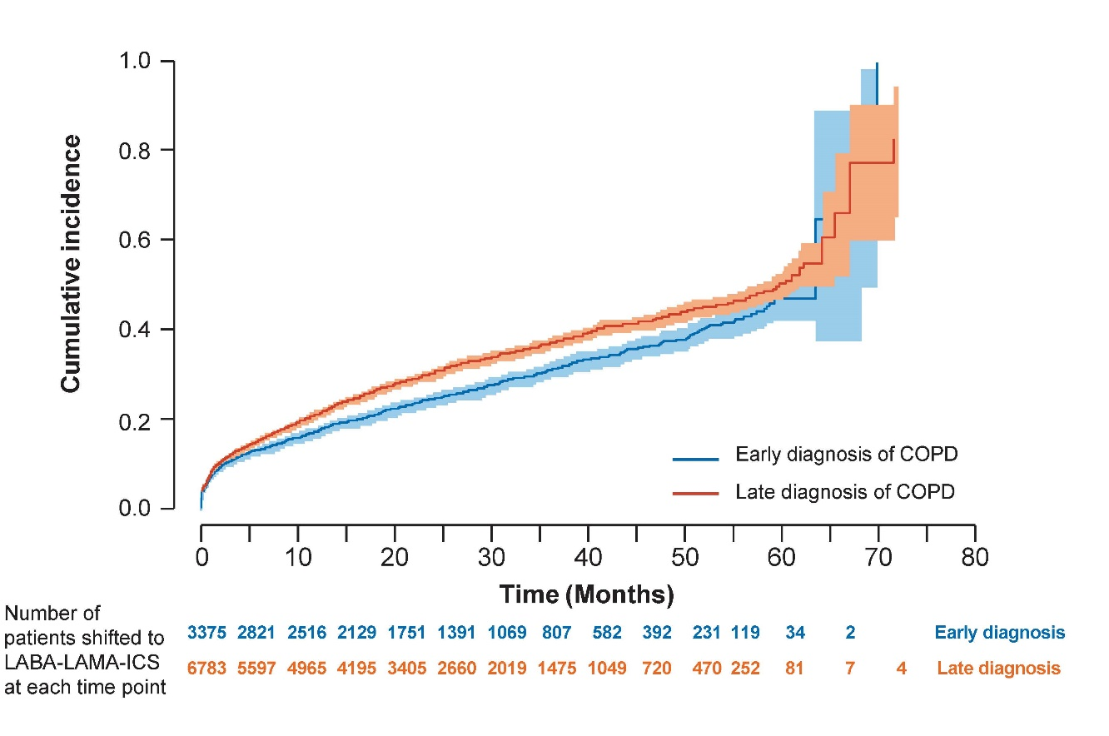

COPD, chronic obstructive pulmonary disease; ICS-LABA-LAMA, inhaled corticosteroid-long-acting β₂-agonist-long-acting muscarinic antagonist

Table S3. COPD-related medication use in the first, second, and third year follow ups

Characteristics | Early diagnosis  (N = 3,375) | Late diagnosis  (N = 6,783) | P-value*
COPD selected treatments during year 1, n | 2,878 | 5,962
SABA
Mono | 1,294 (44.96%) | 1,857 (31.15%)
Combination | 1,656 (57.54%) | 3,538 (59.34%)
Medications other than SABA | 301 (10.46%) | 532 (8.92%)
No COPD drug | 163 (5.66%) | 941 (15.78%)
ICS
Mono | 121 (4.2%) | 250 (4.19%)
Combination | 1,236 (42.95%) | 3,034 (50.89%)
Medications other than ICS | 1,436 (49.9%) | 1,897 (31.82%)
No COPD drug | 163 (5.66%) | 941 (15.78%)
LABA and LAMA
LABA | 260 (9.03%) | 449 (7.53%)
LABA/ICS | 727 (25.26%) | 1,837 (30.81%)
LABA/LAMA | 74 (2.57%) | 178 (2.99%)
LAMA/ICS | 54 (1.88%) | 157 (2.63%)
LABA/LAMA/ICS | 493 (17.13%) | 1,341 (22.49%)
LAMA | 955 (33.18%) | 1,607 (26.95%)
No COPD drug | 163 (5.66%) | 941 (15.78%)
Medications other than LABA or LAMA | 790 (27.45%) | 995 (16.69%)
Prescriptions for COPD medications during year 1 | 8.58 (5.6%) | 9.66 (5.2%) | < 0.0001
Patients with 2 years of follow-up, n | 1,916 | 3,960
SABA
Mono | 428 (22.34%) | 840 (21.21%)
Combination | 775 (40.45%) | 1,929 (48.71%)
Medications other than SABA | 149 (7.78%) | 292 (7.37%)
No COPD drug | 737 (38.47%) | 1,279 (32.3%)
ICS
Mono | 47 (2.45%) | 94 (2.37%)
Combination | 635 (33.14%) | 1,726 (43.59%)
Medications other than ICS | 523 (27.3%) | 911 (23.01%)
No COPD drug | 737 (38.47%) | 1,279 (32.3%)
LABA and LAMA
LABA | 114 (5.95%) | 186 (4.7%)
LABA/ICS | 372 (19.42%) | 1,038 (26.21%)
LABA/LAMA | 45 (2.35%) | 83 (2.1%)
LAMA/ICS | 35 (1.83%) | 58 (1.46%)
LABA/LAMA/ICS | 282 (14.72%) | 871 (21.99%)
LAMA | 367 (19.15%) | 812 (20.51%)
No COPD drug | 737 (38.47%) | 1,279 (32.3%)
Medications other than LABA or LAMA | 278 (14.51%) | 464 (11.72%)
Prescriptions for COPD medications during year 2 | 8.81 (5.1%) | 9.57 (5.4%) | < 0.0001
Patients with 3 years of follow-up, n | 1,080 | 2,193
SABA
Mono | 225 (20.83%) | 403 (18.38%)
Combination | 417 (38.61%) | 1,068 (48.7%)
Medications other than SABA | 127 (11.76%) | 334 (15.23%)
No COPD drug | 439 (40.65%) | 767 (34.97%)
ICS
Mono | 25 (2.31%) | 46 (2.1%)
Combination | 353 (32.69%) | 991 (45.19%)
Medications other than ICS | 277 (25.65%) | 416 (18.97%)
No COPD drug | 439 (40.65%) | 767 (34.97%)
LABA and LAMA
LABA | 41 (3.8%) | 92 (4.2%)
LABA/ICS | 188 (17.41%) | 558 (25.44%)
LABA/LAMA | 24 (2.22%) | 48 (2.19%)
LAMA/ICS | 21 (1.94%) | 35 (1.6%)
LABA/LAMA/ICS | 182 (16.85%) | 527 (24.03%)
LAMA | 200 (18.52%) | 413 (18.83%)
No COPD drug | 439 (40.65%) | 767 (34.97%)
Medications other than LABA or LAMA | 149 (13.8%) | 206 (9.39%)
Prescriptions for COPD medications during year 3 | 8.95 (5.3%) | 9.8 (5.1%) | < 0.0001
P-values: *Unequal variance 2-sample t-test.
COPD, chronic obstructive pulmonary disease; ICS, inhaled corticosteroids (beclometasone dipropionate, budesonide, ciclesonide, fluticasone propionate, fluticasone furoate, mometasone furoate, flunisolide, betamethasone, triamcinolone, mometasone); LABA, long-acting β₂-agonist (formoterol fumarate, salmeterol, indacaterol, olodaterol, bambuterol hydrochloride, vilanterol); LAMA, long-acting muscarinic antagonist (tiotropium, glycopyrronium, aclidinium bromide, umeclidinium); methylxanthines (aminophylline, theophylline); PDE4, phosphodiesterase-4-inhibitor (roflumilast); SABA, short-acting β₂-agonist (salbutamol, terbutaline, fenoterol, rimiterol, pirbuterol, reproterol); combined therapy was considered either in fixed dose or free combination.

