Supplementary materials

Supplementary Figures

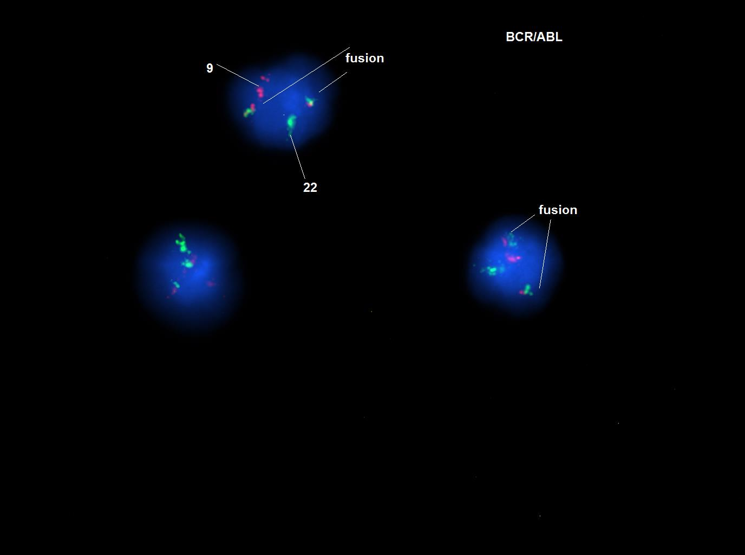

Figure S1 FISH analysis of CD34+CD176+IL1RAP+population in CML-4. Fusion gene is shown by fusion of the colors. Cells were tested before CFU assay.

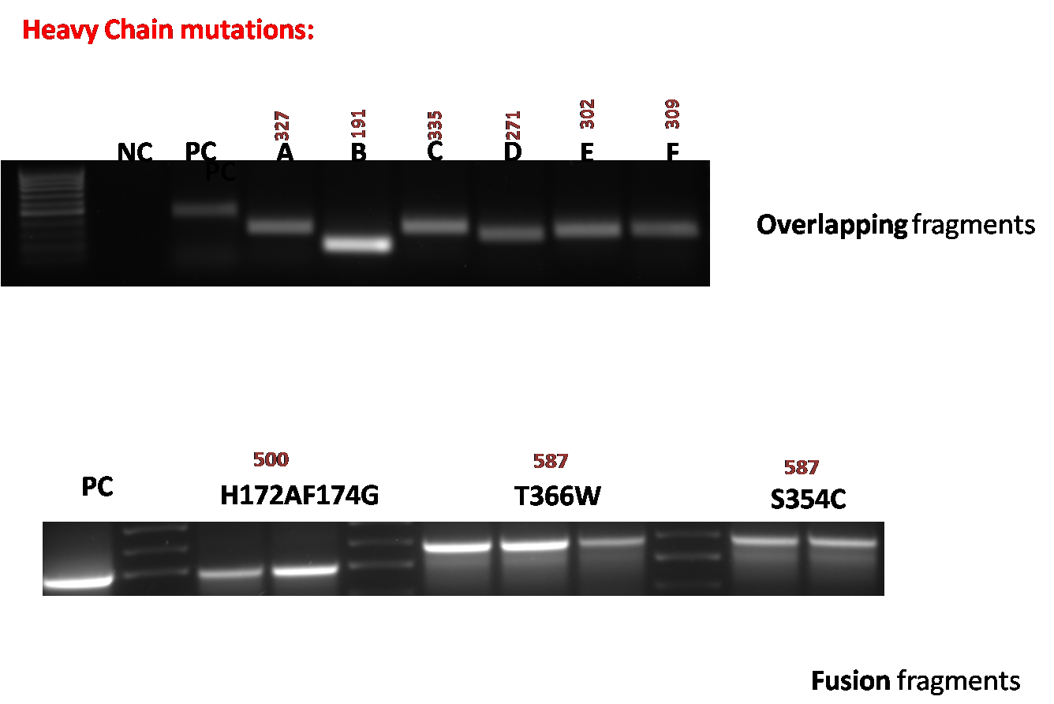
Figure S2. Gel electrophoresis picture showing bands of PCR-amplified overlapping and fusion fragments for heavy chain mutations. Refer to Supplementary table 3.

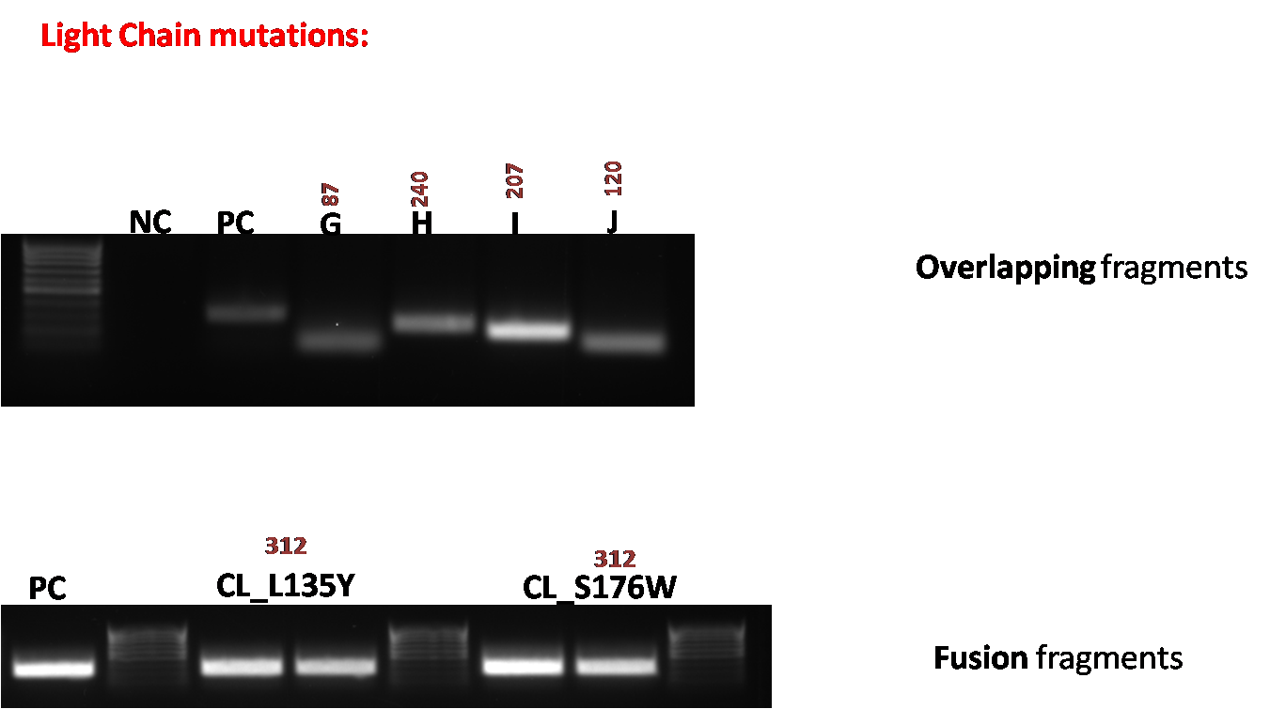
Figure S3. Gel electrophoresis picture showing bands of PCR-amplified overlapping and fusion fragments for light chain mutations. Refer to Supplementary table 3.

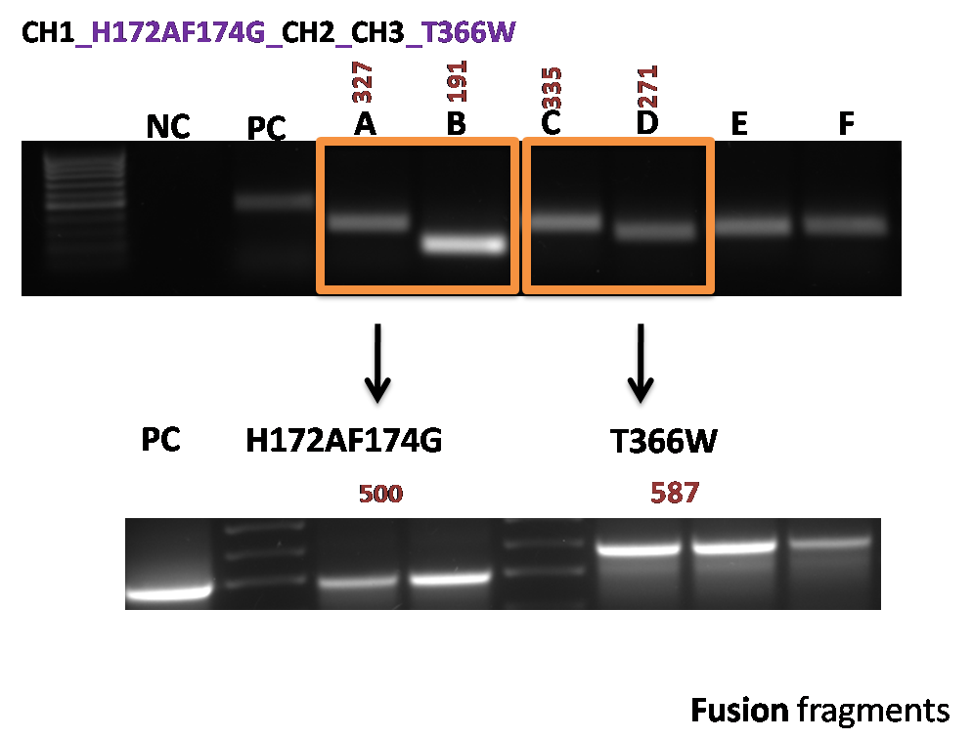

Figure S4. Gel electrophoresis picture showing bands of CH1_H172AF174G _CH2_CH3_T366W mutation. Refer to Supplementary table 3.

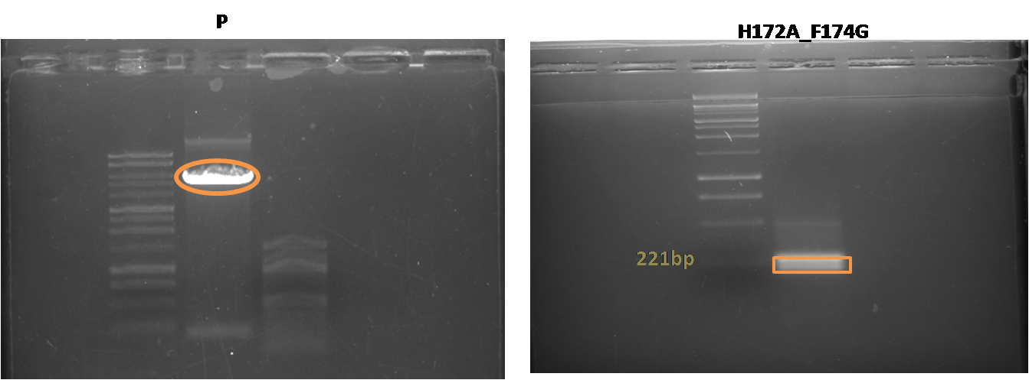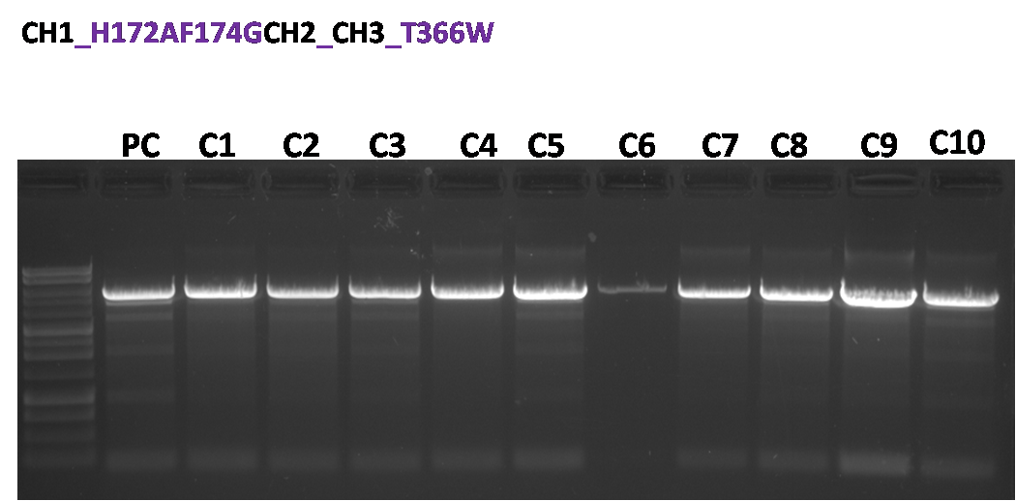
Figure S5. Gel electrophoresis picture showing bands sub-cloning bands (up) and restriction mapping of the CH1_H172AF174G _CH2_CH3_T366W mutation(down). Refer to Supplementary table 3.
P: plasmid; PC: positive control (wild type).

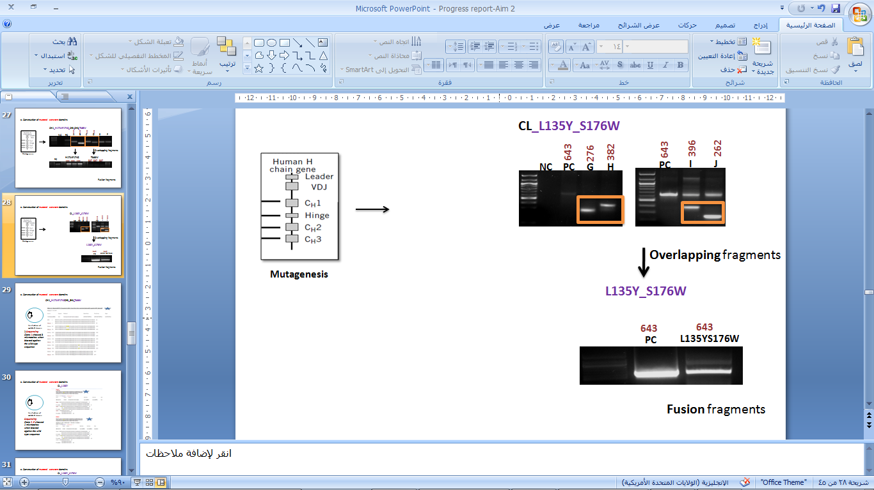
Figure S6. Gel electrophoresis picture showing bands sub-cloning bands restriction mapping of the CL_L135Y_S176W mutation. Refr to supplementary table 3. PC: positive control (wild type).

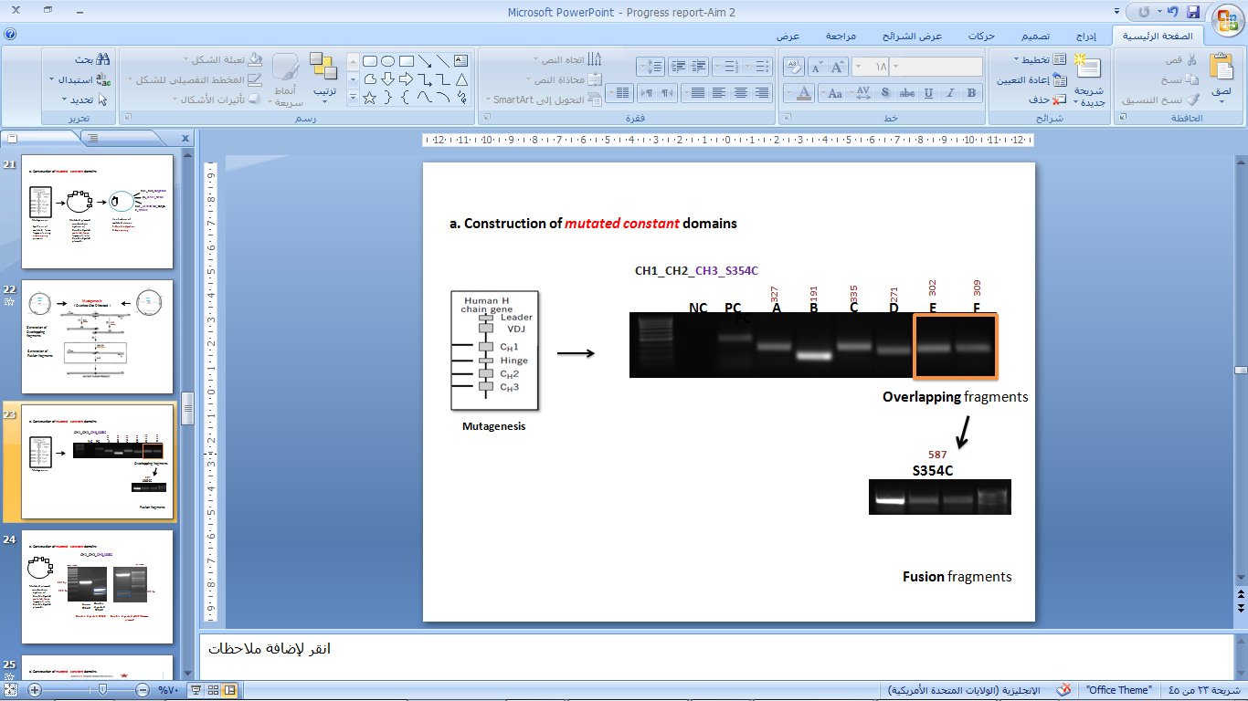

Figure S7. Gel electrophoresis picture showing bands sub-cloning bands restriction mapping of the CH1__CH2_CH3_S354C mutation. Refer to Supplementary table 3.

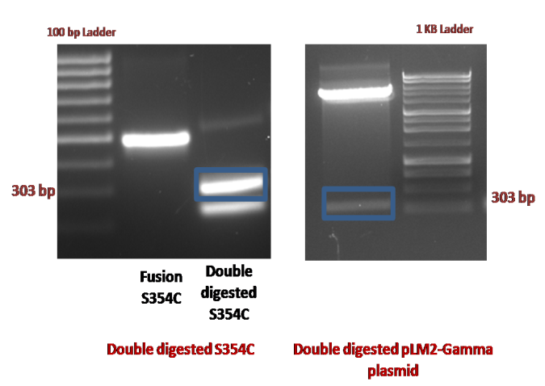

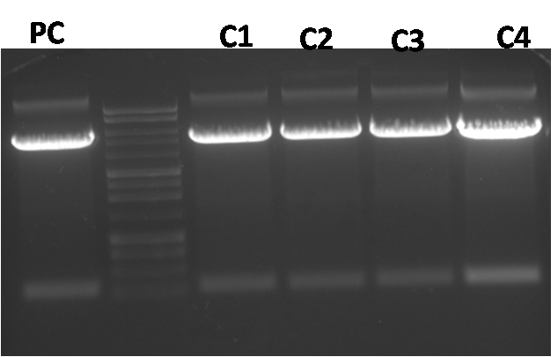
Figure S8. Gel electrophoresis picture showing bands sub-cloning bands (up) and restriction mapping of the CH1__CH2_CH3_S354C(down). Refer to supplementary table 3.

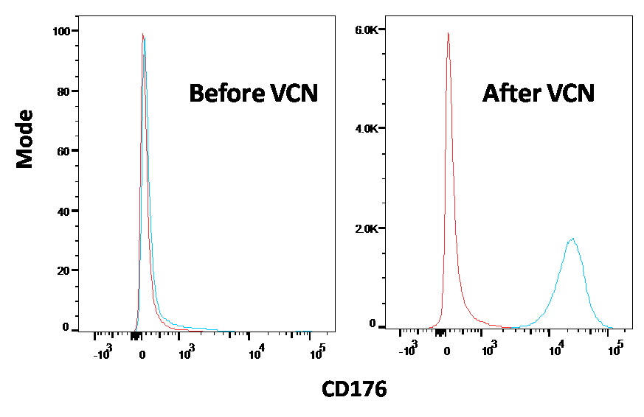
Figure S9. Histogram illustrating the level of CD176 expression in KG1 cell line before and after VCN treatment. VCN; Vibrio Cholera Neuroaminidase, an enzyme that exposes the CD176 antigen on the surface of cells for better expression. As shown in figure, anti-CD176 mAb binding was significantly increased after pretreatment with VCN.

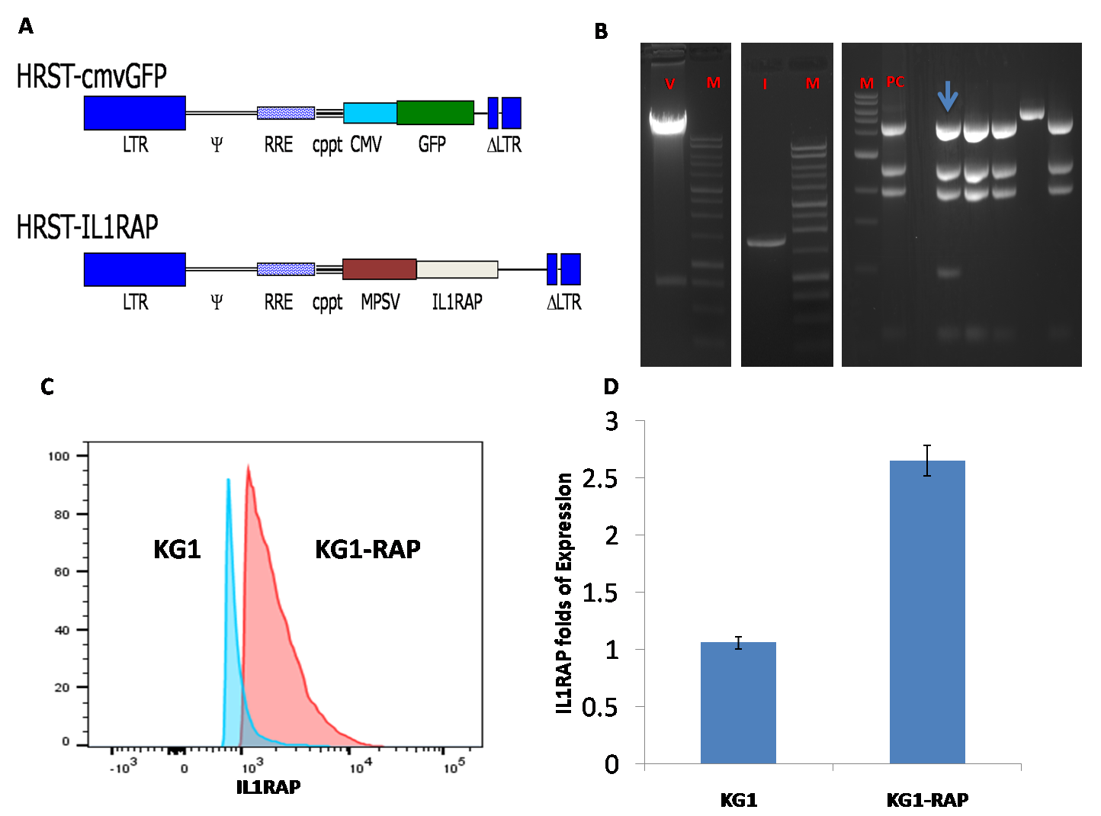

Figure S10. IL1RAP is induced as a consequence of Lentiviral expression of KG1 cells (KG1/RAP; a cell line positive for both antigens). A. pHRST-MPSV/CMV and pHRST-IL1RAP. B. Construction of pHRST-IL1RAP lentiviral vector and verification. The 700 bp GFP band was digested using BamHI/XhoI restriction enzymes. IL1RAP cDNA was PCR amplified with primers flanked with BamHI/XhoI sequences then ligated to the linearized pHRST-MPSV lentiviral backbone, transformed into E-coli and screened for colonies. Colonies were screened using HIND III , and an extra 1KB band (red box) was diagnostic for pHRST-MPSV-IL1RAP construct. V; Vector, M: DNA marker, I; insert, PC: positive control. C. Histogram showing IL1RAP expression in KG1/RAP versus KG1 cell line. D. IL1RAP expression was increased by more than 50% as a result of lentiviral transduction. Each point represents Mean ± SEM of the four samples.

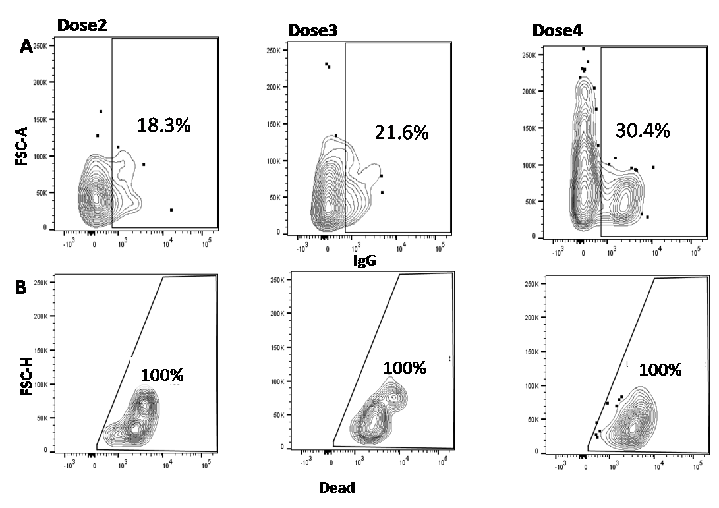
Figure S11. Gating strategy used for analysis of the bi-specific antibody binding and killing (CML-3). First, an IgG gate was drawn on the lymphocytes population in order to identify the binding capacity of the Bs-Ab. Then a second gate; LD stained, was drawn within the IgG+ population, in order to identify the frequency of dead cells within the bound cell population at different doses of TF1RAPa (A and B).

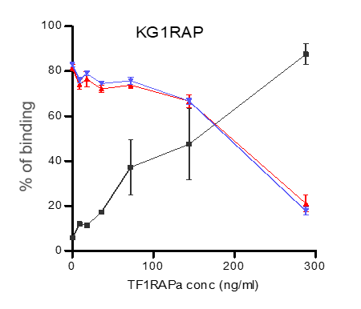
Figure S12. Receptor occupancy of the bispecific antibody (black line) versus the anti-IL1RAP and anti-CD176 mAbs (red and blue lines, respectively). These data demonstrate that increasing concentration of the Bis-Ab is specifically inhibiting the binding of both the IL1RAP and CD176 mAbs.

Figure S13. Killing of CML PBMCs CD176+IL1RAP+cells by the bi-specific antibody; TF1RAPa. In line with the level of CD176 and IL1RAP expression, no obvious CDC effect was seen in normal PBMCs (A) versus CML (B) cells, whereas TF1RAPa induced the strongest dose-dependent CDC effect in CML CD176+IL1RAP+ (C) as compared to other populations (D-F). As a control for nonspecific CDC effects, a mouse anti-human IgG antibody was also used in the experiments. Each graph shows the average and SD of antibody-induced cell death from a minimum of three CML samples.

Figure S14. Different receptors interaction with TF1RAPa, as compared to CD176+IL1RAP+. Using Post-Hoc Bonferroni test, significant difference was observed on comparing between CD176+IL1RAP+ to CD176+IL1RAP- and CD176-IL1RAP- and not CD176-IL1RAP+.

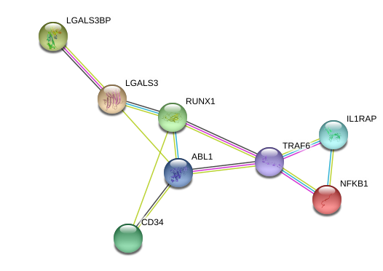

Figure S15. Network connections between different molecules.
Protein interactions as identified by String online tool where network nodes represent proteins and edges represent protein-protein associations.

Supplementary Tables

Table S1: Sequences of primers used for mutagenesis.
Primer | Sequence
CH1_H172A_F174G_Forward* | 5'gtggccaccggcccggctgtcctacagtcctcagga3'
CH1_H172A_F174G_Reverse | 5'agccgggccggtggccacgccgctggtcagggcgcctgag3'
CH1_Flanking_Forward | 5’ctggtgacgaattcgatatctcgagt3’
CH1_Flanking_Reverse | 5’gaacttgacctcagggtcttcgtg3’
CH3_S354C_Forward | 5'cccccatgccgggaggagatgaccaagaaccaggtcagcc3'
CH3_S354C_Reverse | 5'tctcctcccggcatgggggcagggtgtacacctg3'
CH3_T366W_Forward | 5'gtcagcctgtggtgcctggtcaaaggcttctatccca3'
CH3_T366W_Reverse | 5'tttgaccaggcaccacaggctgacctggttcttggtcat 3'
CH3_Flanking_Forward | 5'cacgaagaccctgaggtcaagttc3'
CH3_Flanking_Reverse | 5'ctgcaataaacaagttgggccatg3'
CL_L135Y_Forward | 5’gtgtgttatataagtgacttctacccgggag3’
CL_L135Y_Reverse | 5’acttatataacacaccagtgtggccttgttggc3’
CL_S176W_Forward | 5’gcggcctggagctatctgagcctgacgcctgag3’
CL_S176W_Reverse | 5’atagctccaggccgcgtacttgttgttgct3’
CL_Flanking_Forward | 5’tccactttgcctttctctccaca3’
CL_Flanking_Reverse | 5’gatgagtttggacaaaccacaacta3’
SP6 Forward | 5’atttaggtgacactatag3’
*The two mutations in the H172A_F174G were included in the same primer for their proximity
Bold text shows the sequences of the overlapping parts of the inward primers.
Underlined text denotes the mutations.

Table S2: Lengths of generated overlapping and fusion fragments.

Mutation | Template for PCR | Fragment | Primers | Expected  Length (bp) | Fusion Fragment Length (bp) | Sub-cloning restriction enzymes
CH1  H172A  F174G | wild type,  heavy chain | A | F_CH1_H172A  R_CH1_Flanking | 327 | 500 | BstEII, EcoRI
CH1  H172A  F174G | wild type,  heavy chain | B | F-CH1_Flanking  R-CH1_CH1_H172A | 191 | 500 | BstEII, EcoRI
CH3-Knob  T366W | wild type,  heavy chain | C | F_CH3_S354C  R_CH3_Flanking | 335 | 586 | BsrGI , Not I
CH3-Knob  T366W | wild type,  heavy chain | D | F_CH3_Flanking  R_CH3_S354C | 271 | 586 | BsrGI , Not I
CH3-Hole  S354C | wild type,  heavy chain | E | F_CH3_T366W  R_CH3_Flanking | 302 | 590 | BsrGI ,Not I
CH3-Hole  S354C | wild type,  heavy chain | F | F_CH3_Flanking  R_CH3_T366W | 309 | 590 | BsrGI ,Not I
CL-  L135Y | wild type,  light chain | G | F-CL_ Flanking  R-CL_L135Y | 276 | 643 | EcoRI , Not I
CL-  L135Y | wild type,  light chain | H | F-CL_L135Y  R-CL_ Flanking | 382 | 643 | EcoRI , Not I
CL-  S176W | Mutated light chain (CL_L135Y) | I | R-CL_ S176W  F-CL_ Flanking | 396 | 643 | EcoRI , Not I
CL-  S176W | Mutated light chain (CL_L135Y) | J | F-CL_S176W  R-CL_ Flanking | 262 | 643 | EcoRI , Not I

Table S3. Table showing CML patients follow up history
CML patient | Follow up history | IL1RAP+CD176+ (%) in CD43+ population
CML-1 |  | 51.5
  Dasatinib 7/2010 – 7/2011
  Discontinued due to recurrent pleural effusion; needed pleurodesis and prednisone
  -Niolotinib initiated 7/2012
  -Blast crisis 9/2014
  -Deceases 9/2014
CML-2 |  | 18.5
  Deceased 08/2010
  -Took alemtuzumab three times a week for 7 weeks
  -Continued with transfusions
  -Developed thrombocytopenia
  Took G-CSF and darbepoietin
CML-3 |  | 6.65
  Alive
  Current therapy: Imatinib initiated May 2010; 3x weekly
  Major molecular remission: May 2012
  Admitted for septic shock in 11/2017
  Peripheral blood smear 11/2017
  Off imatinib treatment for uncertain period of time due to intercurrent illness.
CML-4 |  | 1.35
  Alive
  -Imatinib 1/2012 to current
  -Last peripheral blood smear (3/2017) “essentially normal”
  -Still alive

Information obtained from the Gunderson Bio-Bank

