Supplementary Table 1. MPPD baseline settings.
MPPD baseline input categories | Baseline input settings
Individual characteristics (airway morphometry and deposition/clearance) | Human species; Yeh-Schum symmetric single path lung model; FRC = 3,300 mL; URT volume = 50 mL  Tracheal mucous velocity = 5.5 mm/min; fast human clearance rate = 0.02/day; medium human clearance rate = 0.001/day; slow human clearance rate = 0.0001/day; lymph node human clearance rate = 0.00002/day
Exposure scenario: constant exposure | Acceleration of gravity = 981.0 cm/sec2; body orientation = upright; aerosol concentration = 0.3 mg/m3; breathing frequency = 20/min;  VT = 1,250 mL; inspiratory fraction = 0.5; pause fraction = 0; breathing scenario, oronasal-mouth breather; number of hours per day = 8; number of days per week = 5
Particle properties | Density = 3.9 g/cm3; diameter = 0.04 μm; count median diameter checked; NP model checked; inhalability adjustment not checked; GSD (diameter) = 1.25

Supplementary Table 2 Effects of Nano-TiO₂ on coefficient of lung, liver and kidney in rats (mean ± SD)

Group | Number  of mice | Lung |  |  |  | Liver |  |  |  | Kidney
Group | Number  of mice | Day 1 | Day 3 | Day 7 |  | Day 1 | Day 3 | Day 7 |  | Day 1 | Day 3 | Day 7
Control | 5 | 0.0062±0.0009 | 0.0062±0.0008 | 0.0062±0.0007 |  | 0.0429±0.0015 | 0.0429±0.0016 | 0.0431±0.0018 |  | 0.0085±0.0004 | 0.0085±0.0001 | 0.0086±0.0006
0.2g/kg | 5 | 0.0063±0.0003 | 0.0063±0.0008 | 0.0063±0.0003 |  | 0.0438±0.0018 | 0.0437±0.0013 | 0.0437±0.0023 |  | 0.0086±0.0008 | 0.0086±0.0005 | 0.0085±0.0007
1g/kg | 5 | 0.0063±0.0007 | 0.0064±0.0005 | 0.0063±0.0009 |  | 0.0433±0.0018 | 0.0438±0.0017 | 0.0433±0.0019 |  | 0.0085±0.0008 | 0.0086±0.0005 | 0.0085±0.0001

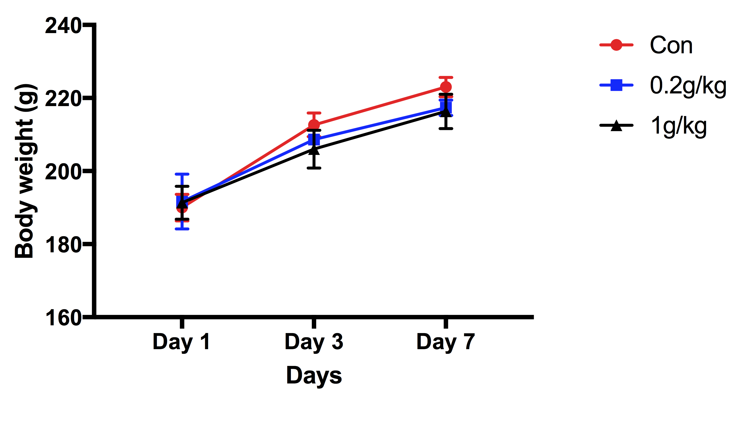
Supplementary Figure.1
After exposure for 1, 3 and 7 days, the weight of rats was in control group, 0.2g/kg group and 1 g/kg group.

Supplementary Figure.2

Supplementary Figure.2
A: ICP-MS Titanium standard curve (μg/L) B: ICP-MS response analysis: The abscissa represents the molecular weight of different metals, Titanium (47.867), Rhodium (102.91); the ordinate represents the concentration (μg/L)

