Supplementary Material

¹H-NMR for S1 2
¹H-NMR and ¹³C-NMR spectra for 2 3
LC/ESI-MS analysis for 2 4
¹H-NMR and ¹³C-NMR spectra for 3 5
LC/ESI-MS analysis for 3 6
¹H-NMR and ¹³C-NMR spectra for 4 7
LC/ESI-MS analysis for 4 8
¹H-NMR and ¹³C-NMR spectra for 5 9
LC/ESI-MS analysis for 5 10
¹H-NMR and ¹³C-NMR spectra for KA39 11
LC/ESI-MS analysis for KA39 12
¹H-NMR and ¹³C-NMR spectra for KA26 13
LC/ESI-MS analysis for KA26 14
¹H-NMR and ¹³C-NMR spectra for KA25 15
LC/ESI-MS analysis for KA25 16

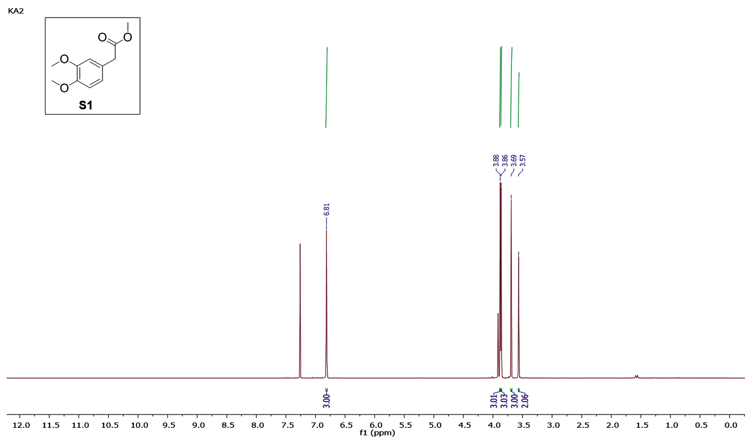

Figure S1. ¹H-NMR for compound S1(1) .

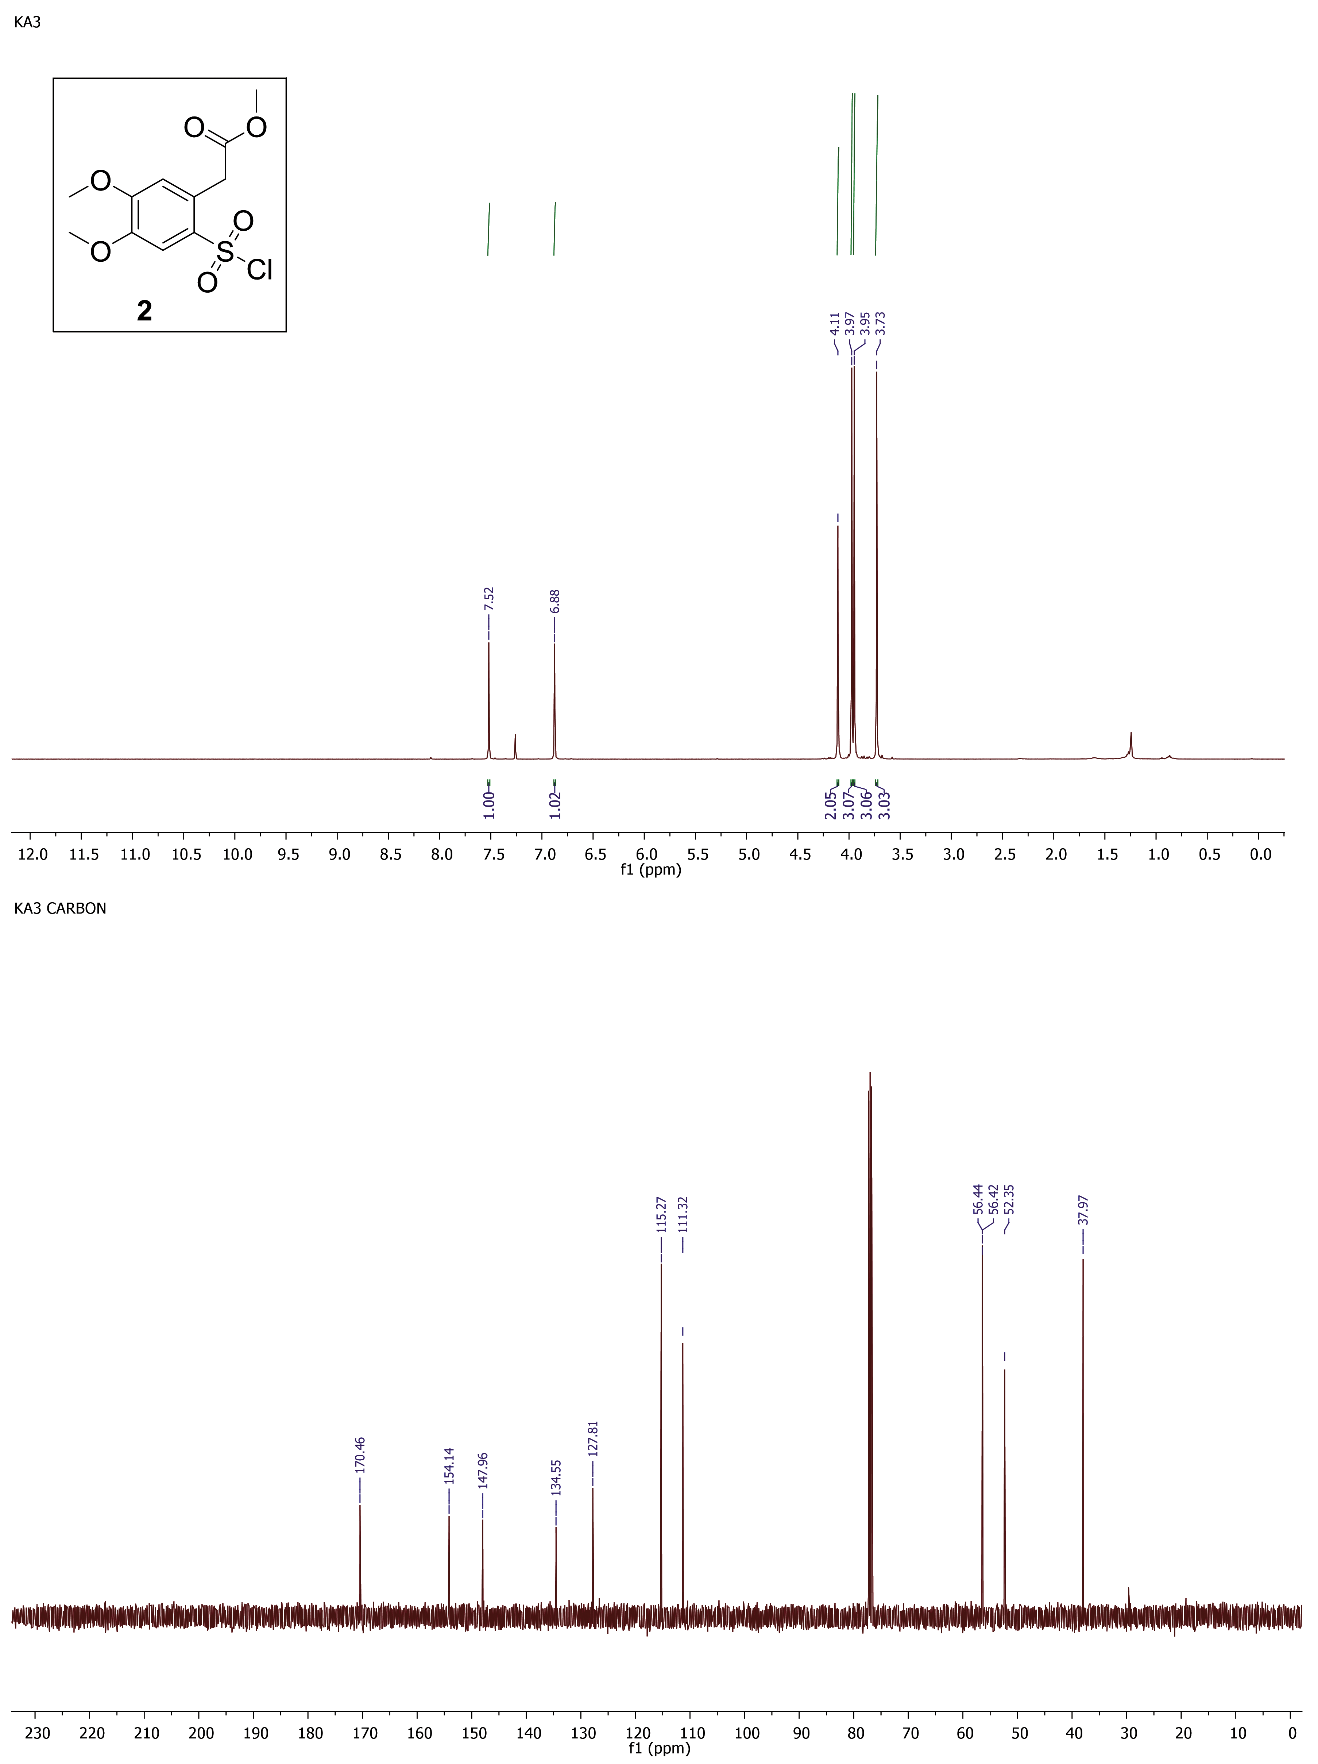

Figure S2. ¹H-NMR and 13C-NMR spectra for compound 2.

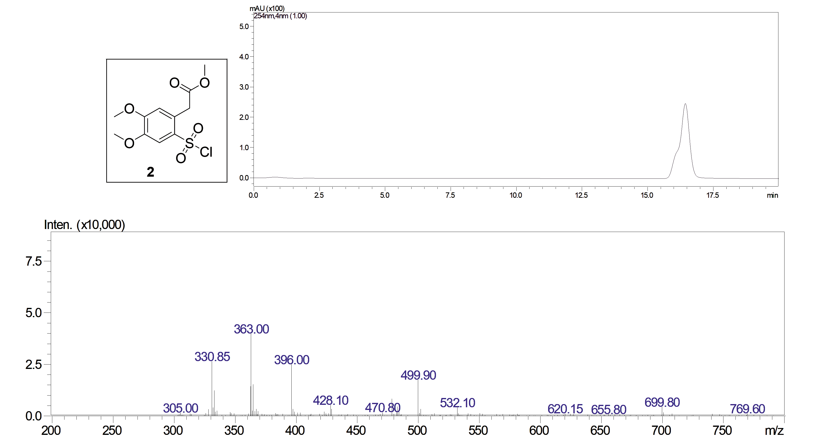

Figure S3. LC/ESI-MS analysis for compound 2. ESI-MS, positive mode: m/z calcd mass for C₁₁H₁₃ClNaO₆S [M+Na]⁺= 331.0, was found 330.85. Analytical method for LC-MS: LC-20AD Shimadzu connected to Shimadzu LCMS-2010EV; Mobile Phase: methanol; LC isocratic; HPLC column: SUPELCO Discovery C18, 25cm x 4.6mm, 5μm; Flow rate: 0.4 mL/min; Column temperature: 26 °C; UV detector: 254 nm; MS detector: 1.65K; Run time: 20 min; Retention time: 16.5 min.

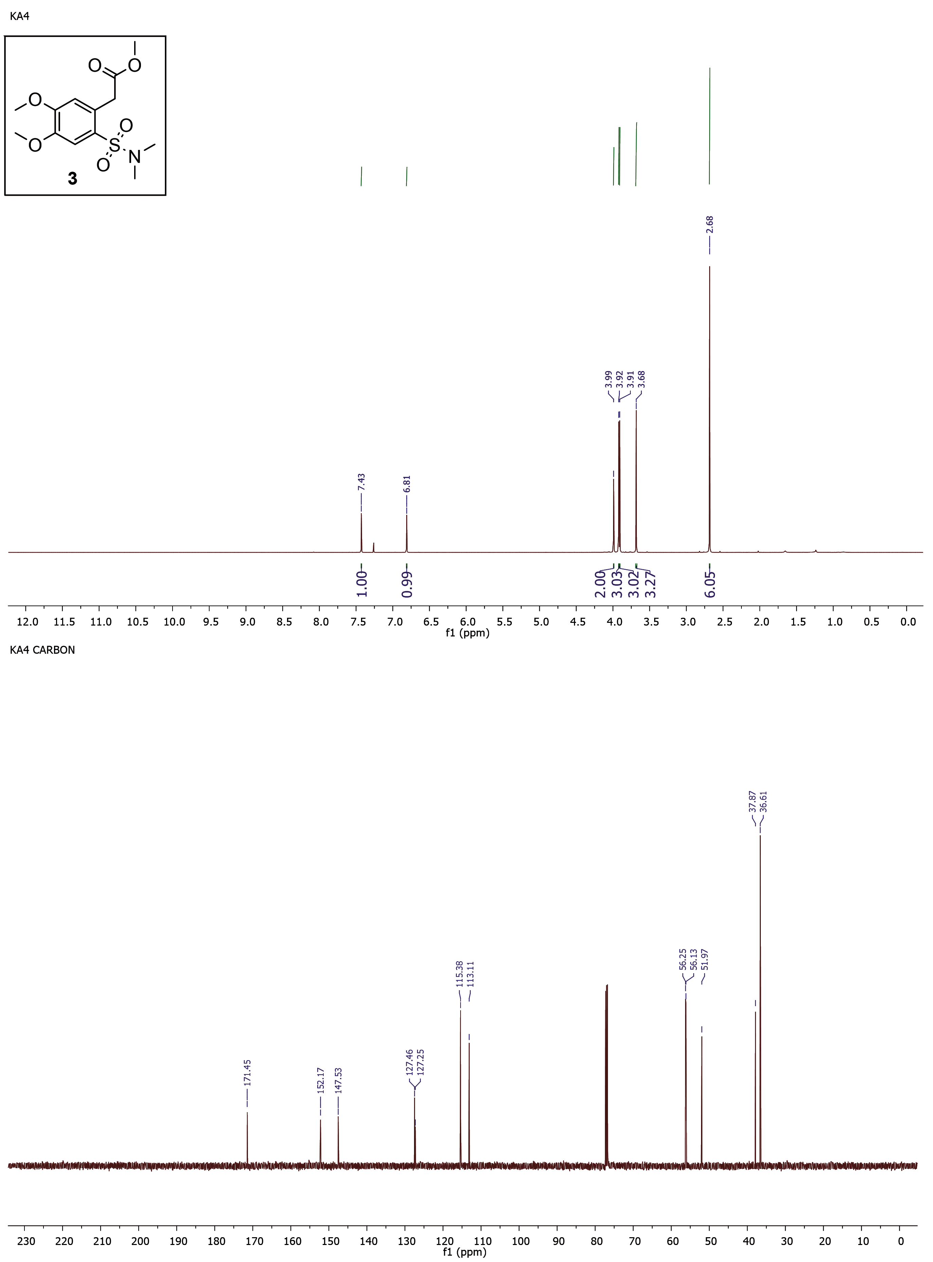

Figure S4. ¹H-NMR and ¹³C-NMR spectra for compound 3.

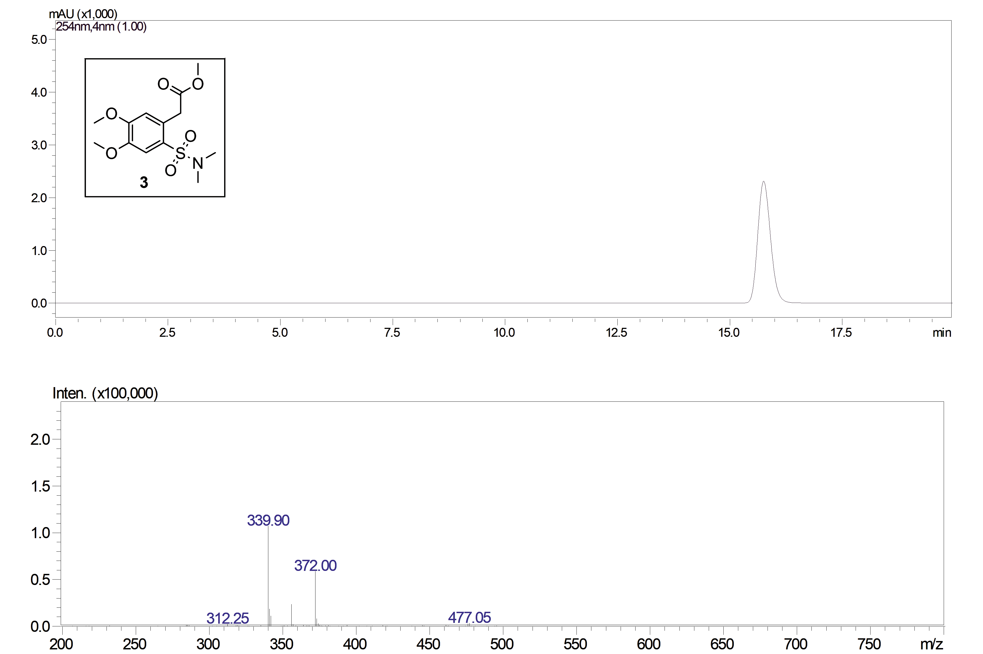

Figure S5. LC/ESI-MS analysis for compound 3. ESI-MS, positive mode: m/z calcd mass for C₁₃H₁₉NNaO₆S [M+Na]⁺= 340.08, was found 339.90. Analytical method for LC-MS: LC-20AD Shimadzu connected to Shimadzu LCMS-2010EV; Mobile Phase: methanol; LC isocratic; HPLC column: SUPELCO Discovery C18, 25cm x 4.6mm, 5μm; Flow rate: 0.4 mL/min; Column temperature: 26 °C; UV detector: 254 nm; MS detector: 1.65K; Run time: 20 min; Retention time: 15.8 min.

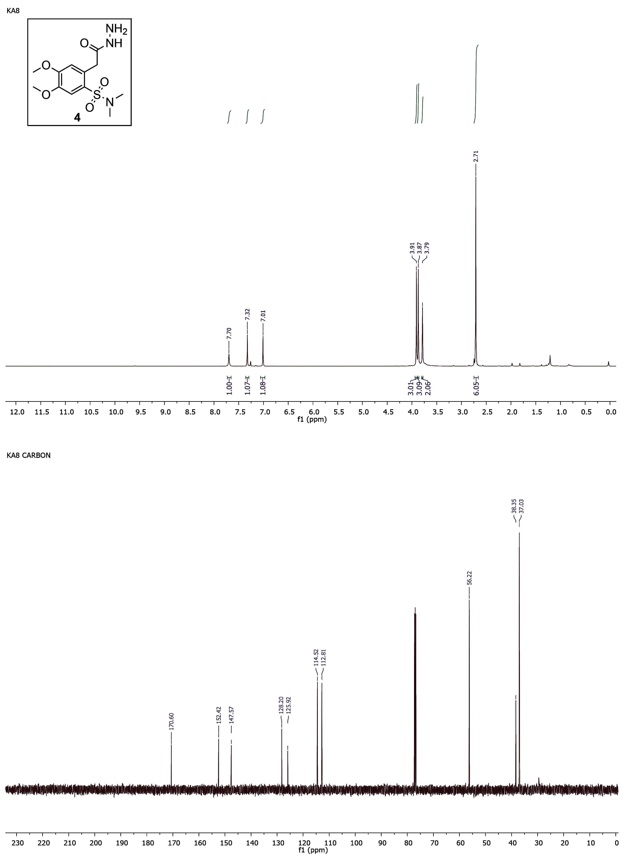

Figure S6. ¹H-NMR and ¹³C-NMR spectra for compound 4.

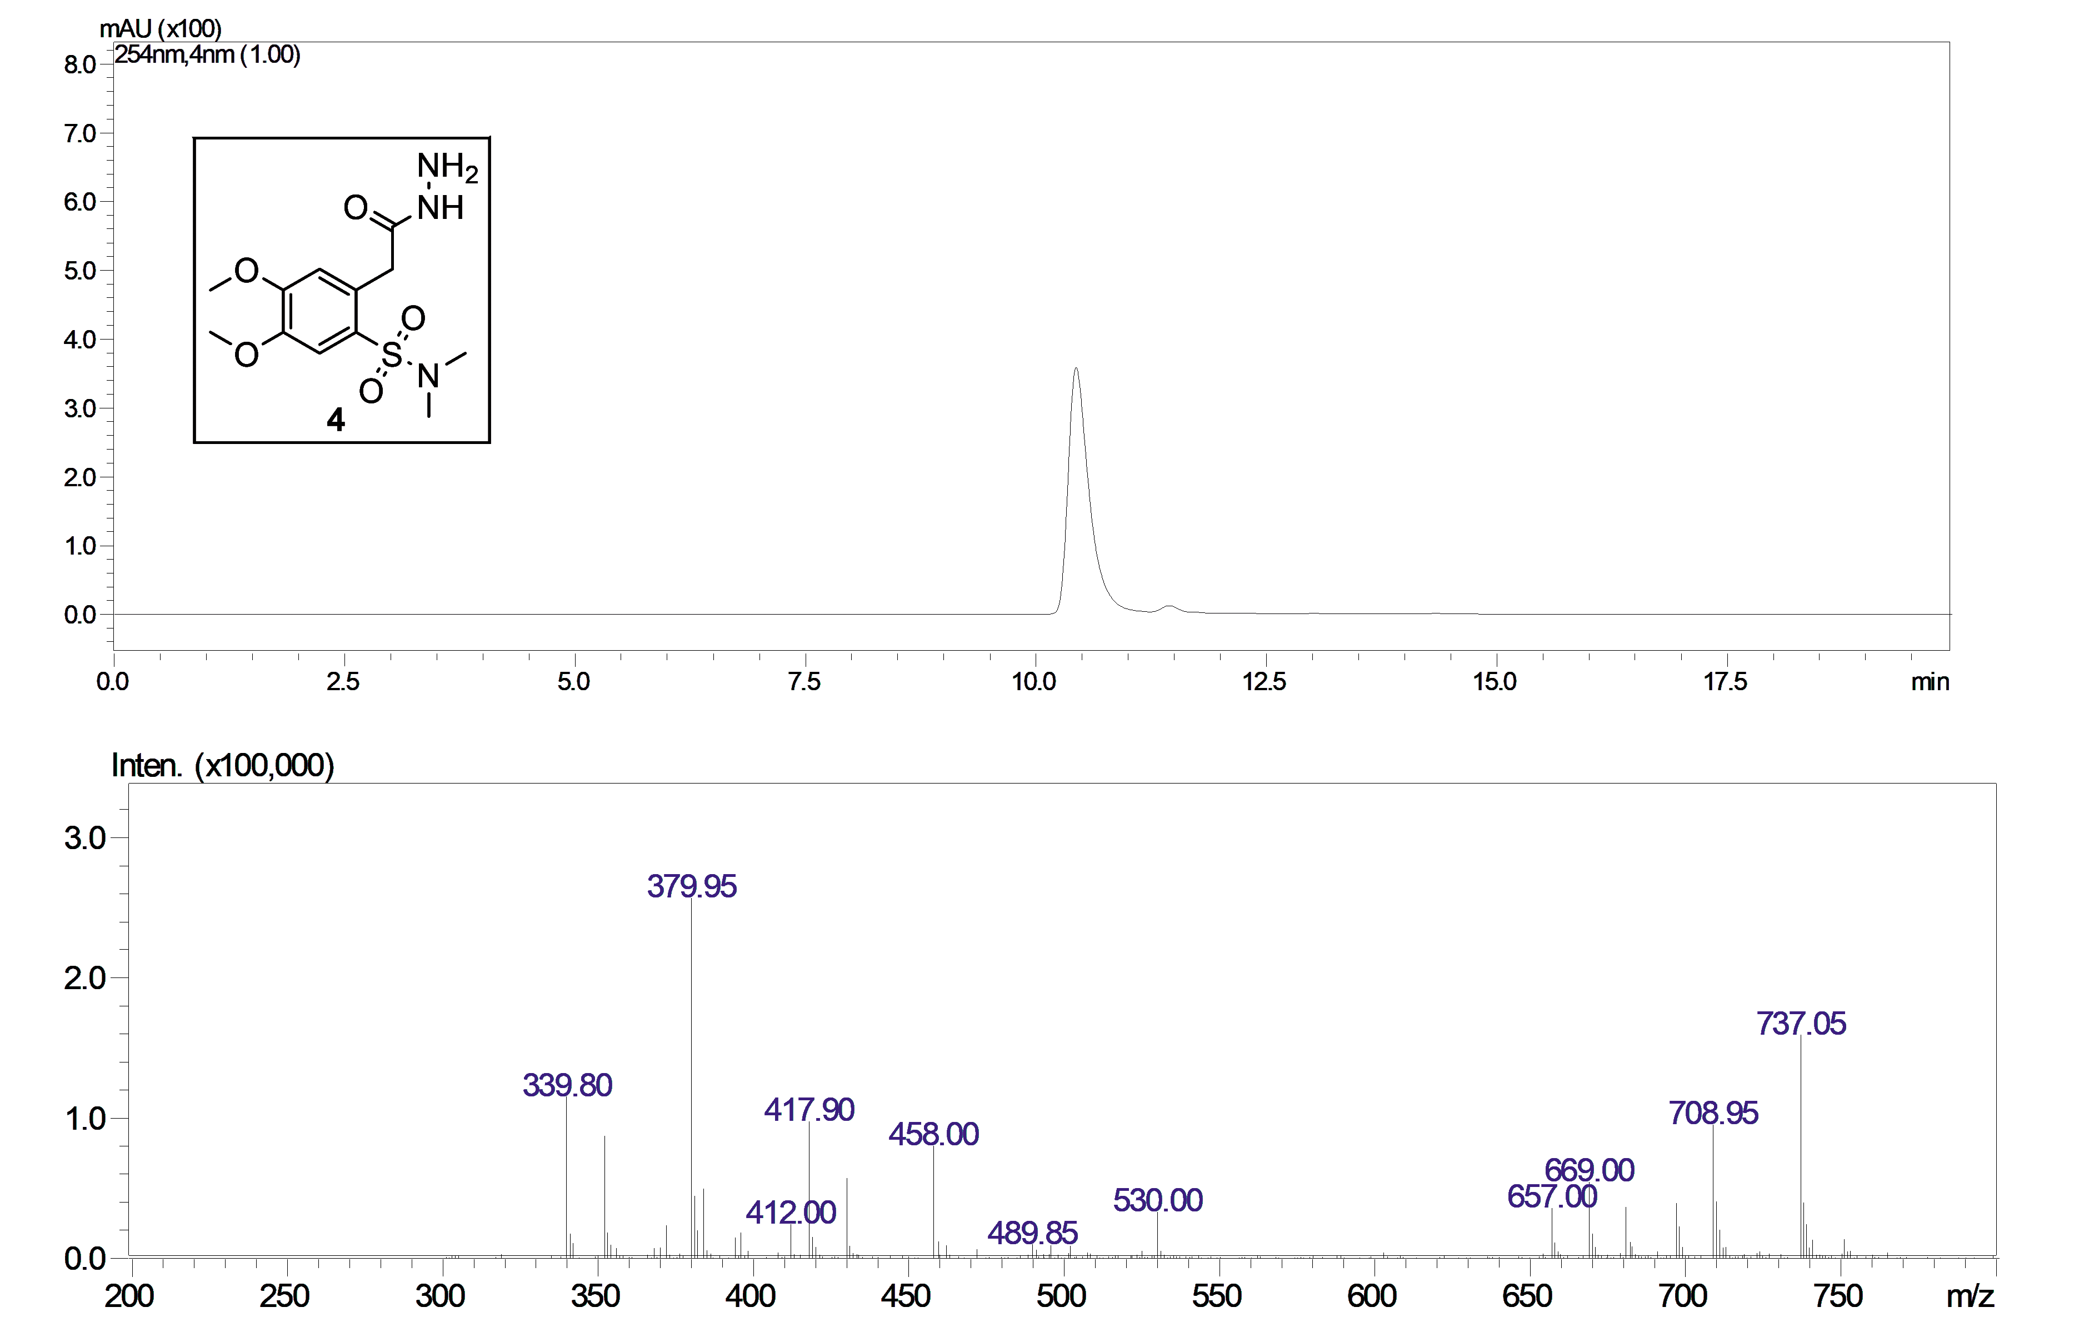

Figure S7. LC/ESI-MS analysis for compound 4. ESI-MS, positive mode: m/z calcd mass for C₁₂H₁₉N₃NaO₅S [M+Na]⁺= 340.09, was found 339.85. Analytical method for LC-MS: LC-20AD Shimadzu connected to Shimadzu LCMS-2010EV; Mobile Phase: methanol; LC isocratic; HPLC column: SUPELCO Discovery C18, 25cm x 4.6mm, 5μm; Flow rate: 0.4 mL/min; Column temperature: 26 °C; UV detector: 254 nm; MS detector: 1.65K; Run time: 20 min; Retention time: 10.4 min.

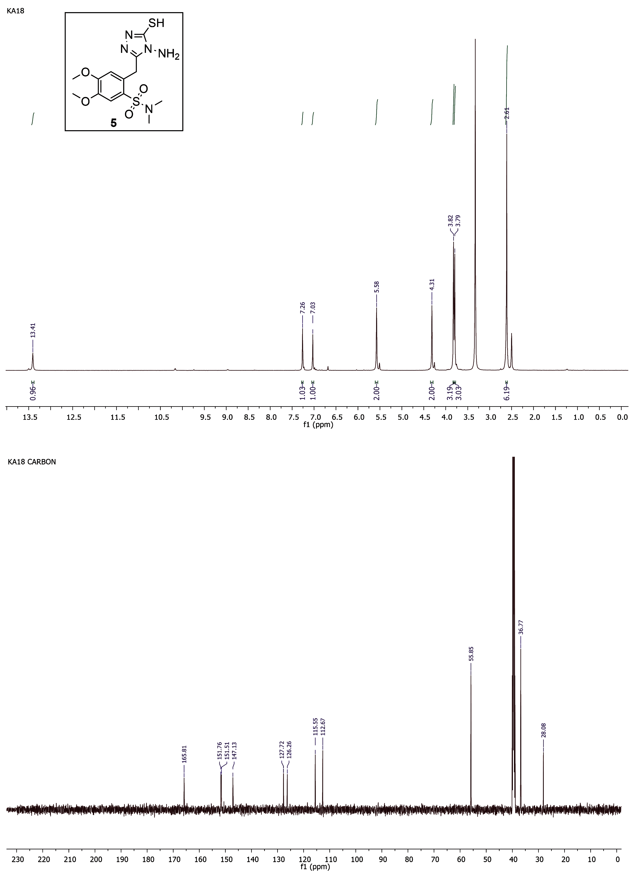
Figure S8. ¹H-NMR and ¹³C-NMR spectra for compound 5.

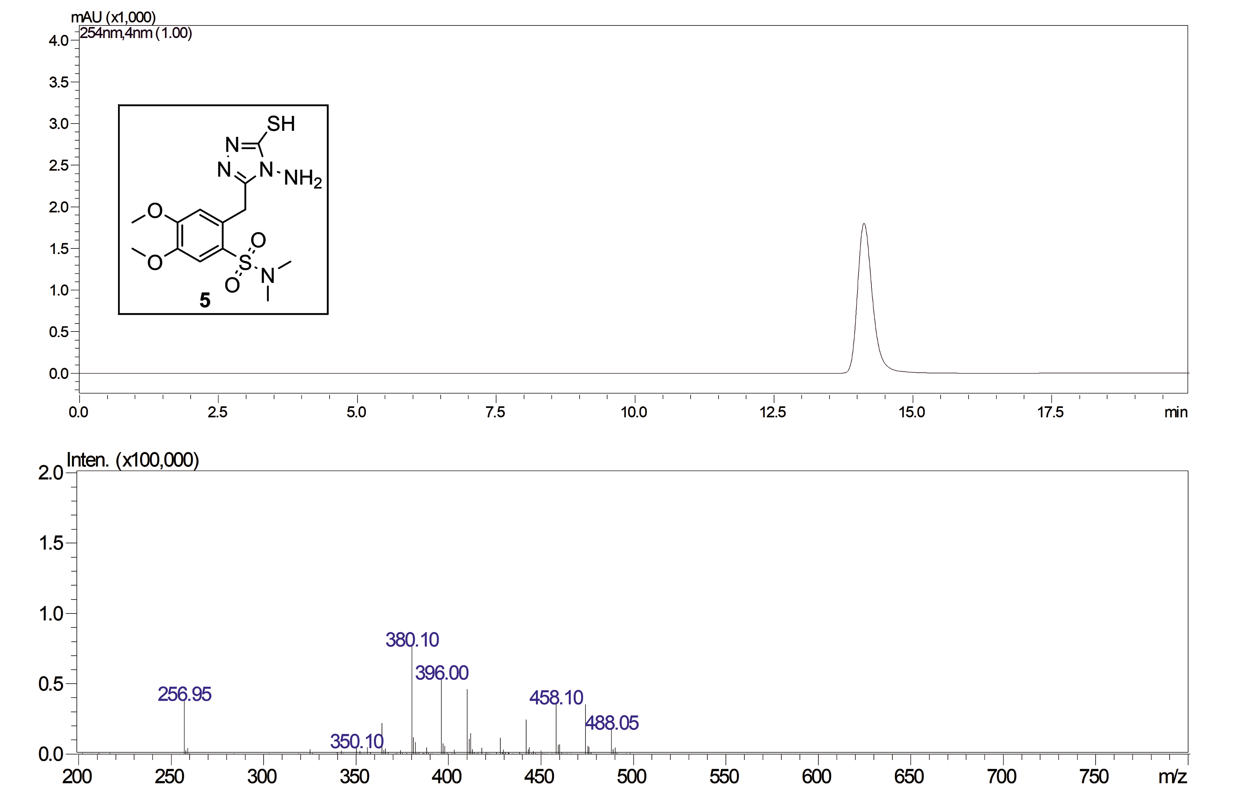

Figure S9. LC/ESI-MS analysis for compound 5. ESI-MS, positive mode: m/z calcd mass for C₁₃H₁₉N₅NaO₄S₂ [M+Na]⁺= 396.08, was found 396.00. Analytical method for LC-MS: LC-20AD Shimadzu connected to Shimadzu LCMS-2010EV; Mobile Phase: methanol; LC isocratic; HPLC column: SUPELCO Discovery C18, 25cm x 4.6mm, 5μm; Flow rate: 0.4 mL/min; Column temperature: 26 °C; UV detector: 254 nm; MS detector: 1.65K; Run time: 20 min; Retention time: 14.1 min.

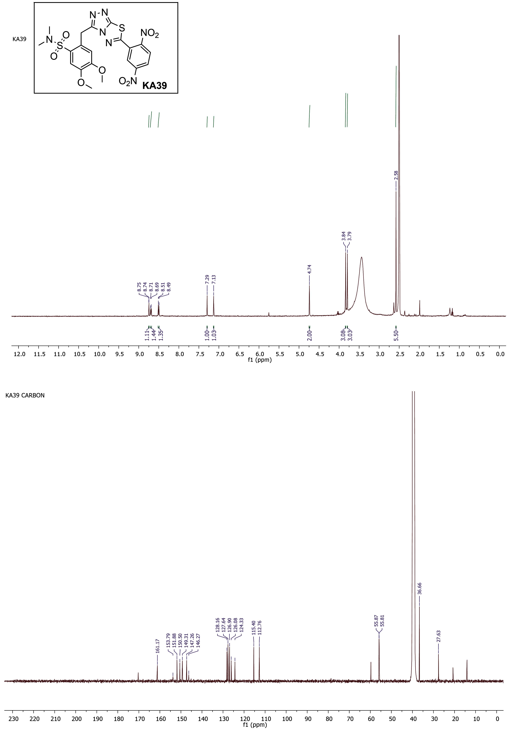

Figure S10. ¹H-NMR and ¹³C-NMR spectra for compound KA39.

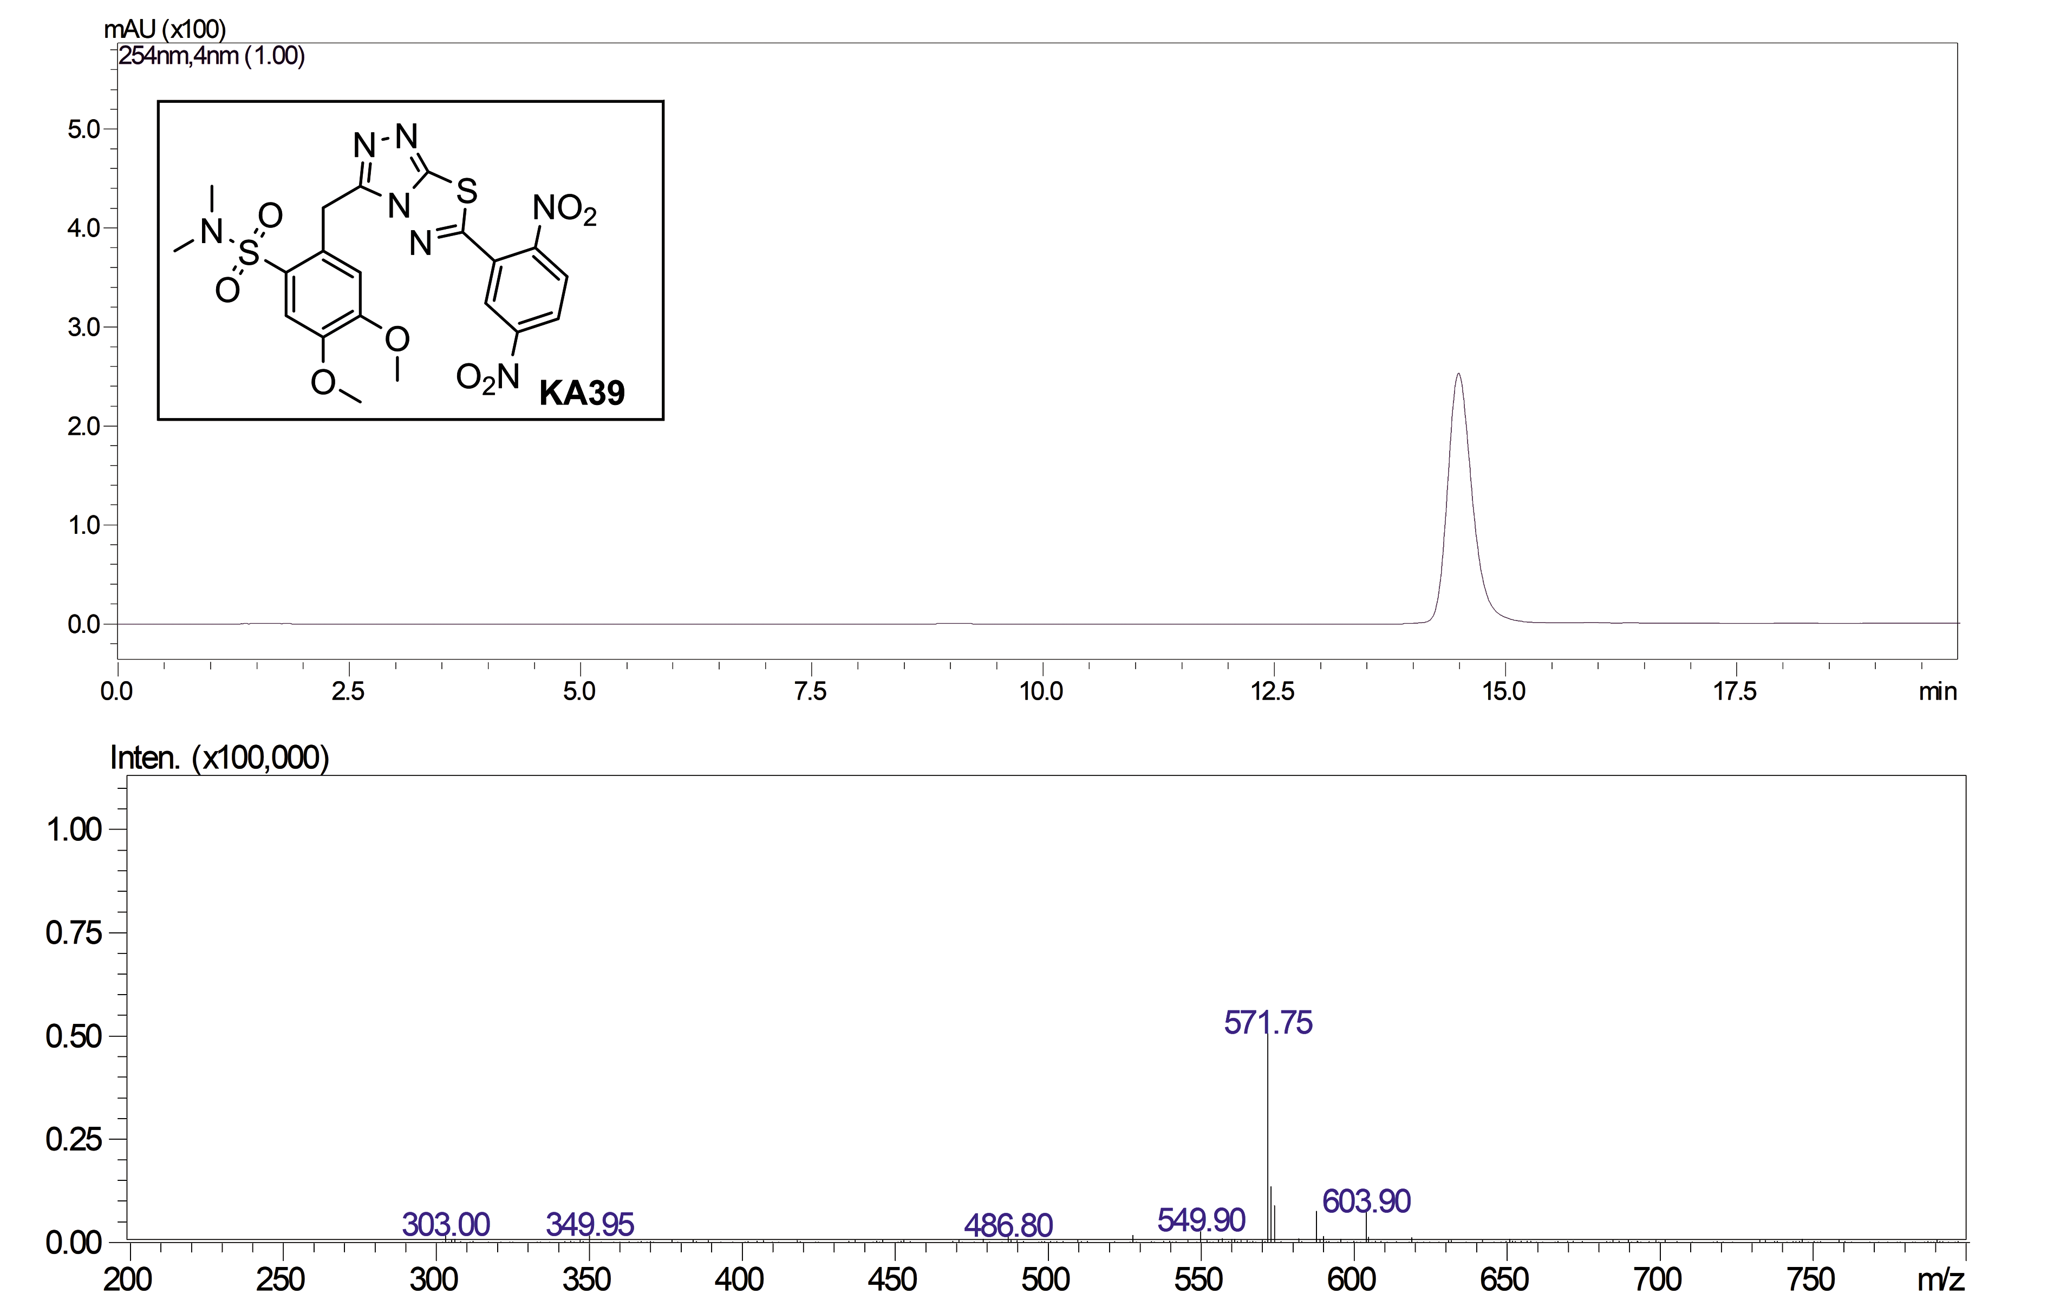

Figure S11. LC/ESI-MS analysis for compound KA39. ESI-MS, positive mode: m/z calcd mass for C₂₀H₁₉N₇NaO₈S₂ [M+Na]⁺= 572.06, was found 571.75. Analytical method for LC-MS: LC-20AD Shimadzu connected to Shimadzu LCMS-2010EV; Mobile Phase: methanol; LC isocratic; HPLC column: SUPELCO Discovery C18, 25cm x 4.6mm, 5μm; Flow rate: 0.4 mL/min; Column temperature: 26 °C; UV detector: 254 nm; MS detector: 1.65K; Run time: 20 min; Retention time: 14.5 min.

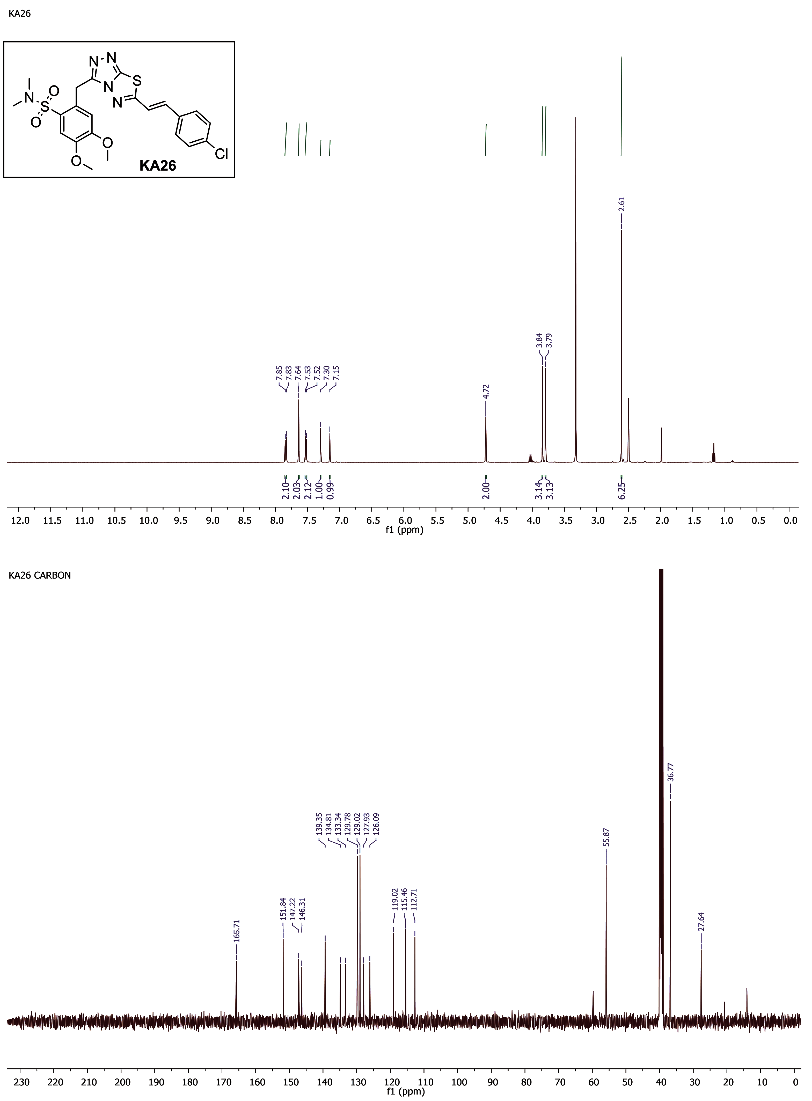

Figure S12. ¹H-NMR and ¹³C-NMR spectra for compound KA26.

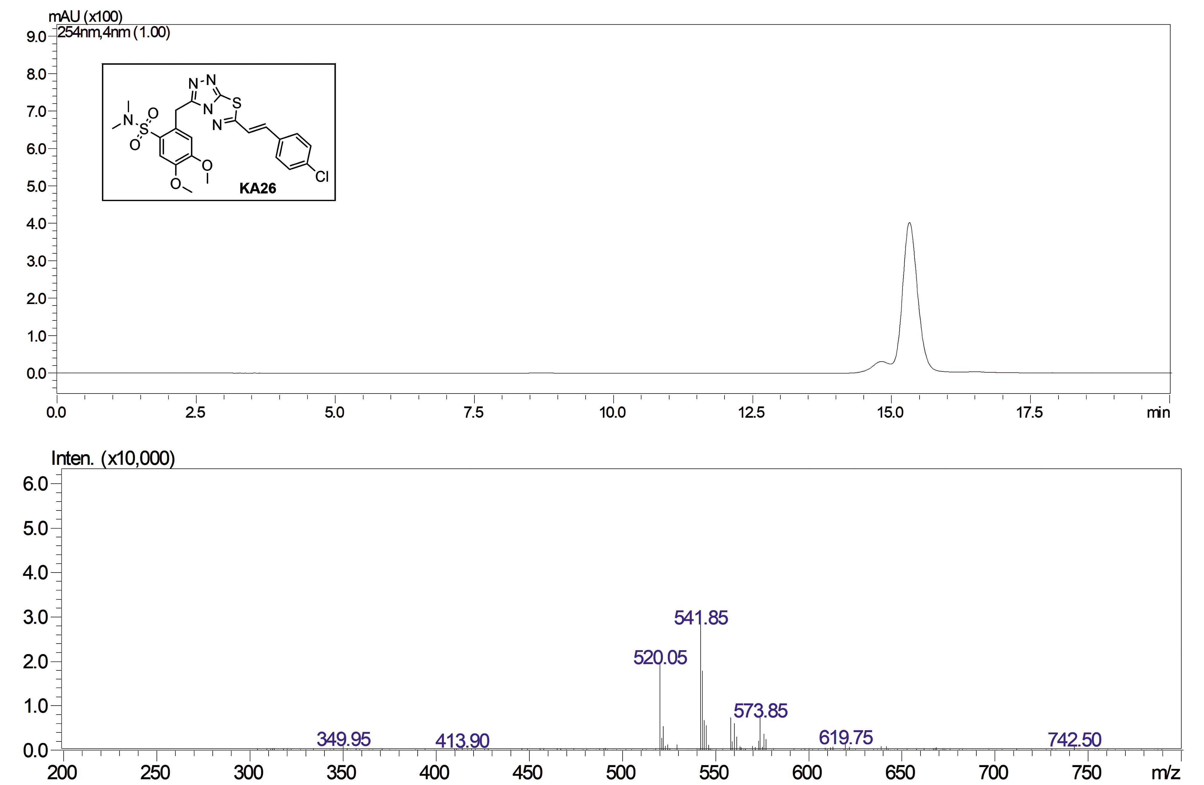

Figure S13. LC/ESI-MS analysis for compound KA26. ESI-MS, positive mode: m/z calcd mass for C₂₂H₂₂ClN₅NaO₄S₂ [M+Na]⁺= 542.07, was found 541.85. Analytical method for LC-MS: LC-20AD Shimadzu connected to Shimadzu LCMS-2010EV; Mobile Phase: methanol; LC isocratic; HPLC column: SUPELCO Discovery C18, 25cm x 4.6mm, 5μm; Flow rate: 0.4 mL/min; Column temperature: 26 °C; UV detector: 254 nm; MS detector: 1.65K; Run time: 20 min; Retention time: 15.4 min.

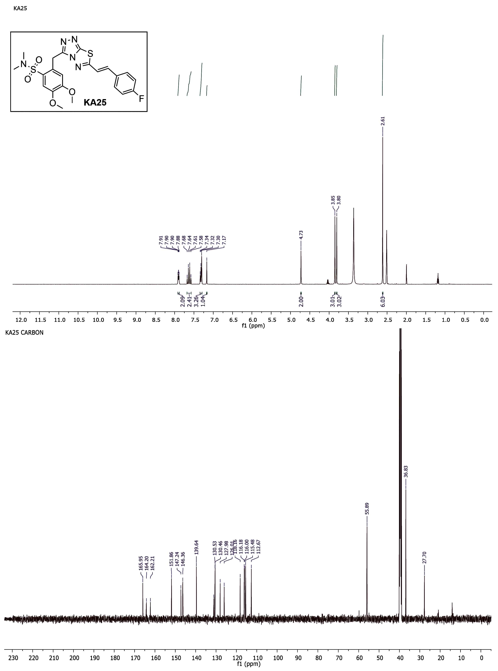

Figure S14. ¹H-NMR and ¹³C-NMR spectra for compound KA25.

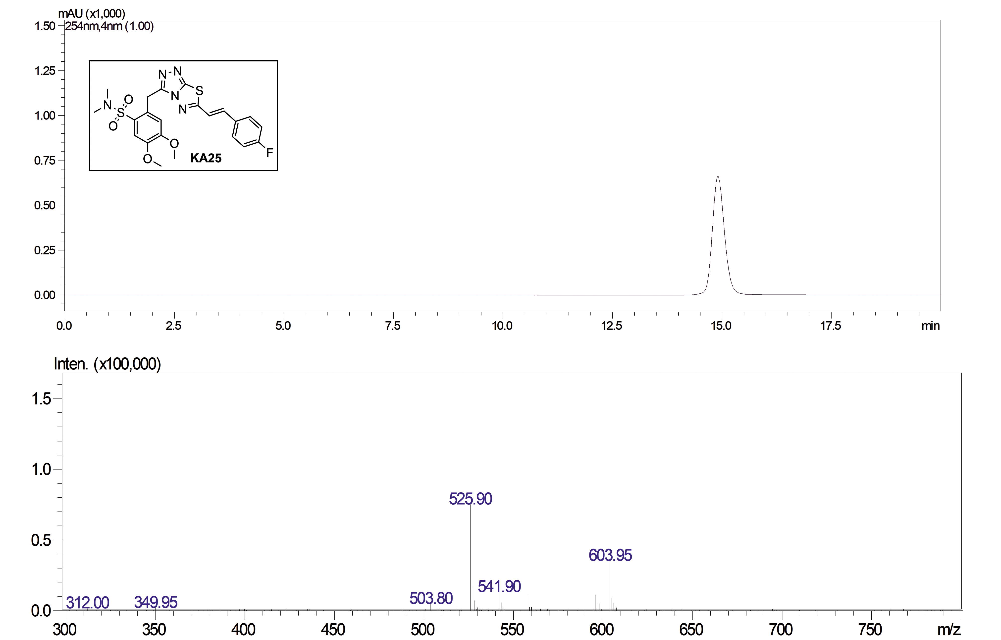

Figure S15. LC/ESI-MS analysis for compound KA25. ESI-MS, positive mode: m/z calcd mass for C₂₂H₂₂FN₅NaO₄S₂ [M+Na]⁺= 526.10, was found 525.90. Analytical method for LC-MS: LC-20AD Shimadzu connected to Shimadzu LCMS-2010EV; Mobile Phase: methanol; LC isocratic; HPLC column: SUPELCO Discovery C18, 25cm x 4.6mm, 5μm; Flow rate: 0.4 mL/min; Column temperature: 26 °C; UV detector: 254 nm; MS detector: 1.65K; Run time: 20 min; Retention time: 15 min.

