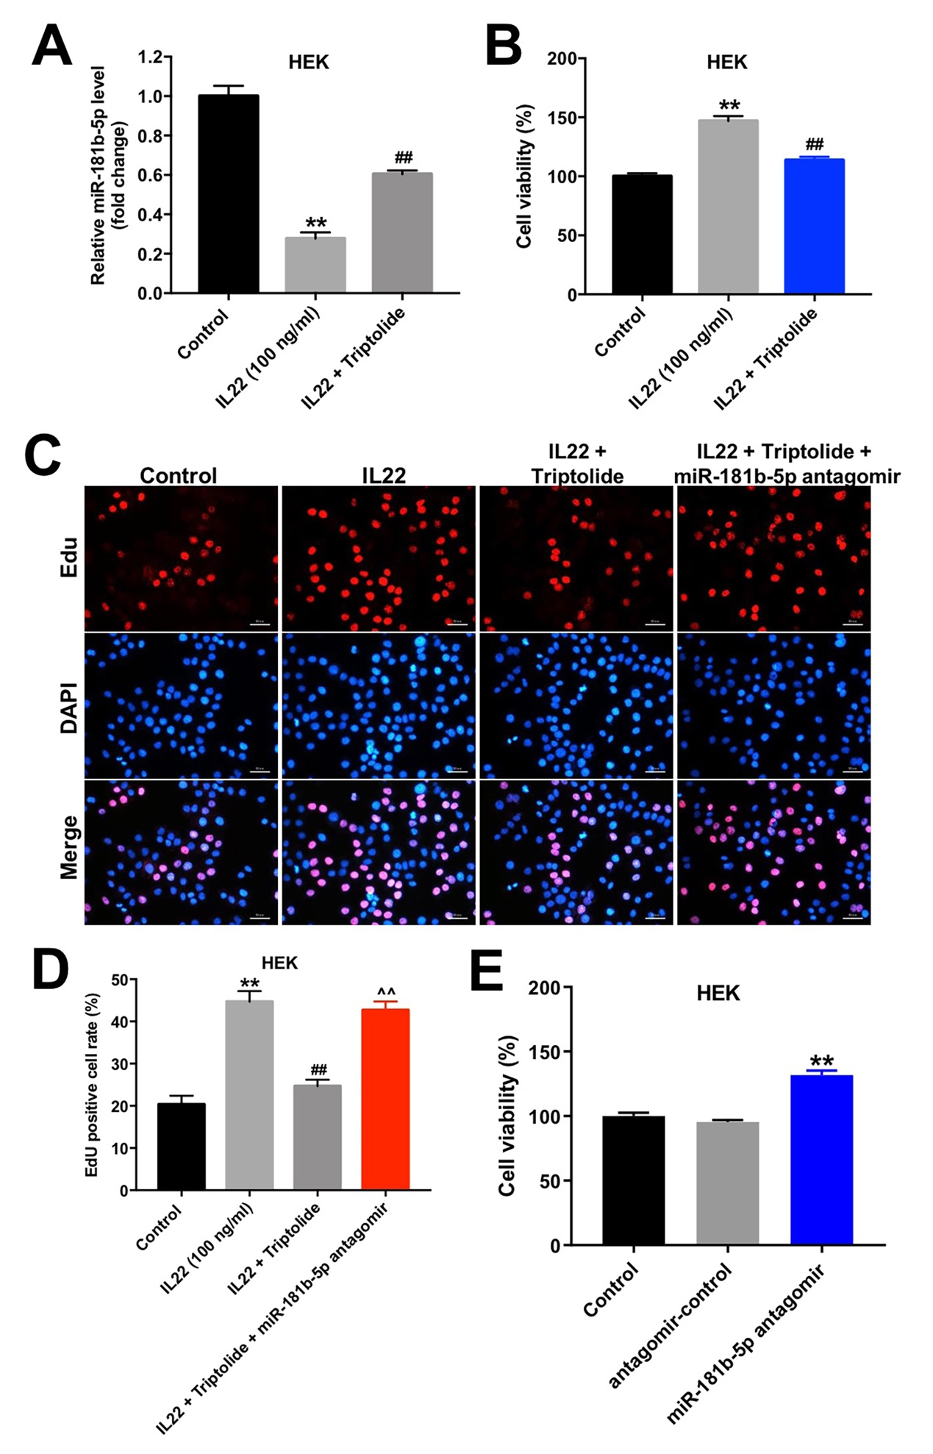
Supplementary Figure 1 Triptolide inhibits the proliferation of HEK cells induced by IL22 via upregulating miR-181b-5p. (A) HEK cells were exposed to 10 μM Triptolide for 24 h, and then treated with 100 ng/mL of IL22 for 24 h. The level of miR-181b-5p in cells was detected using RT-qPCR. (B) HEK cells were transfected with miR-181b-5p antagonist and exposed to 10 μM triptolide for 24 h, and then treated with 100 ng/mL of IL22 for 24 h. CCK-8 assay was used to determine the cell proliferation. (C, D) EdU immunofluorescence staining was used to assess the cell proliferation. (E) HEK cells were transfected with miR-181b-5p antagonist or control for 24 h. CCK-8 assay was used to determine the cell proliferation.
*P < 0.05, **P < 0.01, compared with the control group. ##P < 0.01, compared with the 100 ng/mL IL22 group. ^^P < 0.01, compared with IL22 + triptolide group.

