Supporting Information
for
Multimodal mesoporous silica nanocarriers for dual stimuli-responsive drug release and excellent photothermal ablation of cancer cells

Vy Anh Tran^{1,2,}*, Van Giau Vo^{3,4,}*, Kyuhwan Shim⁵, Sang-Wha Lee^{1#}, and Seong Soo A. An^{6#}
¹Department of Chemical and Biological Engineering, Gachon University, Republic of Korea
²NTTHi-Tech Institute, Nguyen Tat Thanh University, Ho Chi Minh City 700000, Vietnam
³Institute of Research and Development, Duy Tan University, Danang 550000, Vietnam
⁴Department of Industrial and Environmental Engineering, Graduate School of Environment, Gachon University, Seongnam 13120, Republic of Korea
⁵Department of Neurology, Veterans Medical Research Institute, Veterans Health Service Medical Center, Seoul 05368, Republic of Korea
⁶Department of BioNano Technology, Gachon University, Seongnam 13120, Republic of Korea
*These authors contributed equally to this work
Gachon University, San 65, Bokjeong-Dong, Sujeong-Gu, Seongnam City, 461-701, South Korea

#Corresponding authors:
Sang-Wha Lee, PhD
E-mail: lswha@gachon.ac.kr

Seong Soo A. An, PhD
E-mail: seongaan@gachon.ac.kr

Instrumental analysis
Scanning electron microscopy (SEM): Hitachi S-4700 FE-SEM (Japan) was used. For all samples, imaging was performed in high vacuum at 15 kV accelerating voltage. Samples in water were dripped down the cover glass (22 x 22 mm). After drying, samples containing cover glass pieces were attached to the polished aluminum stubs substrate through carbon tape. For these samples, it was found to be not necessary to coat the samples (with gold/palladium). This lead to accurate size measurements. All sample solutions were treated in an ultrasonic (30 seconds) bath and vortex mixer (5 seconds) before deposition to reduce aggregation.
Transmission electron microscopy (TEM): TEM specimens were prepared by placing one drop (10 μL) of the nanoparticle solution onto a carbon-coated copper grid and drying at room temperature. As with other techniques, all sample solutions were treated in an ultrasonic (30 seconds) bath and vortex mixer (5 seconds) before deposition to reduce aggregation. TEM was performed with a Hitachi H-7600 (Japan) microscope operated at 80 kV and a Tecnai G2 F30 (Germany) microscope operated at 300 kV.
Photoluminescence (PL): The fluorescence emission spectra of samples were obtained using a fluoroluminescence spectrometer (Quanta Master, Photon Technology International, NJ, USA) equipped with a xenon lamp (Arc Lamp Housing, A-1010B™), monochromator, and power supply (Brytexbox). All samples include MSNs, S3, S3P, FS3P-G were dispersed in HPLC-grade water with same concentration 4 mg/ml. Samples were checked both for excitation and emission scan with integration 0.1 seconds.
Fourier Transform Infrared Spectra (FTIR): After powder samples were dried by a freeze-dryer, then put a small amount of these powder directly on between two support plates without hygroscopic material (such as NaCl or KBr). The FTIR spectra were recorded using a FTIR spectrometer (Vertex 70, Bruker, USA).
UV-visible absorption: With the in-vitro release tests, to determine the amounts of released drugs, standard calibration curves were obtained from the ultraviolet-visible absorption peaks of the drug. Immediately after S3/C, FS3P/C or FS3P-G/C were added to the PBS solution, an aliquot was periodically sampled from the solution to monitor the released drug amounts by UV-vis spectroscopy (NanoDrop; NanoDrop Technologies, Wilmington, Delaware, USA).
Raman spectroscopy: Raman spectra of probe molecules were measured by a micro-Raman spectrometer (ANDOR Monora 500i) and light microscope BX43-Olympus. Indium tin oxide (ITO) glass was used to check Raman spectra which as is a substrate to surface-enhanced Raman scattering (SERS). ITO glass was washed by sonication for 5 min in HPLC-grade water, then samples in water were deposited on a surface of ITO glass. After the deposition process was complete, samples were dried at room temperature and checking Raman spectroscopy.

Figure S1. The schematic illustration of APTMS-FITC conjugates, PDA coting, and electrostatic interactions between Polydopamine and Graphene oxide in FS3 NPs.

Figure S2. (a) UV-Vis absorption spectra of FS3, FS3P, FS3P-G and FS3P-A NPs in PBS, (b) SEM image of FS3P-G NPs, (c) EDS spectra of core-shell FS3P-A.
(a) (b)
Figure S3. Temperature-variation curves of S, S3P-G/C, F (Fe₃O₄), FS3P-G/C, S3P-A/C and FS3P-A/C solutions under NIR irradiation by an 808 nm laser for 10 min: (a) at a power density of 1.5 W/cm² and NPs concentration of 2.5 mg/mL, (b) at a power density of 2.0 W/cm² and NPs concentration of 5 mg/mL.
Figure S4. (a) Cumulative cisplatin release profiles from FS3P/C, and FS3P-A/C in PBS at pH 7.4 and pH 5.5; (b) the model fit of release amounts versus cumulative square root time by SP/C and FS3P/C, and FS3P-G/C, FS3P-A/C in PBS at 37ºC pH 5.5.

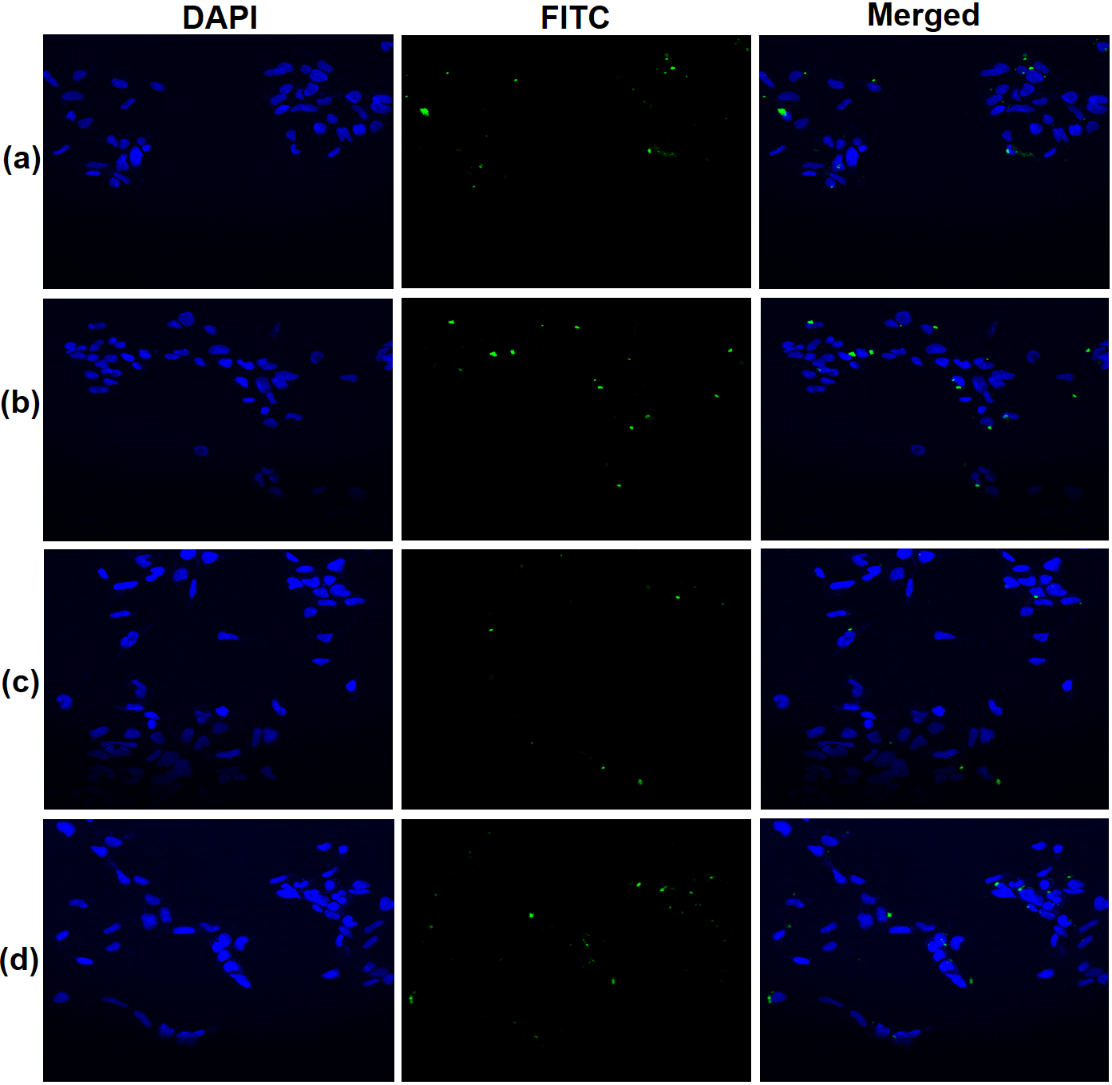
Figure S5. Confocal Microscopy of HEK293 cells after 4h incubation with (a) SP/C, (b) FS3P-G/C, (c) FS3P-A/C and (d) FS3P-G-E/C

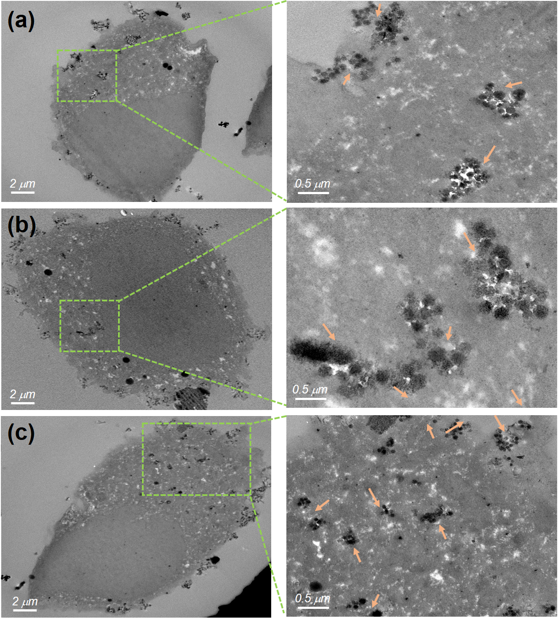
(a)

Figure S6. Thin-section TEM images of SH-SY5Y incubated with Magnetic mesoporous silica nanoparticles. (a) SP/C, (b) FS3P-G/C and (c) FS3P-G-E/C. Arrows denote metal oxide particles or particulate matter.
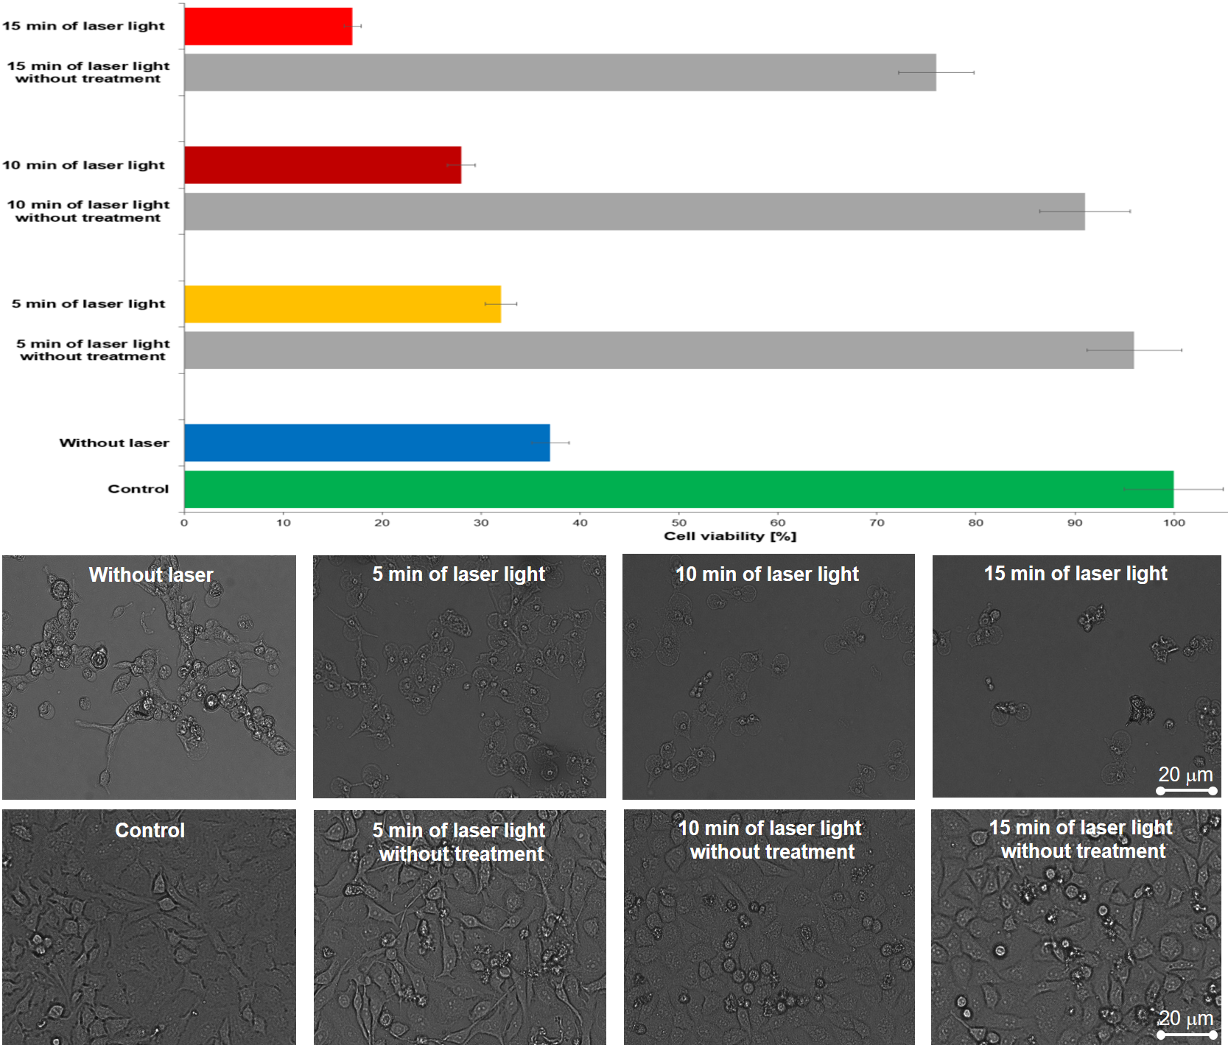
Figure S7. Cell viability of HeLa cells and their morphological observation (the down panel) incubated with or without FS3P-G/C (concentration 5 μg/ml) with or without 808 nm NIR laser irradiation at 1.5 W/cm² for 5, 10 and 15 min.

Table S1. Physicochemical properties of S, S3, FS3 and FS3P measured by BET–BJT and Zeta potential
Sample | Surface Area^{a)}  (m²/g) | Pore Volume^{b)}  (cm³/g) | Pore Size^{b)}  (nm) | Average pore diameter ^{c)}  (nm) | Zeta-potential at pH 7.4  (mv)
S | 260 | 0.62 | 10.2 | 2.38 | −37.7 ±5.5
S3 | 1156 | 1.67 | 5.6 | 1.45 | −12.3±4.2
FS3 | 846 | 1.30 | 6.2 | 1.54 | −19.1±3.6
FS3P | 16 | 0.05 | 23.1 | 3.1 | +21.1±3.8
^{a)} The surface area was estimated according to the Brunauer–Emmett–Teller (BET) method.
^{b)} The pore size and pore volume were calculated by the Barrett–Joyner–Halenda (BJH) method.
^{c)} Average pore diameter, estimated using the desorption branch of the isotherm and the BJH formula (average pore diameter = pore volume / surface area).

Table S2. The summary of fitted parameter values of kinetic models applied to the release data of SP/C, FS3P/C and FS3P-G/C and FS3P-A/C
Case | As-prepared NPs | Diffusion models | Formula | Parameters
A | SP/C | Sigmoid behavior  (S-shaped behavior) | Q_{t}/Q∞ = (Q_{max} t^{γ})/(Q_{1/2} + t^{γ}) | γ = 2.1
A | FS3P/C | K-P model # | Q_{t}/Q∞ = k_{R} t^{n} | k_{R} = 9.5  n = 0.64
B | FS3P-G/C | K-P model | Q_{t}/Q∞ = k_{R} t^{n} | k_{R} = 10.5  n = 0.62
B | FS3P-A/C | K-P model | Q_{t}/Q∞ = k_{R} t^{n} | k_{R} = 6.9  n = 0.71

# K-P model indicate the Korsmeyer-Peppas model.

References
1. Rejeeth, C.; Vivek, R.; Kannan, S., A novel magnetic drug delivery nanocomplex with a cisplatin-conjugated Fe3O4 core and a PEG-functionalized mesoporous silica shell for enhancing cancer drug delivery efficiency. RSC Advances 2015, 5 (115), 94534-94538.
2. Kim, J.; Kim, H. S.; Lee, N.; Kim, T.; Kim, H.; Yu, T.; Song, I. C.; Moon, W. K.; Hyeon, T., Multifunctional uniform nanoparticles composed of a magnetite nanocrystal core and a mesoporous silica shell for magnetic resonance and fluorescence imaging and for drug delivery. Angewandte Chemie (International ed. in English) 2008, 47 (44), 8438-41.
3. Tran, V. A.; Lee, S. W., A prominent anchoring effect on the kinetic control of drug release from mesoporous silica nanoparticles (MSNs). Journal of colloid and interface science 2018, 510, 345-356.
4. Lodha, A.; Lodha, M.; Patel, A.; Chaudhuri, J.; Dalal, J.; Edwards, M.; Douroumis, D., Synthesis of mesoporous silica nanoparticles and drug loading of poorly water soluble drug cyclosporin A. Journal of Pharmacy & Bioallied Sciences 2012, 4 (Suppl 1), S92-S94.
5. Andersson, A.; Hedenmalm, H.; Elfsson, B.; Ehrsson, H., Determination of the Acid Dissociation Constant for Cis–Diammineaquachloroplatinum( I I) Ion. A Hydrolysis Product of Cisplatin. Journal of Pharmaceutical Sciences 1994, 83 (6), 859-862.
6. Vivero-Escoto, J. L.; Elnagheeb, M., Mesoporous Silica Nanoparticles Loaded with Cisplatin and Phthalocyanine for Combination Chemotherapy and Photodynamic Therapy in vitro. Nanomaterials (Basel, Switzerland) 2015, 5 (4), 2302-2316.
7. Sreejith, S.; Ma, X.; Zhao, Y., Graphene Oxide Wrapping on Squaraine-Loaded Mesoporous Silica Nanoparticles for Bioimaging. Journal of the American Chemical Society 2012, 134 (42), 17346-17349.
8. Raj, V.; Prabha, G., Synthesis, characterization and in vitro drug release of cisplatin loaded Cassava starch acetate–PEG/gelatin nanocomposites. Journal of the Association of Arab Universities for Basic and Applied Sciences 2016, 21, 10-16.
9. Nguyen, N. H.; Nguyen, T. T.; Ma, P. C.; Ta, Q. T. H.; Duong, T. H.; Vo, V. G., Potential Antimicrobial and Anticancer Activities of an Ethanol Extract from Bouea macrophylla. Molecules (Basel, Switzerland) 2020, 25 (8).

