Factor | N (%) or median (range)
age | 68.08 (50-90)
gender
female | 106 (26.2%)
male | 299 (73.8%)
grade
low | 21 (5.0%)
high | 384 (95%)
stage
I | 2 (0.4%)
II | 129 (31.9%)
III | 139 (34.3%)
IV | 135 (33.3%)
Supplementary Table 1 Patient characteristics and pathologic features

Supplementary Table 2 Prognostic value of DEGs in low grade and high grade of BLCA tumors validated by TCGA database
Gene | p value
FADS1 | 0.0000075
TM4SF1 | 0.002072
CRTAC1 | 0.003204
HSD17B2 | 0.005248
MST1R | 0.005507
PHGDH | 0.005588
BTBD16 | 0.006728
FBN2 | 0.00789
CTSE | 0.008339
ANLN | 0.012581
PLCD3 | 0.037367
CDKN3 | 0.04206
HMGB2 | 0.044853

Supplementary Table 3 Hub genes expression level in BLCA patients
Gene | Low grade (Mean ± SEM) | High grade(Mean ± SEM) | p value
FADS1 | 1.601 ± 0.4624 | 5.679 ± 0.3447 | 0.0063
TM4SF1 | 11.3 ± 3.483 | 55.45 ± 3.411 | 0.0028
CRTAC1 | 85.54 ± 40.5 | 12.54 ± 2.837 | <0.0001
HSD17B2 | 20.91 ± 2.782 | 4.88 ± 0.4152 | <0.0001
MST1R | 15.74 ± 2.216 | 7.921 ± 0.4288 | <0.0001

Supplementary Table 4 Univariate and multivariate Cox proportional hazard regression analyses of overall survival (OS) in BLCA patients
 | Univariate analysis |  |  | Multivariate analysis
Variable | HR (95% CI) | p value |  | HR (95% CI) | p value
Age | 2.27 (1.39-3.71) | 0.001 |  | 1.93 (1.18-3.17) | 0.009
Gender | 0.88 (0.62-1.25) | 0.485 |  | 0.86 (0.60-1.23) | 0.404
Stage | 1.84 (1.50-2.27) | <0.001 |  | 1.65 (1.33-2.04) | <0.001
FADS1 | 1.02 (1.01-1.04) | 0.012 |  | 1.03 (1.01-1.05) | 0.014
TM4SF1 | 1.00 (1.00-1.01) | <0.001 |  | 1.00 (1.00-1.01) | 0.003
CRTAC1 | 0.99 (0.99-1.00) | 0.083 |  | 1.00 (0.99-1.00) | 0.618
HSD17B2 | 0.97 (0.94-0.99) | 0.006 |  | 0.99 (0.97-1.02) | 0.671
MST1R | 0.96 (0.93-0.98) | <0.001 |  | 0.96 (0.94-0.99) | 0.006

Supplementary Figure S1
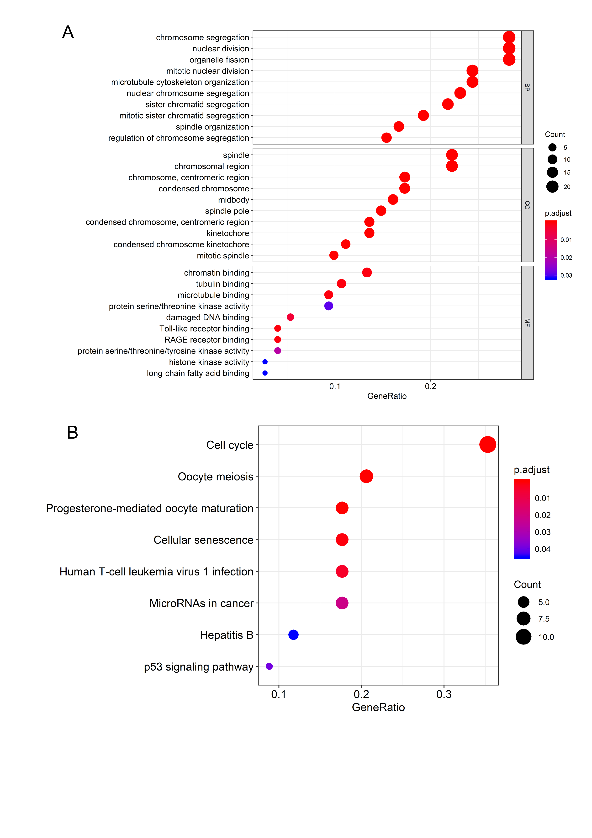
Figure. S1 The functional analysis of up-regulated DEGs. (A) Gene Ontology analysis and significant enriched GO terms related with tumor grade. (B) KEGG pathway enrichment terms related with tumor grade.

Supplementary Figure S2
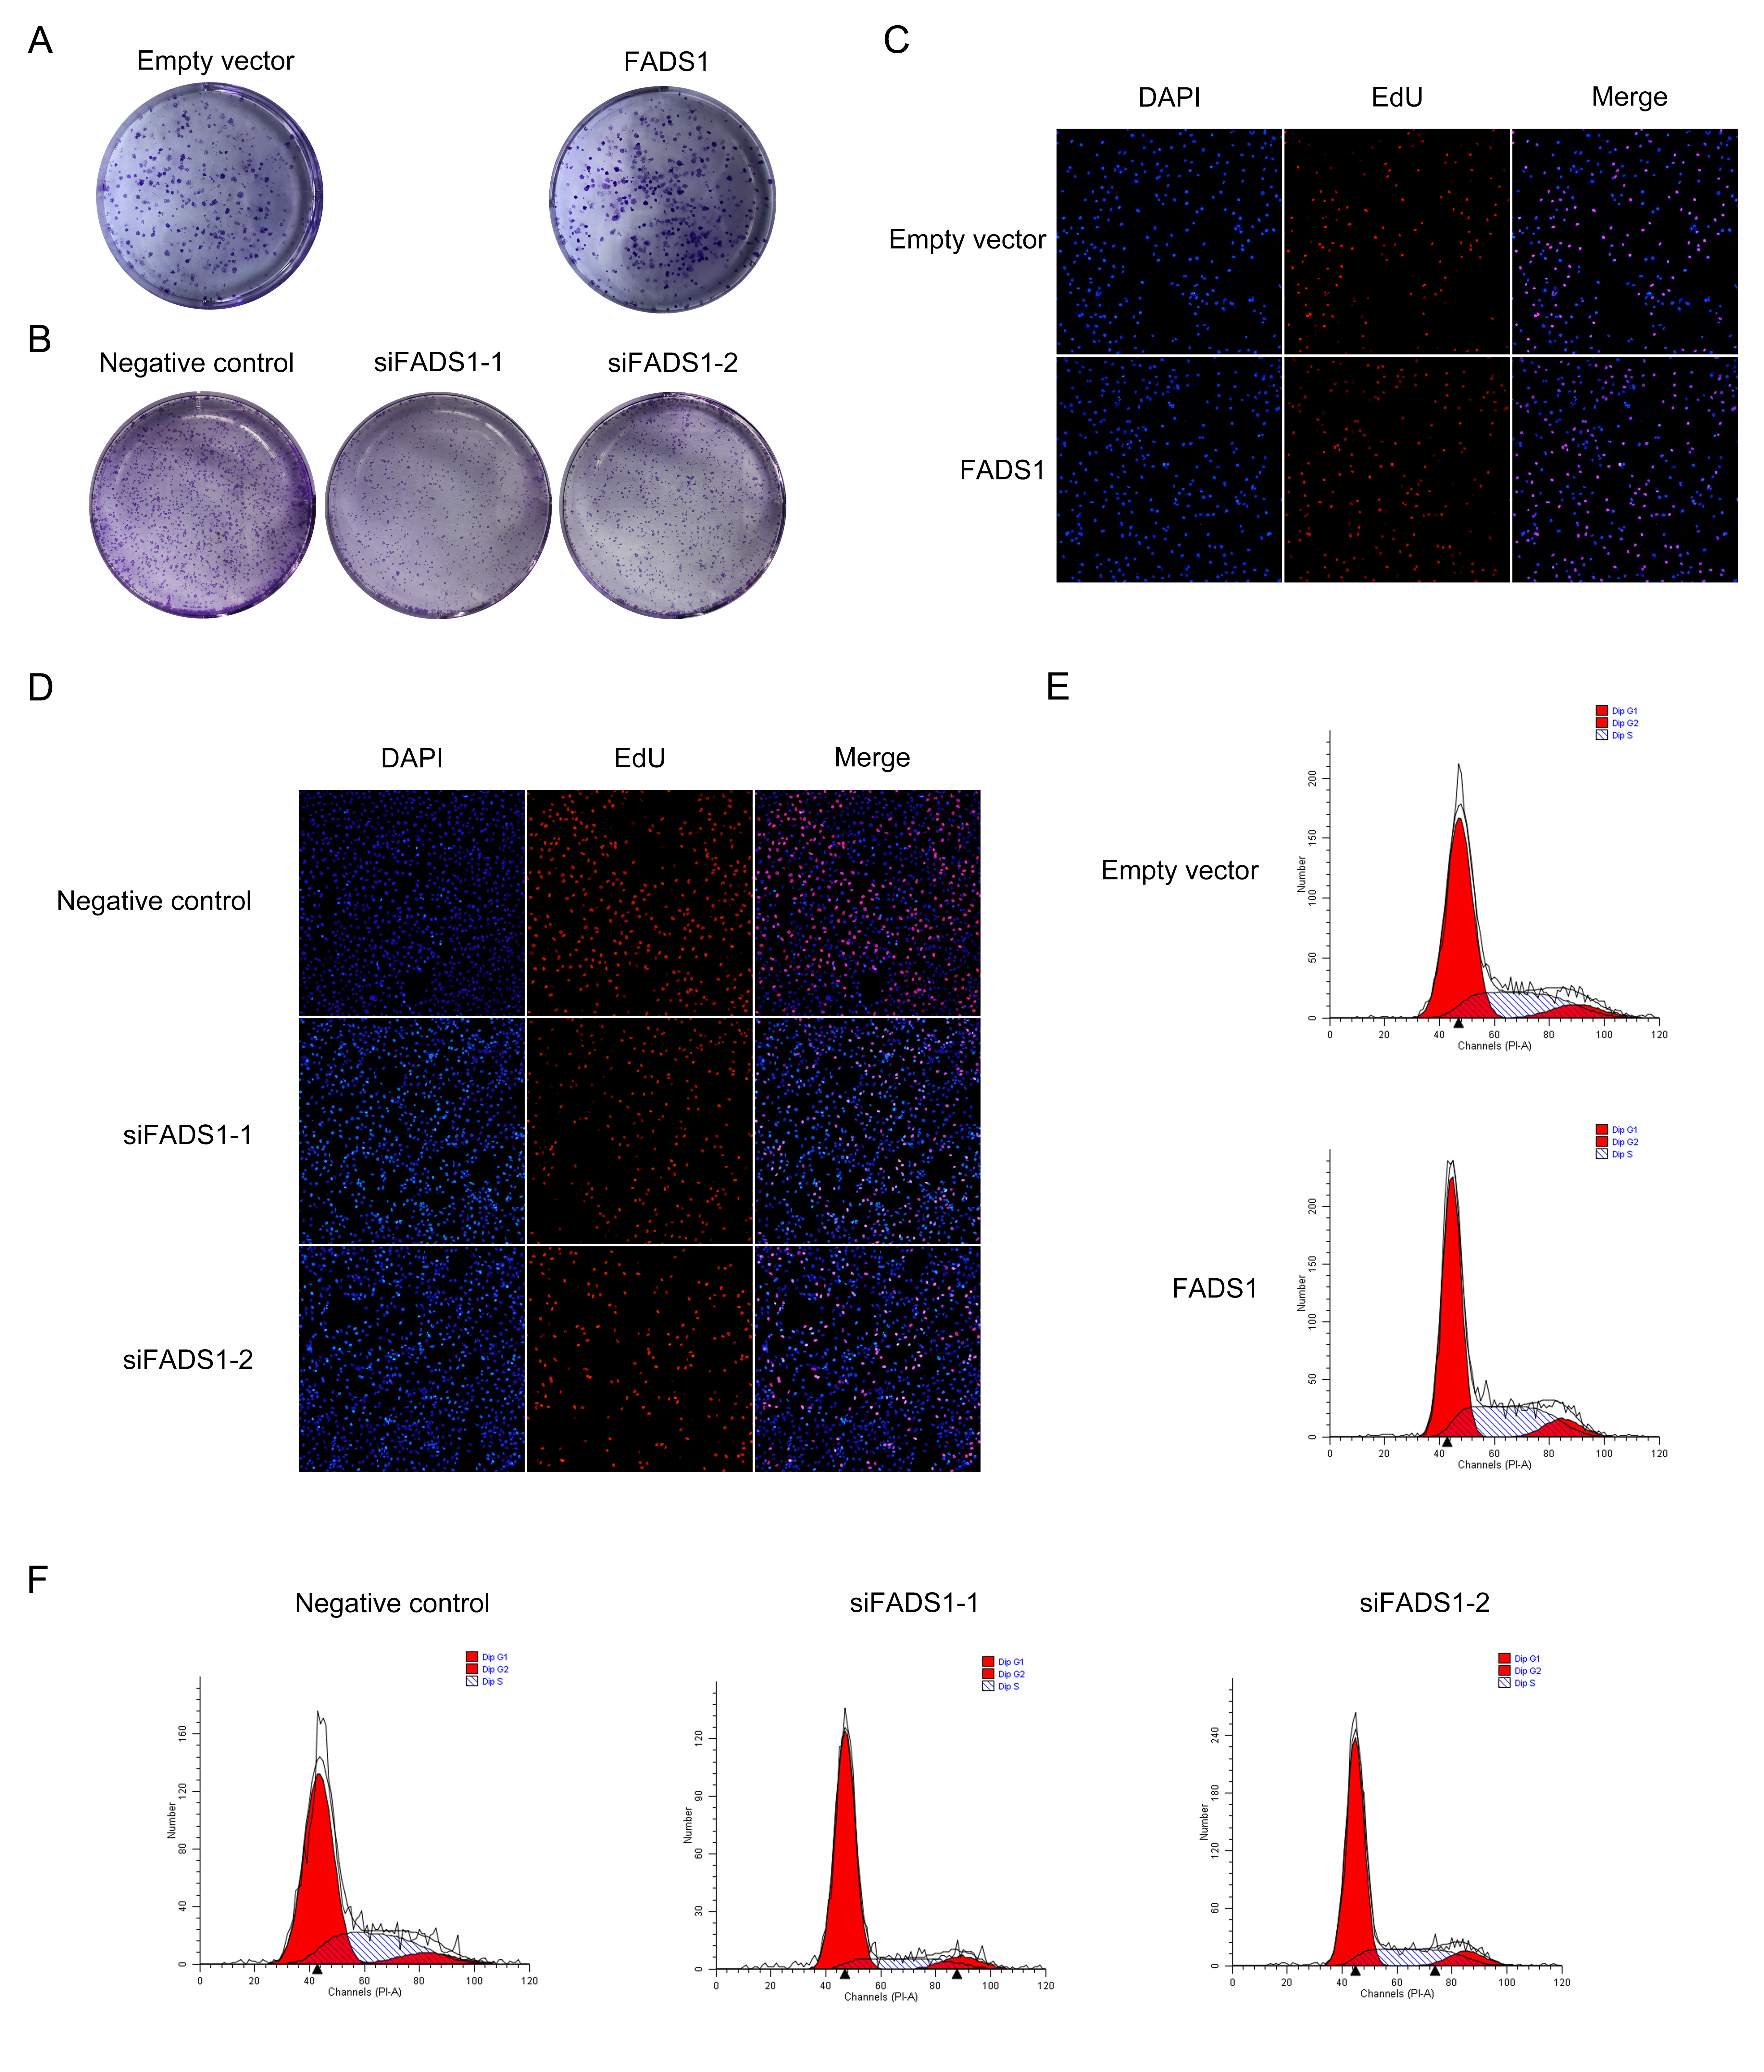
Figure. S2 (A, B) The representative figures of the colony-formation assay of 5637 cells. (C, D) The representative figures of the EdU assays, red spot represents replicated cells. (E, F) Representative figures of the cell cycle analysis.

