Supplementary materials
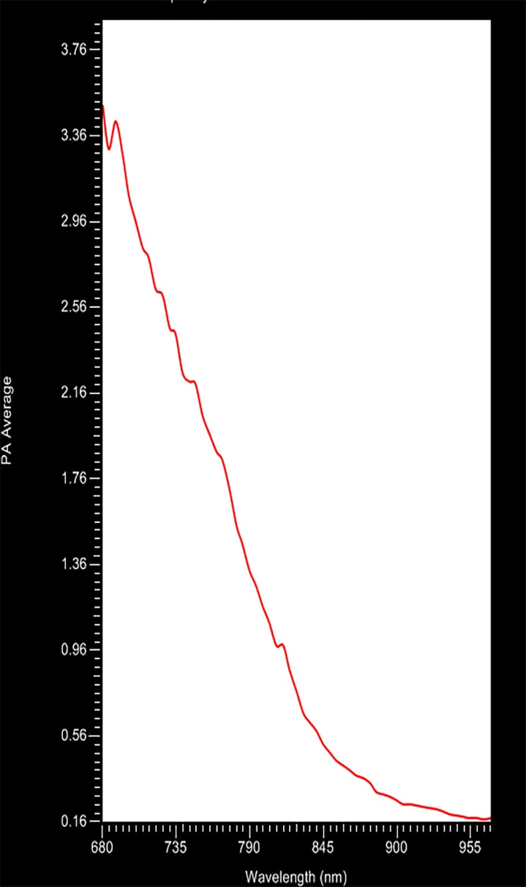
Supplementary Figure S1. The most optimal wavelength for PA imaging by full-wavelength scanning.

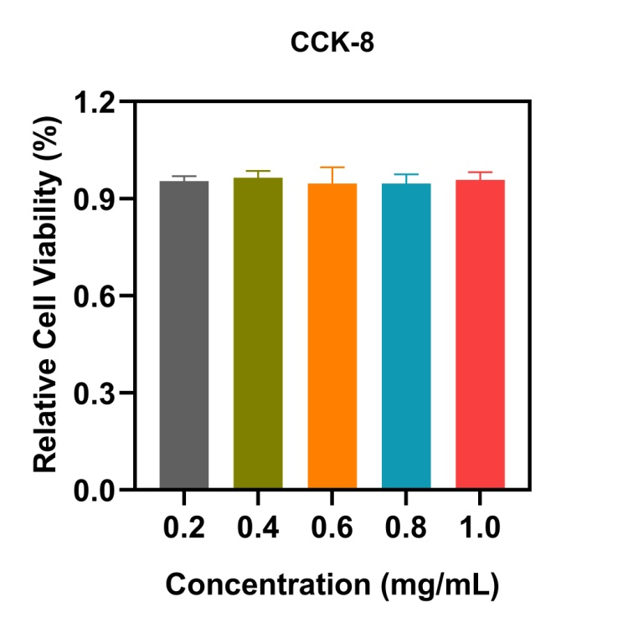
Supplementary Figure S2. The relative cell viabilities of MCF-7 cell incubated with different concentrations for 24h.

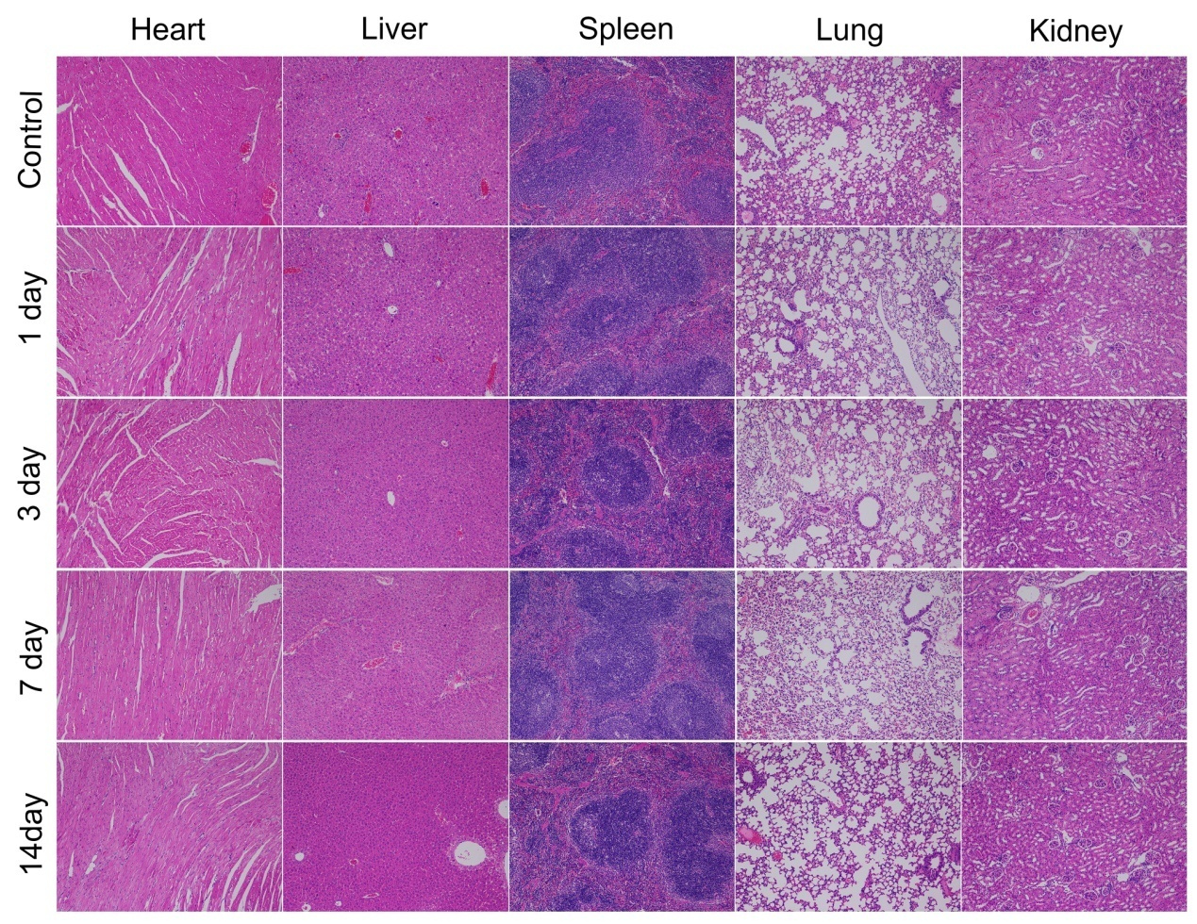
Supplementary Figure S3. H&E staining of the major organs (heart, liver, spleen, lung, and kidney) of the
treated-mice at control(pre-injection) and 1, 3, 7, and 14 days post-injection with A-FP NPs via
the tail vein. The scale bars are 50 μm.

