Supplementary Materials
Supplementary Table 1. Quality assessment of studies by the case-control study items of STROBE
Items | Sub-items | Gui, Y. X. et al. 2013 ^{[19]} | Zhou, Y. et al. 2012 ^{[20]} | Tian, J. Y. et al. 2012 ^{[17]} | Lv, Z.Y. et al. 2012 ^{[18]} | Lu, C. S. et al. 2012 ^{[14]} | Tomiyama, H. et al. 2011 ^{[16]} | Kauther, K. M. et al. 2011 ^{[12]} | Tan, E. K. et al. 2010 ^{[13]}
1 | a | 1 | 1 | 0 | 1 | 1 | 1 | 1 | 0
 | b | 1 | 1 | 1 | 1 | 1 | 1 | 1 | 0
2 |  | 1 | 1 | 1 | 1 | 1 | 1 | 1 | 1
3 |  | 1 | 1 | 1 | 1 | 1 | 1 | 0 | 1
4 |  | 1 | 1 | 1 | 1 | 1 | 1 | 1 | 0
5 |  | 1 | 1 | 0 | 1 | 0 | 0 | 0 | 0
6 | a | 1 | 1 | 1 | 1 | 1 | 0 | 0 | 0
 | b | 1 | 1 | 1 | 1 | 1 | 1 | 0 | 0
7 |  | 1 | 1 | 1 | 1 | 1 | 0 | 0 | 0
8 |  | 1 | 1 | 1 | 1 | 1 | 0 | 1 | 0
9 |  | 1 | 0 | 0 | 0 | 1 | 0 | 0 | 0
10 |  | 0 | 0 | 0 | 0 | 0 | 0 | 0 | 0
11 |  | 0 | 1 | 0 | 0 | 0 | 0 | 0 | 1
12 | a | 1 | 0 | 0 | 1 | 1 | 0 | 0 | 0
 | b | 1 | 0 | 0 | 1 | 0 | 0 | 0 | 0
 | c | 0 | 0 | 0 | 0 | 0 | 0 | 0 | 0
 | d | 1 | 0 | 0 | 1 | 0 | 0 | 0 | 0
 | e | 0 | 0 | 0 | 0 | 0 | 0 | 0 | 0
13 | a | 1 | 1 | 1 | 1 | 0 | 0 | 1 | 1
 | b | 0 | 0 | 0 | 0 | 0 | 0 | 0 | 0
 | c | 0 | 0 | 0 | 0 | 0 | 0 | 0 | 0
14 | a | 1 | 1 | 1 | 0 | 1 | 0 | 1 | 0
 | b | 0 | 0 | 0 | 0 | 1 | 0 | 0 | 0
15 |  | 1 | 1 | 1 | 1 | 1 | 1 | 1 | 1
16 | a | 0 | 0 | 0 | 1 | 1 | 0 | 0 | 0
 | b | 1 | 1 | 1 | 1 | 1 | 1 | 1 | 1
 | c | 0 | 0 | 0 | 0 | 0 | 0 | 0 | 0
17 |  | 1 | 1 | 1 | 1 | 1 | 0 | 0 | 0
18 |  | 1 | 1 | 1 | 1 | 1 | 1 | 0 | 1
19 |  | 1 | 0 | 0 | 1 | 0 | 0 | 0 | 0
20 |  | 1 | 1 | 1 | 1 | 1 | 1 | 1 | 0
21 |  | 1 | 1 | 1 | 1 | 1 | 0 | 0 | 0
22 |  | 0 | 1 | 1 | 0 | 1 | 1 | 1 | 1
Total |  | 23 | 20 | 17 | 22 | 21 | 11 | 11 | 8
Rating |  | intermediate | intermediate | intermediate | intermediate | intermediate | poor | poor | poor
Note:
STROBE: Reporting of Observational Studies in Epidemiology. Relative to the rating of the STROBE tools, the cut-offs for three levels of score were adopted: 0-14 as poor quality, 15-25 as intermediate quality and 26-33 as good quality of the study in this systematic review and meta-analysis. For detailed literature evaluation and scoring methods, please refer to the Supplementary Table 2 excerpted from relevant literature [23].

Supplementary Table 2. STROBE Statement-Checklist of items that should be included in reports of case-control studies
 | Item No | Recommendation
Title and abstract | 1 | (a) Indicate the study’s design with Title and abstract 1 a commonly used term in the title or the abstract
Title and abstract | 1 | (b) Provide in the abstract an informative and balanced summary of what was done and what was found
Introduction
Background/rationale | 2 | Explain the scientific background and rationale for the investigation being reported
Objectives | 3 | State specific objectives, including any prespecified hypotheses
Methods
Study design | 4 | Present key elements of study design early in the paper
Setting | 5 | Describe the setting, locations, and relevant dates, including periods of recruitment,exposure, follow-up, and data collection
Participants | 6 | (a) Give the eligibility criteria, and the sources and methods of case ascertainment and control selection. Give the rationale for the choice of cases and controls
Participants | 6 | (b) For matched studies, give matching criteria and the number of controls per case
Variables | 7 | Clearly define all outcomes, exposures, predictors, potential confounders, and effect  modifiers. Give diagnostic criteria, if applicable
Data sources/measurement | 8* | For each variable of interest, give sources of data and details of methods of  assessment (measurement). Describe comparability of assessment methods if there is  more than one group
Bias | 9 | Describe any efforts to address potential sources of bias
Study size | 10 | Explain how the study size was arrived at
Quantitative variables | 11 | Explain how quantitative variables were handled in the analyses. If applicable,  describe which groupings were chosen and why
Statistical methods | 12 | (a) Describe all statistical methods, including those used to control for confounding
Statistical methods | 12 | (b) Describe any methods used to examine subgroups and interactions
Statistical methods | 12 | (c) Explain how missing data were addressed
Statistical methods | 12 | (d) If applicable, explain how matching of cases and controls was addressed
Statistical methods | 12 | (e) Describe any sensitivity analyses
Results
Participants | 13* | (a) Report numbers of individuals at each stage of study—eg numbers potentially eligible, examined for eligibility, confirmed eligible, included in the study, completing follow-up, and analysed
Participants | 13* | (b) Give reasons for non-participation at each stage
Participants | 13* | (c) Consider use of a flow diagram
Descriptive data | 14* | (a) Give characteristics of study participants (eg demographic, clinical, social) and information on exposures and potential confounders
Descriptive data | 14* | (b) Indicate number of participants with missing data for each variable of interest
Outcome data | 15* | Report numbers in each exposure category, or summary measures of exposure
Main results | 16 | (a) Give unadjusted estimates and, if applicable, confounder-adjusted estimates and their precision (eg, 95% confidence interval). Make clear which confounders were their precision (eg, 95% confidence interval). Make clear which confounders were adjusted for and why they were included
Main results | 16 | (b) Report category boundaries when continuous variables were categorized
Main results | 16 | (c) If relevant, consider translating estimates of relative risk into absolute risk for a  meaningful time period
Other analyses | 17 | Report other analyses done-eg analyses of subgroups and interactions, and sensitivity analyses
Discussion
Key results | 18 | Summarise key results with reference to study objectives
Limitations | 19 | Discuss limitations of the study, taking into account sources of potential bias or imprecision.  Discuss both direction and magnitude of any potential bias
Interpretation | 20 | Give a cautious overall interpretation of results considering objectives, limitations, multiplicity  of analyses, results from similar studies, and other relevant evidence
Generalisability | 21 | Discuss the generalisability (external validity) of the study results
Other information
Funding | 22 | Give the source of funding and the role of the funders for the present study and, if applicable,  for the original study on which the present article is based
*Give information separately for cases and controls.
Note 1: An Explanation and Elaboration article discusses each checklist item and gives methodological background and
published examples of transparent reporting. The STROBE checklist is best used in conjunction with this article (freely
available on the Web sites of PLoS Medicine at http://www.plosmedicine.org/, Annals of Internal Medicine at
http://www.annals.org/, and Epidemiology at http://www.epidem.com/). Information on the STROBE Initiative is
available at http://www.strobe-statement.org.
Note 2: This STROBE checklist is excerpts from the reference [23] of “von Elm E, Altman DG, Egger M et al. The strengthening the reporting of observational studies in epidemiology (STROBE) statement: guidelines for reporting observational studies. Int J Surg 2014; 12(12):1495-1499”.

Supplementary Table 3. The genotype distribution and alle frequences of all the SNPs included in the systematic review
Variants | Variation type | Position | Study | Genotypes |  |  |  |  |  |  |  |  |  | Alles |  |  |  |  | HWE (P)
 |  |  |  | Cases |  |  |  |  | Controls |  |  |  |  | Cases |  |  | Controls |  | HWE (P)
 |  |  |  | total | A1A1 | A1A2 | A2A2 |  | total | A1A1 | A1A2 | A2A2 |  | A1 | A2 |  | A1 | A2 | HWE (P)
rs2267369 (c.87 G>A, p.Val29Val) | Synonymous | Exon 2 | Kauther, K. M. et al. 2011 ^{[12]} | 102 | 97 | 5 | 0 |  | 101 | 95 | 6 | 0 |  | 199 | 5 |  | 196 | 6 | 0
rs2267369 (c.87 G>A, p.Val29Val) | Synonymous | Exon 2 | Lu, C. S. et al. 2012 ^{[14]} | 25 | 19 | 4 | 2 |  | 96 | 75 | 19 | 2 |  | 42 | 8 |  | 169 | 23 | 1
rs2267369 (c.87 G>A, p.Val29Val) | Synonymous | Exon 2 | Lv, Z. Y. et al. 2012 ^{[18]} | 533 | 415 | 117 | 1 |  | 561 | 462 | 93 | 6 |  | 947 | 119 |  | 1017 | 105 | 1
rs2267369 (c.87 G>A, p.Val29Val) | Synonymous | Exon 2 | Tomiyama, H. et al. 2011 ^{[16]} | 116 | 98 | 17 | 1 |  | / | / | / | / |  | 35 | 1 |  | / | / | /
rs2267369 (c.87 G>A, p.Val29Val) | Synonymous | Exon 2 | Tan, E. K. et al. 2010 ^{[23]} | 96 | 74 | 22 | 0 |  | 100 | / | / | / |  | 44 | 0 |  | / | / | /
rs76718524 (1381 C>T, Arg461Trp) | Missense | Exon 10 | Kauther, K. M. et al. 2011 ^{[12]} | 268 | 267 | 1 | 0 |  | 256 | 255 | 1 | 0 |  | 535 | 1 |  | 511 | 1 | 0.975
rs76718524 (1381 C>T, Arg461Trp) | Missense | Exon 10 | Zhou, Y. et al. 2012 ^{[20]} | 202 | 202 | 0 | 0 |  | 212 | 212 | 0 | 0 |  | 404 | 0 |  | 424 | 0 | /
rs140758033 (c.2417 C>G, p.Pro806Arg) | Missense | Exon 17 | Lu, C. S. et al. 2012 ^{[14]} | 200 | 199 | 1 | 0 |  | 200 | 198 | 2 | 0 |  | 399 | 1 |  | 398 | 2 | 0.943
rs140758033 (c.2417 C>G, p.Pro806Arg) | Missense | Exon 17 | Tan, E. K. et al. 2010 ^{[13]} | 96 | 95 | 1 | 0 |  | 100 | 100 | 0 | 0 |  | 191 | 1 |  | 200 | 0 | /
rs140758033 (c.2417 C>G, p.Pro806Arg) | Missense | Exon 17 | Tomiyama, H. et al. 2011 ^{[16]} | 379 | 367 | 12 | 0 |  | 310 | 300 | 10 | 0 |  | 746 | 12 |  | 610 | 10 | 0.772
rs199935023 (c.991 G>T, p.Asp331Tyr) | Missense | Exon 7 | Lu, C. S. et al. 2012 ^{[14]} | 982 | 975 | 6 | 1 |  | 802 | 798 | 4 | 0 |  | 1956 | 8 |  | 1600 | 4 | 0.943
rs199935023 (c.991 G>T, p.Asp331Tyr) | Missense | Exon 7 | Tomiyama, H. et al. 2011 ^{[14]} | 379 | 378 | 1 | 0 |  | 310 | 310 | 0 | 0 |  | 757 | 1 |  | 620 | 0 | /
c.1959 T>A (Gly653Gly) | Synonymous | Exon 14 | Gui, Y. X. et al. 2013 ^{[19]} | 250 | 249 | 1 | 0 |  | 550 | 550 | 0 | 0 |  | 499 | 1 |  | 1100 | 0 | /
c.1959 T>A (Gly653Gly) | Synonymous | Exon 14 | Tan, E. K. et al. 2010 ^{[13]} | 96 | 95 | 1 | 0 |  | 100 | 100 | 0 | 0 |  | 191 | 1 |  | 200 | 0 | /
c.1966 C>G (Leu656Val) | Missense | Exon 13 | Gui, Y. X. et al. 2013 ^{[19]} | 250 | 249 | 1 | 0 |  | 550 | 550 | 0 | 0 |  | 499 | 1 |  | 1100 | 0 | /
c.2077 C>G (Leu693Val) | Missense | Exon 14 | Gui, Y. X. et al. 2013 ^{[19]} | 250 | 249 | 1 | 0 |  | 550 | 550 | 0 | 0 |  | 499 | 1 |  | 1100 | 0 | /
c.1791delC (P.His597fx69) | Frame-shift | Exon 12 | Gui, Y. X. et al. 2013 ^{[19]} | 250 | 249 | 1 | 0 |  | 550 | 550 | 0 | 0 |  | 499 | 1 |  | 1100 | 0 | /
c.G2036T (p.Gly679Val) | Missense | Exon 15 | Tian, J. Y. et al. 2012 ^{[17]} | 72 | 71 | 1 | 0 |  | 500 | 500 | 0 | 0 |  | 143 | 1 |  | 1000 | 0 | /
rs4375 | / | intron 3 | Lv, Z.Y. et al. 2012 ^{[18]} | 533 | 261 | 223 | 49 |  | 561 | 266 | 250 | 45 |  | 745 | 321 |  | 782 | 340 | 0.192
rs132985 | / | intron 1 | Lv, Z.Y. et al. 2012 ^{[18]} | 533 | 195 | 247 | 91 |  | 561 | 222 | 262 | 77 |  | 637 | 429 |  | 706 | 416 | 0.982
rs2284063 | / | intron1 | Lv, Z.Y. et al. 2012 ^{[18]} | 533 | 294 | 201 | 38 |  | 561 | 321 | 211 | 29 |  | 789 | 277 |  | 853 | 269 | 0.452
c.1077 G>A (p.Met358IlefsX) | Missense | Exon 7 | Lu, C. S. et al. 2012 ^{[14]} | 981 | 979 | 2 | 0 |  | 802 | 802 | 0 | 0 |  | 1960 | 2 |  | 1604 | 0 | /
rs201727354 (c.1077 G>A , p.Met358IlefsX) | Missense | Exon 14 | Lu, C. S. et al. 2012 ^{[14]} | 981 | 980 | 1 | 0 |  | 802 | 802 | 0 | 0 |  | 1961 | 1 |  | 1604 | 0 | /
rs367854265 (c.901 C>T, p.Arg301Cys) | Missense | Exon 7 | Tomiyama, H. et al. 2011 ^{[16]} | 379 | 378 | 1 | 0 |  | 310 | 310 | 0 | 0 |  | 757 | 1 |  | 620 | 0 | /
rs11570597 (-130 C>T) | / | 5'-UTR | Kauther, K. M. et al. 2011 ^{[12]} | 102 | 100 | 2 | 0 |  | 101 | 98 | 3 | 0 |  | 202 | 2 |  | 199 | 3 | 0.879
rs771809118 (756 C>T, Asn252Asn) | Synonymous | Exon 5 | Kauther, K. M. et al. 2011 ^{[7]} | 102 | 101 | 1 | 0 |  | 101 | 101 | 0 | 0 |  | 203 | 1 |  | 202 | 0 | /
rs11570679 (957 G>A, Thr319Thr) | Synonymous | Exon 7 | Kauther, K. M. et al. 2011 ^{[12]} | 102 | 101 | 1 | 0 |  | 101 | 101 | 0 | 0 |  | 203 | 1 |  | 202 | 0 | /
rs144033740 (966 C>T, His322His) | Synonymous | Exon 7 | Kauther, K. M. et al. 2011 ^{[12]} | 102 | 101 | 1 | 0 |  | 101 | 101 | 0 | 0 |  | 203 | 1 |  | 202 | 0 | /
rs11570680 (1027 G>A, Ala343Thr) | Missense | Exon 7 | Kauther, K. M. et al. 2011 ^{[12]} | 102 | 100 | 2 | 0 |  | 101 | 93 | 8 | 0 |  | 202 | 2 |  | 194 | 8 | 0.678
rs2413502 (1086 C>T, Asn362Asn) | Synonymous | Exon 8 | Kauther, K. M. et al. 2011 ^{[12]} | 102 | 101 | 1 | 0 |  | 101 | 101 | 0 | 0 |  | 203 | 1 |  | 202 | 0 | /
rs139093920 (2341 G>A, Ala781Thr) | Missense | Exon 17 | Kauther, K. M. et al. 2011 ^{[12]} | 102 | 101 | 1 | 0 |  | 101 | 101 | 0 | 0 |  | 203 | 1 |  | 202 | 0 | /
-20C>A | / | 5'-UTR | Kauther, K. M. et al. 2011 ^{[12]} | 268 | 265 | 3 | 0 |  | 256 | 254 | 2 | 0 |  | 533 | 3 |  | 510 | 2 | 0.950
rs138683183 (2340 C>T, Asn780Asn) | Missense | Exon 17 | Kauther, K. M. et al. 2011 ^{[12]} | 268 | 266 | 2 | 0 |  | 256 | 251 | 5 | 0 |  | 534 | 2 |  | 507 | 5 | 0.875
2339A>G (Asn780Ser) | Missense | Exon 17 | Kauther, K. M. et al. 2011 ^{[12]} | 166 | 164 | 2 | 0 |  | 155 | 155 | 0 | 0 |  | 330 | 2 |  | 310 | 0 | /
rs150572286 (c.1983 G>A, Thr661Thr) | Synonymous | Exon 14 | Tan, E. K. et al. 2010 ^{[13]} | 96 | 95 | 1 | 0 |  | 100 | 100 | 0 | 0 |  | 191 | 1 |  | 200 | 0 | /
rs146591896 (c.2355 C>T, Thr785Thr) | Synonymous | Exon 17 | Tan, E. K. et al. 2010 ^{[13]} | 96 | 95 | 1 | 0 |  | 100 | 100 | 0 | 0 |  | 191 | 1 |  | 200 | 0 | /
HWE: Hardy-Weinberg equilibrium; ‘‘A2’’ represented the minor allele and ‘‘A1’’ represented the major allele.

Supplementary Figure 1
(A)
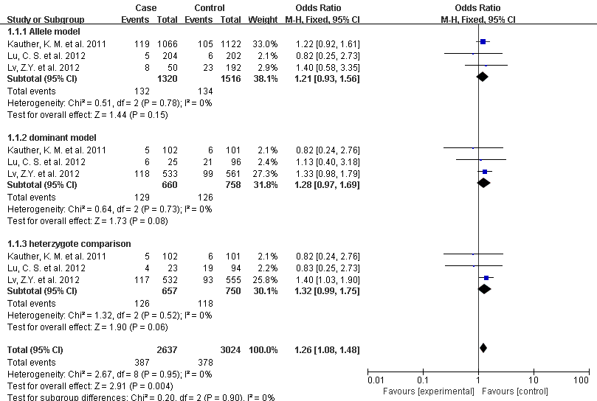

(B)
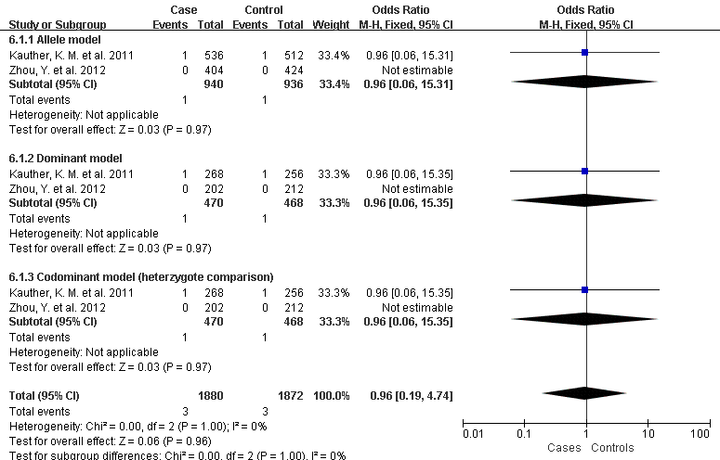

(C)
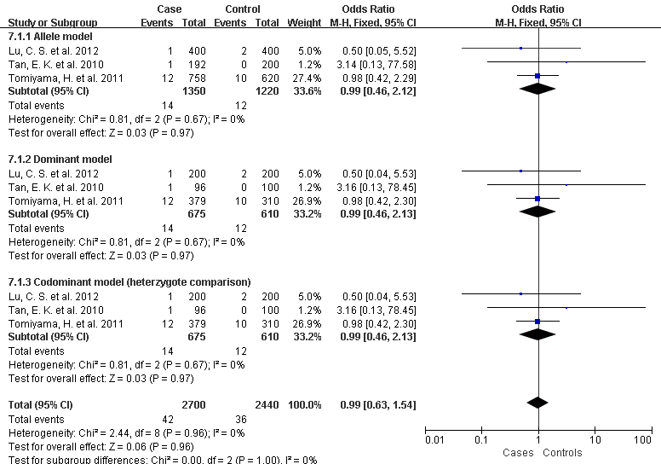

(D)
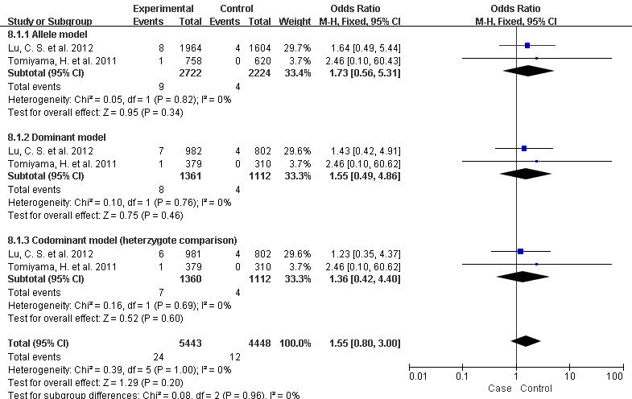

(E)
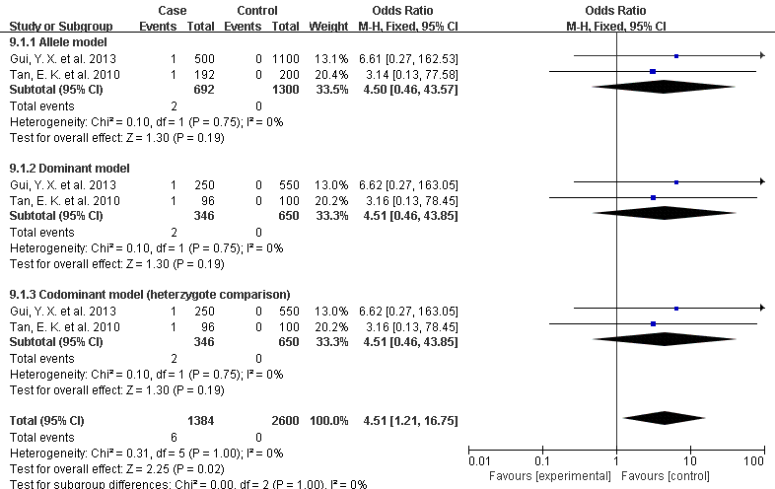

Supplementary Figure 1. Forest plot of the association between PLA2G6 rs2267369 (A), rs76718524 (B), rs140758033 (C), rs199935023 (D) and c.1959T>A (Gly653Gly) (E) and PD. The pooled ORs and 95% CI for each study and for pooled samples of the 5 single nucleotide polymorphisms (SNPs) under the allele model, dominant model and codominant model of heterzygote comparison.

