Supplementary
- Hidden Markov Models (HMMER) Profile Construction
For the first step, the training datasets were aligned using the Clustalo alignment tool [18]. The alignment was carried out using the command line:
Clustalo –i ACTrainings. Fasta –o ACTrainings.sto --outfmt=st ……………………………………………………………………………………………(i)
The command line simply states <<do an alignment of the sequences which are in the upper case found in the input file “dataset.fasta” with the Fasta, using Clustalo as multiple alignment tools and GCG Postscript output for graphical printing>>. The output of the command results in the construction of aligned sequences, called “dataset.msf”. The aligned sequences was used as input in the next step.
The next step enhances the construction of the profiles of the target class sequences by showing the common motifs/signatures within the profiles. To achieve this, the “Build profiles” was run using the following command:
hmmbuild ACTrainings.hmm ACTrainings.sto………………………………………….(ii)
The resulting profiles “dataset.hmm” was used in evaluating the profiles performance by testing the created profiles on an independent AMP dataset.
The independent testing of each created profile was performed in a step called “Query profiles”. The testing data were queried against the created profiles using the command line, with an E-value threshold of 95% or 0.05:
Hmmsearch –E5e-2 ACTrainings.hmm profile query.txt > resultfile.txt …… ……………………………………(iv)

Figure S1: Hidden Markov Models (HMMER) Profile Construction
- Discovery of Novel anticancer AMPs
The discovery stage command line is given as follows:msearch–E 5e-2 FOTrainings.hmm target pathogen query.txt > resultfile.txt …...............………………………………………………………………………….(v)

Figure S2: Discovery of Novel anticancer AMPs

- Table S1: Discovery of Putative Anticancer AMPs
AMPs | Organism Discovered | Amino acid sequences | E values | Bit scores
BOO1 | Homo sapiens | FLALLGDFFRKSKP----IGKEFKRIVQRIKDFLRNLVPRTES | 1.2e-06 | 30.9
BOO2 | Gorilla gorilla | FLALLGDFFRKAKP----IGKESKRIVQRIKDFLRNLVPRTES | 1.2e-06 | 30.9
BOO3 | Mus musculus | RFKKILSRLAGLLRKGGP----IGEkLKKIGQKIKNFFQKLVPQPE | 1.9e-06 | 30.5
BOO4 | Echinops telfairi | TGSFDITCDQPQRV----GRLGEFFRRSGPHVEKIGQKLEQIGQRiKDFFQNLAPRVE | 6.8e-05 | 27.0
BOO5 | Erinaceus europaeus | LFGRLRDLIKKGTP----IGRKLRKVGQQiKDFIRNLRPREE | 0.00057 | 23.8

- 3- D Structure of the putative anticancer AMPs and Cadherin-1
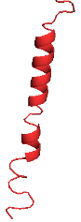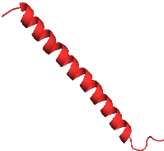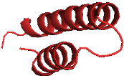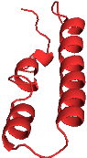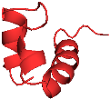
BOO1 BOO2 BOO3 BOO4 BOO5
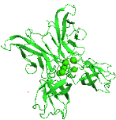
Cadherin 1
Figure S3: 3-D Homology Model of the Putative Anticancer AMPs and Cadherin 1 by ITASSER and visualized using PyMol. The Structure in TV red colour depicted the putative anticancer AMPs and the green colour represented the protein receptor, cadherin 1.Section 3.6:

- Table S2: Motif
Pfam ID | Pfam ID number | Position | E value | Description
Cadherin | PF00028 - | 161.253 | 4.1e-3 | Cadherin domain
Cadherin_C | PF01049 | 734.878 | 6.7e-49 | Cadherin cytoplasmic region
Cadherin_pro | PF08758 | 27.116 | 5e-31 | Cadherin pro domain like
RET_CLD1 | PF17756 | 521.559 | 0.017 | RET Cadherin like domain 1
Cadherin_3 | PF16184 | 357.428 | 0.39 | Cadherin like

- Docking Analysis of the putative anticancer AMPs and Cadherin 1
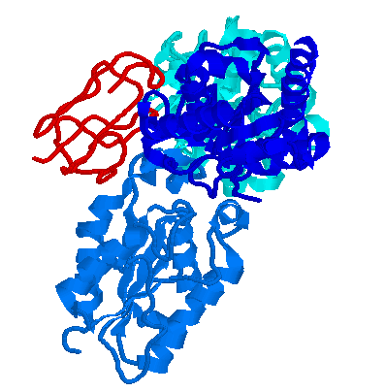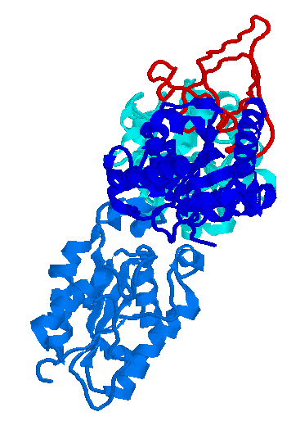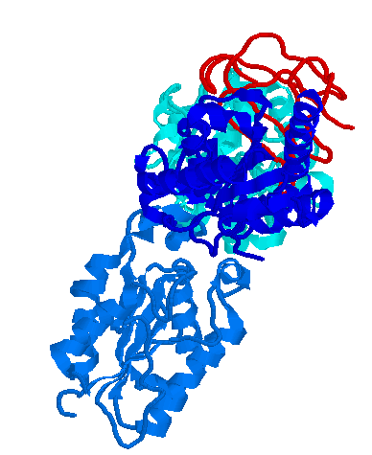
BOO1_Cadherin 1 BOO2_Cadherin 1 BOO3_Cadherin 1
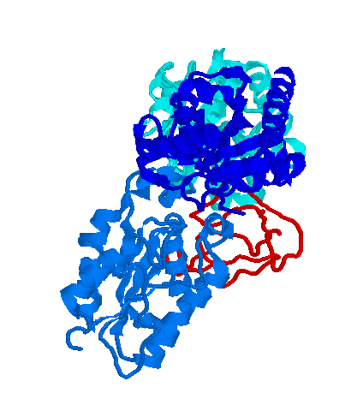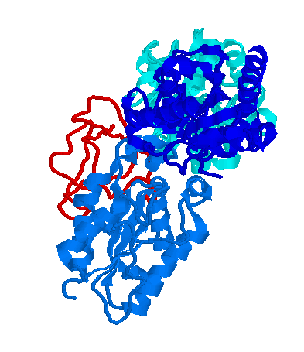
BOO4_Cadherin 1 BOO5_Cadherin 1
Figure S4: Interaction Analysis of the Cadherin 1 and anticancer AMPs. The blue colour indicates the protein, cadherin 1 and the red, indicates putative anticancer AMPs.

