Table S1.- Comparison between the control and CAD patients, and the control and CAD groups included in this study
 | Control patientsª  (n = 41) | Control group  (n = 23) | P | CAD patients^{b}  (n = 43) | CAD group  (n = 16) | P
Age | 56.70 ± 1.89 | 54.96 ± 2.92 | 0.598 | 62.33 ± 0.96 | 63.56 ± 1.67 | 0.521
Gender (W/M) | 6/12 | 6/17 | 0.786 | 1/42 | 0/16 | 0.538
Statin use, n (%) | 16 (39%) | 8 (35%) | 0.737 | 41 (95%) | 14 (88%) | 0.222
Fibrate, n (%) | 1 (2%) | 0 (0%) | 0.450 | 3 (7%) | 1 (6%) | 0.403
DM2, n (%) | 7 (17%) | 4 (17%) | 0.752 | 16 (37%) | 6 (38%) | 0.405
BMI (kg/m²) | 26.75 ± 0.47 | 26.00 ± 0.64 | 0.380 | 26.92 ± 0.49 | 26.19 ± 0.77 | 0.458
SBP (mmHg) | 119.02 ± 2.22 | 118.78 ± 2.76 | 0.934 | 126.82 ± 2.92 | 129.00 ± 4.51 | 0.636
DBP (mmHg) | 70.00 (60.00 – 80.00) | 72.09 ± 2.28 | 0.787 | 70.00 (70.00 – 80.50) | 77.13 ± 3.11 | 0.752
Uric acid (mg/dL) | 7.09 ± 0.30 | 7.49 ± 0.29 | 0.224 | 6.37 ± 0.23 | 6.34 ± 0.42 | 0.910
Creatinine (mg/dL) | 0.98 ± 0.04 | 0.95 ± 0.05 | 0.677 | 0.99 ± 0.03 | 1.01 ± 0.04 | 0.541
Magnesium (mg/dL) | 2.07 ± 0.03 | 2.05 ± 0.04 | 0.784 | 2.09 ± 0.03 | 2.12 ± 0.05 | 0.505
Calcium (mg/dL) | 9.24 (8.97 – 9.49) | 9.20 ± 0.11 | 0.812 | 9.35 (9.00 – 9.59) | 9.20 ± 0.12 | 0.577
Phosphorous (mg/dL) | 3.91 ± 0.08 | 3.81 ± 0.14 | 0.540 | 3.76 ± 0.13 | 3.86 ± 0.18 | 0.661
Alkaline phosphatase (UL) | 83.11 ± 3.68 | 87.17 ± 6.16 | 0.558 | 87.19 ± 4.02 | 85.68 ± 5.87 | 0.837
Glucose (mg/dL) | 90.16 ± 2.82 | 93.64 ± 5.77 | 0.881 | 90.30 ± 2.52 | 89.96 ± 4.20 | 0.947
Total cholesterol (mg/dL) | 137.24 ± 5.79 | 130.04 ± 7.77 | 0.530 | 112.84 ± 3.47 | 118.66 ± 5.25 | 0.340
Triglycerides (mg/dL) | 111.11 ± 5.83 | 103.98 ± 7.07 | 0.557 | 108.88 ± 5.07 | 122.87 ± 8.60 | 0.137
LDL-cholesterol (mg/dL) | 82.13 ± 5.22 | 79.75 ± 6.80 | 0.995 | 60.03 ± 3.30 | 64.52 ± 5.01 | 0.610
HDL-cholesterol (mg/dL) | 33.30 ± 1.51 | 29.49 ± 1.42 | 0.162 | 29.03 ± 1.08 | 29.58 ± 2.00 | 0.877
HDL-triglycerides (mg/dL) | 23.21 ± 1.42 | 24.06 ± 2.63 | 0.975 | 21.59 ± 1.67 | 23.36 ± 3.05 | 0.517
HDL-phospholipids (mg/dL) | 65.80 ± 2.77 | 60.88 ± 3.15 | 0.397 | 60.71 ± 2.12 | 64.78 ± 3.90 | 0.354
EAT volume (mL) | 118.44 ± 9.22 | 105.68 ± 14.24 | 0.369 | 141.44 ± 9.70 | 142.38 ± 18.04 | 0.992
CAC score (AU)* | 0.00 | 0.00 | 1.000 | 412.30 (108.60 – 1060.00) | 364.25 (119.40 – 1380.10) | 0.792
Data are shown as mean ± standard error (SE), as number of subjects (percentage), or as median (interquartile range). Student’s t, χ2 test or U-Mann Whitney test, patients vs group. CAD: coronary artery disease, W: women, M: men, BMI: body mass index, DM2: type 2 diabetes mellitus, SBP: systolic blood pressure, DBP: diastolic blood pressure, HDL: high-density lipoprotein, LDL: low-density lipoprotein, EAT: epicardial adipose tissue, CAC: coronary artery calcium, AU: Agatston units. *n=41 in control patients, n=35 in CAD patients. a: aortic valve stenosis patients, b: coronary artery disease patients

Table S2.- Correlation analysis between CAC score and the gene expression level
 | r | p
OPN | -0.171 | 0.541
ON | -0.111 | 0.694
OPG | -0.429 | 0.111
BMP-2 | -0.224 | 0.405
BMP-4 | -0.103 | 0.704
Spearman correlation. n=16 CAD group. OPN: osteopontin, ON: osteonectin, OPG: osteoprotegerin, BMP: bone morphogenetic protein

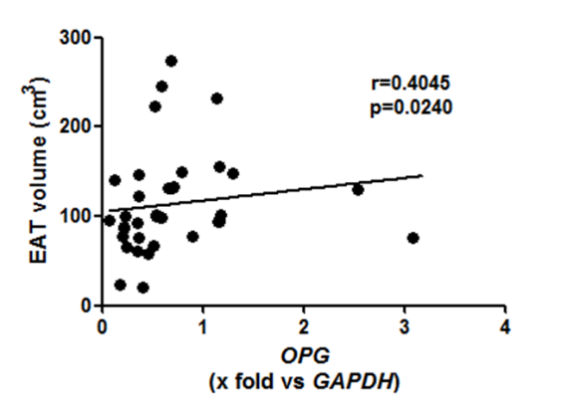
Figure S1. Correlation between EAT volume and OPG (n=39)

