- Definition about renal diseases
Chronic kidney disease (CKD): decreased kidney function shown by glomerular filtration rate (GFR) of less than 60 mL/min per 1.73 m², or markers of kidney damage, or both, of at least 3 months duration, regardless of the underlying cause.
Kidney failure: decreased kidney function shown by glomerular filtration rate (GFR) of less than 15 mL/min per 1.73 m² or dialysis.

- Drugs and classifications
All the drugs which were used during vancomycin treatment were classified and listed below, and other drugs not taken during the period were omitted. The classification was based Drug Classification Code of the First Affiliated Hospital, Zhejiang University School of Medicine, which was compiled referring to Anatomical Therapeutic Chemical (ATC) classification system.
  - Antibiotics included
2.1.1Cephalosporins (cefuroxime, cefotiam, ceftazidime, ceftriaxone, cefepime, cefotaxime, cefoxitin, cefminox),
2.1.2 Carbapenems (meropenem, biapenem)
2.1.3 Aminoglycosides (gentamicin, amikacin,)
2.1.4 Fluoroquinolones (moxifloxacin, levofloxacin, ofloxacin)
2.1.5 Penicillins (amoxicillin, furacilin)
2.1.6 Others (piperacillin tazobactam, cefoperazone sulbactam, imipenem cilastatin, daptomycin, tygacil, teicoplanin, linezolid, metromidazole).
  - Non steroidal anti-inflammatory drugs included aspirin, paracetamol, ibuprofen, flurbiprofen indomethacin, celecoxib, parecoxib, imrecoxib and diclofenac.
  - Contrast agents included iodixanol, iohexol, iopromide, iobitridol.
  - Antiviral agents included acyclovir, ganciclovir, entecavir, valaciclovir, tenofovir, oseltamivir, lamivudine.
  - Antifungal agents included fluconazole, voriconazole, caspofungin and micafungin.
  - Immunosuppressive agents included cyclosporine, tacrolimus and sirolimus.
  - β-blockers included metoprolol, esmolol, bisoprolol, propranolol.
  - Angiotensin II receptor antagonists included valsartan, losartan, telmisartan and irbesartan.
  - Calcium channel blockers included amlodipine, nifedipine, nimodipine and nicardipine.
2.10Diuretics included furosemide, torasemide, spironolactone, hydrochlorothiazide.

- Baseline laboratory tests
Baseline laboratory tests in this study included total protein, albumin, aspartate aminotransferase (AST), alanine aminotransferase (ALT), creatinine, glomerular filtration rate(GFR), fasting glucose, cystatin, white blood cell count, neutrophil count, lymphocyte count, monocyte count, platelet count, red blood cell count, hemoglobin.

Table S1. Potential predictors of vancomycin-associated AKI screened by univariate analysis in the derivation cohort with P＜0.1
Variables | Total(n=341) | AKI group (n=55) | Non-AKI group (n=286) | P value
Hypertension(n,%) | 108（31.7） | 25（45.5） | 83（29.0） | 0.016
Diabetes(n,%) | 54（15.8） | 13（23.6） | 41（14.3） | 0.084
Heart failure(n,%) | 22（6.5） | 8（14.5） | 14（4.9） | 0.008
Arrhythmia(n,%) | 27（7.9） | 8（14.5） | 19（6.6） | 0.047
Dosage adjustment(n,%) | 99（29.0） | 27（49.1） | 72（25.2） | 0.001
Piperacillin/tazobactam(n,%) | 114（33.4） | 25（45.5） | 89（31.1） | 0.039
Furosemide(n,%) | 201（58.9） | 46（83.6） | 155（54.2） | ＜0.001
Hydrochlorothiazide(n,%) | 20（5.9） | 6（10.9） | 14（4.9） | 0.082
NSAID(n,%) | 118（34.6） | 9（16.4） | 109（38.1） | 0.002
C_{min} (μg/ml) | 11.4±7.2 | 17.3±10.3 | 10.3±5.8 | ＜0.001
Total protein(g/L) | 59.1±10.4 | 56.9±11.1 | 59.5±10.2 | 0.090
Albumin(g/L) | 34.6±6.6 | 32.6±6.9 | 34.9±6.5 | 0.015
Platelet Count(10E9/L) | 179.2±104.2 | 157.0±99.6 | 183.5±104.7 | 0.084

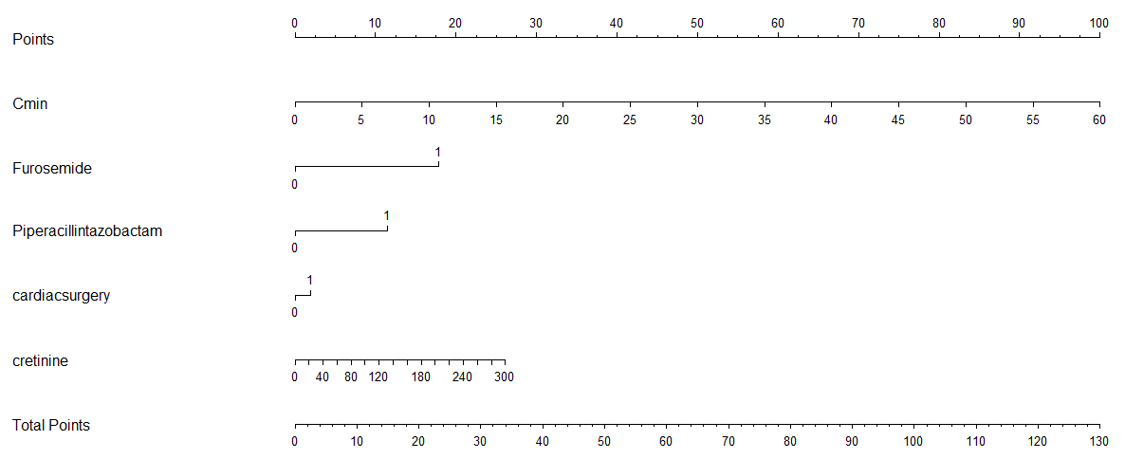
Figure S1. Nomogram for the alternative model

