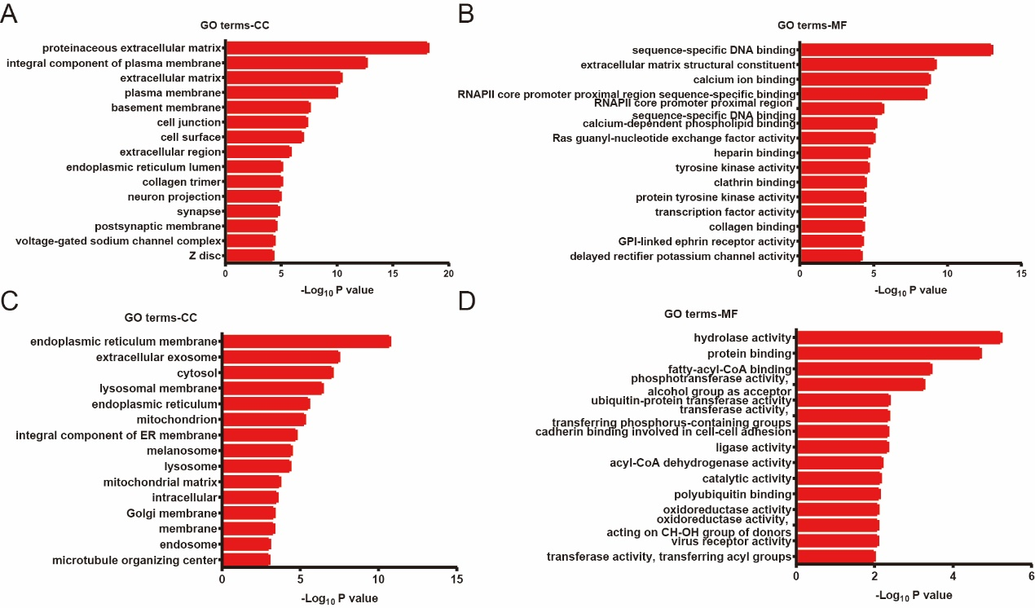

Supplementary Figure 1 GO enrichment results of differentially expressed genes. For enrichment analysis, a P-value ＜0.05 is taken to indicate statistical significance.
A. The GO- CC (Cellular Component) enrichment terms of upregulated genes.
B. The GO- MF (Molecular Function) enrichment terms of upregulated genes.
C. The GO- CC (Cellular Component) enrichment terms of downregulated genes.
D.The GO- MF (Molecular Function) enrichment terms of upregulated genes.

Supplementary Figure 2 Gene set enrichment analysis (GSEA) results of LanCL1 overexpression in prostate cancer cells (Top 10-15). In the analysis, we used the following values as cut-off values: the P-value cut-off value is 0.05 and the false discovery rate (FDR q-val) is <0.25.

