Supplementary Illustration 1: Illustration of study design
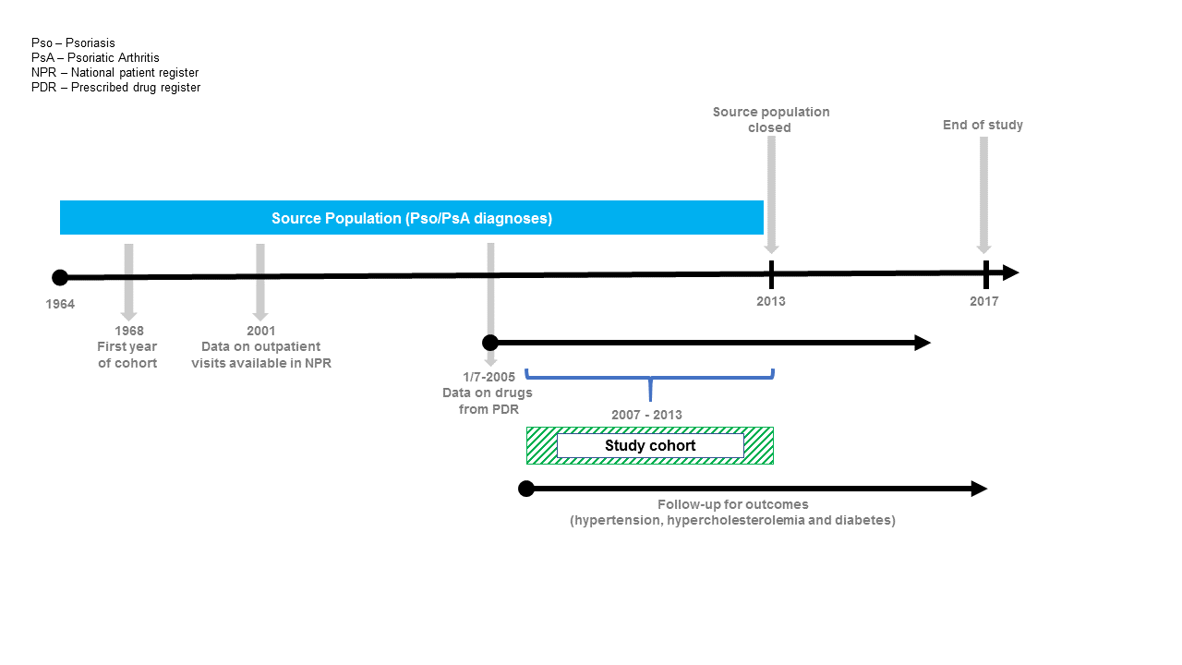

Supplementary Figure 1: Hazard Ratio (with 95% confidence interval) of hypertension among patients with mild psoriasis
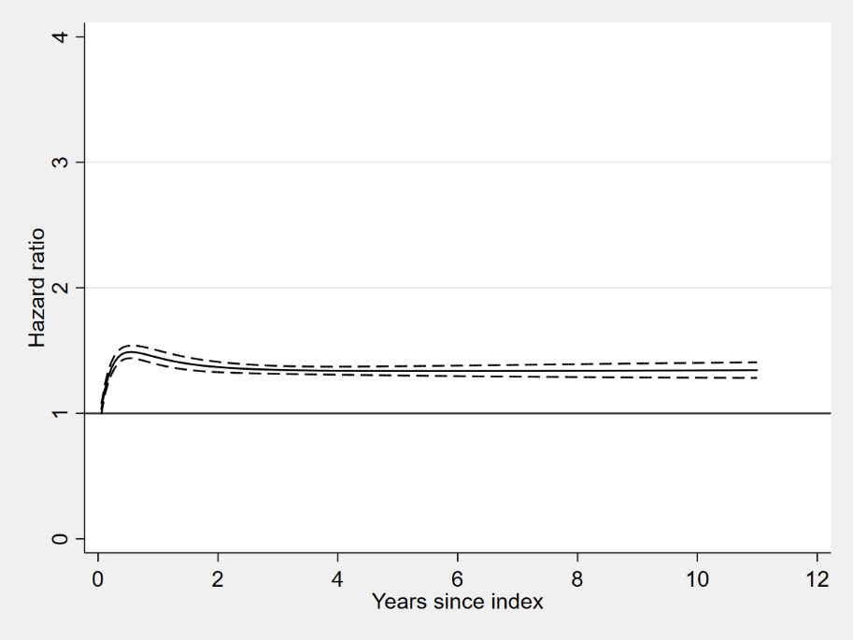
Supplementary Figure 2: Hazard Ratio and 95% confidence interval of hypertension among patients with moderate psoriasis
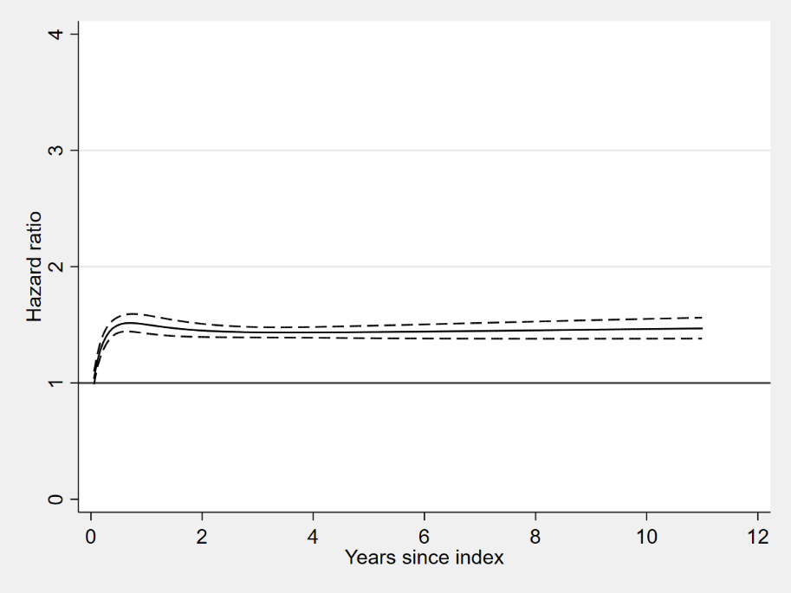
Supplementary Figure 3: Hazard Ratio and 95% confidence interval of hypertension among patients with severe psoriasis
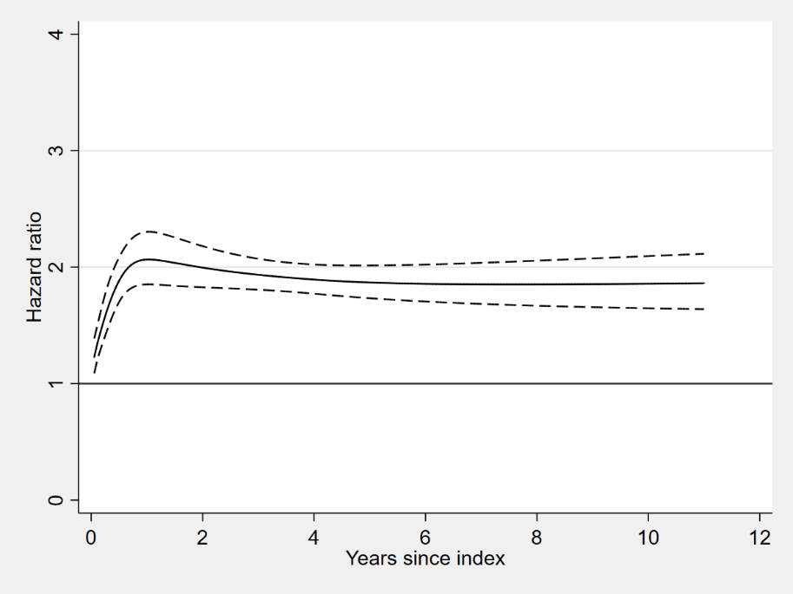

Supplementary Figure 4: Hazard Ratio and 95% confidence interval of hypercholesterolemia among patients with mild psoriasis
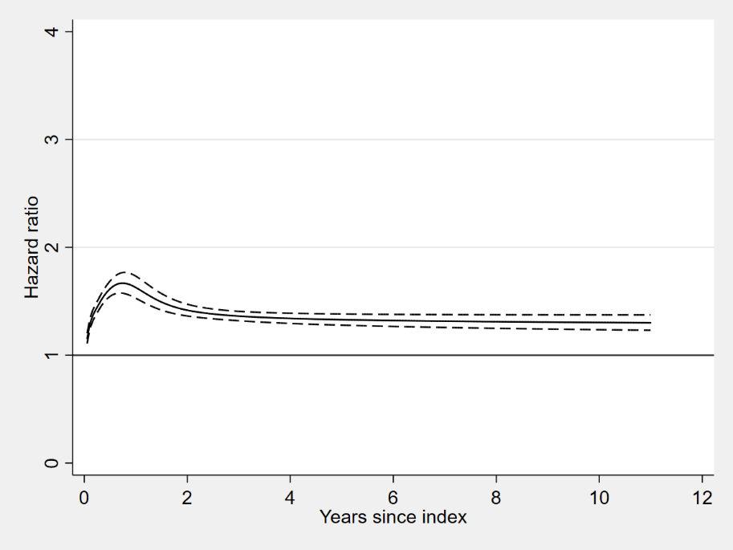
Supplementary Figure 5: Hazard Ratio and 95% confidence interval of hypercholesterolemia among patients with moderate psoriasis
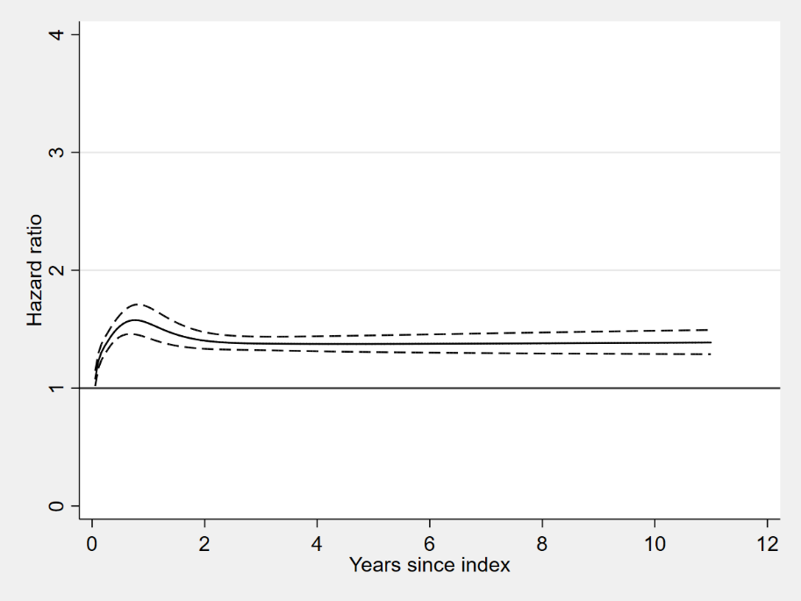
Supplementary Figure 6: Hazard Ratio and 95% confidence interval of hypercholesterolemia among patients with severe psoriasis
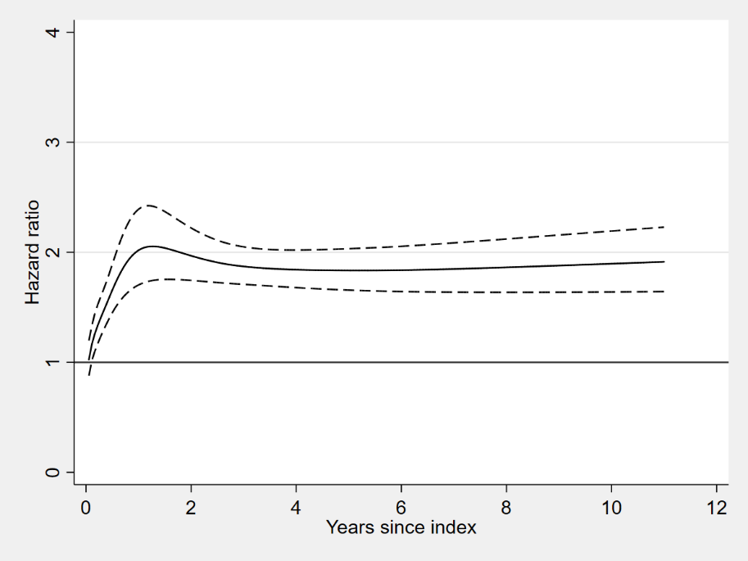

Supplementary Figure 7: Hazard Ratio and 95% confidence interval of diabetes among patients with mild psoriasis
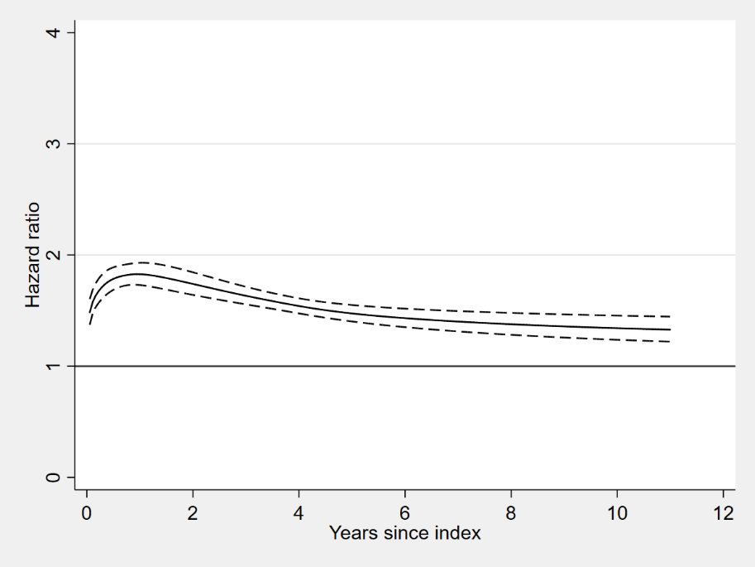
Supplementary Figure 8: Hazard Ratio and 95% confidence interval of diabetes among patients with moderate psoriasis
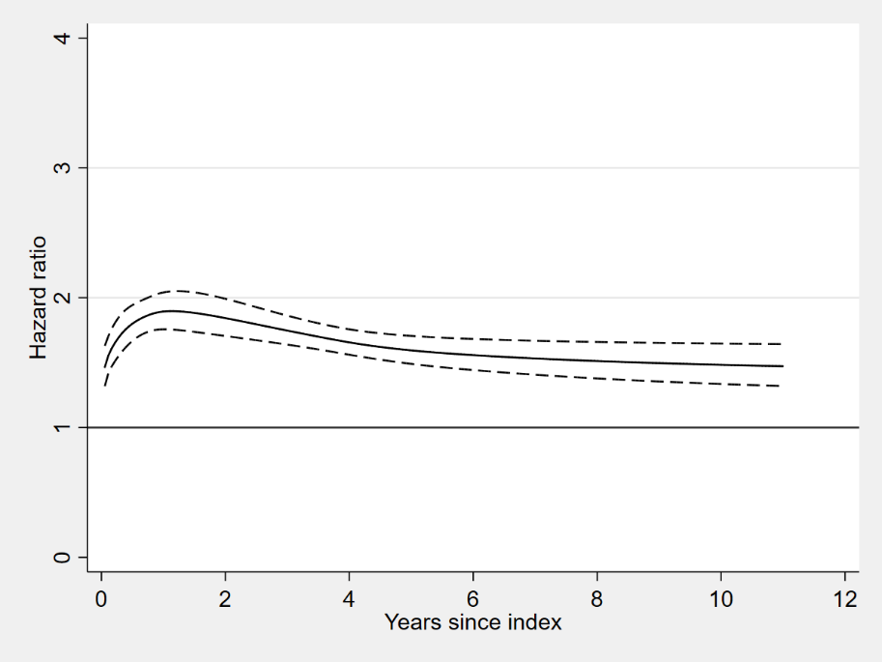
Supplementary Figure 9: Hazard Ratio and 95% confidence interval of diabetes among patients with severe psoriasis
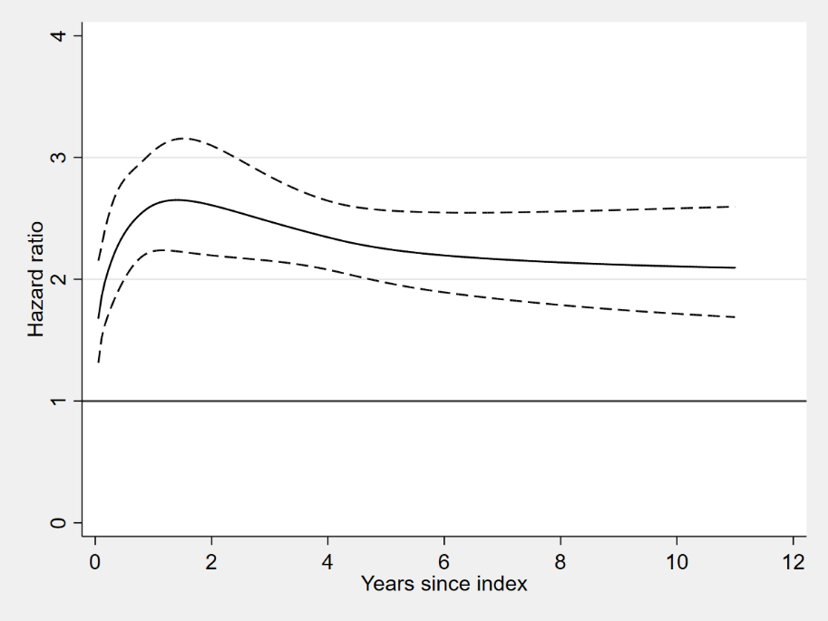

Supplementary Figure10: Predicted risk (with 95% confidence interval) of hypertension among patients with mild psoriasis and their matched controls 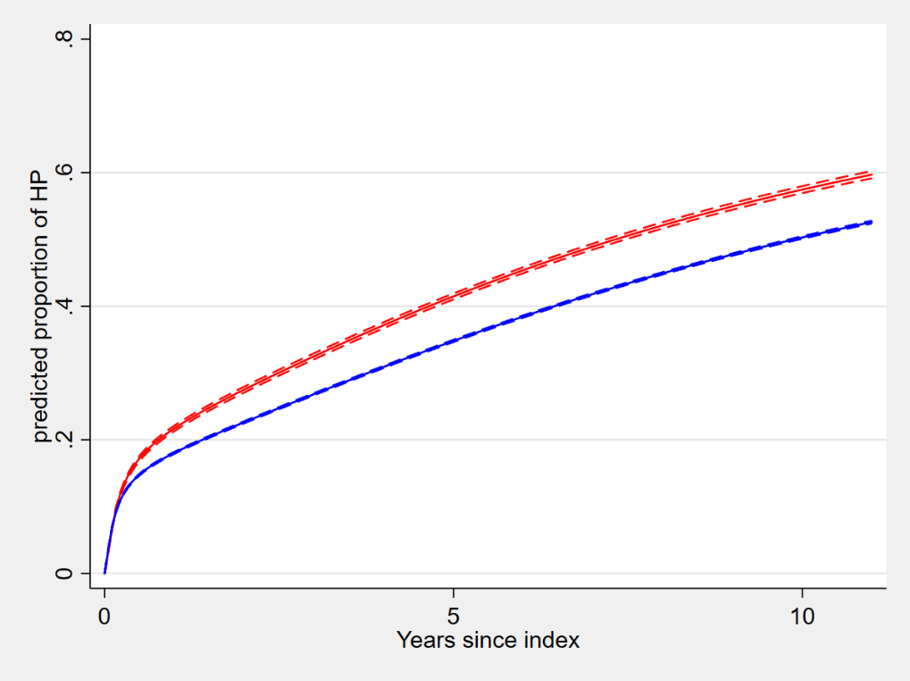
Survival probability of hypertension
Supplementary Figure 11: Predicted risk (with 95% confidence interval) of hypertension among patients with moderate psoriasis and their matched controls
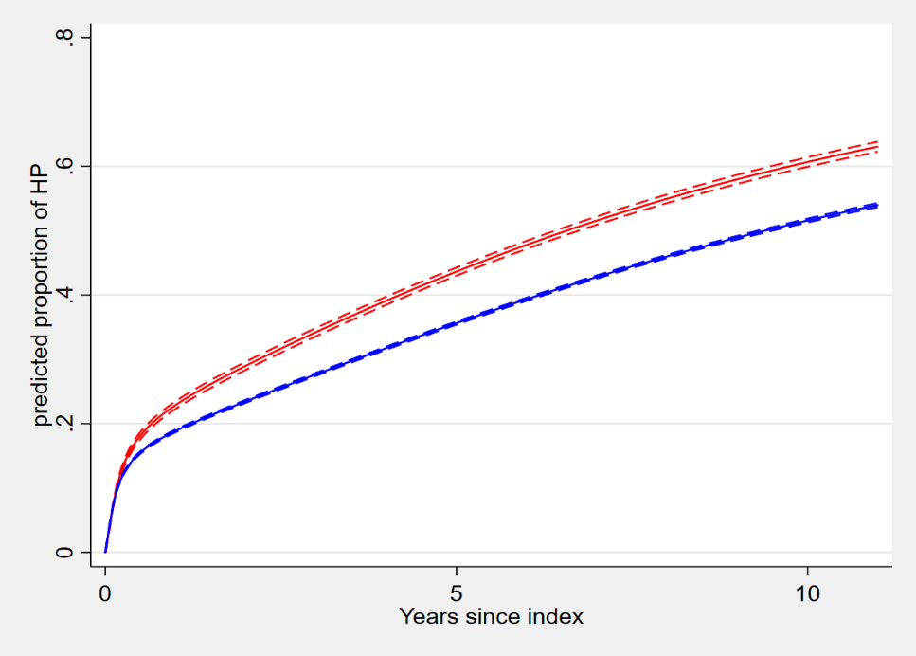
Survival probability of hypertension
Supplementary Figure 12: Predicted risk (with 95% confidence interval) of hypertension among patients with severe psoriasis and their matched controls
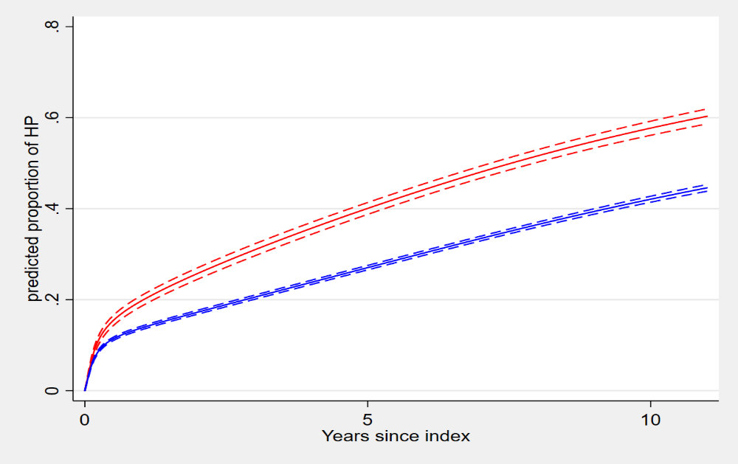
Survival probability of hypertension

Supplementary Figure 13: Predicted risk (with 95% confidence interval) of hypercholesterolemia among patients with mild psoriasis and their matched controls
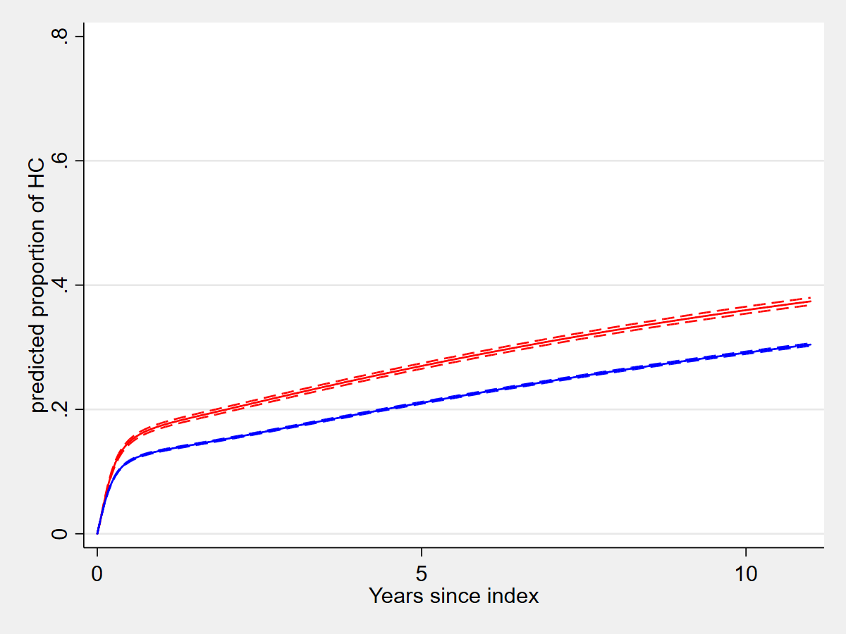
Survival probability of hypercholesterolemia
Supplementary Figure 14: Predicted risk (with 95% confidence interval) of hypercholesterolemia among patients with moderate psoriasis and their matched controls
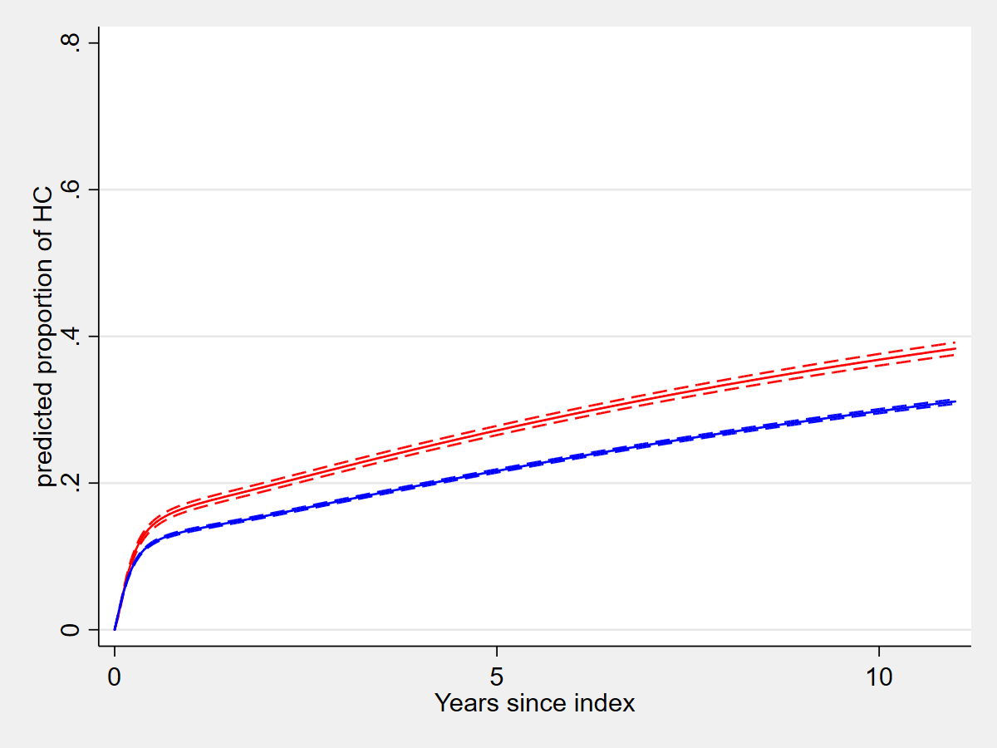
Survival probability of hypercholesterolemia
Supplementary Figure 15: Predicted risk (with 95% confidence interval) interval of hypercholesterolemia among patients with severe psoriasis and their matched controls
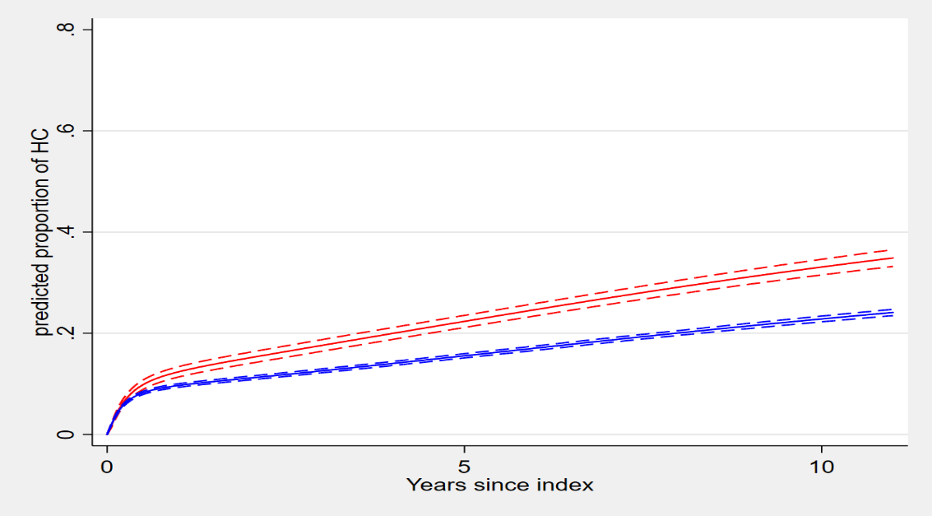
Survival probability of hypercholesterolemia

Supplementary Figure 16: Predicted risk (with 95% confidence interval) of diabetes among patients with mild psoriasis and their matched controls
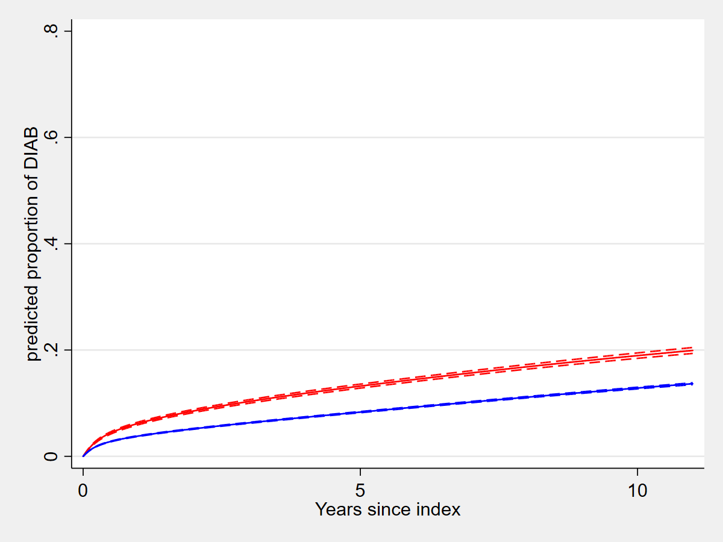
Survival probability of diabetes
Supplementary Figure 17: Predicted risk (with 95% confidence interval) of diabetes among patients with moderate psoriasis and their matched controls
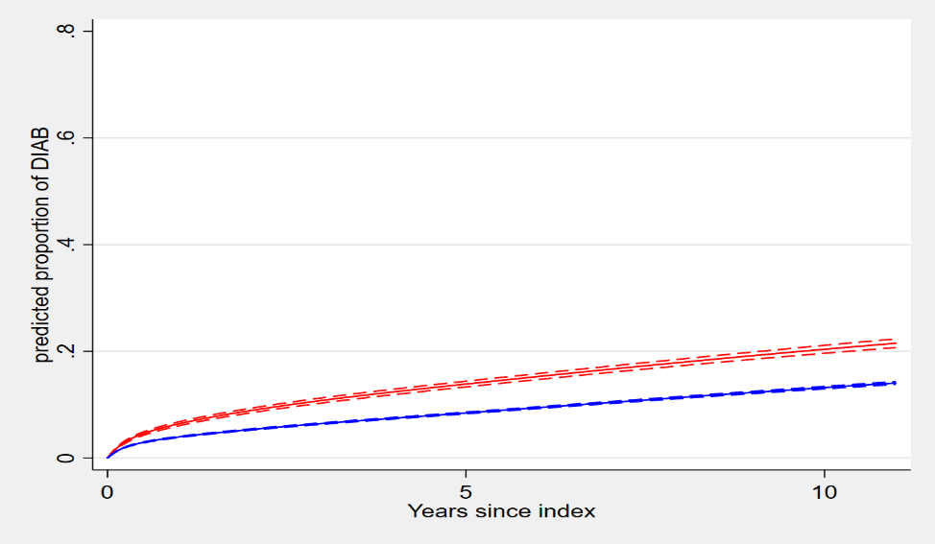
Survival probability of diabetes
Supplementary 18: Predicted risk (with 95% confidence interval) of diabetes among patients with severe psoriasis and their matched controls
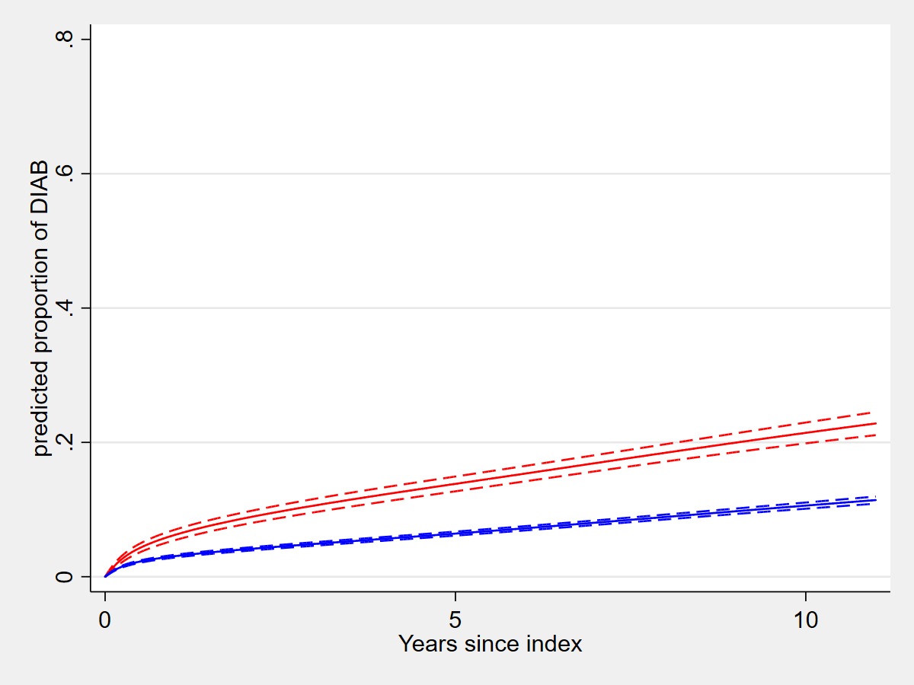
Survival probability of diabetes

Supplementary Table 1: ICD-10 and ATC codes used to define the outcomes
Outcome | ICD-10 | ATC
Hypertension | I10 | C02, C07, C08, C09, C03A, C03B
Hypercholesterolemia | E780 | C10
Diabetes | E10-E11 | A10A, A10B

